Memorandum

To: Technical Advisory Committee

FROM: KEITH CRONIN, PROJECT LEAD, and SAM DENT, TECHNICAL LEAD - VEIC

subject: v13.0 Errata Measures effective 01/01/2025

Date: 06/20/2025

Cc: CELIA JOHNSON, SAG

This memo documents errata changes to Version 13.0 of the Illinois Technical Reference Manual (TRM) that the Technical Advisory Committee (TAC) recommends be made effective 01/01/2025.

VEIC has provided a summary table below showing the errata measures and a brief summary of what was changed, followed by the v13.0 measures themselves.

TRM Policy Document, Section 3.2.1, states that,

“TAC participants should notify the TAC when a TRM mistake or omission is found. If a significant mistake or omission is found in the TRM that results in an unreasonable savings estimate, the Program Administrators, Evaluators, TRM Administrator, and TAC will strive to reach consensus on a solution that will result in a reasonable savings estimate. For example, an unreasonable savings estimate may result from an error or omission in the TRM.

“In these limited cases where consensus is reached, the TRM Administrator shall inform the Evaluators to use corrected TRM algorithms and inputs to calculate energy and capacity savings, in addition to using the Commission-approved TRM algorithms and inputs to calculate savings. If the corrected TRM algorithms and inputs are stipulated for acceptance by all the parties in the Program Administrator’s savings docket, then the corrected TRM savings verification values may be used for the purpose of measuring savings toward compliance with the Program Administrator’s energy savings goals. Errors and omissions found in the TRM will be officially corrected through the annual TRM Update proceeding and will be identified as ‘Errata’.”

It is our belief and understanding that the following measures have been determined to be consensus errata by the Program Administrators, Evaluators, and the entire TAC. The term ‘errata’ is used to describe these measures, and in accordance with the TRM Policy Document, the Evaluators may use this version of the measures during evaluation of the current program year (in addition to the measures currently in Version 13.0 of the TRM).

Summary of Errata Measures
Section | Measure Name | Measure Code | Brief Summary of Change | TAC Reviewed and Approved As of
4.4.9 | Air and Water Source Heat Pump Systems (Centrally Ducted and Ductless) | CI-HVC-HPSY-V13-250101 | Error in ASHPSiteHeatingImpact algorithm for non-fuel switch measures >60kBtuh. A 3412 btu/kWh factor is provided since calculation uses COP for efficiency, however it was erroneously only applied to the baseline heatload.  Edits to unit conversions when using COP efficiency ratings. | 01/01/2025
4.4.15 | Single-Package and Split System Unitary Air Conditioners | CI-HVC-SPUA-V11-250101 | Corrected code baseline SEER2 value for split systems <65,000 Btu/h. Value was incorrectly transcribed from code. The compliance date for these baseline systems was also incorrect, updated that as well. Also made minor adjustments/updates, transitioning the SEER/EER metrics for systems <65,000 Btu/h to SEER2/EER2 | 01/01/2025
4.4.58 | Steam Trap Monitoring System | CI-HVC-STMS-V2-250101 | Correct deemed table values for process heating based on variable inputs provided. | New
4.4.60 | Variable Refrigerant Flow HVAC System | CI-HVC-VFFY-V4-250101 | Energy saving algorithm for units >65 kBtu/hr should use IEER rather than EER. | 01/01/2025

4.4.9 Air and Water Source Heat Pump Systems (Centrally Ducted and Ductless)

Description
This measure applies to the installation of high-efficiency air cooled and water source heat pump systems with conditioned air delivered to the building via ductwork, ductless systems and “hybrid” systems that work in conjunction with fuel-fired heating systems. This measure could apply to replacing an existing unit at the end of its useful life, or installation of a new unit in a new or existing building.
This measure was developed to be applicable to the following program types: TOS, NC, EREP. If applied to other program types, the measure savings should be verified.

Definition of Efficient Equipment
In order for this characterization to apply, the efficient equipment is assumed to be a high-efficiency air cooled or water source, heat pump system that exceeds the baseline and meets program requirements.

Definition of Baseline Equipment
New construction / Time of Sale: To calculate savings with an electric baseline, the baseline equipment is assumed to be a standard-efficiency air cooled or water source heat pump system that meets the Code energy efficiency requirements (IECC or Code of Federal Regulations whichever is higher) in effect on the date of equipment purchase (if date unknown assume current Code minimum). The rating conditions for the baseline and efficient equipment efficiencies must be equivalent.
To calculate savings with a furnace/ AC baseline, the baseline equipment is assumed to meet the Code energy efficiency requirements (IECC or Code of Federal Regulations whichever is higher).
Where unknown, the baseline should be determined via EM&V and the algorithms are provided to allow savings to be calculated from any baseline condition.
In order for this characterization to apply, the baseline equipment is assumed to meet the efficiency requirements within the IECC code in effect on the date of the building permit. As code requirements and adoption can differ from municipality to municipality, the user should verify which version of code is applicable given these constraints.
Note, IECC 2021 is became effective statewide on 1/1/2024. IECC 2018 is the requisite code for any projects with permitting dates spanning July 1, 2019 to 12/31/2023. Prior to July 1, 2019, IECC 2015 is the applicable code. If evaluation determines the applicable version of code, given location and timing, isn’t an appropriate baseline due to supply constraints, low compliance, or other issues, the previous iteration of code may be used through 2023.
IECC 2021 leverages new DOE testing methods and associated metrics. The following conversion factors are recommended for use if the efficient equipment is not rated under the new testing procedure but the stipulated baseline is:
SEER2 = X * SEER
EER2 = X * EER
HSPF2 = X * HSPF
Where:
X | SEER2 | EER2 | HSPF2
Ducted | 0.95 | 0.95 | 0.85
Ductless | 1.00 | 1.00 | 0.90
Packaged | 0.95 | 0.95 | 0.84
Note: new Federal Standards affecting heat pumps and air conditioning equipment became effective January 1, 2023.
Early replacement / Retrofit: The baseline for this measure is the efficiency of the existing heating and cooling equipment for the assumed remaining useful life of the existing unit and a new baseline heating and cooling system meeting the code energy efficiency requirements (IECC or Code of Federal Regulations whichever is higher) for the remainder of the measure life.
A weighted average early replacement rate is provided for use in programs when the actual baseline early replacement rates are unknown.
Deemed Early Replacement Rates For ASHP
Equipment Type | Full System Displacement | Partial System Displacement
Cooling | 30% | 30%
Heating | 30% | 100%

Note to apply these deemed early replacement rates, an assumption of the percentage of replacements that are full displacement v partial displacement is required. This should be determined through evaluation, or a deemed ratio of 100% Full Displacement for ducted ASHPs and 50% Full: 50% Partial for Ductless ASHPs can be used. Savings should be calculated following both the full and partial displacement methodology and then this ratio should be used to weight the savings accordingly.

Deemed Lifetime of Efficient Equipment
The expected measure life is assumed to be 16 years.
Remaining life of existing equipment is assumed to be 6 years for ASHP and Central AC, 6 years for furnace, 8 years for boilers and 16 years for electric resistance.

Deemed Measure Cost
Ducted Air Source Heat Pumps:
New Construction and Time of Sale: For analysis purposes, the incremental capital cost for this measure is assumed as $100 per ton for air-cooled units. The incremental cost for all other equipment types should be determined on a site-specific basis.
Early Replacement: The actual full installation cost of the Heat Pump (including any necessary electrical or distribution upgrades required) should be used. The assumed deferred cost of replacing existing equipment with a new baseline unit should also be incorporated.
Ductless Minisplit Heat Pumps:
New Construction and Time of Sale: The actual installed cost of the DMSHP (including any necessary electrical or distribution upgrades required) should be used (defaults are provided below), minus the assumed installation cost of the baseline equipment ($6,562 + $600 per ton for ASHP, or $2,011 for a new baseline 80% AFUE furnace, or $4,053 for a new 84% AFUE boiler, and $952 per ton for new baseline Central AC replacement ).
Default full cost of the DMSHP is provided below. Note, for smaller units a minimum cost of $2,000 should be applied:
Unit Size | Full Install Cost ($/ton)
9-9.9 | $1,443
10-10.9 | $1,605
11-12.9 | $1,715
13+ | $2,041

The incremental cost of the DSMHP compared to a baseline minimum efficiency DSMHP is provided in the table below:
Efficiency (HSPF2) | Incremental Cost ($/ton) over an HSPF2 7.5 DHP
8.1-8.9 | $62
9-9.8 | $224
9.9-11.6 | $334
11.7+ | $660

Early Replacement/retrofit (replacing existing equipment): The actual full installation cost of the DMSHP (including any necessary electrical or distribution upgrades required) should be used. The assumed deferred cost (after 8 years) of replacing existing equipment with a new baseline unit is assumed to be $7,527 + $688 per ton for a new baseline Air Source Heat Pump, or $2,296 for a new baseline 80% AFUE furnace or $4,627 for a new 84% AFUE boiler and $1,047 per ton for new baseline Central AC replacement. If replacing electric resistance heat, there is no deferred replacement cost. This future cost should be discounted to present value using the nominal societal discount rate.
Where the DMSHP is a supplemental HVAC system, the full installation cost of the DMSHP (including any necessary electrical or distribution upgrades required) should be used without a deferred replacement cost.
If the install cost is unknown a default is provided above. Fuel switch scenarios are likely to require additional installation work which may include adding new electrical circuits, capping existing gas lines and upgrading electrical panels. These costs are likely to range significantly and actual values should be used wherever possible. If unknown, assume an additional $300 for fuel switch installations.

Loadshape
Loadshape C05 - Commercial Electric Heating and Cooling

Coincidence Factor
The summer peak coincidence factor for cooling is provided in two different ways below. The first is used to estimate peak savings during the utility peak hour and is most indicative of actual peak benefits, and the second represents the average savings over the defined summer peak period, and is presented so that savings can be bid into PJM’s capacity market. Both values provided are based on analysis of Itron eShape data for Missouri, calibrated to Illinois loads, supplied by Ameren.
CF_{SSP} = Summer System Peak Coincidence Factor for Commercial cooling (during system peak hour)
= 91.3%
CF_{PJM} = PJM Summer Peak Coincidence Factor for Commercial cooling (average during peak period)
= 47.8%
Algorithm

Calculation of Savings

Electric And Fossil Fuel Energy Savings
Non fuel switch measures:
ΔkWh_{Non Fuel Switch} = ASHPSiteCoolingImpact + ASHPSiteHeatingImpact

Where:
For units with cooling capacities less than 65 kBtu/hr (ASHP only):
ASHPSiteCoolingImpact = ((CoolingLoad/DuctlessSave * (1/(SEER2_base))) – (CoolingLoad * 1/(SEER2_ee )))/1,000
ASHPSiteHeatingImpact = ((HeatLoad_Disp/DuctlessSave * (1/(HSPF2_base * HSPF2_ClimateAdj))) – (HeatLoad_Disp * 1/(HSPF2_ee * HSPF2_ClimateAdj))) / 1,000
For ASHP units with cooling capacities equal to or greater than 65 kBtu/hr and all WSHPs:
ΔkWh_{Non Fuel Switch} = ASHPSiteCoolingImpact + ASHPSiteHeatingImpact

Where:
ASHPSiteCoolingImpact = ((CoolingLoad * (1/(IEER_base))) – (CoolingLoad * 1/(IEER_ee )))/1,000
ASHPSiteHeatingImpact = (HeatLoad_Disp / 3,412 * (1/COP_base – 1/COP_ee))

Fuel switch measures:
Fuel switch measures must produce positive total lifecycle energy savings (i.e., reduction in Btus at the premises) in order to qualify. This is determined as follows (note for early replacement measures the lifetime savings should be calculated by calculating savings for the remaining useful life of the existing equipment and for the remaining measure life):
SiteEnergySavings (MMBTUs) = FuelSwitchSavings + NonFuelSwitchSavings
FuelSwitchSavings = GasHeatReplaced - HPSiteHeatConsumed
NonFuelSwitchSavings = FurnaceFanSavings + HPSiteCoolingImpact
For units with cooling capacities less than 65 kBtu/hr (ASHP only):
ASHPSiteHeatConsumed = ((HeatLoad_Disp * (1/(HSPF2_ee * HSPF2_ClimateAdj * PD_Adj))) /1,000 * 3,412)/ 1,000,000
ASHPSiteCoolingImpact = (((CoolingLoad/DuctlessSave * (1/(SEER2_base)) – ((CoolingLoad * 1/(SEER2_ee)))/1,000 * 3412) / 1,000,000
FurnaceFanSavings = (FurnaceFlag * HeatLoad_Disp/DuctlessSave * 1/AFUE_{base} * F_{e}) / 1,000,000
GasHeatReplaced = (HeatLoad_Disp/DuctlessSave * 1/AFUE_{base}) / 1,000,000
For ASHP units with cooling capacities greater than 65 kBtu/hr and all WSHPs:
ASHPSiteHeatConsumed = (HeatLoad_Disp * (1/(COP_ee * PD_Adj))) / 1,000,000
ASHPSiteCoolingImpact = (((CoolingLoad * (1/(IEER_base)) – ((CoolingLoad * 1/(IEER_ee)))/1,000 * 3,412) / 1,000,000
FurnaceFanSavings = (FurnaceFlag * HeatLoad_Disp * 1/AFUE_{base} * F_{e}) / 1,000,000
GasHeatReplaced = (HeatLoad_Disp * 1/AFUE_{base}) / 1,000,000
If SiteEnergySavings calculated above is positive, the measure is eligible.
The appropriate savings claim is dependent on which utilities are supporting the measure as provided in a table below:
Measure supported by: | Electric Utility claims (kWh): | Gas Utility claims (therms):
Electric utility only | SiteEnergySavings * 1,000,000/3,412 | N/A
Electric and gas utility  (Note utilities may make alternative agreements to how savings are allocated as long as total MMBtu savings remains the same). | %IncentiveElectric * SiteEnergySavings *  1,000,000/3,412 | %IncentiveGas * SiteEnergySavings * 10
Gas utility only | N/A | SiteEnergySavings * 10

Note for Early Replacement measures, the efficiency terms of the existing unit should be used for the remaining useful life of the existing equipment (6 years for ASHP and Central AC, 6 years for furnace, 8 years for boilers, 15 years for electric resistance), and the efficiency terms for a new baseline unit should be used for the remaining years of the measure. See assumptions below.
Programs where existing system unknown
In programs where the existing fuel or system type is unknown, savings should be apportioned between the Fuel Switch and Non- Fuel Switch scenarios, as follows:
Savings from Non-Fuel Switch (kWh) = (1 – %FuelSwitch) * ΔkWh_{Non Fuel Switch}
Plus
Savings from Fuel Switch (MMBtu converted to appropriate fuel as table above)
= %FuelSwitch * SiteEnergySavings (MMBTUs)
Where:
%FuelSwitch = The percentage of replacements resulting in fuel-switching.
= 1 when fuel switching is known, 0 if non fuel switch
= when unknown, e.g. midstream program, determine via evaluation
CoolingLoad = Annual cooling load for the building
= EFLH_{cool} * Capacity_{cool}
Capacity_{cool} = Output capacity of the cooling equipment in Btu per hour (1 ton of cooling capacity equals 12,000 Btu/hr).
= Actual installed
SEER2_{base} = Seasonal Energy Efficiency Ratio of the baseline equipment
= SEER from tables below, based on the applicable Code on the date of equipment purchase (if unknown assume current Code).
SEER2_{ee} = Seasonal Energy Efficiency Ratio of the energy efficient equipment.
= Actual installed
EFLH_{cool} = Equivalent Full Load Hours for cooling in Existing Buildings or New Construction are provided in section 4.4 HVAC End Use.
DuctlessSave = Factor used to adjust ducted heating or cooling load displaced by ductless systems that are not subject to losses from existing ductwork.
= 1-0.15 = 0.85 for ducted system displaced by ductless system
= 1.00 for ducted system displaced by ducted system or ductless system displaced by ductless system
HSPF2_{base} = Heating Seasonal Performance Factor of the baseline equipment
= HSPF from tables below, based on the applicable Code on the date of equipment purchase (if unknown assume a blended baseline value of 5.1 HSPF2).
HSPF2_{ee} = Heating Seasonal Performance Factor of the energy efficient equipment.
= Actual installed. If rating is COP, HSPF = COP * 3.413
HSPF_ClimateAdj = Adjustment factor to account for observed discrepency between seasonal heating performance relative to rated HSPF as provided by standard AHRI 210/240 rating conditions. Note, the adjustment is dependent on the test method use for the rating (i.e. HSPF or HSPF2 rating) :
City (county based upon) | HSPF_ClimateAdj  When using HSPF2 rating
1 (Rockford) | 77%
2 (Chicago) | 77%
3 (Springfield) | 91%
4 (Belleville) | 91%
5 (Marion) | 91%
Weighted Average  ComEd  Ameren  Statewide | 77%  89%  80%

IEER_{base} = Integrated Energy Efficiency Ratio of the baseline equipment
= IEER (or EER2) from tables below, based on the applicable Code on the date of equipment purchase (if unknown assume current Code). For air-cooled units < 65 kBtu/hr, assume the following conversion from SEER2 to EER2 for calculation of peak savings:
EER2 = (-0.02 * SEER2²) + (1.12 * SEER2)
IEER_{ee} = Integrated Energy Efficiency Ratio (or EER2) of the energy efficient equipment. For air-cooled units < 65 kBtu/hr, if the actual EER2_{ee} is unknown, assume the conversion from SEER2 to EER2 as provided above.
= Actual installed
HeatLoad_Disp = Annual heat load for the building displaced by the ASHP (Btus)
= EFLH_{heat} * Capacity_{heat} * HeatLoadFactor
EFLH_{heat} = heating mode equivalent full load hours in Existing Buildings or New Construction are provided in section 4.4 HVAC End Use.
Capacity_{heat} = output capacity of the heat pump equipment in Btu per hour.
= Actual installed
HeatLoadFactor = Portion of HeatLoad displaced by ASHP in partial displacement applications. Varies by Switchover Temperature and Climate Region. If Switchover Temperature is unknown, use 32°F.
= 1.0 if full displacement (e.g. cold climate heat pumps and water source heat pumps) or if switchover temperature is lower than 17°F or if Partial Displacement with simultaneous operation
Climate Zone  (City based upon) | HeatLoadFactor (by Switchover Temperature)
 | 47°F | 44°F | 41°F | 38°F | 35°F | 32°F | 29°F | 26°F | 23°F | 20°F | 17°F
1 (Rockford) | 4% | 8% | 12% | 16% | 26% | 36% | 45% | 58% | 66% | 71% | 78%
2 (Chicago) | 4% | 9% | 15% | 21% | 32% | 43% | 52% | 66% | 74% | 77% | 84%
3 (Springfield) | 4% | 9% | 15% | 21% | 37% | 52% | 59% | 69% | 76% | 79% | 85%
4 (Belleville) | 7% | 14% | 22% | 30% | 41% | 55% | 66% | 77% | 85% | 90% | 93%
5 (Marion) | 7% | 16% | 25% | 34% | 53% | 67% | 76% | 86% | 90% | 93% | 97%
Weighted Average  ComEd  Ameren  Statewide | 4%  5%  4% | 9%  11%  9% | 15%  17%  16% | 20%  24%  21% | 31%  38%  33% | 43%  52%  45% | 51%  60%  54% | 66%  71%  67% | 73%  79%  75% | 77%  82%  79% | 84%  88%  85%

PD_Adj = Adjustment multiplier to account for increased heat pump efficiency in Partial Displacement applications when there is no electric resistance backup and switchover temperature is higher than 17F. Varies by Switchover Temperature and Climate Region. If Switchover Temperature is unknown, use 32F.
= 1.0 if full displacement (e.g. cold climate heat pumps or water source heat pumps) or if switchover temperature is lower than 17F or if Partial Displacement with simultaneous operation
Climate Zone  (City based upon) | PD_Adj (by Switchover Temperature)
 | 47°F | 44°F | 41°F | 38°F | 35°F | 32°F | 29°F | 26°F | 23°F | 20°F | 17°F
1 (Rockford) | 153% | 149% | 146% | 143% | 138% | 134% | 132% | 128% | 126% | 124% | 122%
2 (Chicago) | 153% | 148% | 145% | 142% | 138% | 134% | 132% | 128% | 126% | 125% | 123%
3 (Springfield) | 153% | 148% | 145% | 142% | 137% | 133% | 132% | 129% | 128% | 127% | 125%
4 (Belleville) | 152% | 149% | 145% | 143% | 139% | 135% | 133% | 131% | 128% | 127% | 126%
5 (Marion) | 153% | 148% | 145% | 142% | 138% | 135% | 134% | 131% | 130% | 129% | 128%
Weighted Average  ComEd  Ameren  Statewide | 153%  153%  153% | 148%  148%  148% | 145%  145%  145% | 142%  142%  142% | 138%  138%  138% | 134%  134%  134% | 132%  132%  132% | 128%  130%  129% | 126%  128%  127% | 125%  127%  126% | 123%  125%  124%

3412 = Btu per kWh.
COP_{base} = coefficient of performance of the baseline equipment
= COP from tables below, based on the applicable Code on the date of equipment purchase (if unknown assume current Code). If rating is HSPF2, COP = HSPF2 / 3.413
COP_{ee} = coefficient of performance of the energy efficient equipment.
= Actual installed. If rating is HSPF2, COP = HSPF2 / 3.413
AFUE_{base} = Baseline Annual Fuel Utilization Efficiency Rating. For early replacement measures, use actual AFUE rating for the remaining useful life of the existing equipment (6 years for furnace, 8 years for boilers). For new systems (time of sale, new construction or remaining years of early replacement), use appropriate code level efficiency.
FurnaceFlag = 1 if system replaced is a gas furnace, 0 if not.
F_{e} = Furnace Fan energy consumption as a percentage of annual fuel consumption
= 7.7%
%IncentiveElectric = % of total incentive paid by electric utility
= Actual
%IncentiveGas = % of total incentive paid by gas utility
= Actual

Code of Federal Redulations (baseline effective 1/1/2019):
Equipment type | Cooling capacity | Heating type | Cooling Efficiency level | Heating Efficiency level | Compliance date
Small Commercial Packaged Air Conditioning and Heating Equipment (Air-Cooled) | ≥65,000 Btu/h and <135,000 Btu/h | Electric Resistance Heating or No Heating | IEER = 12.2  IEER = 14.1 | N/A | 1/1/2018  1/1/2024
 |  | All Other Types of Heating | IEER = 12.0  IEER = 13.9 | COP = 3.3  COP = 3.4 | 1/1/2018  1/1/2024
Large Commercial Packaged Air Conditioning and Heating Equipment (Air-Cooled) | ≥135,000 Btu/h and <240,000 Btu/h | Electric Resistance Heating or No Heating | IEER = 11.6  IEER = 13.5 | N/A | 1/1/2018  1/1/2024
 |  | All Other Types of Heating | IEER = 11.4  IEER = 13.3 | COP = 3.2  COP = 3.3 | 1/1/2018  1/1/2024
Very Large Commercial Packaged Air Conditioning and Heating Equipment (Air-Cooled) | ≥240,000 Btu/h and <760,000 Btu/h | Electric Resistance Heating or No Heating | IEER = 10.6  IEER = 12.5 | N/A | 1/1/2018  1/1/2024
 |  | All Other Types of Heating | IEER = 10.4  IEER = 12.3 | COP = 3.2 | 1/1/2018  1/1/2024
Small Commercial Package Air-Conditioning and Heating Equipment (Air-Cooled, Single-Phase, Split-System) | <65,000 Btu/h | All | SEER2 = 14.3  EER2 = 9.4 | HSPF2 = 7.5 | 1/1/2023
Small Commercial Package Air-Conditioning and Heating Equipment (Air-Cooled, Single-Phase, Single-Package) | <65,000Btu/h | All | SEER2 = 13.4  EER2 = 8.8 | HSPF2 = 6.7 | 1/1/2023
Small Commercial Package Air-Conditioning and Heating Equipment (Air-Cooled, 3-Phase, Split-System) | <65,000 Btu/h | All | SEER2 = 14.3  EER2 = 9.4 | HSPF2 = 7.5 | 1/1/2025
Small Commercial Package Air-Conditioning and Heating Equipment (Air-Cooled, 3-Phase, Single-Package) | <65,000Btu/h | All | SEER2 = 13.4  EER2 = 8.8 | HSPF2 = 6.7 | 1/1/2025
Small Commercial Packaged Air-Conditioning and Heating Equipment (Water Source: Water-to-Air, Water-Loop) | <17,000 Btu/h | All | EER = 12.2 | COP = 4.3 | 10/9/2015
 | ≥17,000 Btu/h and <65,000 Btu/h | All | EER = 13.0 | COP = 4.3 | 10/9/2015
 | ≥65,000 Btu/h and <135,000Btu/h | All | EER = 13.0 | COP = 4.3 | 10/9/2015

Minimum Efficiency Requirements: 2015 IECC (baseline effective 1/1/2016 to 6/30/2019)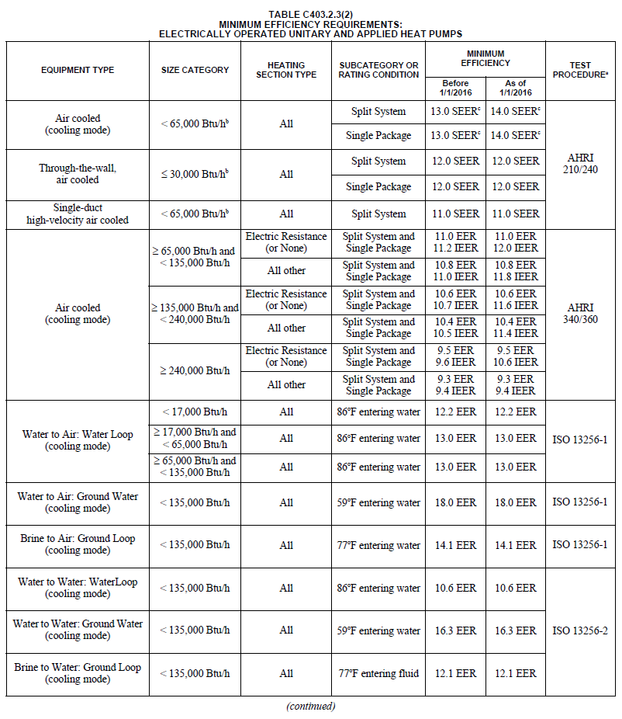

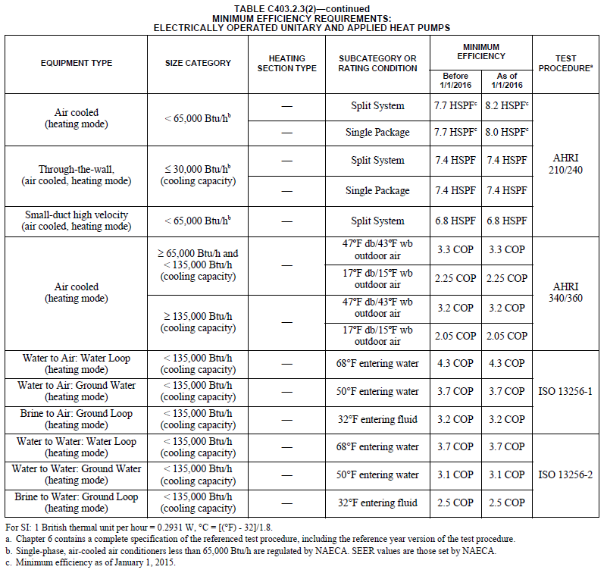

Minimum Efficiency Requirements: 2018 IECC (baseline effective 7/1/2019 to 9/30/2022)
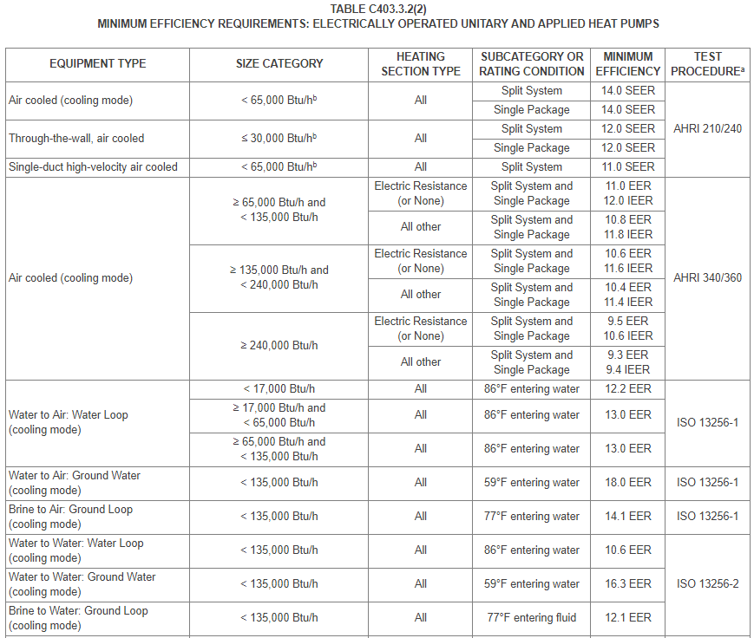

IECC2018 Table C403.3.2(2) continued from previous page:
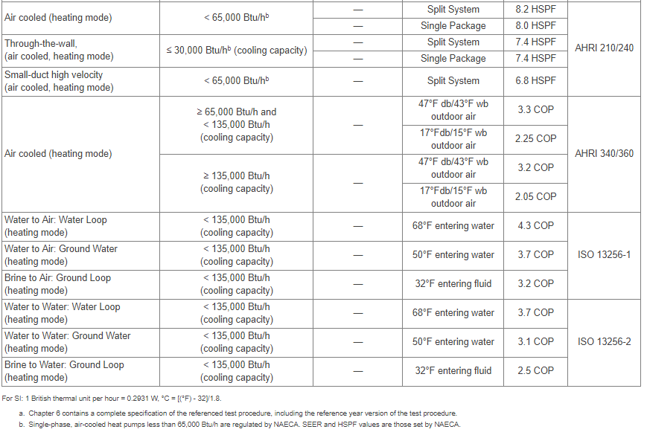

Minimum Efficiency Requirements: 2021 IECC (baseline effective 10/1/2022 for New Construction measures)
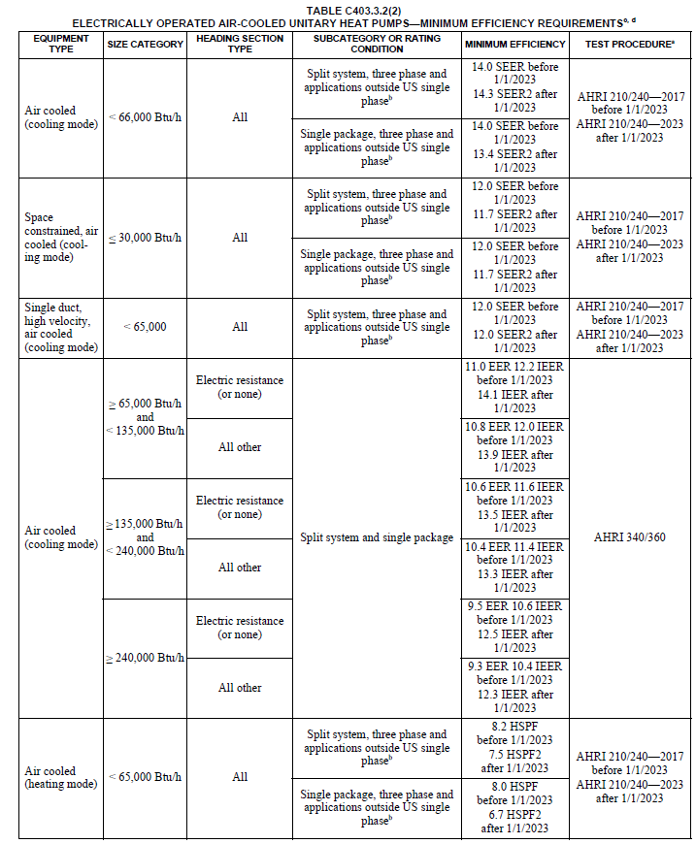

IECC2021 Table C403.3.2(2) continued from previous page
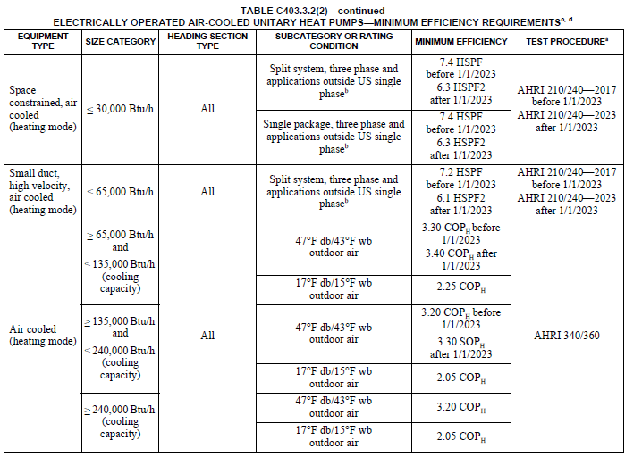

Non Fuel Switch example, a 5-ton single phase split system 60,000 Btuh capacity heat pump, with an efficiency SEER2 of 16, and an efficient HSPF2 of 9.5, at a new restaurant in Chicago with a building permit dated after 1/1/2023 saves:
ΔkWh = Annual kWh Savings_{cool} + Annual kWh Savings_{heat}
Annual kWh Savings_{cool} = (Capacity_{cool} * EFLH_{cool} * (1/SEER_{base} – 1/SEER_{ee}))/1000
Annual kWh Savings_{heat} = (HeatLoad * (1/(HSPF_{base} * HSPF_ClimateAdj) – 1/(HSPF_{ee}* HSPF_ClimateAdj)/1000
ΔkWh = (60,000 * 761 * (1/14.3 – 1/16))/1000 + (60,000 * 797 * (1/(7.5 * 0.7) – 1/(9.5 * 0.7))/1000
= 2257 kWh

Fuel Switch Illustrative Examples
[for illustrative purposes 50:50 Incentive is used for joint programs]
New construction using gas furnace and central AC baseline:
For example, a 60,000 Btu, 16 SEER2, 9.5 HSPF2 single phase split system Air Site Heat Pump installed in a new Chicago restaurant, in place of a 120,000 Btuh natural gas furnace and 5 ton Central AC unit:
SiteEnergySavings (MMBTUs) = GasHeatReplaced + FurnaceFanSavings - HPSiteHeatConsumed + HPSiteCoolingImpact
GasHeatReplaced = (HeatLoad * 1/AFUE_{base}) / 1,000,000
= (60,000 * 797 * 1/0.8) / 1000000
= 59.8 MMBtu
FurnaceFanSavings = (FurnaceFlag * HeatLoad * 1/AFUE_{base} * F_{e}) / 1,000,000
= (1 * 60,000 * 797 * 1/0.8 * 0.077) / 1,000,000
= 4.6 MMBtu
HPSiteHeatConsumed = ((HeatLoad * (1/(HSPF_{ee} * HSPF_ClimateAdj))) /1000 * 3412)/ 1,000,000
= ((60,000 * 797 * (1/(9.5 * 0.77))) / 1000 * 3412) / 1,000,000
= 22.3 MMBtu
HPSiteCoolingImpact = ((FLHcool * Capacity_{cool} * (1/SEERbase - 1/SEER_{ee}))/1000 * 3412) / 1,000,000
= ((761 * 60,000 * (1/14.3 - 1/16)) / 1000 * 3412)/1,000,000
= 1.2 MMBtu

SiteEnergySavings (MMBTUs) = 59.8 + 4.6 – 22.3 + 1.2 = 43.3 MMBtu [Measure is eligible]

Fuel Switch Illustrative Example continued
Savings would be claimed as follows:
Measure supported by: | Electric Utility claims: | Gas Utility claims:
Electric utility only | 43.3 * 1,000,000/3412  = 12,691 kWh | N/A
Electric and gas utility | 0.5 * 43.3 * 1,000,000/3412  = 6,345 kWh | 0.5 * 43.3 * 10  = 217 Therms
Gas utility only | N/A | 43.3 * 10  = 433 Therms

Summer Coincident Peak Demand Savings
ΔkW = ((Capacity_{cool}/DuctlessSave * 1/EER2_base) – (Capacity_{cool} * 1/EER2_ee)) / 1000 * CF
Where CF value is chosen between:
CF_{SSP} = Summer System Peak Coincidence Factor for Commercial cooling (during system peak hour)
= 91.3%
CF_{PJM} = PJM Summer Peak Coincidence Factor for Commercial cooling (average during peak period)
= 47.8%
For example, a 5 ton single phase split system air source heat pump, with an efficient EER2 of 12.5 with a building permit dated after 1/1/2023 saves:
ΔkW = ((60,000/1 * 1/9.4) – (60,000 * 1/12.5))/1000 *0.913
= 1.44 kW

Fossil Fuel Savings
Calculation provided together with Electric Energy Savings above.

Water Impact Descriptions and Calculation
N/A

Deemed O&M Cost Adjustment Calculation
N/A

Cost Effectiveness Screening and Load Reduction Forecasting when Fuel Switching
This measure can involve fuel switching from gas to electric.
For the purposes of forecasting load reductions due to fuel switch ASHP projects per Section 16-111.5B, changes in site energy use at the customer’s meter (using ΔkWh algorithm below), customer switching estimates, NTG, and any other adjustment factors deemed appropriate, should be used.
The inputs to cost effectiveness screening should reflect the actual impacts on the electric and fuel consumption at the customer meter and, for fuel switching measures, should therefore reflect the decrease in one fuel and increase in another, as opposed to the single savings value calculated in the “Electric and Fossil Fuel Energy Savings” section above. Therefore in addition to the calculation of savings claimed, the following values should be used to assess the cost effectiveness of the measure. For Early Replacement measures, the efficiency terms of the existing unit should be used for the remaining useful life of the existing equipment (6 years for ASHP and Central AC, 7 years for furnace, 8 years for boilers or GSHP, 15 years for electric resistance), and the efficiency terms for a new baseline unit should be used for the remaining years of the measure.
ΔTherms = [Heating Consumption Replaced]
= [(%FuelSwitch * HeatLoad_Disp/DuctlessSave * 1/AFUE_{base}) / 100,000]
ΔkWh = [FurnaceFanSavings] - [HP heating consumption] + [Cooling savings]
For units with cooling capacities less than 65 kBtu/hr:
= %FuelSwitch * [FurnaceFlag * HeatLoad_Disp/DuctlessSave * 1/AFUE_{base} * F_{e} * 0.000293] - [(HeatLoad_Disp * (1/(HSPF2_{ee} * HSPF2_ClimateAdj * PD_Adj))/1000] + [((CoolingLoad/DuctlessSave * 1/SEER2_{base}) - (CoolingLoad * 1/SEER2_{ee}))/1000]
For units with cooling capacities greater than 65 kBtu/hr:
= %FuelSwitch * [FurnaceFlag * HeatLoad_Disp * 1/AFUE_{base} * F_{e} * 0.000293] - [HeatLoad_Disp/3412 * 1/(COP_{ee} * PD_Adj)] + [(CoolingLoad * (1/IEER_{base} - 1/IEER_{ee}))/1000]

Measure Code: CI-HVC-HPSY-V13-250101

Review Deadline: 1/1/2028

4.4.15 Single-Package and Split System Unitary Air Conditioners

Description
This measure promotes the installation of high-efficiency unitary air-, water-, and evaporatively-cooled air conditioning equipment, both single-package and split systems. Air conditioning (AC) systems are a major consumer of electricity and systems that exceed baseline efficiency requirements can significantly reduce energy consumption. This measure could apply to the replacing of an existing unit at the end of its useful life or the installation of a new unit in a new or existing building.
This measure was developed to be applicable to the following program types: TOS, NC, EREP. If applied to other program types, the measure savings should be verified.

Definition of Efficient Equipment
The efficient equipment is assumed to be a high-efficiency air-, water-, or evaporatively-cooled air conditioner that exceeds the energy efficiency requirements as prescribed by the program.

Definition of Baseline Equipment
In order for this characterization to apply, the baseline equipment is assumed to be a standard-efficiency air-, water, or evaporatively-cooled air conditioner that meets the Code energy efficiency requirements (IECC or Code of Federal Regulations whichever is higher) in effect on the date of equipment purchase (if date is unknown, assume current Code minimum).
For Early Replacement programs, use the actual efficiency of the existing unit or assume IECC code base in place at the original time of existing unit installation. To qualify under the early replacement characterization, baseline equipment must meet these additional qualifications:
- The existing unit is operational when replaced or the existing unit would be operational with minor repairs.
In order for this characterization to apply, the baseline equipment is assumed to meet the efficiency requirements within the IECC code in effect on the date of the building permit. As code requirements and adoption can differ from municipality to municipality, the user should verify which version of code is applicable given these constraints.
Note, IECC 2021 became effective statewide on 1/1/2024. IECC 2018 is the requisite code for any projects with permitting dates spanning July 1, 2019 to 12/31/2023. Prior to July 1, 2019, IECC 2015 is the applicable code. If evaluation determines the applicable version of code, given location and timing, isn’t an appropriate baseline due to supply constraints, low compliance, or other issues, the previous iteration of code may be used through 2023.
IECC 2021 leverages new DOE testing methods and associated metrics. The following conversion factors are recommended for use if the efficient equipment is not rated under the new testing procedure but the stipulated baseline is:
SEER2 = X * SEER
EER2 = X * EER
HSPF2 = X * HSPF
Where:
X | SEER2 | EER2 | HSPF2
Ducted | 0.95 | 0.95 | 0.85
Ductless | 1.00 | 1.00 | 0.90
Packaged | 0.95 | 0.95 | 0.84

Note: new Federal Standards affecting heat pumps and air conditioning equipment became effective January 1, 2025.

Deemed Lifetime of Efficient Equipment
The expected measure life is assumed to be 15 years.
For early replacement, the remaining life of existing equipment is assumed to be 5 years.

Deemed Measure Cost
The incremental capital cost for this measure is based upon capacity and efficiency level (defined be CEE specifications), as outlined in the following table:
 | Incremental cost ($/ton)
Capacity | Up to and including  CEE Tier 1 units | CEE Tier 2 and above
< 135,000 Btu/hr | $63 | $127
135,000 Btu/hr to > 250,000 Btu/hr | $63 | $127
250,000 Btu/hr and greater | $19 | $38

For early replacement, the full cost of the installed unit should be used. If unknown use defaults below. The assumed deferred cost (after 5 years) of replacing existing equipment with a new baseline unit is also provided. This future cost should be discounted to present value using the real discount rate:
 | Full Install Cost ($/ton)
Capacity | Base Units | Up to and including  CEE Tier 1 units | CEE Tier 2 and above
< 135,000 Btu/hr | $895 | $958 | $1,021
135,000 Btu/hr to > 250,000 Btu/hr | $762 | $825 | $889
250,000 Btu/hr and greater | $673 | $691 | $710

Loadshape
Loadshape C03 - Commercial Cooling

Coincidence Factor
The summer peak coincidence factor for cooling is provided in two different ways below. The first is used to estimate peak savings during the utility peak hour and is most indicative of actual peak benefits, and the second represents the average savings over the defined summer peak period and is presented so that savings can be bid into PJM’s capacity market. Both values provided are based on analysis of Itron eShape data for Missouri, calibrated to Illinois loads, supplied by Ameren.
CF_{SSP} = Summer System Peak Coincidence Factor for Commercial cooling (during system peak hour)
= 91.3%
CF_{PJM} = PJM Summer Peak Coincidence Factor for Commercial cooling (average during peak period)
= 47.8%
Algorithm

Calculation of Savings

Electric Energy Savings
Time of Sale:
For units with cooling capacities less than 65 kBtu/hr:
$$ΔkWH= (kBtu/hr) * [\frac{1}{SEER2base} – \frac{1}{SEER2ee}(1/SEERee] * EFLH$$
For units with cooling capacities equal to or greater than 65 kBtu/hr:
$$ΔkWH= (kBtu/hr) * [\frac{1}{IEERbase} – \frac{1}{IEERee}] * EFLH$$
Early replacement:
For units with cooling capacities less than 65 kBtu/hr:
For remaining life of existing unit (1st 5 years):
$$ΔkWH= (kBtu/hr) * [\frac{1}{SEER2exist} – \frac{1}{SEER2ee}] * EFLH$$
For remaining measure life (next 10 years):
$$ΔkWH= (kBtu/hr) * [\frac{1}{SEER2base} – \frac{1}{SEER2ee}] * EFLH$$
For units with cooling capacities equal to or greater than 65 kBtu/hr:
For remaining life of existing unit (1st 5 years):
$$ΔkWH= (kBtu/hr) * [\frac{1}{IEERexist} – \frac{1}{IEERee}] * EFLH$$
NOTE: If the existing equipment age is such that IEER ratings are not available, EER may be substitued when necessary. In such instances both existing and efficient unit efficiencies should be specified in EER.
For remaining measure life (next 10 years):
$$ΔkWH= (kBtu/hr) * [\frac{1 }{IEERbase}– \frac{1}{IEERee}] * EFLH$$
Where:
kBtu/hr = capacity of the cooling equipment actually installed in kBtu per hour (1 ton of cooling capacity equals 12 kBtu/hr)
SEER2_{base} = Seasonal Energy Efficiency Ratio of the baseline equipment
= SEER2 values from tables below, based on applicable Code on date of equipment purchase (if unknown assume current Code).
SEER2_{ee} = Seasonal Energy Efficiency Ratio of the energy efficient equipment (actually installed)
SEE2R_{exist} = Seasonal Energy Efficiency Ratio of the existing equipment
= Actual, or assume Code base in place at the original time of existing unit installation
IEER_{base} = Integrated Energy Efficiency Ratio of the baseline equipment. See table below based on applicable Code on date of equipment purchase (if unknown assume current Code).
IEER_{ee} = Integrated Energy Efficiency Ratio of the energy efficient equipment (actually installed)
IEER_{exist} = Integrated Energy Efficiency Ratio of the existing equipment
= Actual, or assume Code base in place at the original time of existing unit installation
EFLH = Equivalent Full Load Hours for cooling in Existing Buildings or New Construction are provided in section 4.4 HVAC End Use
The rating conditions for the baseline and efficient equipment efficiencies must be equivalent.

Code of Federal Redulations (baseline effective 1/1/2025):
Equipment type | Cooling capacity | Heating type | Efficiency level | Compliance date
Small Commercial Packaged Air Conditioning and Heating Equipment (Air-Cooled) | ≥65,000 Btu/h and <135,000 Btu/h | Electric Resistance Heating or No Heating | IEER = 12.9  IEER = 14.8 | 1/1/2018  1/1/2023
 |  | All Other Types of Heating | IEER = 12.7  IEER = 14.6 | 1/1/2018  1/1/2023
Large Commercial Packaged Air Conditioning and Heating Equipment (Air-Cooled) | ≥135,000 Btu/h and <240,000 Btu/h | Electric Resistance Heating or No Heating | IEER = 12.4  IEER = 14.2 | 1/1/2018  1/1/2023
 |  | All Other Types of Heating | IEER = 12.2  IEER = 14.0 | 1/1/2018  1/1/2023
Very Large Commercial Packaged Air Conditioning and Heating Equipment (Air-Cooled) | ≥240,000 Btu/h and <760,000 Btu/h | Electric Resistance Heating or No Heating | IEER = 11.6  IEER = 13.2 | 1/1/2018  1/1/2023
 |  | All Other Types of Heating | IEER = 11.4  IEER = 13.0 | 1/1/2018  1/1/2023
Small Commercial Package Air-Conditioning and Heating Equipment (Air-Cooled, 3-Phase, Split-System) | <65,000 Btu/h | All | SEER2 = 13.4 | 1/1/2025
Small Commercial Package Air-Conditioning and Heating Equipment (Air-Cooled, 3-Phase, Single-Package) | <65,000Btu/h | All | SEER2 = 13.4 | 1/1/2025

2015 IECC Minimum Efficiency Requirements (baseline effective 1/1/2016 to6/30/2019)
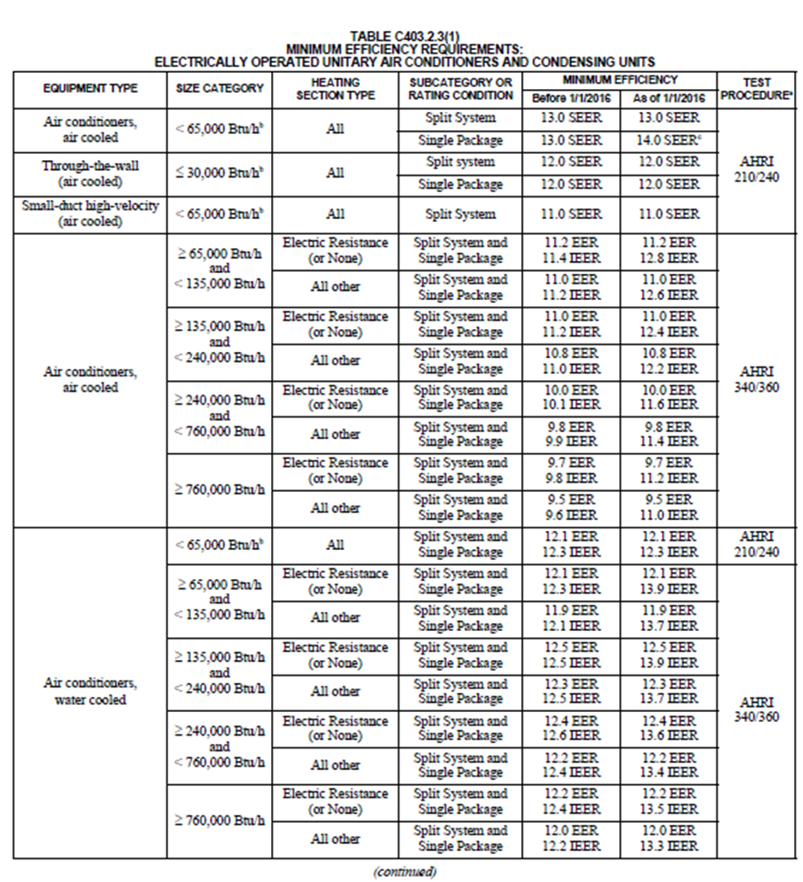

2018 IECC Minimum Efficiency Requirements (baseline effective 7/1/2019 to 9/30/2022)
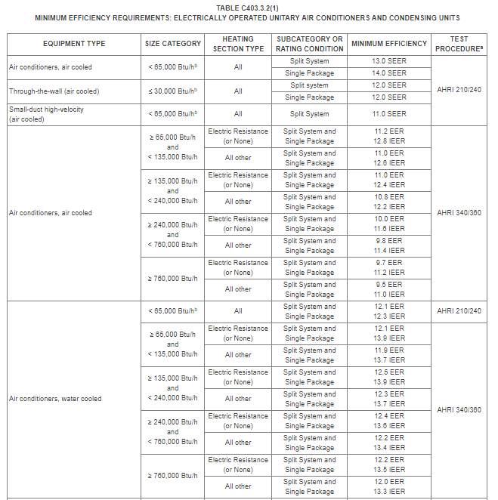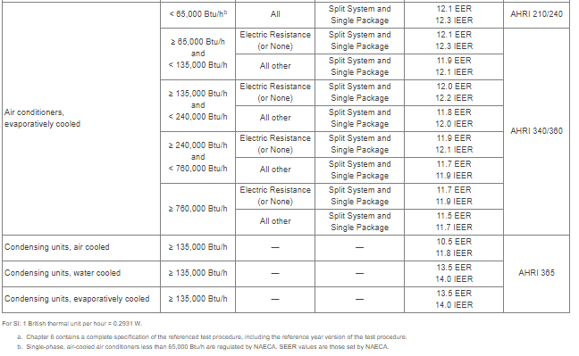

2021 IECC Minimum Efficiency Requirements (baseline effective 10/1/2022)
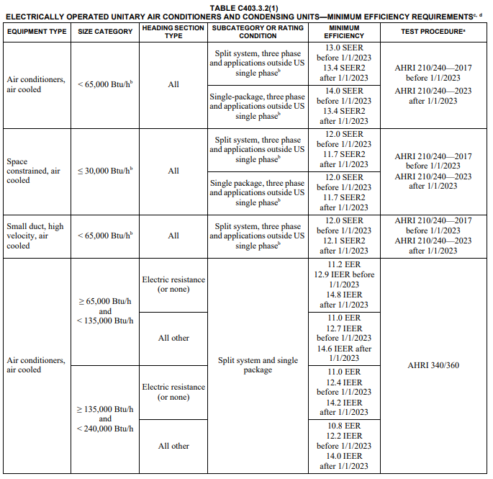

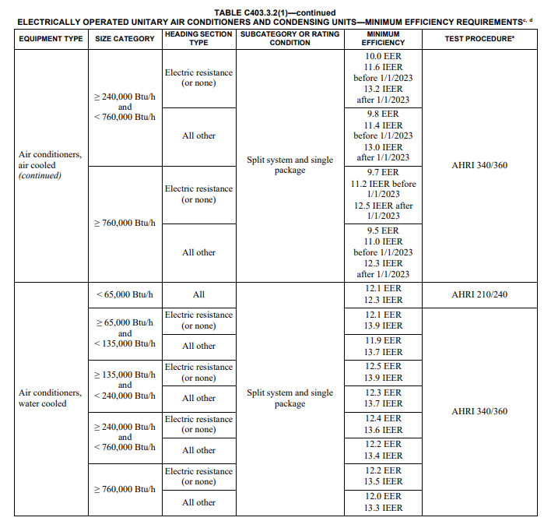
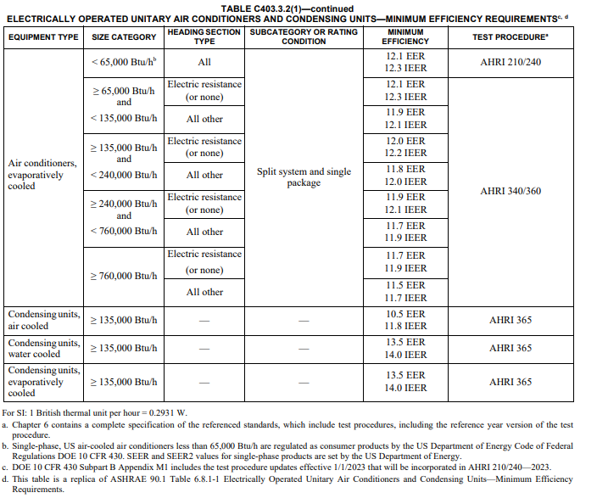

For example, a 5 ton air cooled split system with a SEER2 of 15 at an existing retail strip mall in Rockford would save:
ΔkWH = (60) * [(1/13.4) – (1/15)] * 697
= 290 kWh

Summer Coincident Peak Demand Savings
Time of Sale:
$$ΔkW = (kBtu/hr * (\frac{1}{EER2base} - \frac{1 }{EER2ee})* CFΔkW = (kBtu/hr) * (\frac{1}{EER2base} - \frac{1 }{EER2ee})* CF$$
Early Replacement:
For remaining life of existing unit (1st 5 years):
$$ΔkW= (kBtu/hr) * [\frac{1}{EER2exist} – \frac{1}{EER2ee}] * CF$$
For remaining measure life (next 10 years):
$$ΔkW= (kBtu/hr) * [\frac{1}{EER2base} – \frac{1}{EER2ee}] * CF$$
Where:
EER2_{base} = Energy Efficiency Ratio of the baseline equipment
= EER values from tables above, based on applicable Code on date of equipment purchase (if unknown assume current Code). (For air-cooled units < 65 kBtu/hr, assume the following conversion from SEER to EER for calculation of peak savings: EER = (-0.02 * SEER²) + (1.12 * SEER))
EER2_{ee} = Energy Efficiency Ratio of the energy efficient equipment. If the actual EER_{ee} is unknown, assume the conversion from SEER to EER for calculation of peak savings as above).
= Actual installed
EER2_{exist} = Energy Efficiency Ratio of the existing equipment
= Actual, or assume Code base in place at the original time of existing unit installation
CF_{SSP} = Summer System Peak Coincidence Factor for Commercial cooling (during system peak hour)
= 91.3%
CF_{PJM} = PJM Summer Peak Coincidence Factor for Commercial cooling (average during peak period)
= 47.8%
For example, a 5 ton air cooled split system with a SEER of 15 in Rockford would save:
ΔkW_{SSP} = (60) * [(1/11.4) – (1/12.3)] * 0.913
= 0.352 kW

Fossil Fuel Savings
N/A

Water Impact Descriptions and Calculation
N/A

Measure Code: CI-HVC-SPUA-V11-250101

Review Deadline: 1/1/2026

4.4.58 Steam Trap Monitoring System

Description
The measure applies to the installation of a steam trap monitoring system. The measure is applicable to commercial applications, commercial HVAC including multifamily buildings, and industrial applications. An existing measure, 4.4.16 Steam Trap Replacement or Repair, covers the replacement of a faulty steam trap in the failed open or leaking state. In addition to the steam trap replacement savings, the proposed measure allows to account for savings due to faster repair of the steam traps. Once a failed steam trap is detected, it can be immediately repaired/replaced. Continuous steam trap monitoring leaves behind manual inspections (audits) by using sensors to transmit real-time conditions of the steam system.
Energy savings for each steam trap occurs only when failed open, and steam trap failure rates vary based on trap size, type, and pressure. Energy savings are calculated on a per trap basis with the assumed annual failure rate for each application. Separate savings methodologies are recommended for space heating and process heating applications.
This measure was developed to be applicable to the following program types: TOS, RF. If applied to other program types, the measure savings should be verified.

Definition of Efficient Equipment
Customers must install a steam trap monitoring system on properly functioning steam traps serving either space heating or process heating load. The monitoring system must be capable of tracking the following, but not limited to, number of steam traps, trap type, operating pressure, operating temperature, ambient temperature, trap condition, date/time, application, and trap location. Applicants must provide characteristics for the steam system such as heating efficiency, steam trap orifice size(s), and system pressure(s). Customer must commit to repairing/replacing steam traps identified as failed by the steam trap monitoring system.

Definition of Baseline Equipment
The baseline criterion are functioning steam traps serving either space heating or process heating load with no pre-existing monitoring system. No minimum leak rate is required.

Deemed Lifetime of Efficient Equipment
10 years based on vendor estimates.

Deemed Measure Cost
The costs are subject to the subscription period chosen by the customer as shown in table below. The approximate installed cost is per trap per year and includes sensors, gateway, cellular service, cloud hosting, User license, data, and reports.
Number of Traps | Term
 | 1 Year | 2 Years | 3 Years | 4 Years | 5 Years
100 – 250 | $300 | $282 | $265 | $249 | $234
250 – 499 | $291 | $274 | $257 | $242 | $227
500 – 999 | $282 | $265 | $249 | $234 | $220
1000 – 1999 | $274 | $257 | $242 | $227 | $214
2000 – 2999 | $266 | $250 | $235 | $221 | $207
3000 – 4999 | $262 | $246 | $232 | $218 | $204
5000 – 5999 | $258 | $242 | $228 | $214 | $201
6000 – 6999 | $254 | $238 | $224 | $210 | $198
7000+ | $251 | $235 | $221 | $207 | $196
Additional costs exist for the repair or replacement of steam traps once identifying a fault.

Loadshape
N/A

Coincidence Factor
N/A
Algorithm

Calculation of Energy Savings

Electric Energy Savings
Secondary kWh Savings for Water Supply and Wastewater Treatment
The following savings should be included in the total savings for this measure but should not be included in TRC tests to avoid double counting the economic benefit of water savings. These savings only apply to situations in which steam is lost from the steam system.
$$∆{kWh}_{water}={∆Water \left(gallons\right)}/{1,000,000 ×E_{water supply}}$$
Where
E_{water supply} = Water Supply Energy Factor (kWh/Million Gallons)
= 2571

Summer Coincident Peak Demand Savings
N/A

Fossil Fuel Savings
$$∆Therm=N ×P_{malfunctioning}×F_{o}×S_{a}×\left(\frac{\left(Hv+Hs×\left(T_{1}-T_{source}\right)\right)×Hours}{\left(100,000×η_{B}\right)}\right)$$
Where:
N = Total number of steam traps monitored through the steam trap monitoring system
P_{malfunctioning} = Annual Percentage of malfunctioning traps
$$P_{malfunctioning} =L×T_{audit}×T_{u}$$
Where:
L = Leaking & Blow-thru
= custom, if unknown:
Steam System | L (%)
Commercial Dry Cleaners | 27%
Commercial Heating (including Multifamily) LPS | 27%
Industrial and Process Low Pressure ≤ 15 psig | 16%
Medium Pressure > 15 psig < 30 psig | 16%
Medium Pressure ≥ 30 < 75 psig | 16%
High Pressure ≥ 75 < 125 psig | 16%
High Pressure ≥ 125 < 175 psig | 16%
High Pressure ≥ 175 < 250 psig | 16%
High Pressure ≥ 300 psig | 16%
T_{audit} = Average time between audits
Custom, if unknown use 1 year
Tu = Average percentage of year trap malfunctions are undetected for steam systems without a steam trap monitoring system
Custom, if unknown use 50%
F_{o} = Failed open to total failed ratio
= Custom, if unknown:
96%, Space heating applications
98%, Dry cleaners³
94%, All other steam systems and applications³
S_{a} = Steam loss per leaking trap, $\left({lbs}/{hr}\right)$
Hv = Heat of vaporization of steam, $\left({Btu}/{lbm}\right)$
Steam System | Average Inlet Pressure psig | Heat of Vaporization $\left({Btu}/{lbm}\right)$
Commercial Dry Cleaners | -- | 890
Commercial Space Heating (including Multifamily) LPS | 11.2 | 951
Industrial/Process Low Pressure: psig < 15 | 11.2⁹ | 951
Medium Pressure: 15 ≤ psig < 30 | 16 | 944
Medium Pressure: 30 ≤ psig < 75 | 47 | 915
High Pressure: 75 ≤ psig < 125 | 101 | 880
High Pressure: 125 ≤ psig < 175 | 146 | 859
High Pressure: 175 ≤ psig < 250 | 202 | 837
High Pressure: 250 ≤ psig < 300 | 263 | 816
High Pressure: 300 ≤ psig | -- | Custom

Hs = Specific heat of water, $\left({Btu}/{\left(lbm*°R\right)}\right)$
= $1.001$
T₁ = Temperature of Saturated Steam, $\left(°R\right)$
= $507.89×{P_{1}}^{0.0962}$
Where:
= $507.89=Constant, {°R×\left({{in}^{2}}/{{lb}_{f}}\right)}^{0.0962}$
T_{source} = $513.67 °R$
Hours = Annual hours when steam system is pressurized
= custom, if unknown:
Steam System | Zone (Where applicable) | Hours/Yr
Commercial Dry Cleaners | All Climate Zones | 2,425
Industrial/Process Low Pressure: psig < 15 |  | 8,282
Medium Pressure: 15 ≤ psig < 30 |  | 8,282
Medium Pressure: 30 ≤ psig < 75 |  | 8,282
High Pressure: 75 ≤ psig < 125 |  | 8,282
High Pressure: 125 ≤ psig < 175 |  | 8,282
High Pressure: 175 ≤ psig < 250 |  | 8,282
High Pressure: 250 ≤ psig < 300 |  | 8,282
High Pressure: 300 ≤ psig |  | 8,282
Commercial Space Heating LPS | Rockford | 4,272
 | Chicago | 4,029
 | Springfield | 3,406
 | Belleville | 2,515
 | Marion | 2,546
Multifamily Space Heating LPS | For steam traps that are part of steam systems where the boiler cycles on/off to maintain space setpoint temperature or for steam traps located downstream of a steam control valve that opens/closes to maintain setpoint temperature, use Heating EFLH values in Section 4.4 for High Rise or Mid-Rise MF buildings.  For steam traps that are exposed to steam continuously throughout the heating season, use the values listed above for Commercial Space Heating LPS for your appropriate climate zone.
100,000 = Conversion factor $\left({Btu}/{Therms}\right)$
η_{B} = Boiler efficiency
= custom, if unknown:
80.7% for steam boilers, except multifamily low-pressure
64.8% for multifamily low-pressure steam boilers

Space Heating Savings Estimates
For systems used in space heating applications that operate at 5 psig or lower, use the following equation to calculate S_{a}. The condensate return system pressure, P₂, will typically be atmospheric pressure, 14.696 psia.
$$S_{a}=1,519.3×P_{1}×D^{2}×{\left[\left(1/{T_{1}}\right)×\left(γ/{\left(γ-1\right)}\right)×\left({\left({P_{2}}/{P_{1}}\right)}^{\left(2/γ\right)}-{\left({P_{2}}/{P_{1}}\right)}^{\left({\left(γ+1\right)}/γ\right)}\right)\right]}^{0.5}×A×FF$$
Where:
1,519.3 = Constant, ${\left(s^{2}×°R^{0.5}\right)}/{\left(ft×hr\right)}$
P₁ = Average steam trap inlet pressure $\left(absolute, psia\right)$. If not available, use defaults provided in table below (note that defaults are provided in psig, not psia)
D = Diameter of orifice, inches. Actual value should be used wherever possible as this value has a significant impact on steam flowrate value.
γ = Heat Capacity Ratio $\left(unitless\right)$
= $5.071×{10}^{-4}×P_{1}+1.332$
P₂ = Average steam trap outlet pressure $\left(absolute, psia\right)$. If unknown, assume atmospheric pressure, $14.696 psia$
A = Adjustment factor
= 50%, all steam systems. This factor accounts for reduction in the maximum theoretical steam flow to the average steam flow (the Enbridge factor).
FF = Flow factor. In addition to the Adjustment factor (A), and additional 50% flow factor adjustment is recommended for medium and high-pressure steam systems to address industrial float and thermostatic style traps where additional blockage is possible.

Defaults are provided in table below if custom calculation is not performed. The savings are averages for common orifice diameters $\left(1/8, 3/{16},1/4,5/{16}inches\right)$ at an assumed 5 psig.
Savings per Steam Trap Orifice Size |  | 1/8 | 3/16 | 1/4 | 5/16
S_{a} | (lbs/hr) | 3.84 | 8.64 | 15.35 | 23.99
ΔTherms | (Therms/trap/yr) | 14.23 | 32.02 | 56.92 | 88.94

Process Heating Savings Estimates
Use the following equation, for all other steam systems and applications
$$S_{a}=24.24×P_{1}×D^{2}×A×FF$$
Where:
24.24 = Constant, ${lbm}/{\left(hr×psia×{in}^{2}\right)}$

Defaults are provided in table below if custom calculation is not performed.
Steam System | Average Steam Trap Inlet Pressure  (psig) | Diameter of Orifice  (in) | Adjustment Factor | Flow Factor | S_{a} (lbs/trap/hr) | ΔTherm
Commercial Dry Cleaners | 82.8 | 0.1250 | 50% | 100% | 18.5 | 86
Commercial LPS Space Heating | 11.2 | 0.2100 | 50% | 100% | 13.8 | 101
Industrial/Process Low Pressure: psig < 15 | 11.2 | 0.2100¹⁹ | 50% | 100% | 13.8 | 121
Medium Pressure: 15 ≤ psig < 30 | 16 | 0.1875 | 50% | 50% | 6.5 | 57
Medium Pressure: 30 ≤ psig < 75 | 47 | 0.2500 | 50% | 50% | 23.4 | 209
High Pressure: 75 ≤ psig < 125 | 101 | 0.2500 | 50% | 50% | 43.8 | 395
High Pressure: 125 ≤ psig < 175 | 146 | 0.2500 | 50% | 50% | 60.7 | 551
High Pressure: 175 ≤ psig < 250 | 202 | 0.2500 | 50% | 50% | 82.1 | 745
High Pressure: 250 ≤ psig < 300 | 263 | 0.2500 | 50% | 50% | 105.2 | 954

Water and Other Non-Energy Impact Descriptions and Calculation
The hourly water volume saved per each repaired or replaced leaking trap is calculated by dividing the “Steam Loss per Leaking Trap (lbm/hr/trap)” by the density of water saved, 8.33 lbm/gal, that replaces the lost steam. The steam loss is provided in the table for parameter S_{a}, the “Steam loss per leaking trap” in the Fossil Fuel savings section above. Annual water savings are calculated using Hours and P_{malfunctioning}, the annual percentage of malfunctioning traps, as defined above.
Water savings only apply to situations where condensate is lost from the steam system. If a condensate recovery system is in place, assume zero water savings or provide a custom calculation based on site-specific operation.
The annual water savings for a replaced or repaired trap is given by:
$$∆Water=GAL×Hours×N ×P_{malfunctioning}×F_{o}$$
Where:
GAL = average actual water volume saved per leaking trap, as listed in the following table and based on steam system type.
Other variables as defined above
Steam System | S_{a} | GAL  (gal/hr/trap)
Commercial Dry Cleaners | 18.5 | 2.22
Multifamily LPS Space Heating | 6.9 | 0.83
Industrial/Process Low Pressure: psig < 15 | 13.8 | 1.66
Medium Pressure: 15 ≤ psig < 30 | 6.5 | 0.79
Medium Pressure: 30 ≤ psig < 75 | 23.4 | 2.81
High Pressure: 75 ≤ psig < 125 | 43.8 | 5.26
High Pressure: 125 ≤ psig < 175 | 60.9 | 7.31
High Pressure: 175 ≤ psig < 250 | 82.1 | 9.85
High Pressure: 250 ≤ psig < 300 | 105.2 | 12.63
High Pressure: 300 ≤ psig | Calculated | Calculated Steam Loss / 8.33

Deemed O&M Cost Adjustment Calculation
N/A

Measure Code: CI-HVC-STMS-V2-250101

Review Deadline: 1/1/2025

4.4.60 Variable Refrigerant Flow HVAC System

Description
This measure applies to the installation of air source Variable Refrigerant Flow (VRF) HVAC systems. VRF systems are heat pumps that have one outdoor condensing unit with refrigerant piped to multiple indoor evaporator units to deliver cooling and/or heating to individual interior zones as needed. This measure could apply to replacing an existing unit at the end of its useful life or the installation of a new unit in a new or existing building.
This measure was developed to be applicable to the following program times: TOS and NC. If applied to other program types, the measure savings should be verified.

Definition of Efficient Equipment
This measure applies to both retrofit and new construction installations of VRF systems. Savings are based in the inherent efficiency of VRF systems as compared to traditional HVAC systems. VRF systems should meet or exceed ASHRAE 90.1 minimum efficiency requirements for air source VRF systems.

Definition of Baseline Equipment
Time of Sale / New Construction
Non-fuel switch measures:
To calculate savings with an electric baseline, the baseline equipment is assumed to be a ducted split-system heat pump for non-residential buildings 25,000 square feet or fewer and is 3 floors or fewer. For non-residential buildings over 25,000 square feet or 4 floors or higher, the baseline equipment is assumed to be a standard-efficiency air cooled heat pump roof top unit (RTU) system. For residential buildings types which utilize individual in-unit HVAC systems, such as multifamily, lodging, dormitories, etc., the baseline equipment is assumed to be a residential style standard-efficiency packaged terminal heat pump split system.
Fuel switch measures:
To calculate savings with a gas or fuel heating baseline, the baseline equipment is assumed to be single zone furnace and air-conditioning units for non-residential buildings 25,000 square feet or fewer and is 3 floors or fewer. For non-residential buildings over 25,000 square feet or taller than 3 floors, the baseline equipment is assumed to be a packaged variable-air-volume (VAV) system with DX cooling and hot water reheat. For residential buildings types which utilize individual in-unit HVAC systems, such as multifamily, lodging, dormitories, etc., the baseline equipment is assumed to be a packaged terminal air conditioner (PTAC) with hot-water radiator heating. If the residential building is 4 stories or more, the baseline system will be a water source heat pump (WSHP) system with a boiler and cooling tower.
Standard efficiency implies equipment that complies with Code energy efficiency requirements (IECC or Code of Federal Regulations, whichever is higher) in effect on the date of equipment purchase (if date unknown, assume current Code minimum). The rating conditions for the baseline and efficient equipment efficiencies must be equivalent. Note: IECC 2018 is baseline for all New Construction permits from July 1, 2019, and if permit date unknown. Note: new Federal Standards affecting heat pumps become effective January 1, 2023.
Baseline selection:
The following table can be used to determine the appropriate baseline HVAC system type.
 | Non-Fuel Switch | Fuel Switch
Multifamily or Lodging,  3 floors or fewer | Packaged Terminal Heat Pump | PTAC w/ Hot Water Radiator
Multifamily or Lodging,  4 floors or more | Packaged Terminal Heat Pump | Water Source Heat Pump with Cooling Tower and Natural Gas Boiler
Non-residential <25,000 SF and 3 floors or fewer | Ducted-Split System Heat Pump | Packaged Single Zone (Furnace) + Air Conditioner
Non-Residential >25,000 SF OR more than 3 floors | Heat Pump RTU | Packaged VAV RTU with Hot Water Reheat

Deemed Lifetime of Efficient Equipment
The expected measure life for VRF is 16 years.

Deemed Measure Cost
Time of Sale: For analysis, the incremental capital costs are summarized in the following table. Site specific cost data should be used where available.
Baseline System | Incremental Cost ($/ton)
Packaged Terminal Heat Pump | $610
Ducted Split System Heat Pump | $860
Heat Pump RTU | $130
PTAC w/ Hot Water Radiator | $160
Water Source Heat Pump | $0
Packaged Single Zone (Furnace) + Air Conditioner | $835
Packaged VAV RTU with Hot Water Reheat | $540

Loadshape
Loadshape C05 – Commercial Electric Heating and Cooling

Coincidence Factor
The summer peak coincidence factor for cooling is provided in two different ways below. The first is used to estimate peak savings during the utility peak hour and is most indicative of actual peak benefits. The second represents the average savings over the defined summer peak period and is presented so that savings can be bid into PJM’s capacity market. Both values provided are based on analysis of Itron eShape data for Missouri, calibrated to Illinois loads, supplied by Ameren.

CFSSP | = Summer System Peak Coincidence Factor for Commercial cooling (during system peak hour)  = 91.3%
CFPJM | = PJM Summer Peak Coincidence Factor for Commercial cooling (average during peak period)  = 47.8%
Algorithm

Calculation of Energy Savings

Electric Energy Savings
Savings are calculated as a sum of system switching savings and efficiency savings, analogous to the following equation:
Annual Savings = [System Switch Savings] + [Savings from improved VRF efficiency]
For fuel-switching calculations, the above equation is used for calculating the cooling savings, while the heating savings are calculated by as the following:
Annual Savings = [Gas Heat Replaced x System Switch Adjustment Factor] + [Fan Savings] – [Heat Pump heat consumed x System Switch Adjustment Factor] + [Heat Pump Cooling * System Switch Savings + Heat Pump Cooling Savings from improved VRF efficiency]
The system switching savings are calculated by multiplying the cooling or heating load (EFLH times heat or cool capacity) and multiplying it by system heating (Heatadj) and cooling (Cooladj) factors. These adjustment factors were calculated with energy model data of different building types. The VRF performance curves were calibrated based on independent field monitored data.
- The difference in building code baseline efficiency between VRF and the baseline system.
- The improved part load performance of the VRF inverter driven compressor compared to single-stage or two-stage compressors.
- Heat recovery mode savings from the VRF units.
- Decrease in energy from cooling towers (WSHP baseline) and water pumps (baseline systems with hot water and WSHP).
- WSHP electric heating and boiler fuel consumption (WSHP baseline).
- Differences in treating ventilation between mixed recirculating systems and VRF systems with dedicated outdoor air systems (Heat Pump RTU and VAV baseline systems only).
Savings from improved VRF efficiency is similar to other efficiency savings from other TRM measures, where savings are calculated as the load multiplied by the change in efficiency.

Non-fuel switch measures:
For units with cooling capacities less than 65 kBtu/hr:
ΔkWh  Annual kWh Savingscool  Annual kWh Savingsheat  FanSavings | = Annual kWh Savingscool + Annual kWh Savingsheat + FanSavings  = [System Switch Savings] + [Savings from improved VRF efficiency]  = (Cooladj * Capacitycool * EFLHcool /3,412)+ (Capacitycool * EFLHcool * (1/SEERbase – 1/SEERee))/1000  = [System Switch Savings] + [Savings from improved VRF efficiency]  = (Heatadj * HeatLoad/3,412) + (HeatLoad * (1/HSPFbase – 1/HSPFee))/1000  = (Flag * HeatLoad * 1/AFUEbase * Fe) / 3,412
For units with cooling capacities equal to or greater than 65 kBtu/hr:
ΔkWh  Annual kWh Savingscool  Annual kWh Savingsheat  FanSavings | = Annual kWh Savingscool + Annual kWh Savingsheat + FanSavings  = [System Switch Savings] + [Savings from improved VRF efficiency]  = (Cooladj * Capacitycool * EFLHcool/3,412) + (Capacitycool * EFLHcool * (1/IEERbase – 1/IEERee))/1000  = [System Switch Savings] + [Savings from improved VRF efficiency]  = (Heatadj * HeatLoad)/3,412 + (HeatLoad * (1/COPbase – 1/COPee)) /3,412  = (Flag * HeatLoad * 1/AFUEbase * Fe) / 3,412

Fuel switch measures:
Fuel switch measures must produce positive total lifecycle site energy savings in order to qualify. This is determined as follows (note for early replacement measures the lifetime savings should be calculated by calculating savings for the remaining useful life of the existing equipment and for the remaining measure life):
SiteEnergySavings (MMBTU) | = GasHeatReplaced + FanSavings – HPSiteHeatConsumed + HPSiteCoolingImpact
GasHeatReplaced (MMBTU) | = (GasHeatadj * HeatLoad * 1/AFUEbase) / 1,000,000
FanSavings (MMBTU) | = (Flag * HeatLoad * 1/AFUEbase * Fe) / 1,000,000
For units with cooling capacities less than 65 kBtu/hr:
HPSiteHeatConsumed (MMBTU) | = (Heatadj * HeatLoad * (1/HSPFee)) * 3,412 / 1,000 / 1,000,000
HPSiteCoolingImpact (MMBTU) | = [System Switch Savings] + [Savings from improved VRF efficiency]  = ((Cooladj * Capacitycool * EFLH_{cool}) / 1,000,000) + ((EFLH_{cool} * Capacitycool * (1/SEERbase - 1/SEERee)) * 3,412 / 1,000 / 1,000,000)
For units with cooling capacities greater than 65 kBtu/hr:
HPSiteHeatConsumed (MMBTU) | = (Heatadj * HeatLoad * (1/COPee)) / 1,000,000
HPSiteCoolingImpact (MMBTU) | = [System Switch Savings] + [Savings from improved VRF efficiency]  = ((Cooladj * Capacitycool * EFLH_{cool}) / 1,000,000) + ((EFLHcool * Capacitycool * (1/IEER_base - 1/IEER_ee)) * 3,412 /1,000 / 1,000,000)

Savings are adjusted by heating (Heatadj) and cooling (Cooladj) factors presented in the following table. These values bring the expected savings in line with energy model estimated savings.
Baseline System | GasHeatadj | Cooladj | Heatadj
Packaged Terminal Heat Pump | N/A | 0.1 | 0.0
Ducted Split System Heat Pump | N/A | 0.0 | 0.0
Heat Pump RTU | N/A | -0.2 | 0.5
PTAC w/ Hot Water Radiator | 0.7 | 0.0 | 1.3
Water Source Heat Pump | 0.4 | 0.1 | 0.5
Packaged Single Zone (Furnace) + Air Conditioner | 1.4 | 0 | 1.6
Packaged VAV RTU with Hot Water Reheat | 0.9 | -0.2 | 1.8

If SiteEnergySavings calculated above is positive, the measure is eligible. The appropriate savings claim is dependent on which utilities are supporting the measure as provided in a table below:
Measure supported by: | Electric Utility claims (kWh): | Gas Utility claims (therms):
Electric utility only | SiteEnergySavings * 1,000,000/3,412 | N/A
Electric and gas utility  (Note: utilities may make alternative agreements to how savings are allocated as long as total MMBtu savings remains the same). | %IncentiveElectric * SiteEnergySavings * 1,000,000/3,412 | %IncentiveGas * SiteEnergySavings * 10
Gas utility only | N/A | SiteEnergySavings * 10

Where:
Cooladj |  | = This cooling adjustment factor is derived from energy modeling results to calibrate TRM calculation savings to energy modeling savings estimates. Adjustment factor values are presented in a table above.
Heatadj |  | = This heating adjustment factor is derived from energy modeling results to calibrate TRM calculation savings to energy modeling savings estimates. Adjustment factor values are presented in a table above.
GasHeatadj |  | = This gas heating adjustment factor is derived from energy modeling results to calibrate TRM calculation savings to energy modeling savings estimates. Adjustment factor values are presented in a table above.
Capacitycool |  | = input capacity of the cooling equipment in Btu per hour (1 ton of cooling capacity equals 12,000 Btu/hr).  = Actual installed
SEERbase |  | =Seasonal Energy Efficiency Ratio of the baseline equipment  = SEER from tables below, based on the applicable Code on the date of equipment  purchase (if unknown assume current Code).
SEERee |  | = Seasonal Energy Efficiency Ratio of the energy efficient equipment.  = Actual installed
EFLHcool |  | = Equivalent Full Load Hours for cooling in Existing Buildings or New Construction are  provided in section 4.4 HVAC End Use.
HSPFbase |  | = Heating Seasonal Performance Factor of the baseline equipment  = HSPF from tables below, based on the applicable Code on the date of equipment  purchase (if unknown assume current Code).
HSPFee |  | = Heating Seasonal Performance Factor of the energy efficient equipment.  = Actual installed. If rating is COP, HSPF = COP * 3.413
IEERbase |  | = Integrated Energy Efficiency Ratio of the baseline equipment  = IEER from tables below, based on the applicable Code on the date of equipment purchase (if unknown assume current Code).
IEERee |  | = Integrated Energy Efficiency Ratio of the energy efficient equipment.  = Actual installed
HeatLoad |  | = Calculated heat load for the building  = EFLHheat * Capacityheat
 |  |  | Where:
EFLHheat = heating mode equivalent full load hours in Existing Buildings or New Construction are provided in section 4.4 HVAC End Use.
Capacityheat = Actual installed input capacity of the heat pump equipment in Btu per hour.
3412 |  | = Btu per kWh.
COPbase |  | = coefficient of performance of the baseline equipment  = COP from tables below, based on the applicable Code on the date of equipment purchase (if unknown assume current Code).  If rating is HSPF, COP = HSPF / 3.413
COPee |  | = coefficient of performance of the energy efficient equipment.  = Actual installed. If rating is HSPF, COP = HSPF / 3.413
AFUEbase |  | = Baseline Annual Fuel Utilization Efficiency Rating. Use appropriate code level efficiency.
Flag |  | = 1 if system replaced is an RTU or ducted system with furnace fan, 0 if not.
Fe |  | = Fan energy consumption as a percentage of annual fuel consumption  = 7.7% for RTU replacement, 3% for multifamily (residential style) furnace replacement
%IncentiveElectric |  | = % of total incentive paid by electric utility  = Actual
%IncentiveGas |  | = % of total incentive paid by gas utility  = Actual
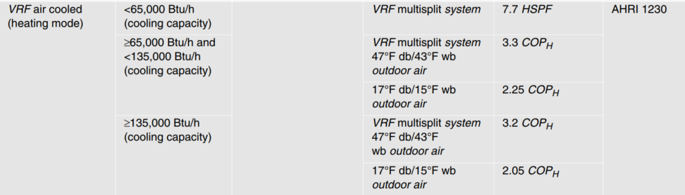
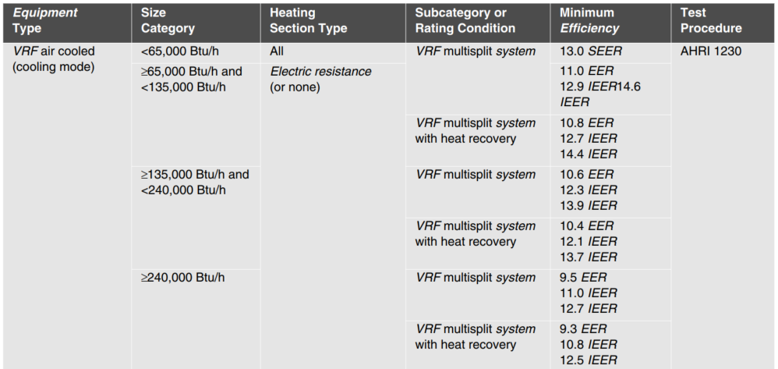
Non Fuel Switch example, a heat recovery VRF system with 8 ton cooling capacity and 96 kbtu heating capacity, an efficient IEER of 18.5 and COP of 3.75, at a new construction low-rise office in Chicago in 2024 saves:
ΔkWh | = Annual kWh Savingscool + Annual kWh Savingsheat + FanSavings
Annual kWh Savingscool  Annual kWh Savingsheat  FanSavings | = (Cooladj * Capacitycool * EFLHcool / 3412) + (Capacitycool * EFLHcool * (1/IEERbase – 1/IEERee))/1000  = (Heatadj * Heat Load / 3412) + (HeatLoad * (1/COPbase – 1/(COPee))/3412  = (Flag * HeatLoad * 1/AFUEbase * Fe) / 3412
ΔkWh | = (0.0 * 96000 * 989/3,412) + (96000 * 989 * (1/14.4 – 1/18.5)/1000 + (0.0 * 916 * 60000/3412) + (916 * 60000 * (1/3.3 – 1/3.75) / 3412) + (1 * 916 * 60000 * 1/0.8 * 0.077) / 3412
ΔkWh | = 3597 kWh

Fuel Switch example, a heat recovery VRF system with 8-ton cooling capacity and 96 kbtu heating capacity, an efficient IEER of 18.5 and COP of 3.75, at a new construction low-rise office in Chicago, assuming a packaged single zone (furnace) and air conditioner baseline. Assuming 50%-50% Incentive agreement is used for joint programs, savings:
SiteEnergySavings (MMBTUs) | = GasHeatReplaced + FanSavings – HPSiteHeatConsumed + HPSiteCoolingImpact
GasHeatReplaced | = (GasHeat_{adj} * HeatLoad * 1/AFUEbase) / 1,000,000
 | = 1.4 * (96000 * 916 * 1/0.8) / 1000000
 | = 153.9 MMBtu
FanSavings | = (Flag * HeatLoad * 1/AFUEbase * Fe) / 1,000,000
 | = (1 * 96000 * 916 * 1/0.8 * 0.030) / 1000000
 | = 3.30 MMBtu
For units with cooling capacities greater than 65 kBtu/hr:
HPSiteHeatConsumed | = (Heatadj * HeatLoad * (1/COPee)) / 1,000,000
 | = (1.6 * 96000 * 916 * (1/3.75)) / 1,000,000
 | = 37.9 MMBtu
HPSiteCoolingImpact | = (Cooladj * Capacitycool * EFLHcool / 1,000,000) * (FLHcool * Capacitycool * (1/IEERbase - 1/IEERee)) * 3,412 / 1,000 / 1,000,000
 | = ((0.0 * 989 * 96000)/1,000,000) + (989 * 96000 * (1/14.4-1/18.5)) * 3,412 / 1,000 / 1,000,000
 | = 5.0 MMBtu
SiteEnergySavings (MMBTUs) | = 153.9 + 3.30 – 37.9 + 5.0 = 124.3 [Measure is eligible]
Savings would be claimed as follows, assuming a 50%-50% incentive agreement:
Measure supported by: | Electric Utility claims (kWh): | Gas Utility claims (therms):
Electric utility only | 124.3 * 1,000,000/3,412  = 36,430 kWh | N/A
Electric and gas utility  (Note utilities may make alternative agreements to how savings are allocated as long as total MMBtu savings remains the same). | 0.5 * 124.3 * 1,000,000/3,412  = 18,215 kWh | 0.5 * 124.3 * 10  = 622 therms
Gas utility only | N/A | 124.3 * 10  = 1,243 therms

Summer Coincident Peak Demand Savings

ΔkW = (Capacitycool / 1,000 * (1/EERbase – 1/EERee)) *CF
Where:
EERbase = Energy Efficiency Ratio of the baseline equipment
= EER from tables below, based on the applicable Code on the date of equipment purchase (if unknown assume current Code). For air-cooled units < 65 kBtu/hr, assume the following conversion from SEER to EER for calculation of peak savings:
EER = (-0.02 * SEER2) + (1.12 * SEER)
EERee = Energy Efficiency Ratio of the energy efficient equipment. For air-cooled units < 65 kBtu/hr, if the actual EERee is unknown, assume the conversion from SEER to EER as provided above.
= Actual installed
CF value is chosen between:
CF_{SSP} = Summer System Peak Coincidence Factor for Commercial cooling (during system peak hour)
= 91.3%
CF_{PJM} = PJM Summer Peak Coincidence Factor for Commercial cooling (average during peak period)
= 47.8%

For example, a heat recovery VRF system with 8-ton cooling capacity and 96 kbtu heating capacity, an efficient EER of 12.5, saves:
ΔkW = (96,000/1,000 * (1/10.8 – 1/12.5)) *0.913
= 1.1 kW

Fossil Fuel Savings
Calculation provided together with Electric Energy Savings above.

Water and Other Non-Energy Impact Descriptions and Calculation
N/A

Deemed O&M Cost Adjustment Calculation
N/A
COST EFFECTIVENESS SCREENING AND LOAD REDUCTION FORECASTING WHEN FUEL SWITCHING
This measure can involve fuel switching from gas to electric.
For the purposes of forecasting load reductions due to fuel switch ASHP projects per Section 16-111.5B, changes in
site energy use at the customer’s meter (using ΔkWh algorithm below), customer switching estimates, NTG, and any other adjustment factors deemed appropriate, should be used.
The inputs to cost effectiveness screening should reflect the actual impacts on the electric and fuel consumption at the customer meter and, for fuel switching measures, should therefore reflect the decrease in one fuel and increase in another, as opposed to the single savings value calculated in the “Electric and Fossil Fuel Energy Savings” section above. Therefore in addition to the calculation of savings claimed, the following values should be used to assess the cost effectiveness of the measure.

ΔTherms | = [Heating Consumption Replaced]  = [GasHeat_{Adj} * HeatLoad * 1/AFUEbase) / 100,000]
ΔkWh | = [FurnaceFanSavings] - [HP heating consumption] + [Cooling savings]
For units with cooling capacities less than 65 kBtu/hr:
ΔkWh | = [FurnaceFlag * HeatLoad * 1/AFUEbase * Fe * 0.000293] - [Heat_{Adj} * HeatLoad/3412 * (1/(COPee ))/1000] + [Cooladj * (Capacitycool * EFLHcool * (1/EERbase - 1/EER_ee))/1000]
For units with cooling capacities greater than 65 kBtu/hr:
ΔkWh | = [FurnaceFlag * HeatLoad * 1/AFUEbase * Fe * 0.000293] - [Heatadj * HeatLoad/3412 * (1/COPee)]  + [Cooladj * (Capacitycool * EFLHcool * (1/IEERbase - 1/IEER_ee))/1000]

Measure Code: CI-HVC-VFFY-V4-250101

Review Deadline: 1/1/2026

Consortium for Energy Efficiency (CEE), Testing, Testing, M1, 2, 3, Transitioning to New Federal Minimum Standards, CEE Summer Program Meeting, August, 2022.
Consistent with Residential assumptions – should be updated with Commercial data when available. Program tracking data from ComEd and Ameren between 2018 and 2020 was used to develop these assumptions. During this period the air source heat pump programs operated downstream and projects were classified as Time of Sale or Early Replacement. Note that any fuel switch scenario at the time would have been classified as Time of Sale and therefore the rates provided likely represent a low estimate of the true early replacement rates. In the absence of alternative data, the TAC agreed to apply these rates and the deemed full v partial displacement assumptions listed, but these assumptions should be revisited through future evaluation.
Consistent with Residential measure and based on 2016 DOE Rulemaking Technical Support document, as recommended in Guidehouse ‘ComEd Effective Useful Life Research Report’, May 2018.
Assumed to be one third of effective useful life of replaced equipment.
Assume full measure life (16 years) for replacing electric resistance as we would not expect that resistance heat would fail during the lifetime of the efficient measure.
Based on a review of TRM incremental cost assumptions from Vermont, Wisconsin, and California.
Full install ASHP costs are based upon data provided by Ameren. See ‘ASHP Costs_06242022’.
Furnace and boiler costs are based on data provided in Appendix E of the Appliance Standards Technical Support Documents including equipment cost and installation labor. Where efficiency ratings are not provided, the values are interpolated from those that are.
Based on 3 ton initial cost estimate for a conventional unit from ENERGY STAR Central AC calculator
The cost per ton table provides reasonable estimates for installation costs of DMSHP, which can vary significantly due to requirements of the home. It is estimated that all units, even those 1 ton or less will be at least $2000 to install.
Full costs based upon full install cost of an ASHP plus incremental costs provided in Memo from Opinion Dynamics Evaluation Team, Ductless Mini-Split Heat Pumps: Incremental Cost Analysis, April 27, 2017.
Memo from Opinion Dynamics Evaluation Team, Ductless Mini-Split Heat Pumps: Incremental Cost Analysis, April 27, 2017
All baseline replacement costs are consistent with their respective measures and include inflation rate of 1.91%.
Based on analysis of Itron eShape data for Missouri, calibrated to Illinois loads, supplied by Ameren. The AC load during the utility’s peak hour is divided by the maximum AC load during the year.
Based on analysis of Itron eShape data for Missouri, calibrated to Illinois loads, supplied by Ameren. The average AC load over the PJM peak period (1-5pm, M-F, June through August) is divided by the maximum AC load during the year.
Blended Baseline value came from percentage of accounts with heat pumps (40.17%) at 7.5 HSPF2 and electric furnaces (59.83%) at 3.41 HSPF as reported in the ComEd Baseline Study August 14, 2020.
Adjustment factors are based on findings from NEEA, July 2020 ‘EXP07:19 Load-based and Climate-Specific Testing and Rating Procedures for Heat Pumps and Air Conditioners’. See ‘NEEA HP data’ for calculation. Findings were consistent with other reviewed sources including ASHRAE, 2020 ‘Right-Sizing Electric Heat Pump and Auxiliary Heating for Residential Heating Systems Based on Actual Performance Associated with Climate Zone’ and Cadmus, 2022 ‘Residential ccASHP Building Electrification Study’. The difference between HSPF and HSPF2 ratings is based on the change in testing procedure that will correct for some of this effect where ducted systems will have an approximately 9% lower HSPF2 rating as compared to HSPF, based on CEE presentation, July 2022, ‘Testing Testing, M1, 2, 3: Transitioning to New Federal Minimum Standards’.
Weighting for Ameren is based on electric heat accounts in each of the heating zones. Weighting for ComEd and Statewide average is based on number of occupied residential housing units in each zone. ComEd is weighted average of Zones 1-2. Alternative program-weighted assumptions can be used if appropriate.
Based on Wassmer, M. (2003). A Component-Based Model for Residential Air Conditioner and Heat Pump Energy Calculations. Masters Thesis, University of Colorado at Boulder. Note this is appropriate for single speed units only.
Values based on Morehead Energy 2024 analysis of TMYx typical hourly weather data for 2007-2021. See 'ASHP Partial Displacement Analysis 20240611_HDD55.xlsx'.
Weighting for Ameren is based on electric heat accounts in each of the heating zones. Weighting for ComEd and Statewide average is based on number of occupied residential housing units in each zone. ComEd is weighted average of Zones 1-2. Alternative program-weighted assumptions can be used if appropriate.
Values based on Morehead Energy 2024 analysis of TMYx typical hourly weather data for 2007-2021. See 'ASHP Partial Displacement Analysis 20240611_HDD55.xlsx'.
Weighting for Ameren is based on electric heat accounts in each of the heating zones. Weighting for ComEd and Statewide average is based on number of occupied residential housing units in each zone. ComEd is weighted average of Zones 1-2. Alternative program-weighted assumptions can be used if appropriate.
F_{e} is estimated using TRM models for the three most popular building types for programmable thermostats: low-rise office (10.2%), sit-down restaurant (8.6%), and retail – strip mall (4.4%). 7.7% reflects the average Fe of the three building types. See “Fan Energy Factor Example Calculation 2021-06-23.xlsx” for reference.
Code of Federal Regulations: Table 3 to §431.97—Updates to the Minimum Cooling Efficiency Standards for Air Conditioning and Heating Equipment and Table 4 to §431.97—Updates to the Minimum Heating Efficiency Standards for Air-Cooled Air Conditioning and Heating Equipment [Heat Pumps]. For 1/1/2024 compliance dates, note these manufacturing and import federal standards go into effect on 1/1/2023. The measure characterization is recommending delaying adopting these standards until 1/1/2024.
Based on analysis of Itron eShape data for Missouri, calibrated to Illinois loads, supplied by Ameren. The AC load during the utility’s peak hour is divided by the maximum AC load during the year.
Based on analysis of Itron eShape data for Missouri, calibrated to Illinois loads, supplied by Ameren. The average AC load over the PJM peak period (1-5pm, M-F, June through August) is divided by the maximum AC load during the year.
Based on ComEd Small Business Trade Ally feedback. For units rated at less than 20 ton units, the cost of common repairs is under $2,000, significantly less than the cost of purchasing new equipment. Therefore, if the cost of repair is less than $2,000, it can be considered early replacement because customers would repair instead of replace a failed unit. Repair cost data was not available for units larger than 20 tons.
Consortium for Energy Efficiency (CEE), Testing, Testing, M1, 2, 3, Transitioning to New Federal Minimum Standards, CEE Summer Program Meeting, August, 2022.
Measure Life Report: Residential and Commercial/Industrial Lighting and HVAC Measures, GDS Associates, Inc., June 2007.
Assumed to be one third of effective useful life.
CEE Commercial Unitary Air-conditioning and Heat Pumps Specification, which provides high efficiency performance specifications for single-package and split system unitary air conditioners.
NEEP Incremental Cost Study (ICS) Final Report – Phase 3, May 2014.
Based on analysis of Itron eShape data for Missouri, calibrated to Illinois loads, supplied by Ameren. The AC load during the utility’s peak hour is divided by the maximum AC load during the year.
Based on analysis of Itron eShape data for Missouri, calibrated to Illinois loads, supplied by Ameren. The average AC load over the PJM peak period (1-5pm, M-F, June through August) is divided by the maximum AC load during the year.
The two equations are provided to show how savings are determined during the initial phase of the measure (existing to efficient) and the remaining phase (new baseline to efficient). In practice, the screening tools used may either require a First Year savings (using the first equation) and then a “number of years to adjustment” and “savings adjustment” input which would be the (new base to efficient savings)/(existing to efficient savings).
Code of Federal Regulations: Table 3 to §431,97 – Updates to Minimum Cooling Efficiency Standards for Air Conditioning and Heating Equipment
Based on Wassmer, M. (2003). A Component-Based Model for Residential Air Conditioner and Heat Pump Energy Calculations. Masters Thesis, University of Colorado at Boulder. Note this is appropriate for single speed units only.
Based on analysis of Itron eShape data for Missouri, calibrated to Illinois loads, supplied by Ameren. The AC load during the utility’s peak hour is divided by the maximum AC load during the year.
Based on analysis of Itron eShape data for Missouri, calibrated to Illinois loads, supplied by Ameren. The average AC load over the PJM peak period (1-5pm, M-F, June through August) is divided by the maximum AC load during the year.
Measure life as referenced in Michigan CI Technologies & Franklin Energy “Work paper FES-H8a – Steam Trap Monitoring System” dated September 2016.
The Everactive Steam Trap Monitoring Service Price
This factor includes 2571 kWh/MG for water supply based on Illinois energy intensity data from a 2012 ISAWWA study. For more information please review Elevate Energy’s ‘IL TRM: Energy per Gallon Factor, May 2018 paper’. Note since the water loss associated with this measure is due to evaporation and does not discharge into the wastewater system, only the water supply factor is used here.
Dry cleaners survey data as referenced in CLEAResult “Work Paper Steam Traps Revision #2" Revision 3 dated March 2, 2012.
The energy savings estimates of this measure assume that without an automatic steam trap monitoring system, manual audits would be performed once per year, so a leaking steam trap would, on average, leak for 6 months before being detected and repaired/replaced when the trap fails
Results from Steam Trap Audit/Replacement efficiency improvement research through the C&I and public Sector Prescriptive Rebate Program, Small Business Program and the Multi-family program. The evaluation included project and population data from years 2019 through 2022
Heat of vaporization of steam at the inlet pressure to the steam trap. Implicit assumption that the average boiler nominal pressure where the vaporization occurs, is essentially that same pressure. Referenced in CLEAResult “Work Paper Steam Traps Revision #2" Revision 3 dated March 2, 2012.
Results from Armstrong International research through the steam trap management platform SAGE. The research population data included Commercial Heating LPS as well as Industrial or Process Low Pressure, < 15 psi applications. The search of the database yield 120,853 steam traps meeting these parameters: Average orifice size 0.21” and average pressure 11.2 psi.
US DOE Building America Program. Building America Analysis Spreadsheet. For Chicago, IL.
Medium and high-pressure steam trap annual operating hours based on Navigant analysis of source collected during program implementation by Nicor Gas for GPY1 through GPY4. For each steam trap project, the data provided measure savings description, operating pressure, installation Zip code, business building type, program year, and annual operating hours.
US DOE Building America Program. Building America Analysis Spreadsheet. For Chicago, IL.
Katrakis, J. and T.S. Zawacki. “Field-Measured Seasonal Efficiency of Intermediate-sized Low-Pressure Steam Boilers”. ASHRAE V99, pt. 2, 1993.
See “Derivation of Equation for Subsonic Compressible Flow through an Orifice and Supporting Calculations for Illinois TRM Steam Trap Measure” paper for more information
Enbridge adjustment factor used as referenced in CLEAResult “Work paper Steam Traps Revision #2” Revision 3 dated March 2, 2012 and DOE Federal Energy Management Program Steam Trap Replacement Assessment.
Default values are directly calculated using the equations above.
Medium and high-pressure steam trap inlet pressure based on Navigant analysis of source collected during program implementation by Nicor Gas for GPY1 through GPY4. For each steam trap project, the data provided measure savings description, operating pressure, installation Zip code, business building type, program year, and annual operating hours. Dry cleaning steam trap inlet pressure based on C5 Steam Traps – Nicor FINAL 10.27.11.
Default values are directly calculated using the equations above.
Results from Armstrong International research through the steam trap management platform SAGE. The research population data included Commercial Heating LPS as well as Industrial or Process Low Pressure, < 15 psi applications. The search of the database yields 120,853 steam traps meeting these parameters: Average orifice size 0.21” and average pressure 11.2 psi.
Consistent with Residential air source heat pump measure and based on a 2016 DOE Rulemaking Technical Support document, as recommended in Guidehouse ‘ComEd Effective Useful Life Research Report’, May 2018.
Estimated measure incremental costs for PTHP, HP RTU and PTAC based other incremental costs and differences in installed cost from U.S. Energy Information Administration (EIA), Updated Buildings Sector Appliance and Equipment Costs and Efficiencies: https://www.eia.gov/analysis/studies/buildings/equipcosts/pdf/full.pdf. For Ducted Split HP, Packaged Single Zone Furnace + AC and Packaged VAV RTU is based on Mid-Atlantic Technical Reference Manual version 9, Variable Refrigerant Flow (VRF) Heat Pump Systems measure. Published October, 2019. Water-source HP systems estimated from data collected from manufacturers. Water-source heat pump systems were not very different compared to VRF systems.
Based on analysis of Itron eShape data for Missouri, calibrated to Illinois loads, supplied by Ameren. The AC load during the utility’s peak hour is divided by the maximum AC load during the year.
Based on analysis of Itron eShape data for Missouri, calibrated to Illinois loads, supplied by Ameren. The average AC load over the PJM peak period (1-5pm, M-F, June through August) is divided by the maximum AC load during the year.
Based on Variable Refrigerant Flow Study. See ‘Variable Refrigerant Flow Study 2023’.
Based on Variable Refrigerant Flow Study. See ‘Variable Refrigerant Flow Study 2023’.
Based on Variable Refrigerant Flow Study. See ‘Variable Refrigerant Flow Study 2023’.
Fe is estimated using TRM models for the three building types: low-rise office, sit-down restaurant and retail-strip mall. 7.7% represents the average Fe of the three building types. See “Fan Energy Factory Example Calculation 2021-06-23.xlsx” for reference. Mutlifamily is 3%, lower than commercial, due to typically lower fan static pressure in residential style applications.
Based on Wassmer, M. (2003). A Component-Based Model for Residential Air Conditioner and Heat Pump Energy Calculations. Masters Thesis, University of Colorado at Boulder. Note this is appropriate for single speed units only.

