Summary of Disadvantaged Areas NTG Policy Proposal
REVISED PROPOSED POLICY LANGUAGE – 5/10/23 Meeting Edits in Yellow
Free ridership for certain types of customers in economically-disadvantaged areas and communities are highly likely to be very low. That notion is supported by data indicating that the participation rate for smaller customers in economically-disadvantaged areas has historically been much lower than for similar customers in communities that are not as economically challenged. To reflect that reality, the net to gross (NTG) ratio for such customers will be set to 100%. This will have the added advantage of creating greater incentives for utilities to target delivery of their efficiency programs to economically disadvantaged areas.”

The economically-disadvantaged areas designated by this policy are:
- Income-eligible communities, using census tracts where at least half of the households earn an income of 80% or less than the Area Median Income, and
- the entire area of certain municipalities (tbd) where at least 50% of the municipality is identified as income-eligible through ILSfA (“disadvantaged municipality”)
The policy will apply to all program activity involving the following customer segments within disadvantaged areas:
- residential customers,
- business customers with rate class designations in the table below
Program Administrator | Electric rate class | Gas rate class | Usage
Ameren | DS-2 and DS-3A | GDS-2 and GDS-3 | <400 kW and <1,000 therms per day
ComEd | C28 and C29 |  | <400 kW
Nicor |  | Rate 4 | <1,000 therms per day
PG/NS |  | Service Class 2 | Monthly average <41,000 therms

- any general delivery service municipal customers in a disadvantaged municipality .

It is expected that, though customers in disadvantaged areas are currently underrepresented in evaluation research due to lower participation levels, going forward, this policy will require that research to establish NTGRs for program activity explicitly sample customers in non-disadvantaged areas.

SOME ADDITIONAL INFORMATION
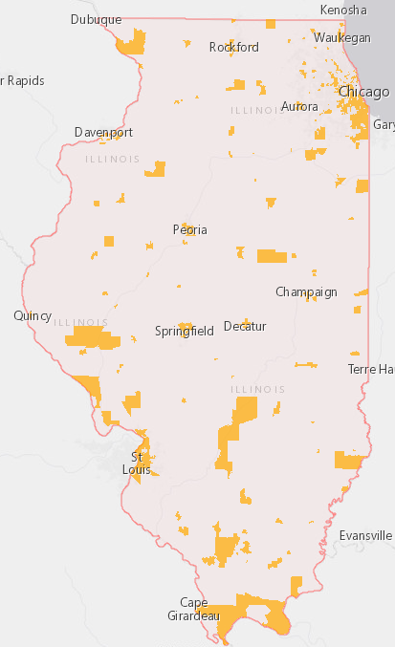
Definition of Disadvantaged Areas
FIGURE 1. ILSfA – Income-Eligible Communities
The disadvantaged areas identified as income-eligible communities identified by Illinois Solar for All (ILSfA) (ILSfA Designations) are shown in Figure 1 or can be viewed interactively at: ILSfA Census Tract Income Eligibility Search Tool (arcgis.com).

Eligible Customers
A breakdown of the energy usage by rate class for the Ameren Illinois service territory is provided in Table 1 below.

TABLE 1. Ameren Illinois Accounts and Energy Use by Rate Class
AIC RATE CLASS | Number of Business Accounts | Annual Electricity Use (MWH) | % of Total | Average Electricity Use per Account (MWH)
DS2 | 165,213 | 4,821,516 | 21% | 29
D3A | 2,715 | 1,977,172 | 9% | 728
D3B | 909 | 1,837,758 | 8% | 2,022
DS4 | 514 | 14,274,570 | 62% | 27,772
DS5 | 6,526 | 108,842 | 0% | 17
DS6 | 131 | 71,007 | 0% | 542
AIC RATE CLASS | Number of Business Accounts | Annual Gas Use (Therms) | % of Total | Average Gas Use per Account (Therms)
GS2 | 63,812 | 220,915,078 | 21% | 3,462
GS3 | 1,537 | 147,645,627 | 14% | 96,061
GS4 | 323 | 651,691,424 | 62% | 2,017,621
GS5 | 240 | 23,844,176 | 2% | 99,351

Program implementers may convert from the two geographies listed (census tracts and municipal boundaries) to zip code tabulation areas for operational purposes (especially with program ally driven initiatives). The method for used for this conversion should comply with industry standards (see https://www.huduser.gov/portal/periodicals/cityscpe/vol20num2/ch16.pdf for more information on this type of conversion.
See https://www.illinoissfa.com/programs/non-profit-and-public-facilities/ for more information and an interactive map identifying these communities.

