IL EE Stakeholder Advisory Group (SAG)
Request for Comments on Inflation Reduction Act (IRA) Savings Attribution Proposal

Instructions:
- Using this template, send written comments to the SAG Facilitator, Celia Johnson: Celia@CeliaJohnsonConsulting.com by Wednesday, January 28, 2026.
- Include “IRA Proposal Feedback” in the subject line of the email.
- All comments will be posted on the SAG website, and circulated to SAG.

Background Information:
- During the January 13, 2026 Large Group SAG meeting, Illinois utilities (Ameren Illinois, ComEd, Nicor Gas, Peoples Gas and North Shore Gas) jointly shared an IRA savings attribution proposal.
- Please review the following materials from the January 13 meeting:
  - Illinois EPA Presentation: IRA Home Energy Rebate Program Update
  - Joint Utility Presentation: Inflation Reduction Act (IRA) Savings Attribution Discussion
- A follow-up meeting is anticipated on Friday, February 6 (9:30 – 11:00 am) to discuss comments received.

Comments Submitted By:
Name:
Company or Organization:
Company or Organization Website (if applicable):
Email:
Phone:

Question 1: Please describe comments and /or questions on the joint utilities’ IRA savings attribution proposal, excerpted from slide 6 of the January 13 presentation to SAG:

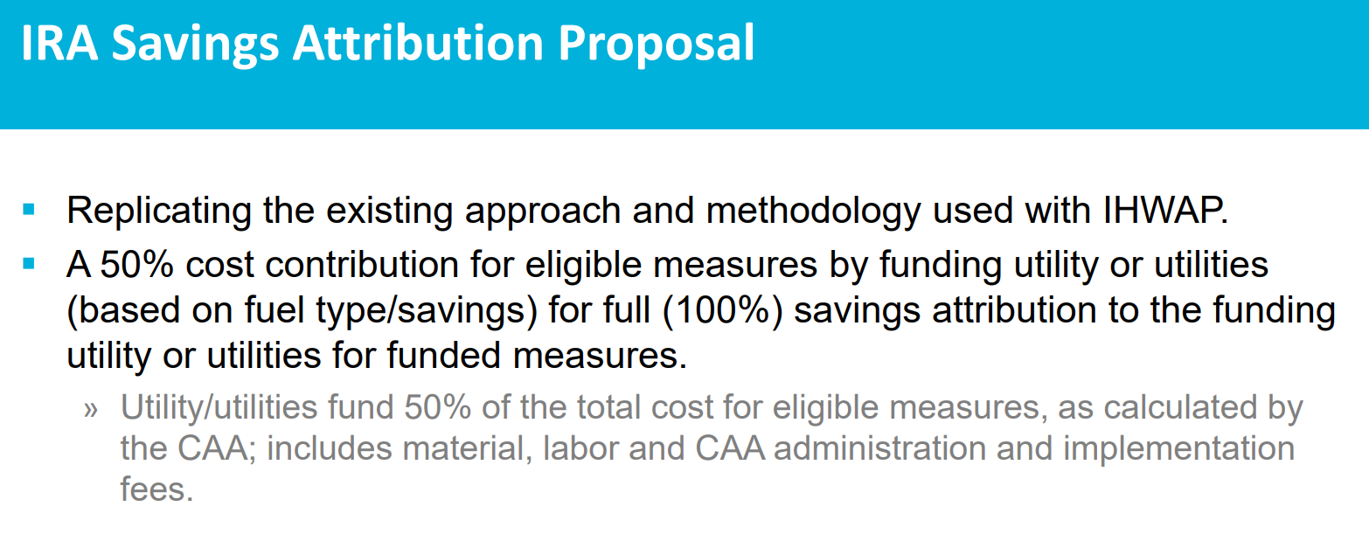

Response:

