Illinois EE Stakeholder Advisory Group (SAG)
Large Group Meeting

Wednesday, July 15, 2026
10:00 – 11:00am
Teleconference

Attendees and Meeting Notes

Meeting Materials 1
Attendees 1
Meeting Notes 3
Introduction to July 15 Meeting 3
2026 SAG Plan Overview 3
Next Steps 8

Meeting Materials
Posted on the July 15 meeting page:
- July 15, 2026 Large Group SAG Agenda
- SAG Facilitator Introduction to July 15 Meeting
- SAG Facilitator Presentation: Overview of 2026 SAG Plan
- 2026 SAG Plan (Final Draft updated 7/13/26)
- SAG Process Guidance – 2026 Update (Redline 7/9/26)

Attendees

Name | Company or Organization
Celia Johnson | Facilitator (Celia Johnson Consulting)
Zoe Knaus | SAG Facilitation Support (Inova Energy Group)
Adam Roche | Cascade Energy
Andy Vaughn | Leidos
Anthony Albano | Resource Innovations
Antonia Ornelas | Elevate
Brad Fortson | ICF
Brent Nakayama | Leidos
Brian Lynch | Baan Consulting
Cassidy Kraimer | Community Investment Corporation (CIC)
Channel Turbides | ComEd
Charles Ampong | Guidehouse
Cheryl Watson | Equitable Resilience and Sustainability
Chris Vaughn | Nicor Gas
Colin Santel | Ameren Illinois
Danielle Marquis | Equinox Creative
Danish Murtaza | Peoples Gas and North Shore Gas
Darleen DeRosa | Bidgely
David Salmonson | CLEAResult
Ed Schmidt | MCR Group
Elder Calderon | ComEd
Elena Savona | ES Consulting
Elizabeth Horne | ICC Staff
Hassan Khurshid | DNV
Houston Dowen | Frontiner Energy
Jean Gibson | Peoples Gas and North Shore Gas
Jeffrey Carroll | DNV
Jenae Batt | Center for Energy & Environment
John Carroll | Leidos
John Lavallee | Leidos
Jonathan Skarzynski | Nicor Gas
Julie Soderna | Energy Solutions
Karen Lusson | National Consumer Law Center
Kari Ross | NRDC
Keely Hughes | The JPI Group
Kegan Daugherty | Resource Innovations
Keith Cronin | VEIC (IL-TRM Administrator)
Kelly Mulder | Equinox Creative
Kit White | Midwest Energy Efficiency Alliance (MEEA)
LaJuana Garrett | Nicor Gas
Lance Escue | Ameren Illinois
Laura Agapay-Read | Guidehouse
Lilieric FlorezMonroy | Peoples Gas and North Shore Gas
Maass | Swift Strategy
Mark Szczygiel | Nicor Gas
Matt Armstrong | Ameren Illinois
Matt Worms | ComEd
Minya Coleman | ComEd
Nick Burstein | CMC Energy
Nicole Popejoy | IL Association of Community Action Agencies
Nikki Pacific | Ameren Illinois
Randy Opdyke | Nicor Gas
Ron Ramey | Energy Solutions
Rose Williamson | E Source
Salina Colon | CEDA
Sanjyot Varade | Resource Innovations
Scott Mallory | Brubaker & Associate, representing IIEC
Selena Worster Walde | ERTHE Energy Solution
Seth Craigo-Snell | SCS Analytics
Shelby Smith | IL Office of the Attorney General
Stephen Linkous | Bellawatt
Sue Hanson | EMC Insights
Teri Lewand | ComEd
Theodora Okiro Quarles | EcoHealth Strategies
Tyler Schaub | Slipstream
Tyler Sellner | E Source
Zach Ross | E Source

Meeting Notes
See red text for follow-up items.

Introduction to July 15 Meeting
Celia Johnson, SAG Facilitator

Purpose of July 15 Meeting:
- To provide an overview of the 2026 SAG Plan and request feedback.
  - Written feedback due Monday, July 27
  - SAG Plan will be finalized by Friday, July 31

2026 SAG Plan Overview
Celia Johnson, SAG Facilitator

Agenda
- 2026 SAG Plan
  - SAG Facilitation
  - SAG Meeting Break
  - SAG Plan Highlights
  - Large Group SAG Topics
  - Large Group SAG Schedule
  - SAG Subcommittees
  - SAG Working Groups
  - SAG Steering Committee
- SAG Process Guidance Updates
- SAG Website Survey
- Next Steps
- Reminder on SAG Open Items
- Q&A

Please note:
- Due to open EE Plan dockets and ex parte concerns, we will not discuss specifics about 2027-2029 revised utility EE Plans or items from a utility stipulation
- Due to the confidentiality of individual utility EE Plan negotiations, do not raise discussions that occurred during recent EE Plan negotiations

Facilitation
- SAG is facilitated by Celia Johnson Consulting, including
  - Large Group SAG
  - SAG Subcommittees
  - SAG Working Groups
  - EE Plan negotiations between individual utilities and non-financially interested stakeholders
- SAG Facilitation meeting support is provided by Inova Energy Group
  - Zoe Knaus is providing facilitation support in 2026 for Large Group SAG, SAG Subcommittee, and SAG Working Group meetings

SAG Meeting Break
- Due to the passage of the Clean and Reliable Grid Affordability (CRGA) Act (effective June 1, 2026), revised utility EE Plans for 2027-2029 were filled with the ICC for approval on June 1
  - SAG takes a meeting break following EE Plan filings – regular meetings are proposed to resume in September
  - To avoid ex parte concerns, SAG meetings in 2026 will not include discussion of issues in open EE Plan dockets; revised EE Plans must be approved by the ICC by December 1, 2026

2026 SAG Plan Highlights
- Large Group SAG
  - September annual Net-to-Gross update process
  - Q3 meeting (September 29 teleconference)
  - Q4 meeting (November 10 in-person)
  - December Evaluation Plan meetings
- SAG Subcommittees
  - Equity Subcommittee (2)
  - Policy Manual Subcommittee (none planned; a meeting will be scheduled if needed)
- SAG Working Groups
  - Market Transformation Savings Working Group (3)
  - Non-Energy Impacts Working Group (1)
  - Reporting Working Group (none planned)
- SAG Steering Committee
  - Annual meeting to review draft SAG Plan
  - If needed, an additional progress meeting is scheduled mid-year

Large Group SAG Topics
- EE Portfolio Topics
  - Utilities report-out on the progress of EE portfolios (September – Ameren Illinois and ComEd; November – Nicor Gas, Peoples Gas)
  - Ameren Illinois and ComEd each present an electrification update, including algorithms, models, and assumptions used to calculate bill impacts
  - Update on federal EE opportunities through the Inflation Reduction Act (IRA), including Illinois utility updates, if needed
  - ComEd presents moderate income weatherization program design (tentative)
- Evaluation Topics
  - E Source presentation on Partial Displacement Heat Pump Metering Study for Ameren Illinois
  - Annual process to reach agreement on Net-to-Gross (NTG) values for the 2027 program year, with initial NTG value recommendations provided by independent evaluators
  - Annual meetings for evaluators to present draft evaluation plans for 2027

Large Group SAG Schedule
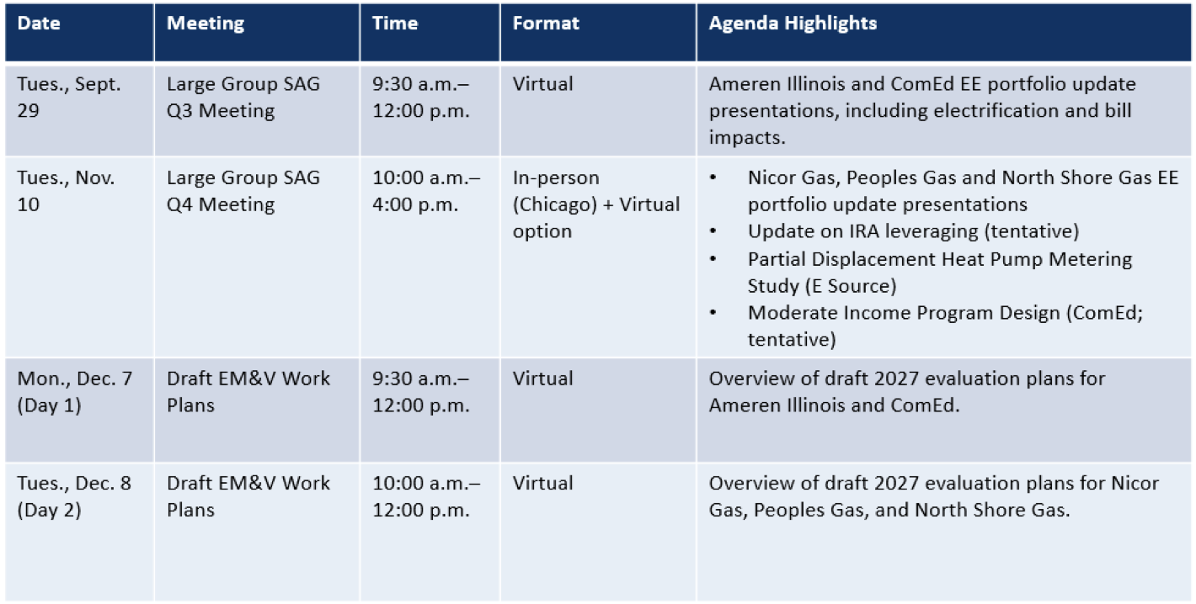
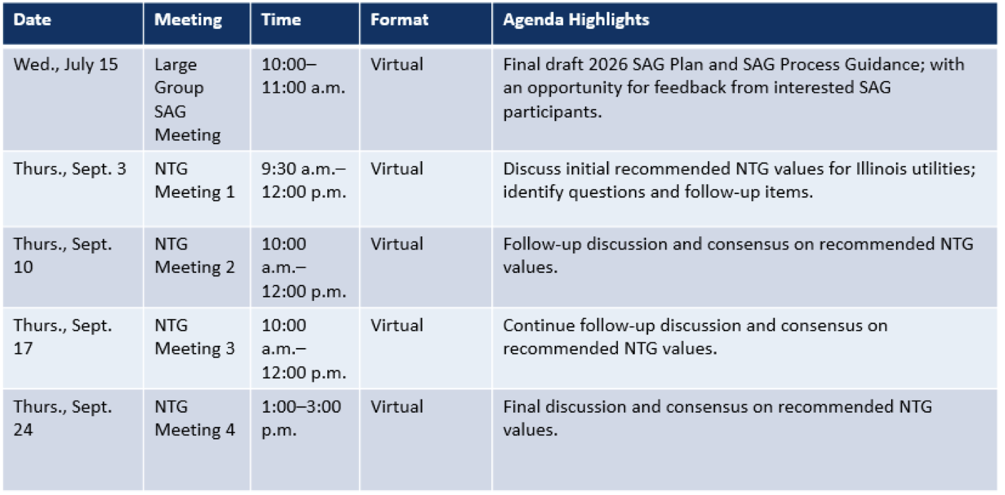
SAG Equity Subcommittee
- Purpose: To discuss topics related to equity in EE portfolios
  - Creation of this Subcommittee was referenced in several of the 2022-2025 utility EE Plan Stipulated Agreements
  - Coordinate with the Low Income Energy Efficiency Accountability Committee (LIEEAC) on topics of interest to CBOS/CAAs and hold joint meetings, as needed
    - LIEEAC = IQ North Advisory Committee and IQ South Advisory Committee
- Website: https://www.ilsag.info/meetings/subcommittees/equity-subcommittee/
- Meetings: Two planned in 2026
- Q3 Meeting: Tuesday, September 22 (joint meeting with IQ South and IQ North)
  - IQ South Advisory Committee report-out on 2026 activities, including sharing the IQ South Memorandum of Understanding with Ameren Illinois for the revised 2027-2029 EE Plan
  - IQ North Advisory Committee update
  - E Source presentation on recent evaluation research study results for Ameren Illinois, including: Income Qualified Electrification Targeting & Barriers Study and Income Qualified Credit & Collections Study
- Q4 Meeting: Wednesday, October 28
  - MDI report-out from Illinois utilities, including results from 2025 and progress in 2026

SAG Policy Manual Subcommittee
- Due to the passage of the CRGA Act, the Policy Manual needs to be updated to correct errors and filed with the ICC for approval
- A trailer bill to CRGA passed on May 31, 2026 which includes a few corrections that may impact the Policy Manual update
  - See HB1700: https://ilga.gov/Legislation/BillStatus?DocNum=1700&GAID=18&DocTypeID=HB&LegId=158789&SessionID=114
  - The Governor has not yet signed this bill.
- Next Steps
  - A proposed redline Policy Manual with corrections will be circulated to the SAG Policy Manual Subcommittee for review (draft anticipated for circulation by the end of July, with comments due in August)
    - Click here to sign-up for the SAG Policy Manual Subcommittee distribution list or email Celia@CeliaJohnsonConsulting.com

SAG Market Transformation Savings Working Group
- Purpose:
  - To provide a forum to discuss policy issues related to market transformation (MT) savings evaluation and estimation
  - To provide an opportunity to review specific MT initiatives and the data/approach proposed to be used to develop savings, including but not limited to:
    - Logic Models
    - Savings/unit
    - Total market unit data collection
    - Natural market baseline data and projections
    - Service territory accounting
    - Market progress indicators
    - The duration of any MT savings credit
  - To discuss evaluation questions related to MT initiatives; and
  - To discuss, and if possible, reach consensus on savings protocols for MT initiatives that may be included in the IL-TRM
- Website: https://www.ilsag.info/mt_savings_working_group/
- Meetings: Three in 2026
  - Monday, June 15: Illinois utilities presented brief status update on each MT initiative
  - Monday, August 31: Topics tentative
  - Tuesday, October 6: Topics tentative

SAG Non-Energy Impacts Working Group
- Purpose: To discuss research plans and results from Illinois non-energy impact (NEI) studies as well as defensible methodologies to use across the state related to calculating non-energy impacts.
- Website: https://www.ilsag.info/nei-working-group/
- Meetings: One in 2026
  - Monday, November 2: ComEd NEI Research – Guidehouse update
    - Participant NEI preliminary findings (single family)
    - Emissions forecast research
    - Economic multiplier research update

SAG Steering Committee
- SAG Steering Committee definition from Section 3.3 of the Policy Manual:
  - Members of the SAG Steering Committee include senior representatives of Program Administrators, community-based organizations, and non-financially interested stakeholder participants. The Steering Committee provides substantive feedback to the SAG Facilitator on: (1) annual SAG Plans; and (2) progress towards meeting annual SAG Plan goals to ensure that the time spent on SAG is as productive and valuable as possible.
  - Typically holds two meetings per year; one to focus on that year’s SAG Plan and a mid-year check-in on progress towards meeting SAG Plan goals (if needed)
- Current Distribution List:
  - Illinois utility representatives + non-financially interested stakeholders that participated in 2027-2029 revised EE Plan negotiations with individual utilities
- Opportunity to Join:
  - If you represent a community-based organization or a non-financially interested stakeholder and are interested in joining the Steering Committee, reach out to Celia@CeliaJohnsonConsulting.com

SAG Process Guidance
- Developed in 2018, to describe guiding principles and process rules for SAG
- This document is updated on an annual basis, as needed
- 2026 Edits:
  - Updated references to EE Plan timing and 2026 activities
  - Updated references to Policy Manual from Version 3.0 to Version 3.1
  - Clarified the process to address policy issues – this process includes new policy proposals, or an interpretation of an existing policy

SAG Website Survey
- SAG website re-design was completed in 2019; a survey is available to collect feedback on the user experience and opportunities to improve functionality
  - Click here to respond to the SAG Website Survey
  - Survey responses are due Friday, August 14
- Survey Questions (excerpted):
  - Which page(s) of the SAG website do you visit most frequently?
  - Have you encountered any broken links, missing pages, or other SAG website issues? If so, please describe.
  - How easy is it to find the information you need on the website? If there is information that is difficult to find, please explain.
  - The SAG website includes an Advanced Search option for evaluation materials. How often do you use this search tool?
  - Do you have any improvements to suggest on the search tool for evaluation materials?
  - The SAG website includes an Advanced Search option for a limited number of Large Group SAG meeting materials. How often do you use this search function?
  - Do you have any improvements to suggest on the search tool for Large Group SAG meeting materials?
  - Would it be useful if the Advanced Search tool was available for all Large Group SAG meeting materials?
  - Do you have any other feedback about using the SAG website?

Next Steps
Celia Johnson, SAG Facilitator

- Comments on Draft SAG Plan and SAG Process Guidance Document
  - Comments from interested SAG participants due Monday, July 27
  - SAG Plan and Process Guidance document finalized by Friday, July 31
- Participating in SAG Steering Committee
  - If you represent a community-based organization or a non-financially interested stakeholder and are interested in joining the Steering Committee, reach out to the SAG Facilitator
- SAG Website Survey
  - Click here to respond to the SAG Website Survey
  - Responses are due Friday, August 14
- There is a separate distribution list for the Large Group SAG, SAG Subcommittee, and SAG Working Groups – reach out to Celia@CeliaJohnsonConsulting.com to be added
  - Large Group SAG: If you received the July 15 meeting invite, you are on the Large Group SAG distribution list
  - 2026 SAG Working Groups
    - SAG Market Transformation Savings Working Group
    - SAG Non-Energy Impacts Working Group
  - 2026 SAG Subcommittees
    - SAG Equity Subcommittee
    - SAG Policy Manual Version 3.2 Subcommittee
      - Click here to sign-up for the SAG Policy Manual Subcommittee distribution list

Reminder on SAG Open Items
- Follow-up from June 8 Large Group SAG Meeting
  - Request for SAG Feedback: Should the location of a Trade Ally in a utility’s service territory be considered when applying the NTG for Disadvantaged Areas policy?
  - Click here to download the NTG Ratio for Disadvantaged Areas Policy Issue Template.
  - Comment Deadline: Friday, June 26, 2026
    - Comments are posted on the June 8 meeting page
    - A second request for comments is anticipated soon, with an opportunity for feedback on a proposed compromise
- Follow-up from March 3 SAG Small Group Meeting
  - Agreement was reached on the IRA attribution policy proposed by Illinois utilities (for a brief explanation of the IRA attribution policy, see slide 4 of the March 3 Facilitator Introductions presentation)
  - Comment Deadline: Friday, July 17, 2026
    - The request for feedback was circulated to participants in the March SAG Small Group meeting
    - The final policy document will be posted on the Policy page of the SAG website

