Nicor Gas and ComEd Residential New Construction Impact Evaluation Report

Energy Efficiency / Demand Response Plan:   
Program Year 2019 (CY2019)   
(1/1/2019-12/31/2019)

Presented to

ComEd

Nicor Gas

DRAFT

March 4, 2020

***Prepared by:***

|  |  |
| --- | --- |
| **Jake Millette**  **Opinion Dynamics** |  |

|  |  |  |  |
| --- | --- | --- | --- |
|  |  |  |  |



[www.guidehouse.com](http://www.guidehouse.com)

**Submitted to:**

ComEd

2011 Swift Drive

Oak Brook, IL 60523

Nicor Gas Company

1844 Ferry Road

Naperville, IL 60563

**Submitted by:**

Guidehouse (which acquired Navigant in 2019)

150 N. Riverside Plaza, Suite 2100

Chicago, IL 60606

**Contact:**

|  |  |
| --- | --- |
| Randy Gunn, Partner  312.583.5714  [randy.gunn@guidehouse.com](mailto:randy.gunn@navigant.com) | Jeff Erickson, Director  608.616.4962  [jeff.erickson@guidehouse.com](mailto:jeff.erickson@navigant.com) |
|  |  |
| Kevin Grabner, Associate Director  608.616.5805  kevin.grabner@guidehouse.com | Nishant Mehta, Managing Consultant  608.616.5823  nishant.mehta@guidehouse.com |

Disclaimer: This report was prepared by Guidehouse for ComEd and Nicor Gas. The work presented in this report represents Guidehouse’s professional judgment based on the information available at the time this report was prepared. Use of this report by any other party for whatever purpose should not, and does not, absolve such party from using due diligence in verifying the report’s contents. Neither Guidehouse nor any of its subsidiaries or affiliates assumes any liability or duty of care to such parties, and hereby disclaims any such liability.

Table of Contents

1. Introduction 1

2. Program Description 1

3. Program Savings Detail 2

4. Cumulative Persisting Annual Savings 4

5. Program Savings by Measure 6

6. Impact Analysis Findings and Recommendations 8

6.1 Impact Parameter Estimates 8

6.2 Other Impact Findings and Recommendations 9

7. Appendix 3. Total Resource Cost Detail 10

List of Tables and Figures

Figure 2‑1. Number of Participants by Tier 2

Figure 4‑1. Cumulative Persisting Annual Savings 6

Figure 5‑1. Verified Net Savings by Measure – Electric 7

Figure 5‑2. Verified Net Savings by Measure – Gas 8

Table 2‑1. CY2019 Volumetric Findings Detail 1

Table 2‑2. Number of Homes by Tier Level Comparison (GPY5/EPY8 – CY2019) 2

Table 3‑1. CY2019 Total Annual Incremental Electric Savings 3

Table 3‑2. CY2019 Total Annual Incremental Therm Savings 3

Table 4‑1. Cumulative Persisting Annual Savings (CPAS) – Electric 5

Table 5‑1. CY2019 Energy Savings by Measure – Electric 7

Table 5‑2. CY2019 Summer Peak Demand Savings by Measure 7

Table 5‑3. CY2019 Energy Savings by Measure – Nicor Gas 8

Table 6‑1. Savings Parameters 9

Table 7‑1. Total Resource Cost Savings Summary 10

# Introduction

This report presents the results of the impact evaluation of the joint Nicor Gas and ComEd CY2019 Residential New Construction (RNC) Program. It presents a summary of the program structure as well as program total and measure-level energy and demand impacts. CY2019 covers January 1, 2019 through December 31, 2019.

# Program Description

Nicor Gas and ComEd jointly offer the RNC Program. Nicor Gas is the lead utility, as most of the avoided costs come from natural gas savings. Residential Science Resources (RSR) implemented the program for Nicor Gas, while Slipstream (formerly known as Seventhwave) implemented the program for ComEd.

At the beginning of the third quarter of CY2018, the program introduced a lower level tier that required homes to achieve, at minimum, 15% better than code compared to the initial minimum 20% requirement. The program ranks homes in one of the following tiers based on performance:

• Tier 1: 15.00-19.99% above code (new in CY2018)

• Tier 2: 20.00-24.99% above code (Tier 1 in GPY6/EPY9)

• Tier 3: 25.00-29.99% above code (Tier 2 in GPY6/EPY9)

• Tier 4: 30.00% or more above code (Tier 3 in GPY6/EPY9)

The RNC Program included a total of 827 homes in CY2019, with 95% in joint Nicor Gas and ComEd service territory. Most of the remaining 5% were in Nicor Gas territory only with only five projects (<1%) ComEd customers only. Thirty builders and eight Home Energy Rating Score (HERS) rating companies completed homes in CY2019, similar to the level of activity from CY2018. One rating company, Energy Diagnostics Inc., accounted for 85% of homes. Two builders, DR Horton and MI Homes, built 38% and 37% of homes, respectively.

The following table and figure show the number of homes in each tier.

Table 2‑1. CY2019 Volumetric Findings Detail



Source: ComEd tracking data and evaluation team analysis

Figure 2‑1. Number of Participants by Tier

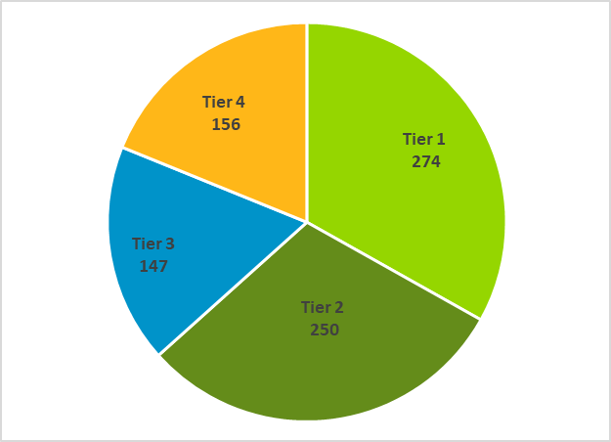

Source: ComEd tracking data and evaluation team analysis

Table 2‑2 shows the number of homes in each tier from GPY5/EPY8 through CY2019. Tier 1 homes made up the largest share of homes (33%), a sizeable increase from CY2018, while the share of Tier 3 homes decreased substantially.Note that due to the inclusion of the bridge period, GPY6/EPY9 was a 19-month period, as compared to a 12-month period for other program years, and participation was accordingly higher in that program year.

Table 2‑2. Number of Homes by Tier Level Comparison (GPY5/EPY8 – CY2019)



* Values may not sum exactly due to rounding.

Source: Navigant analysis of ComEd and Nicor Gas CY2019, CY2018, GPY6/EPY9, and GPY5/EPY8 program tracking data

# Program Savings Detail

Table 3‑1 summarizes the incremental energy and demand savings the RNC Program achieved in CY2019. Table 3‑2 shows the gas savings.

Table 3‑1. CY2019 Total Annual Incremental Electric Savings



NR = Not reported (refers a piece of data that was not reported, i.e., non-coincident demand savings)

NA = Not applicable (refers a piece of data cannot be produced or does not apply)

* The coincident summer peak period is defined as 1:00-5:00 p.m. Central Prevailing Time on non-holiday weekdays, June through August.

Source: ComEd tracking data and evaluation team analysis

Table 3‑2. CY2019 Total Annual Incremental Therm Savings



* Natural gas savings include interactive effects.

Source: ComEd and Nicor Gas tracking data and Navigant team analysis.

# Cumulative Persisting Annual Savings

Table 4‑1 and Figure 4‑1 show the measure-specific and total verified gross savings for the RNC Program and the cumulative persisting annual savings (CPAS) for the measures installed in CY2019. The net electric CPAS across all measures installed in 2019 is 257,366 kWh (Table 4‑1). The evaluation team found no gas savings for this program attributable to ComEd and as such electric CPAS is equivalent to total CPAS.

Table 4‑1. Cumulative Persisting Annual Savings (CPAS) – Electric





Note: The green highlighted cell shows program total first year electric savings. The gray cells are blank, indicating values irrelevant to the CY2019 contribution to CPAS.

* A deemed value. Source: is to be found on the IL SAG web site here: https://www.ilsag.info/ntg_2019.

† Lifetime savings are the sum of CPAS savings through the EUL.

‡ Historical savings go back to CY2018

§ Incremental expiring savings are equal to CPAS Yn-1 - CPAS Yn

Source: Evaluation team analysis

Figure 4‑1. Cumulative Persisting Annual Savings

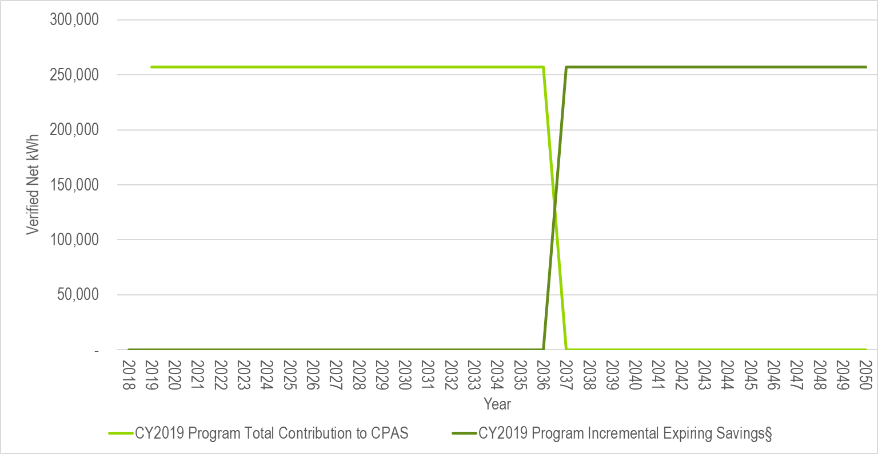

* Expiring savings are equal to CPAS Yn-1 - CPAS Yn + Expiring Savings Yn-1.

Source: Evaluation team analysis

# Program Savings by Measure

The RNC Program includes four home performance tiers that vary by performance above code. The evaluation team calculated verified savings using realization rates for each tier derived from calibrated simulations conducted for the CY2018 evaluation. All savings values include interactive effects. In GPY5/EPY8, the evaluation team conducted the analysis with and without interactive effects and found that the impact on savings was insignificant – the weighted average per home savings was reduced by 0.6% for gas savings and increased by 0.6% for electric savings.

Figure Figure 5‑1 and Table 5‑1 summarize the electric energy savings from the RNC Program by tier, while Table 5‑2 and Table 5‑3 show summer peak demand savings and gas savings, respectively. Figure 5‑1 illustrates that Tier 2 and Tier 4 homes contributed the greatest electric savings (29% each of total verified net kWh savings). Figure 5‑2shows that Tier 2 homes accounted for the largest share of gas savings (31% of total verified net therms savings).

Figure 5‑1. Verified Net Savings by Measure – Electric



Source: ComEd tracking data and evaluation team analysis

Table 5‑1. CY2019 Energy Savings by Measure – Electric



* A deemed value. Source is to be found on the IL SAG web site here: <https://www.ilsag.info/ntg_2019>.

Source: ComEd tracking data and evaluation team analysis

Table 5‑2. CY2019 Summer Peak Demand Savings by Measure

* A deemed value. Source is to be found on the IL SAG web site here: https://www.ilsag.info/ntg_2019.

Note: Values may not sum exactly due to rounding

Source: ComEd tracking data and evaluation team analysis

Figure 5‑2. Verified Net Savings by Measure – Gas



Source: ComEd tracking data and evaluation team analysis

Table 5‑3. CY2019 Energy Savings by Measure – Nicor Gas



* A deemed value. Source is to be found on the IL SAG web site here: https://www.ilsag.info/ntg_2019.

Source: Nicor Gas and ComEd tracking data and evaluation team analysis

# Impact Analysis Findings and Recommendations

## Impact Parameter Estimates

The lifetime energy and demand savings are estimated by multiplying the verified savings by the effective useful life for each measure.

The EM&V team conducted research to validate the parameters that were not specified in the Illinois TRM (TRM). The results are shown in the following table.

Table 6‑1. Savings Parameters

| Gross Savings Input Parameters | Value | Units | Deemed or  Evaluated? | Source * |
| --- | --- | --- | --- | --- |
| Home Quantity, Tier | Varies | # measures | Evaluated | Tracking database |
| NTG | Varies | 0.65 | Deemed | IL SAG Consensus |
| Verified Realization Rates | Varies | NA | Evaluated | Tracking database, calibrated energy simulation from CY2018 |
| Effective Useful Life (EUL) | 18.0 | Years | Deemed | TRM v7.0 |

NA = Not applicable

* TRM is the State of Illinois Technical Reference Manual version 7.0 from http://www.ilsag.info/technical-reference-manual.html. The NTG values can be found on the IL SAG web site here: https://www.ilsag.info/ntg_2019.

## Other Impact Findings and Recommendations

The evaluation team developed findings from the CY2019 evaluation, as follows:

**Finding 1.** The CY2019 RNC Program achieved 257,366 kWh of verified net energy savings and 174,499 therms of verified net gas savings. The overall verified program realization rate was 76% for electric energy savings and 120% for gas savings.

# Appendix 3. Total Resource Cost Detail

Table 7‑1 shows the Total Resource Cost (TRC) cost-effectiveness analysis inputs available at the time of finalizing this impact evaluation report. Additional required cost data (e.g., measure costs, program level incentive and non-incentive costs) are not included in this table and will be provided to the evaluation team later.

Table 7‑1. Total Resource Cost Savings Summary



NA = Not applicable

* The total of the EUL column is the weighted average measure life (WAML), and is calculated as the sum product of EUL and measure savings divided by total program savings.

† Early Replacement (ER) measures are flagged as YES, otherwise a NO is indicated in the column.

Source: Nicor Gas and ComEd tracking data and evaluation team analysis