Market Transformation Evaluation for Stretch Codes
Proposed options and evaluation considerations for Illinois stretch energy code market transformation initiative
Developed by: Slipstream | MEEA | Guidehouse
March 28, 2022
Primary contact:
Jeannette LeZaks
Director of Research and Innovation, Slipstream
jlezaks@slipstreaminc.org

This draft has been reviewed and updated based on comments received on an earlier version presented to the IL Stakeholder Advisory Group (SAG) Market Transformation Working Group on October 4, 2021
Summary of Updates Since Previous Version
- Reorganized evaluation elements to follow sequential order
- Added attribution scoring for code advancement and support actions
- Shortened length of main document to focus on estimation and evaluation only and organized information into the two “main” headers (Eval of Policy Adv and Eval of Stretch Code Support)
- Put background information in Appendices

Table of Contents
Market Transformation Evaluation for Stretch Codes 1
Definitions 4
List of Acronyms 6
Introduction 8
Applying a Market Transformation Framework 8
Stretch Codes Paths in Illinois 9
CEJA Stretch Code 9
Early Adopter / pre-2024 Commercial Stretch Code 9
Municipalities with Population Greater than 1 Million Residents 10
Utility Role in Stretch Energy Codes 10
Logic Model 10
Stretch Energy Code Policy Advancement Programs and Evaluation 16
Utility Actions for Energy Code Advancement 16
Utility Initiated Research 16
Utility Involvement for Advancing Energy Codes 18
Utility Energy Code Support Programs 18
Energy Code Advancement Evaluation Overview 19
policy advancement Market Potential Savings Estimate 19
strech code POLICY adoption Compliance Rate and Achievable Market Savings Estimates 20
Policy Advancement MTI Savings Prediction 21
policy advancedment MTI Savings Attibuted to Utility Estimation 23
policy advancement MTI Savings and Attribution Evaluation 25
Stretch Code Support Programs and Evaluation 1
Utility Programs for Stretch Code Support 1
EVALUATION ACTIONS FOR ENERGY CODE ADVANCEMENT 2
Achievable Market Savings Estimates 5
Net Program Savings (MTI Savings Attributed to Utility) 6
Allocation of Energy Savings 1
Evaluation cost 1
Appendix B: Background on Illinois Energy codes 2
Current Illinois Code 2
Illinois Energy Code Compliance 3
Appendix C: CEJA Stretch Code 5
Appendix D: Logic Model 7
Appendix E: Example of Similar Programs/Evaluations 7
Appendix G: Overview of Utility Activities, Timeframes, and Applicable municipalities and Sectors 8

Definitions
Achievable Market Savings (AMS): The amount of MPS that are considered to be achievable because 100% compliance is likely never achieved, especially in the beginning of a code change; evaluators may apply an estimated compliance rate to either increase or decrease the MPS, depending on compliance rates with code elements, and the AMS may change over time. Also known as Total Market Savings.
Attribution: The attempt to assess the extent to which observed outcomes are caused by the program(s) of interest as opposed to events that would have happened regardless of any intervention. According to TRM v. 10 vol 4, Attachment C, market transformation paints a qualitative case as to whether the initiative was generally successful in causing the intended market changes, rather than treating attribution as a continuous variable that can be quantitatively scored (often in the form of a net-to-gross ratio that adjusts for free ridership and spillover) as in resource acquisition programs.
Attribution Factor - A number created through evaluation that reflects the impact of utility efforts to advance policies in municipalities that adopt the stretch code.
Base Code Baseline (BCB): The estimate of what would have happened if any policy advancement (utility or otherwise) did not exist; similar to the definition of the NMB/NOMAD, but does not account for the impact attributed by utilities.
Compliance Rate: Keep one definition. Mention that there are two separate compliance rates in this document: compliance rate with the base code, and compliance rate with the stretch code.
Delphi Process: working group of 10 to 15 market experts from a range of professions with deep knowledge of the IL residential new construction market, codes & code compliance, stretch codes, residential energy modeling, and/or other perinate market & regulatory attributes. Members are selected not only for market expertise, but also (as much as possible) with preference to independent third parties that can contribute and advise without prejudice. Once assembled, this working group is responsible for assessing and commenting on program facets that are otherwise obscure or otherwise cost prohibitive. E.g., the Delphi process may leverage their industry experience to estimate preliminary compliance rates until further research is available. The Delphi process can also offer additional review of key inputs and arbitrate between stakeholders in the event consensus is not met.
Effectiveness Score (or Factor): A number created through evaluation that reflects the impact of utility efforts to increase compliance with both base energy and stretch energy codes for municipalities that adopt the stretch code.
Energy Savings per Unit: Estimating total market savings requires unit energy savings for each unit. The definition of “units” will depend on the energy-efficient product or service that is the focal point for the MT initiative. Units are defined upfront and typically are measured as: a device; square footage; number of housing units; number of operators; pound of product, etc. The appropriate unit definition will have been identified in the MT Business Plan. Savings are measured in kwh/unit, therms/unit, and kW/unit. Note that the average savings per unit for that market likely will be the weighted average savings per unit for different categories of product (such as top-load or front-load clothes washer categories).
Natural Market Baseline (NMB)/Naturally Occurring Market Adoption (NOMAD): A forecast of the future in which no utility-funded energy efficiency programmatic intervention exists, according to TRM v. 10 vol 4, Attachment C. In this initiative, NMB is a consideration of utility attribution as determined through the Attribution Factor and the BCB (policy advancement) or the Effectiveness Score and the SCCB (code support).
Market Potential Savings (MPS): The total possible savings in the market that potentially could occur because of advancement efforts to get all municipalities to adopt stretch code and achieve 100% compliance; also known as Gross Technical Potential in other utility-funded code programs or Total Market Savings in Attachment C.
Market Transformation: The strategic process of intervening in a market to create lasting change that results in the accelerated adoption of energy efficient products, services and practices. (from TRM v. 10 vol 4, Attachment C)
MTI Savings: The estimated net savings of the Market Transformation Initiative prior to attributing utilities impacts; determined by subtracting the BCB from the AMS for policy advancement, or by subtracting the SCCB from the AMS for code support.
MTI Savings Attributed to Utility: The MTI Savings multiplied by the Attribution Factor (policy advancement) or Effectiveness Score (code support); the savings the utilities can claim for their program efforts.
Total Market Savings – The savings that would result from the entire market adoption of the MTI energy efficiency products or services (from TRM v. 10 vol 4, Attachment C).
Total Market Units : Both the total number of units in the market and the portion of units that meet the efficiency specification in the MT initiative (efficient units). Over time, Market Progress Evaluation Reports will work to track shifts in the relationship between efficient units and total units – which represents the market share of efficient units. For residential stretch codes, this would include number of homes built per year, and for commercial stretch codes, this includes square footage of commercial new construction.
Stretch Code Compliance Baseline (SCCB): The estimate of what would have happened if no stretch code support programs existed; similar to the definition of the NMB/NOMAD, but does not account for the impact attributed by utilities.

List of Acronyms
ASHRAE
BCB – Base Code Baseline (previously referred to as NOMAD/NMB of stretch code advancement program)
CEJA – Climate and Equitable Jobs Act
GTP - Gross Technical Potential (known as MPS in this document)
ICC – International Code Council
IECC – International Energy Conservation Code
MPS – Market Potential Savings (previously known as GTP)
MT – Market Transformation
MTI – Market Transformation Initiative
NMB – Natural Market Baseline
NOMAD – Naturally Occurring Market Adoption
RA/RAP – Resource Acquisition/Resource Acquisition Program
SAG – (Illinois) Stakeholder Advisory Group
SCCB - Stretch Code Compliance Baseline (previously referred to as NOMAD/NMB of code compliance support program)
TRM – Technical Reference Manual

Introduction
Building codes are recognized as an effective way to move the market towards more energy efficient buildings. Several states have energy efficiency programs that are designed to influence the building energy code and allow the utility administering the program to claim savings through Market Transformation Initiatives (MTI). California utilities have been actively influencing codes and standards since the late 1990s. States that have more recently developed code programs include Arizona, Massachusetts, Rhode Island and Vermont.
Illinois utilities currently can claim energy savings for incentivizing new construction buildings to be built beyond current existing energy code requirements. The claimed savings are based on the baseline of the base energy code. Absent a new approach to credit utilities for code advancement, if a municipality were to adopt a stretch energy code—a locally mandated code or alternative compliance path that requires a higher level of energy efficiency than the adopted base code--a utility could provide program support to assist the building community or code officials but would not be able to claim savings for helping meet the mandated stretch energy code under a traditional resource acquisition evaluation framework.
Recognizing that utilities are well-positioned to provide support for municipalities to advance stretch codes and support code compliance, this document provides the evaluation pathways and methods for utilities to claim savings for stretch code advancement and support under a market transformation evaluation framework.
<ADD SENTENCE ON TWO METHODS OF EVALUATION> Structure of this document and the two evaluation methods.

Applying a Market Transformation Framework
Stretch code programs will be evaluated under the MT framework and approach. Attachment C of the Illinois TRM defines market transformation (MT) as the strategic process of intervening in a market to create lasting change that results in the accelerated adoption of energy efficient products, services, and practices. MTIs are intended to make changes in the market over time with the goal of lasting market change. Advancing a code change or stretch code adoption, rather than waiting for market adoption of a particular technology or product, is considered market transformation.
Additionally, energy code compliance support programs play an essential role in stretch code advancement MTIs. If a stretch code policy has low compliance rates, the expected market change may not be as lasting or as penetrating as hoped, and there is little gained in updating the code to new efficiency levels or including more efficient technologies. Compliance support programs can address the shortcomings of low compliance rates and ensure that savings are achieved through building energy codes. They also provide important infrastructure to code officials and the building community to ensure a lasting and significant impact.

Stretch Codes Paths in Illinois
A stretch code, also known as a “reach code,” is a locally mandated code or alternative compliance path that requires a higher level of energy efficiency or sustainability than the adopted base code. There are several ways that Illinois municipalities can move forward with adopting stretch codes, as described below.

CEJA Stretch Code
Illinois Public Act 102-0662 (Climate and Equitable Jobs Act, or CEJA), passed in September 2021, directed the Illinois Capital Development Board (CDB), which manages the state building energy code adoption process, to create a residential and commercial stretch energy code that can be adopted by individual municipalities. Once formally adopted by a municipality, the stretch code would take the place of the state energy code and establish the minimum energy efficiency requirements for new construction, additions, and major renovations. in those communities. (For more information about the CEJA stretch code, see Appendix C.)
The CEJA stretch code, which will be available for adoption no later than January 1, 2024, (explained in detail in Appendix C) is now currently one option for municipalities to consider for adoption. While the CEJA stretch code provides a model stretch code for municipalities to consider, the legislation does not guarantee or require that a municipality adopt the stretch code and then enforce its compliance. Previously, Illinois municipalities could have adopted their own version of above-code energy conservation measures for commercial buildings, but no municipality has done so to date.

Early Adopter / pre-2024 Commercial Stretch Code
Prior to the mandated January 1, 2024 availability of the stretch code, a jurisdiction that does not want to wait can choose to create its own commercial stretch code that is more stringent than the state base energy code. These early adopter cities could either adopt CEJA stretch code targets (prior to actual code language is developed by the state) or adopt something different, and then adopt the state-developed CEJA stretch code once it is officially available.

For residential buildings, no jurisdiction can mandate that residential buildings could be stronger than the base state energy code prior to the mandated January 1, 2024 availability of the stretch code, with the small exception of home-rule cities that had adopted an energy code prior to 2006 (and municipalities with population greater than 1 million, as described in the section below). This is a short list, but these cities can choose to create their own residential stretch code that is more stringent than the state base energy code.

Municipalities with Population Greater than 1 Million Residents
CEJA also maintains the previous statute that Chicago can choose to adopt any energy conservation code (for both commercial and residential buildings), as long as it is at least as efficient as the state energy code.

Utility Role in Stretch Energy Codes
Utilities play a key role in implementing programs that help their customers use less energy. For example, traditional energy efficiency programs, or Resource Acquisition Programs (RAPs), typically target a specific technology (e.g. LED lighting) or an individual building (e.g. new construction design assistance). Utilities are well positioned to help overcome the barriers listed above by providing research and development on stretch code impacts, training for building professionals and officials, and incentives to bring down first costs of more stringent codes. . For energy codes under an MT framework, utilities can play a role in two additional distinct ways: 1) supporting municipalities to adopt or advance the stretch code policy through technical guidance and policy development, and/or 2) providing stretch code support through programs that provide technical assistance, enforcement support, and incentives after an above-code option has been adopted by a jurisdiction.
These two roles require different methods of evaluation that are different from methods used for RAPs. Stretch code policy advancement requires an evaluation process that focuses on the participation of utilities in advancing the policy, while code support focuses on the technical resources and trainings that utilities can provide to increase compliance with the stretch code. Later in this document, we outline the distinct evaluation pathways for both policy advancement and code support.

Logic Model
As stated in Attachment C, “each MT initiative must establish its own unique overarching MT theory with an ‘umbrella hypothesis.’” As described above for a stretch code MTI, the utility can play a role in reducing market barriers and leveraging opportunities to help make lasting change through policy adoption at the municipal level and ensure that stretch codes are complied with when stretch codes are in place. Activities may be taking place outside of utility actions to move the stretch code towards adoption, including actions taken by other advocacy organizations and training organizations.
There are several barriers identified that the logic model seeks to address, described below in Table 1 with descriptions of the barriers.
Table 1. Barriers to advancing and achieving full compliance with energy codes
Barrier | Description
Business and contractor community tend to push back against new regulation and updates to the code. | There is a learning curve with new codes, and some within the contractor or business community will not want to add new regulations to their list of priorities. They may believe that their customers do not want to build higher performing buildings and believe these policies will lead to reduction in business.
Municipalities have limited resources to understand and enforce more complex code. | Energy codes are enforced by code officials that are funded through municipality budgets. Staff time and resources are limited to enforce the code completely as well as learn how to enforce increasingly more complex codes.
Design and construction contractors are not aware of updated or more complex codes. | As new energy codes are adopted, building professionals need to take time to understand the implications on their current building practice.
Enforcement professionals may not prioritize energy code compliance. | Some code officials may not consider energy codes to be the same priority as other life safety codes (such as fire codes).
Higher upfront costs for some energy efficiency investments. | With some higher efficiency building technologies or methods, there can be a higher incremental cost as compared to less efficient alternatives.

The stretch code MTI has several stakeholders that are called out in the logic model and can be involved in a utility-supported code advancement or code support program. We delineate these stakeholders, or target markets, into three main groups: the jurisdiction/policy-maker sector (TM1), the design and construction industry (TM2), and the enforcement industry (TM3); each is described and defined below.
Target market group | Description of actors
Jurisdiction/Policy-Making Sector - Target Market 1 (TM1) | - Entities and persons that are involved in policy development and adoption, including Capital Development Board (CDB) Illinois Energy Codes Advisory Council, and public stakeholders  - Jurisdiction-level code development or adoption bodies, such as city/county councils, mayors, sustainability managers, and/or working groups (e.g., the City of Chicago Decarbonization Working Group)  - Local and state chapters of the International Code Council (ICC), ASHRAE, Illinois Council of Mayors, Metropolitan Mayors Caucus, and the numerous state and local code official associations in Illinois.
Design and construction industry - Target Market 2 (TM2) | - Construction industry stakeholders including builders, subcontractors, material supply houses, site superintendents, energy modelers, building scientists, architects, engineers, and designers  - Local and state chapters of Homebuilder Associations (HBA), American Institute of Architects (AIA), ASHRAE, International Code Council (ICC), Illinois Plumbing and Heating Association, and Illinois Green Alliance, Association of Licensed Architects, Illuminating Engineering Society, Lighting Controls Association, International Association of Lighting Designers, Building Performance Institute (BPI), Associated General Contractors of America, and others
Enforcement industry - Target Market 3 (TM3) | - Local building departments, code officials, and jurisdictional employees that review, permit, and inspect energy code requirements

A logic model is presented below that that summarizes the conditions, constraints, actions, and outcomes we expect to see with a stretch code MTI. This logic model may be refined over time without requiring change to TRM Further versions of logic models should align with utility program design (as the programs as developed), the development of market baselines, and evaluator-reviewed Market Progress Indicators (MPIs).
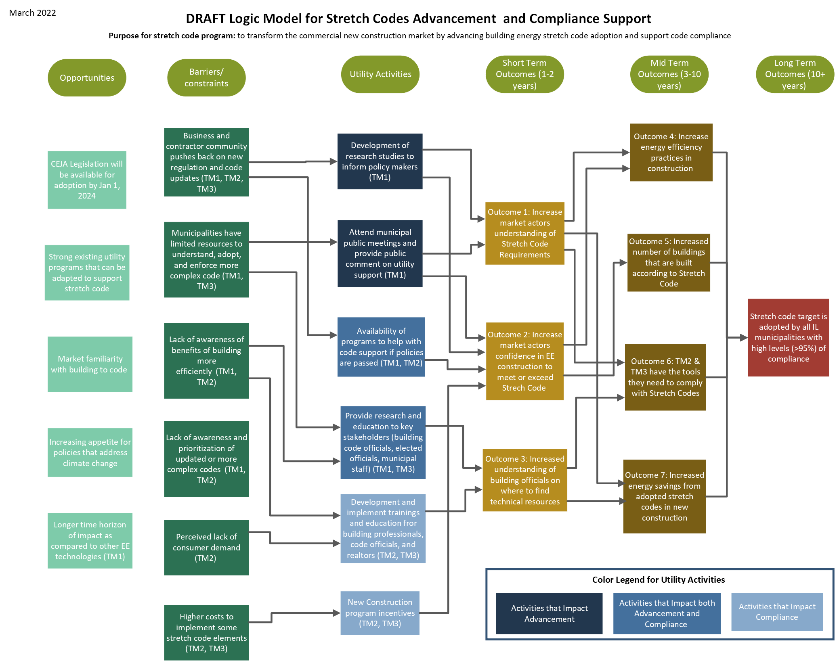
Figure 1: Draft Logic Model for Stretch Codes and Compliance Support

Below we address both the common terminology of stretch code MTIs and the Delphi panel approach which is commonly used in market transformation evaluations.
Table 2. Elements of Stretch Code Market Transformation Evaluation
Policy Advancement Evaluation | Stretch Code Compliance Support Evaluation
- Market Potential Savings  - Compliance Rates  - Achievable Market Savings  - Base Code Baseline  - MTI Savings  - Attribution Score  - MTI Savings Attributed to Utility | - Market Potential Savings  - Compliance Rate  - Achievable Market Savings  - Stretch Code Compliance Baseline  - MTI Savings  - Effectiveness Score  - MTI Savings Attributed to Utility

<***> Policy Advancement:
Market Potential Savings (MPS) x Compliance Rate = Achievable Market Savings (AMS)
AMS -Base Code Baseline (BCB) = MTI Savings
MTI Savings x Attribution Factor = MTI Savings Attributed to Utility
Stretch Code Support:
Market Potential Savings (MPS) x Compliance Rate = Achievable Market Savings (AMS)
AMS -Stretch Code Compliance Baseline (SCCB) = MTI Savings
MTI Savings x Effectiveness Score = MTI Savings Attributed to Utility

More detail of these key elements is described further below.

Stretch Energy Code Policy Advancement Programs and Evaluation
This section focuses on actions that utilities can take to receive attribution for helping to advance the stretch code, and the methods for evaluating utility savings.

Utility Actions for Energy Code Advancement
As of June 2022 in Illinois, municipalities have been able to develop and enforce their own commercial stretch code, but no municipality has taken that step. With CEJA in place, municipalities will have a straightforward way to adopt the state-developed stretch codes for commercial and residential buildings, but not all municipalities will choose to adopt either or both stretch codes.

Utilities have unique opportunities to encourage and support municipality efforts to adopt stretch codes. There are three primary ways that a utility can help advance a stretch code policy: 1) utility-initiated research, 2) advocacy for advancing policy, and 3) the creation of utility programs to support implementation. Many of these efforts can and should be done while municipalities are considering policy advancement, and well in advance of the evaluation efforts described further in this document. In contrast to utility programs that are rolled out service territory-wide at the same time, a stretch code MTI will need to take into account individual municipalities that may adopt a stretch code policy at their own pace. While some municipalities will consider policy adoption in the near-term, over time, more municipalities are expected to adopt stretch code policies.

Utility Initiated Research
Utilities may advance research for stretch code advancement in the form of a study report. The purpose of a study report is to help inform municipalities that are considering adopting a stretch code policy and should be provided to those municipalities. Such a study report should contain:
- Introduction: Brief overview of the historical work that informed the study report.
- Market Analysis: Includes Market Structure, Technical Feasibility, Market Availability, Current Practices, Market Impacts, Economic Assessments, Economic Impacts.
- Energy Analysis: Includes Assumptions and Methodology.
- Cost Effectiveness: Includes Energy Cost Savings, Incremental First Cost, Lifetime Incremental Operation and Maintenance Costs, and Cost Effectiveness Results
- Energy Impacts: Analysis includes first-year savings for each city affected by the proposed stretch code.
- Revisions to Code Language: Precise language to be used in the stretch code.
The introduction would describe how utilities and other stakeholders advocate for code advancement. This section includes significant background information on the proposed update, including a recap of existing technologies, relevant literature, existing code, and comparable stretch code in other states.
The market analysis would include an examination of the technical feasibility, and/or current practices, and should include examining the ability of the markets to meet the proposed stretch code and potentially applicable products currently on the market that would help meet the stretch code. The market analysis would investigate the impacts on market actors like builders, designers, energy consultants, building owners and occupants, building inspectors, etc. The market analysis may also explore how the code might affect occupational health and safety as well as employment within the affected region. An economic impacts analysis could also be conducted with a detailed study on the labor market impact of the proposal (creation/negation of jobs and businesses). Economic impacts would also look at the competitive effects of the proposal, and whether it will benefit in-state business or state and local government entities.
The energy analysis should begin with stating energy analysis assumptions and detail the methodology, including how the savings will be calculated, and what engineering method will be used (e.g., prototypical building energy modeling). The energy impact analysis of a proposed stretch code would be calculated, generally using the previous minimum-compliance code as a baseline for the analysis.
A cost-effectiveness study should begin with the methodology describing how energy savings and costs will be monetized. Ideally inflation, discount rate, avoided energy cost, equipment and labor costs, operation and maintenance (O&M) costs, and water costs would all be considered. Externalities and non-energy benefits may be part of the cost effectiveness analysis. Energy cost savings will be calculated and would consider avoided energy cost and avoided peak reduction as well as nonregulated fuels and other utility costs, such as water. Incremental first cost which is the initial cost of a stretch code compliant building, including material and labor minus the baseline cost, should be calculated. Lifetime incremental O&M costs, which are the O&M costs over the lifetime, minus the baseline O&M costs, would ideally be included. The overall outcome of the cost-effectiveness study would be lifecycle analysis results on a per-SF basis.

Revisions to code language would detail the precise language to be used in the stretch code. Any references used would be included in the revised code language. Any changes to compliance manuals and compliance documents would also be described.

Utility Involvement for Advancing Energy Codes
Utilities may influence stretch code advancement by creating, providing and/or presenting the Utility Initiated Research to a group of key stakeholders. The process by which a stretch code is adopted at a municipal level is driven by a specific municipality’s policy-making process. A utility is uniquely positioned to be involved and influence the process for stretch code adoption through activities such as:
- Vocally (or in chat) participating in discussion at public or decision-making meetings
- Attending public meetings (information-gathering with little-to-no participation)
- Writing and submitting comments
- Creating, providing and/or presenting information to a group or key stakeholders
- Convening stakeholder meetings to develop technical aspects/policy language
- Submitting policy language or recommendations for consideration of adoption
- Funding and conducting participation in public processes on behalf of the utilities
- Giving public testimony in support/against specific policy language/idea
A more-detailed table explaining the relative impacts of each action’s involvement is located in Table 4.
Additionally, this is a MTI, which is by its nature intended on influencing the entire market, not just those that are interacting with the program. Many jurisdictions do not want to be the first adopters of certain initiatives and will claim that other jurisdictions adopting a stretch code first influence their desire and political ability to pass ordinances themselves.

Utility Energy Code Support Programs
A common barrier to passing policies like stretch codes is a lack of technical assistance and support to implement the policy once passed. This hinderance can result in the weakening of a policy or ultimately halt its adoption. Policies have a much better chance of advancing if there is a promise of a program that will support implementation and compliance. One step utilities can take is to vocally support policies that they have the ability to support through a utility program. Another is to make the intention of program creation known to stakeholders, which may include providing financial incentives to new construction and major renovation projects in municipalities that adopt the stretch code. The ultimate step is to create that specific utility program to support code compliance, which is outlined in the next section (Stretch Code Support Programs and Evaluation).

Energy Code Advancement Evaluation Overview
Even while utilities can and should be making efforts to influence policy adoption well ahead of a municipality voting to adopt a stretch code, the evaluation of a stretch code policy advancement program will not start until a municipality adopts a stretch code. The evaluation takes into consideration the key elements described in the overview above and in more detail below.
Once a municipality adopts a stretch code, the evaluators begin the evaluation by estimating the Market Potential Savings (MPS) based on current municipal conditions. This includes a review of actual construction subject to stretch code, program practices, and utility involvement, including an evaluation of energy savings and a confirmation of claimed savings. Evaluators deem compliance rates to estimate AMS and a deemed BCB over the next three years, and a prediction of the MTI, to which an attribution number will be determined and applied, to generate MTI savings attributed to utility.

policy advancement Market Potential Savings Estimate
As defined above, the Policy Advancement MPS are the savings that potentially could occur because of advancement efforts to support or influence a municipality to adopt a stretch code. The Policy Advancement MPS would include the new construction and major renovation market in the municipality that adopted a stretch code and is calculated to assume achieving 100% compliance.
This estimation is based on predicted construction permits in each territory and an estimation of energy consumption based on building type and square footage.
Following are the key evaluation activities to estimate Policy Advancement MPS for whole building savings estimation and the number of applicable units in the commercial new construction market.

Table 3: Market Potential Savings Estimate for Policy Advancement
Evaluation Activity | Description
Review of Primary Sources | - Research on the proposed stretch code prior to its adoption  - Market analysis, energy analysis, cost effectiveness, potential impacts to municipalities considering the stretch code, and draft code language  - Review of (2018-2019 Illinois) Energy Code Compliance Studies, utility-specific baseline studies and potential studies, and other similar studies  - Delivered in the form of spreadsheets, market datasets or memos explaining methods and assumptions
Gap Analysis | - Evaluators may request or seek out additional data where utility documentation appears incomplete
Unit Savings Evaluation | - Evaluators review models created in the policy advancement phase for whole building savings estimation by building type  - The original models could be developed by a utility or another policy advocate using an established comprehensive building energy simulation software such as EQuest, Trane Trace, or Carrier HAP  - The models would be run for the 8,760 hours in a typical weather year and compared savings between stretch code compliant model and a base code model by building type
New Construction Market Estimation | - Reputable third-party sources may be brought in to supply market data allowing for consistent new construction predictions. For example, Dodge Data may be employed to arrive at market data.

strech code POLICY adoption Compliance Rate and Achievable Market Savings Estimates
Since we expect that not every building would immediately achieve 100% compliance with stretch code strategies where adopted, we need to take into consideration how this variable affects savings potential.
Because no stretch code program has been in place in Illinois as of June 2022, evaluators will need to first estimate the expected levels of compliance with the stretch codes. Evaluators should review compliance rates with base energy codes and make assumptions about whether and if so, how stretch code compliance rates may differ.
In Illinois, compliance rates most recently have been estimated through baseline field studies of both commercial and residential buildings in 2019; these baseline studies (sometimes called baseline compliance studies) establish a starting point to measure from in the future, and help identify the areas where compliance is needed. Initially, using the 2019 baseline compliance studies, compliance studies and other market research, a Delphi panel can be employed to estimate what the compliance rates for the stretch code would be on a statewide basis. The compliance rate will be multiplied by the MPS of the specific municipality adopting the stretch code to calculate that municipality’s AMS.
While it is best practice to conduct a compliance study every year, that cadence may be cost-prohibitive; therefore, we recommend conducting Delphi panels informed by market data and research to assess each year that a utility claims savings. At the same time, evaluators will review municipal permit data to understand new construction building stock annually, including building type and square feet.
At least every sixth year of the evaluation process, and preferably after each base or stretch code update, a field-based compliance study should be conducted to assess compliance with the stretch code. The compliance study will review new construction data in a sample of buildings built in the prior years. Details on conducting compliance studies are provided in Appendix F.

Policy Advancement MTI Savings Prediction
The equation to be applied during evaluation is as follows:
Stretch Code MTI Savings=Actualchievable Ma Market Potential Savings ×Compliance Rate-BaseStretch Code Baseline

The Policy Advancement MTI Savings is determined by subtracting the Base Code Baseline (BCB) from the AMS savings. The BCB, which is the estimate of what we expect the market to do without a stretch code policy in place, can be influenced by several factors. Drivers can include non-utility advocacy, utility incentive programs, voluntary standards, mandatory codes and standards, and non-compliance with statewide base code. The calculation of the BCB occurs when a municipality has officially adopted a stretch code policy. BCB will be calculated on a statewide basis, with the possible exception of Chicago which may have its own BCB per the evaluator’s discretion.
As done in other jurisdictions, such as California, we recommend leveraging subject matter experts to determine BCB and MTI Savings. This approach includes several analytical steps:
- Review of existing Illinois field studies to understand market trends, including above code buildings and advanced building initiatives such as LEED.
- Compliance improvements naturally occurring without utility programs.
- Interviews with market actors, including building code officials, constructions firms (representing a mix of commercial, multifamily and residential new construction), and municipalities.
- A Delphi panel of up to 15 subject matter experts which will include building designers and engineers, building code officials, and subcontractors to help determine the BCB.

The Delphi panel will meet over several days to review the aforementioned data gathered and determine the market trajectory for the new construction building industry in Illinois over time absent utility intervention. For this evaluation, we recommend the evaluator as a Delphi facilitator who is impartial and familiar with the research and data collection. As typical of Delphi panel processes, there would be multiple rounds of questions relating to the BCB, with questions progressing from general to specific questions and decision making. The panel could use a market adoption estimation approach such as fitting a Bass curve for the diffusion of innovation over time to historical market adoption data from subsequent baseline studies. The panel would consider other market mechanisms and how their influence would drive BCB. Other market mechanisms may include:
- Non-Utility EE Advocacy: Usually run in parallel to utility activities, such as MEEA.
- Statewide Base Code: Advances in the statewide code may affect BCB.
- Compliance Intervention: If non-utility stakeholders are actively engaging in code compliance support.
While a comprehensive evaluation effort and estimation of BCB may take place every 3 years, for those municipalities that adopt policies in the non-BCB years, evaluators may consider a streamlined effort that estimates potential impact based on limited or secondary data provided to the evaluators without the use of a Delphi panel.
MTI Savings persist beyond a three-year code update cycle; however it needs to be reevaluated as compliance rates are updated and BCB is updated. MTI Savings would go to zero when AMS equals BCB. Lifetime and peak savings should follow Illinois new construction TRM and evaluation conventions.

policy advancedment MTI Savings Attibuted to Utility Estimation
The next analytic step takes the MTI Savings value predicted above and estimates an attribution factor, also known as an attribution score, for utility involvement. An attribution score is determined based on the three categories of utility involvement previously described: utility-initiated research, advocacy for advancing policy, and the development of utility programs to support implementation. Credit will also be given for utility activities that may not be defined prior to this process.
After the program has been in place and municipalities have adopted a stretch code, attribution values are reviewed and scored by a Delphi panel. The panel is presented with the relevant evidence, including utility-supported research, rulemaking dockets, activity and role reports from utilities, and stakeholder interviews. The Delphi panel may consider items such as amount of time spent, fiscal involvement (e.g., funding a study), and achievable level of influence from action. At the panel’s discretion, each of the three attribution areas may be further divided for weighting and scoring. For example, utility-initiated research may be divided into development of technical information and feasibility research on meeting the standard. The attribution factor is derived from the weighted scores.
In Table 4, we provide recommended attribution weights relative to specific utility actions. This list provides utilities with an understanding of the relative weight and impact of how a particular action may result in attribution. The estimated attribution score for each utility is multiplied by the MTI Savings to determine the MTI Savings attributed to each utility. The recommended weighting was derived from the weightings used in California, but modified to fit Illinois policy as outlined in CEJA. The weights were refined by comments from SAG meetings. At the end of a three-year code update cycle the evaluator should make recommendations on future attribution weights based on which factors have proved to be most effective in advancing the adoption of stretch code.

Table 4: Examples of utility participation and categories of influence for stretch code advancement
Category of Influence | Participation Action | Documentation Examples | Weight
Utility-Initiated Research (30%) | Funding and conducting research on market analysis, energy analysis, cost-effectiveness, and statewide impacts. | Scope of work and financial receipt for research papers, final research studies and supporting documentation. | 25
 | Developing revisions to code language that can be used in stretch codes. Reviewing of public documentation and information. | Meeting minutes, email discussions, written language revisions and rationale or included in research papers. List of reviewed public documentation and information and following actions or included in research papers. | 5
Advocacy for Advancing Policy (30%) | Vocally (or in chat) participating in discussion at public or decision-making meetings. Attending public meetings (information-gathering with little-to-no participation). Writing and submitting comments in ordinance development process. | Meeting minutes, calendars. List of comments, email discussions, written comments and rationale. | 10
 | Creating, providing and/or presenting information to a group or key stakeholders. Convening stakeholder meetings to develop technical aspects/policy language. | Meeting agendas, meeting minutes, calendars, stakeholder list, presentations, email discussions, written language, stakeholder survey. | 13
 | Submitting policy language or recommendations for consideration of adoption. Funding and conducting participation in public processes on behalf of the utilities. Giving public testimony in support/against specific policy language/idea. | Submission receipt, email/physical copy of submission, policy language. Scope of work and financial receipt, list of public meetings and participation in processes, meeting minutes, stakeholder survey. Testimony language, meeting minutes, stakeholder survey. | 7
Utility program development (30%) | Submitting a plan to provide technical support or incentives via a utility program to support policy implementation. Creating a specific utility program to fit policy implementation needs. Receiving plan and program approval. | Meeting minutes, presentations, email discussions, written or testimony language, stakeholder survey, stakeholder feedback on utility effects. List and details of program components specifically designed to support stretch code. | 30
Undefined or miscellaneous (10%) | Meaningful influence on code advancement outside of the categories of influence listed above. | To be determined. Depends on nature and content of influence. | 10

policy advancement MTI Savings and Attribution Evaluation
After the stretch code advancement program has been in place for up to three years, and prior to the upcoming utility program cycle, the program will be evaluated to confirm both the MTI Savings and attribution score predictions. The upcoming utility program cycle’s savings will then be adjusted to reflect those findings, if needed.
To confirm the predictions of MTI Savings, evaluators will review documentation and research done similar to the efforts to develop the estimates. For jurisdictions that have adopted a stretch code, evaluators will review construction market data and evaluate the specific policy passed. The compliance rate will be determined either through a Delphi panel or by conducting a code compliance study. The compliance study should be stratified into three sets of buildings: 1) buildings built in city of Chicago that are subject to Chicago’s stretch code if adopted, 2) buildings built outside of Chicago subject to stretch code, and 3) buildings built in municipalities where stretch code is not adopted, but are subject to the latest statewide code. Review of the BCB in this step would help confirm the MTI Savings predictions and make adjustments if necessary.
To confirm the attribution score, evaluators will review documentation on utility participation efforts. As described in Table 4, the documentation needed is dependent on the particular action a utility takes, and may include scopes of work and final reports for research studies, minute minutes, email discussions, public comment, presentations, and stakeholders surveys or interviews. Attribution scores may be adjusted for the next program cycle if found to diverge significantly from the previous estimation.
In Figure 3 we provide an illustration of the full process of the evaluation efforts for an example municipality that adopts the stretch code in late 2023, which is enacted in 2024. This figure shows the ongoing nature of the evaluation efforts with the larger evaluation efforts in gray boxes, along with annual reviews in magenta boxes.

Figure 3: Code advancement illustration for one municipality
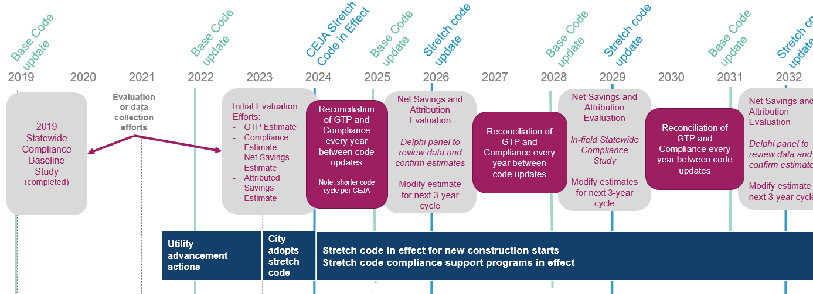

Stretch Code Support Programs and Evaluation

Utility Programs for Stretch Code Support
A stretch code support program works to increase compliance with an above-code policy that has been passed by the local jurisdiction where it would then become the minimum code. While the policy advancement work that a utility takes part in begins before a stretch code policy is adopted by a state or a municipality, the stretch code support program is implemented once a policy is adopted. Not every building would immediately achieve 100% compliance with stretch code strategies where adopted; the inclusion of utility-support programs will increase compliance over time.
Utilities should consider how the support programs and policy advancement works together. One of the most effective ways to advance policy is to confirm that implementation will be supported through technical assistance and programs. Because utilities have experience running programs and support programs conducted in other jurisdictions have proven to be effective in implementing stretch code policies, this strategy is one of the three main ways to support advancement, as outlined above. There are several ways that utilities could support stretch code compliance:
Training program targeting code officials, contractors, or city staff to address knowledge gaps about specific measures and/or ways to comply with stretch code. These training sessions can highlight new additions to the code, explain more confusing aspects of the code, or demonstrate test techniques for determining compliance. Utilizing data gathered in previous baseline studies, training sessions can target historically low-compliance, potentially high-impact areas.
Technical assistance for professionals that may be unsure of how to comply with or assess the compliance of a specific code requirement. This could include:
- Technical support answering code-related questions via email or over the telephone, with responses being tracked annually and provided to evaluators
- Participation in industry groups to offer technical assistance and outreach
- Resource development and delivery for resources that can assist all target markets, which could include compliance checklists, field guides, FAQs, bulletins, pocket guides, online tools
- Supporting a circuit rider, or a third-party specialist (that is not a building code official or an installer) that is available to all building code officials, that can work with multiple jurisdictions to provide technical assistance
- Development of an energy efficiency resource hub/compliance collaborative to provide a singular place where information can be accessed
Providing incentives for project or measures which meet or exceed minimum stretch energy code requirements. This could include:
- Developing a specific programmatic option that provides financial incentives as part of either a dedicated program specific to supporting customers by providing funding for new construction or major renovation projects that meet or exceed the stretch code adopted by municipalities, or as part of an existing program, such as the Nonresidential New Construction program. Consistent with other DSM programs, the incentives provided should be reviewed and revised based on market research and evaluation.
A stretch code support program can help advance energy efficiency in the entire Illinois market, even in non-stretch code adopting communities. If the stretch code is not universally adopted across Illinois, these stretch code support program elements could synergistically help customers comply with the state base energy code, or even exceed the state base energy code. There are significant levels of efficiencies to having both a base code support program and a stretch code support program because many of the same activities implemented for a stretch code support program would likely impact base code compliance. Activities such as technical assistance, training programs, the development of an energy efficiency hub/compliance collaborative, or the provision of incentives all can increase the compliance rates of either the state base or stretch codes. As of June 2022, Illinois does not have a base energy code utility support program in place

EVALUATION ACTIONS FOR ENERGY CODE ADVANCEMENT
While the advancement and support programs can work together, the evaluation of the stretch code support program is a separate evaluation from the code advancement evaluation. The stretch code evaluation examines utility activities that explicitly address helping customers meet the stretch code. Many of the same assumptions and data points would be used in both policy advancement and stretch code compliance support evaluations and we recommend planning for both. Code compliance support program savings need to be evaluated whenever the statewide code is updated or a stretch code is adopted.
Code compliance support evaluation includes an estimate of overall Stretch Code Support Market Potential Savings (MPS), with the emphasis on increasing compliance rates. Additionally, the evaluation for a stretch code policy advancement program includes evaluation of base code compliance (in order to estimate compliance with stretch code policy advancement), making the combination of supporting both base and stretch codes more cost-effective.
Similar to the stretch code advancement evaluation, the code support program evaluation requires a phase of estimating and predicting savings for the current/upcoming program cycle, and then a phase of review to confirm, evaluate, and potentially adjust savings for the next program cycle.
The estimation phase includes an estimate of the Stretch Code Compliance Baseline (SCCB) levels expected to occur over the program cycle, MPS and achievable potential of the market, and a prediction of the net program savings which applies an estimated effectiveness factor. These become the MT savings for the utility in the current program cycle to which the code support program would apply.
The review/evaluation phase includes determining what building stock was actually built and an annual review of program practices and utility involvement, including an evaluation of energy savings and a confirmation of claimed savings. While not cost effective to do every year, the review/evaluation would be largely determined by a formal compliance study at least every six years, and preferably after each base or stretch code update. From this analysis, the estimated effectiveness factor is replaced with the evaluated effectiveness factor based on actual accomplishments, where actual accomplishments are determined either by a compliance study or a Delphi panel examining available evidence. A compliance study, when available, would also inform other assumptions such as stretch code compliance baseline levels and achievable potential. Lessons learned regarding compliance levels and achievable potential would be applied prospectively to future years, not retrospectively.
The evaluation itself would be divided into three main parts: 1) SCCB and estimation of achievable market savings; 2) program implementation; and 3) MTI Savings achieved through program efforts (Figure 4). Each part is described in further detail below.
Figure 4: Evaluation overview for stretch code support programs
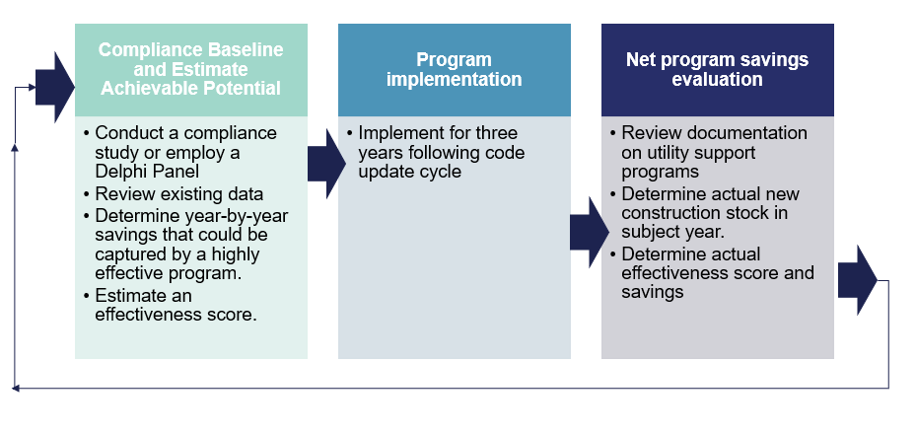

The compliance baseline estimate for stretch code support program should follow the steps as described in the Energy Code Advancement Program and Evaluation section. The compliance rates derived through those efforts will be the same as those that need to be derived for code support evaluation.

Achievable Market Savings Estimates
Like the MPS estimation of stretch code advancement, this evaluation step estimates the level of savings that may be achieved through a stretch code support program. In programs that combine Stretch Code Support with Policy Advancement, non-compliance is already determined in the Compliance Rate section of the Policy Advancement evaluation. In the evaluation of Policy Advancement, the difference between Market Potential Savings and Achievable Market Savings is removing non-compliance. This non-compliance becomes a goal of the Compliance Support program, and thus the estimated Market Potential Savings. This approach ensures there is no double counting of savings between the Advancement and Support aspects of the program.
The MPS for stretch code support programs is calculated using the compliance rates that were determined in the previous step compared against the code requirements and future new construction market data. These inputs are used to determine the total energy remaining due to non-compliance with the stretch code.
To determine the stretch code baseline energy levels, building energy simulations for prototypical buildings are used to generate baseline energy use for each building type. These energy simulations are typically developed by the Pacific Northwest National Laboratory (PNNL) and should be used as a starting point and modified based on changes in climate zones from the prototypical buildings and any changes between the statewide code and the code PNNL modeled. Savings are estimated on a per-unit or per-sf basis individually for each building type.
Achievable Market Savings would follow a Delphi process to determine what portion of the MPS is achievable in each year of the code cycle relative to a highly functioning stretch code compliance program. The Delphi panel, based on their experience and the data collected, then determines achievable energy code compliance levels under two scenarios:
- Achievable code compliance of a highly functioning stretch code compliance program.
- Assuming there was never a stretch code compliance support effort.
The Achievable Market Savings is determined by multiplying the Market Potential Savings by the Compliance Rate generated by the Delphi panel.
The Delphi panel would examine stretch code compliance efforts both within Illinois if applicable, and in other states or jurisdictions. The compliance rate would be set for each year in the code cycle, with higher rates in subsequent years i.e., year one of a new stretch code with a code support program would have a lower compliance rate than year two which builds on the success of year one. Compliance rates are set prospectively, not retrospectively.
NEED TO ADD TEXT ABOUT SCCB aka NOMAD

Net Program Savings (MTI Savings Attributed to Utility)
Evaluators assemble a Delphi panel to determine the effectiveness of stretch code compliance program efforts that are attributable to utilities. Similar to the Delphi panels used in the code advancement evaluation, the panel should be comprised of industry experts including building plans examiners, building commissioners, architects, design engineers, mechanical engineers, consultants, or academics. Data collected to inform savings estimations include collecting surveys, recording number of attendees and number of circuit rider visits for program participants. The portion of Achievable Market Savings achieved is determined by calculating the MTI Savings and a code support effectiveness score. Figure 5 demonstrates methods for determining the savings attributed to the utility (Net Program Savings).
Figure 5: Flow of evaluation steps for Code Support Programs
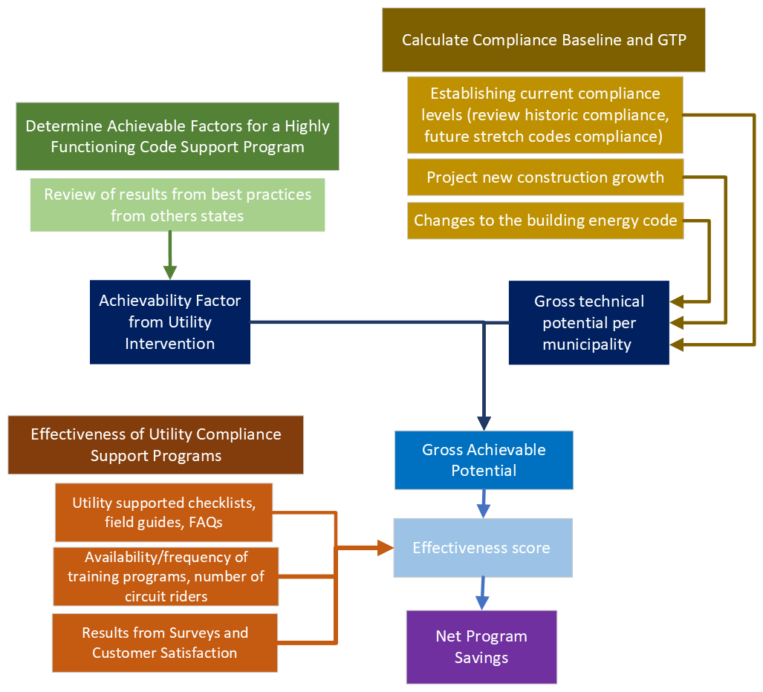
The portion of Market Potential Savings achieved is determined by calculating the MTI Savings and a code support effectiveness score. The weights and scores for effectiveness are developed in the areas described above in Utility Programs for Stretch Code Support. The effectiveness factor is derived from the weighted scores outlines in Table 5. Lastly, the code support effectiveness score is multiplied by the MTI Savings to determine the MTI Savings attributed to the utility derived in earlier evaluation steps. This is ultimately the savings values that will be allocated to utilities.

Table 5: Code support program examples of utility participation and categories of influence for developing the Effectiveness Score
Compliance Enhancement  Activity | Scoring Metrics | Documentation Examples | Score | Notes
Training Sessions: Classroom, In-field, Webinar, etc.  (25%) | Curriculum covers topics where compliance improvement is possible/necessary | Training materials such as PowerPoints or worksheets | 10 | Baseline studies can be used to highlight key areas of low compliance
 | Training sessions are frequent, accessible, and see high attendance as a result | List of trainings held and attendance numbers | 5 | Also, can show a mix of demographics in attendees i.e., builders, code officials, etc.
 | Training sessions increase knowledge/understanding of attendees | Participant surveys completed after the training sessions | 5 | Can utilize a simple rating system over various categories such as Lighting, HVAC, etc.
 | Training sessions result in improved practices by relevant attendees | Participant surveys completed 2-6 months after the session | 5 | Will need to determine which attendees receive this survey
Phone and Email Technical Support  (20%) | Experts are consistently available to answer questions regarding code updates, and these resources are advertised to relevant stakeholders | Hours of availability for information resources, as well as marketing materials for/links to these resources | 10 | Could be undertaken by the utility, local government, or a third party with utility funding/support
 | Information resources are utilized by relevant stakeholders and useful responses are given in a timely manner | Call and email records to/from information hotlines | 10 | Could request to record calls to assess performance
Supporting a circuit rider or third-party specialist.  (25%) | Credentials and effectiveness of circuit riders or specialists. | Resume, CV and experience notes, as well as satisfaction surveys | 10 | Provided by utility
 | Full time equivalence (FTE) of circuit riders or specialists | Employment records and schedule information | 15 | Provided by utility
Resource Development: Checklists, Field Guides, FAQs, etc.  (10%) | Useful resources are developed and distributed by the utility or a third party | Example materials and distribution pathways | 10 | These could be tied into the trainings as well as take-home materials
Stakeholder Engagement  (5%) | Utility participates in industry groups, maintains contact with building departments to make sure information and resources are up to date | Meeting minutes, emails, etc. | 5 | Utility maintaining a list of active builders could be useful as well for training and documentation purposes
Offering incentives for construction to the stretch code standard | Utility includes a specific programmatic option that provides financial incentives for projects or specific measures that meet or exceed the stretch energy code minimum requirements | Plan submitted and program component in place to provide incentives | 10 | Provided by utility
Undefined or miscellaneous (5%) | Meaningful influence on code compliance outside of the categories of influence listed above | To be determined. Depends on nature and content of influence | 5 | Allows utilities to get credit for areas not identified

Allocation of Energy Savings
Each utility will only be able to claim savings within its service territory and applying only those savings that are attributable to the actions it took to advance the code or increase compliance. In the case of policy advancement, a utility can claim savings only for savings within the municipality which adopted the stretch code; for stretch code compliance support programs, the evaluation may identify savings beyond a municipality that has an adopted code, but the savings would still be limited to service territory boundaries. In the case of a municipality that shares utility service with more than one investor-owned utility, the allocation is based on proportion of energy building energy savings by fuel type.

Evaluation cost
The cost of evaluation will be determined by the evaluator based on the final evaluation scope. Costs could include the cost of the evaluation team’s time and resources, and facilitation and coordination of the Delphi panel. One method of balancing cost with accuracy would be to utilize Delphi panels in lieu of conducting compliance field studies every code cycle. Thus, the cost of compliance field studies could be included at least every six years (rather than every three years), and preferably after each base or stretch code update; these costs may end up being lower than the initial compliance baseline field studies (2018-2019 Illinois Energy Code Compliance Studies) because the methodology has been created. Many data-gathering steps for evaluation of policy advancement and of compliance support are similar and can be streamlined to reduce costs. We also recommend the program implementer begin collection of supporting documentation of utility involvement (such as meeting notes, email contacts, etc.) immediately to streamline the evaluation process.

Appendix B: Background on Illinois Energy codes
This document proposes key elements of evaluation for market transformation of stretch code programs. The Slipstream/MEEA team presented to the IL SAG on March 17th on stretch codes, in relation to how utilities might be able to claim savings for policy advancement and policy support. The team was asked to convene with a smaller SAG working group. The smaller group met on May 7th to discuss pathways for utilities to claim savings. Out of that meeting, the MEEA/Slipstream team was tasked to collaborate with the evaluation teams (Guidehouse and Opinion Dynamics Corporation) to develop evaluation pathways for the SAG Market Transformation Working Group to consider. For this first draft of this document, we focus on evaluation pathways for stretch codes. Once we have agreement on stretch code pathways, we can apply similar approaches for building performance standards (BPS) for existing buildings.

Current Illinois Code
In Illinois, commercial and residential buildings follow the Illinois Energy Conservation Code which is based on the International Energy Conservation Coded (IECC). While the Capital Development Board is responsible for administering the code and the code update process, local jurisdictions are responsible for enforcing the code. Additionally, local governments are allowed to adopt stricter energy codes for commercial buildings. Local governments are not allowed to adopt stricter residential codes unless the codes were adopted prior to May 15, 2009 or if a municipality has a population of 1,000,000 or more (Chicago, essentially). For purposes of this document which focuses on stretch codes, we will only be focusing on the energy codes for commercial buildings.
The Capital Development Board is required by the Energy Efficient Building Act to review and adopt the most current IECC within one year of its publication date, which makes it one of the more aggressive energy codes in the country (depending on state amendments). The state energy code is updated every three years. The adoption process is currently underway to update the residential and commercial energy codes based on the 2021 IECC. The new energy codes will become the statewide energy code sometime in 2022.

Illinois Energy Code Compliance
Numerous compliance field studies across the U.S. have shown that full compliance with energy codes is rarely achieved. Energy code compliance baseline studies for single-family residential buildings and commercial buildings were completed in Illinois in 2019. These code compliance studies can be used to establish the baseline levels of non-compliance, can help inform program design elements, and identify missed savings. The studies can also be used to calculate the Market Potential Savings for stretch code advancement and compliance support programs and their future evaluation. As will be discussed further in this document, similar statewide compliance studies should be repeated periodically to provide consistent evaluation data and information for program updates.
The 2018-2019 Illinois Energy Code Compliance Studies found that non-compliance existed in some measures with the Illinois state energy code. About one-fourth of the 40 building sites sampled did not satisfy the requirements for four specific key items. Table 7 outlines identified areas of improvement in that study.
Table 7. Identified Commercial Areas of Improvement in Plan Review and Construction Verification
Category | Identified Non-Compliance
Daylighting and interior lighting controls | Non-compliance in interior lighting shutoff controls (13 of 40 buildings). Ten buildings did not satisfy the daylighting control requirements.
Exterior lighting | Almost one-fourth of the buildings did not meet the key item exterior lighting power density requirement.
Various HVAC controls and functional requirements | 15 buildings had HVAC controls or functionality key item requirements that were not up to code.
Envelope insulation | Six of the buildings did not meet the wall insulation R-value requirement and four did not meet the roof insulation R-value requirement.

Based on non-compliance with the state code, it can be reasonably assumed that increases in energy efficiency in a stretch code in the same areas will likely also result in non-compliance, at least initially. These are areas that utilities can target for a support program. The utility can also use this information to make informed decisions about advancing energy code policies.

Appendix C: CEJA Stretch Code
In September 2021, the Illinois Climate and Equitable Jobs Act (CEJA) was passed that directs the Illinois Capital Development Board (CDB), which manages the state building energy code adoption process, to create a residential and commercial stretch energy code that can be adopted by individual municipalities. This would enable municipalities to improve on the state building energy code. Having a state-created stretch code provides consistency amongst jurisdictions (with only two energy code options rather than an unlimited amount if each jurisdiction creates and adopts their own) and allows flexibility for jurisdictions to choose to adopt it. Once formally adopted by a municipality, the stretch code takes the place of the state energy code and establishes the minimum energy efficiency requirements for new construction, additions, and major renovations. The evaluation pathway provided in this document assumes that the stretch code as defined by CEJA will be the mechanism in Illinois to move stretch codes advancement and support programs forward. The stretch code energy efficiency targets (called a “site energy index”) are set in the CEJA legislation and update every three years, but CDB will determine the specific code requirements and language that meet those targets.
The language for the commercial stretch code in the CEJA bill denotes that the energy efficiency increases each three-year code cycle so that it eventually meets a site energy index no greater than 0.39 of the 2006 International Energy Conservation Code by 2031. The site energy indices for the new Illinois stretch code are outlined in Appendix C. A site energy index is essentially the relationship of any energy code to the 2006 IECC, as calculated and defined by the Pacific Northwest National Laboratory (PNNL). With this system, a score of 1.0 is equal to the 2006 IECC/ASHRAE 90.1-2004, and scores that are lower than 1.0 consume less energy than the 2006 IECC/ASHRAE 90.1-2004. The residential 2021 IECC is estimated to be around 40% more efficient than the 2006 IECC, giving it a score of 0.60. According to the Pacific Northwest National Laboratory (PNNL), the current energy code in Illinois has a site energy index of 0.76 for residential and 0.66 for commercial. Using those numbers to meet the stretch code initial targets, the residential stretch code would need to improve in energy efficiency by 34.2% and the commercial stretch code by 9.1% compared to the current Illinois energy code. The bill language specifically calls out that these targets must be met by conservation measures only, and “excludes net energy credit for any on-site or off-site energy production.”
Table 8. Commercial Targets for Stretch Code in CEJA
Stretch Code Version | Implementation Date | Site Energy Index | Performance Targets | Code Created By
2024 Commercial Stretch Code | December 31, 2023 | 0.60 | At least 40% more efficient than 2006 IECC | Set by CDB by July 31, 2023
2026 Commercial Stretch Code | December 31, 2025 | 0.50 | At least 50% more efficient than 2006 IECC | Set by CDB in 2025
2029 Commercial Stretch Code | December 31, 2028 | 0.44 | At least 56% more efficient than 2006 IECC | Set by CDB in 2028
2032 Commercial Stretch Code | December 31, 2031 | 0.39 | At least 61% more efficient than 2006 IECC | Set by CDB in 2031

While the stretch code in this scenario may be statewide, it is still up to the local jurisdiction to adopt it and then enforce its compliance. This leaves a straightforward path of action for utilities to be involved in stretch code advancement and support with a CEJA stretch code.

Appendix D: Logic Model

Appendix E: Example of Similar Programs/Evaluations
Example of calculating Net Program Savings by assessing Attribution and multiplying it by estimated Gross Technical Potential in the Rhode Island Net Program Savings for Code Compliance Enhancement Initiative. Source: NMR Group, Rhode Island Code Compliance Enhancement Initiative Attribution and Savings Study, 2017.
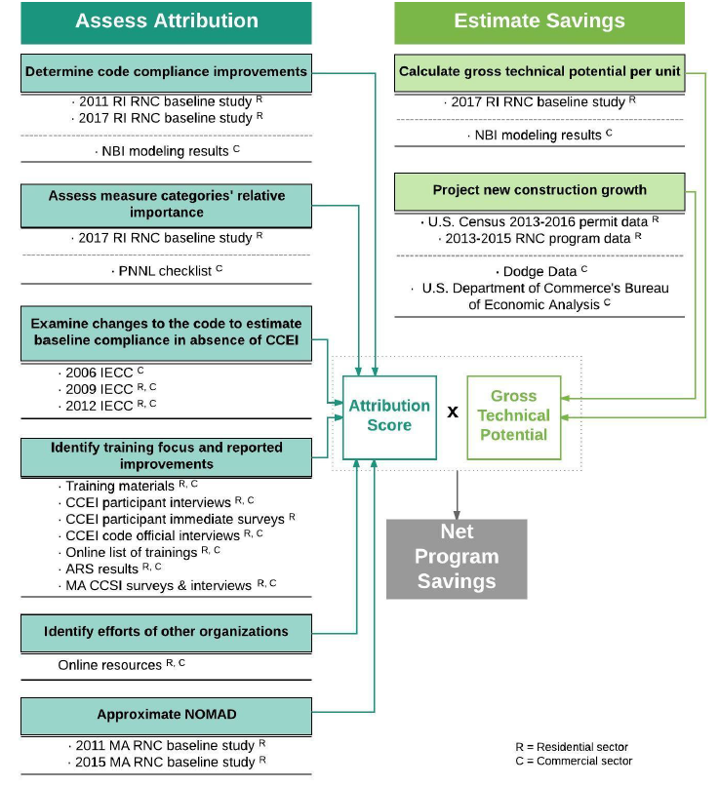

Appendix G: Overview of Utility Activities, Timeframes, and Applicable municipalities and Sectors
Table X. Utility Activities, Timeframes, and Applicable Municipalities and Sectors
Utility Activity | Of What | Municipality Size | Utility Support Timeframe |  | Sector |  | Activity Detail
 |  |  | Pre-1/1/24 | Post-1/1/24 | Com | Res
Accelerate Adoption | Above current statewide base energy code | > 1 million residents | ü | ü | ü | ü | Policy advancement support: research, advocacy, program development, other
 | CEJA stretch code or above | > 1 million residents | üü |  | üü | üü | Early adopter assistance / preparation for CEJA
 | CEJA stretch code or above | > 1 million residents |  | ü | ü | ü | Policy advancement support: research, advocacy, program development, other
 | Above current statewide base energy code | All | ü |  | ü |  | Policy advancement support: research, advocacy, program development, other
 | CEJA stretch code | All | ü |  | ü | ü | Early adopter assistance / preparation for CEJA
 | CEJA stretch code | All |  | ü | ü | ü | Policy advancement support: research, advocacy, program development, other
Support Compliance | Above current statewide base energy code (once adopted) | > 1 million residents | ü | ü | ü | ü | Trainings, technical support, circuit rider/3rd party specialist, resource development, stakeholder engagement, other
 | CEJA stretch code or above | > 1 million residents | ü |  | ü | ü | Early adopter assistance / preparation for CEJA
 | CEJA stretch code | > 1 million residents |  | ü | ü | ü | Trainings, technical support, circuit rider/3rd party specialist, resource development, stakeholder engagement, other
 | CEJA stretch code | All | ü |  | ü | ü | Early adopter assistance / preparation for CEJA
 | CEJA stretch code | All |  | ü | ü | ü | Trainings, technical support, circuit rider/3rd party specialist, resource development, stakeholder engagement, other

If a municipality wants to have a single-family residential stretch code prior to 2024, it must first be created through the state or legislatively, unless it had an energy code before 2006. See next section for details.
If a compliance study is being performed in parallel to the evaluation, then compliance rates would only be estimates until the compliance study is complete.
Subsequent studies are simply called “compliance studies” to measure how much compliance improvement has been achieved since the initial baseline study.
The language recently passed in CEJA will change this. See Section on Stretch Codes.
2018-2019 Illinois Energy Code Compliance Studies, 2019.

