**State of Illinois**

**Energy Efficiency**

**Technical Reference Manual V14.0**

**[Light Duty Electric Vehicle]**

**[New Measure]**

**[Section 5.7 Miscellaneous]**

**[Nick Warnecke, Ameren Illinois  
Seth Craigo-Snell, SCS ANALYTICS]**

**[5/15/25]**

TABLE OF CONTENTS

1 Overview 3

2 New Measure Characterizations 4

3 Proposed Changes to Existing Measures 6

4 References 7

5 Stakeholder Comments 8

Author (Company) and Date 8

Table Work Paper Revision History

|  |  |  |  |
| --- | --- | --- | --- |
| **#** | **MM/DD/YY** | **Author, Company** | **Summary of Changes** |
| 1 | 05/15/25 | Nick Warnecke, Ameren Illinois and Seth Craigo-Snell, SCS ANALYTICS | Initial Submission |
|  |  |  |  |

# Overview

Brief summary of New Measure or Change proposed to Existing measure and the rationale behind the change:

Battery Electric Vehicles (BEVs)are gaining market position in the U.S. as customers are seeking solutions for their transportation needs. Based on consumer survey research completed by Ameren Illinois in 2024, reducing the cost of vehicle ownership, owning an environmentally friendly vehicle, and owning a vehicle with the latest technology were key reasons for owning an electric vehicle. Long charging times, reduced range of travel, and lack of charging infrastructure were the key concerns about electric vehicle ownership (see Reference [1] for more information.

To date, very little attention is being paid to the fuel economy of BEVs as part of the purchase decision. Huether (2024) lays out the case for improving BEV efficiency (kWh/miles traveled) as a key element for success as the U.S. transitions from fossil fuel internal combustion engines to cleaner electric vehicles (see Reference [2] for the detailed report.

In this work paper we are proposing a new measure for the IL TRM that, in absence of a federal standard, establishes a standard fuel economy (efficiency) level for BEVs along with a savings methodology for the promotion of higher fuel economy (efficiency) BEVs based on car class. The approach leverages fuel economy information gathered from vehicle manufacturers and published by the U.S. Department of Energy (<https://www.fueleconomy.gov/feg/download.shtml>).

Below is a chart showing the fuel economy for most (there are some exemptions allowed by DOE) BEV models sold in the U.S. market from 2020-2025. Based on the statistically different average values (at the α=0.05 level) between: Cars and Small SUVS taken as a group, Standard SUVs, and Trucks, we established standard fuel economies and savings for three categories of vehicles.

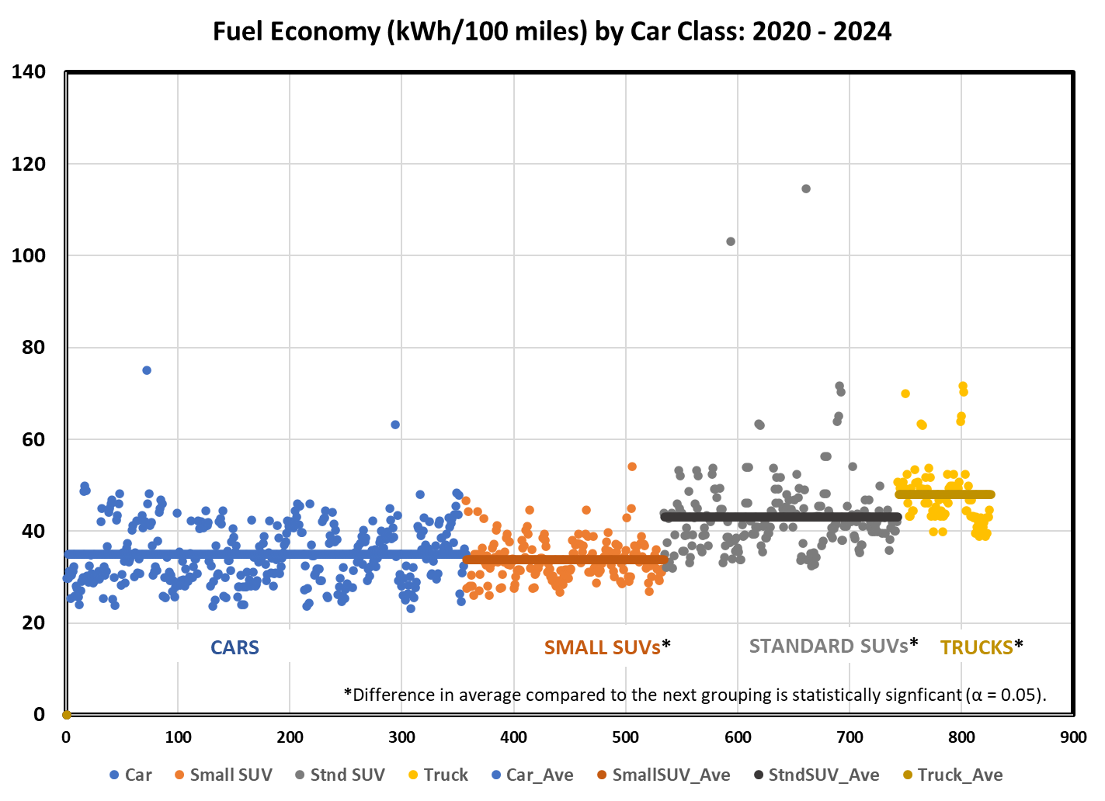

**Income Qualified (IQ) Considerations:**

The following guiding questions were established by the IQ TRM Working Group to encourage TAC members developing TRM updates to consider whether there may be IQ specific assumptions or considerations:

* *Could the baseline efficiency of the measure differ for IQ communities?*
* *If there are any housing characteristics assumptions for this measure, would they differ in an IQ community?*
* *In an IQ community, could the run hours or operation behavior differ?*
* *Could the measure lifetime differ in an IQ setting?*

If the answer is yes to any of these questions, please describe how these considerations might be taken in to account. If you need help or would like to discuss, please contact the IQ TRM Working Group via [iltrmadministrator@veic.org](mailto:iltrmadministrator@veic.org).

# New Measure Characterizations

Each measure characterization uses a standardized format that includes at least the following components. Measures that have a higher level of complexity may have additional components, but also follow the same format, flow and function.

Please provide text for each of the sections below with appropriate citations in footnotes (see section #4) and upload any references or calculation sheets to the Tracker item.

5.7.# Light Duty Electric Vehicles

###### Description

The measure is for the purchase of light duty (gross vehicle weight <8,500 lbs) battery-powered electric passenger vehicles (BEVs). There is a wide range in the efficiency levels within passenger BEV types. The measure establishes standard levels of efficiency for EVs within each car class (e.g., Cars, Small SUVs, Standard SUVs, and Trucks) and electric energy savings associated with the purchase of higher efficiency equipment above that standard level. Based on the statistically different average values (at the α=0.05 level) between: Cars and Small SUVS taken as a group, Standard SUVs, and Trucks, we established standard fuel economies and savings for these three categories of vehicles.

This measure was developed to be applicable to the following program types: TOS. If applied to other program types, the measure savings should be verified.

###### Definition of Efficient Equipment

A newly purchased battery-powered passenger vehicle or BEV that is powered solely by electricity that can be recharged from an external source and exceeds the fuel economy for baseline equipment based on vehicle type.

###### Definition of Baseline Equipment

Baseline equipment is a light duty BEV with standard fuel economy:

* Cars/Small SUVs: BEV_baseline > 40.72 kwh/100 miles
* Standard SUVs: BEV_baseline > 52.45kwh/100 miles
* Trucks: BEV_baseline > 54.91 kwh/100 miles

###### Deemed Lifetime of Efficient Equipment

The expected measure life is assumed to be 15 years.[1]

###### Deemed Measure Cost

The incremental purchase cost for this measure is assumed to be:

$TBD for standard light duty BEV.

###### Loadshape

###### Coincidence Factor

Coincidence factor is assumed to be 1.

Algorithm

###### Calculation of Energy Savings

###### Electric Energy Savings

ΔkWh_BEV baseline = (BEV_stnd - BEV_ee) * VMT / 100

Where:

VMT = Annual vehicle miles traveled of the vehicle measure.

= 10,573[2]

BEV_stnd = Standard BEV Fuel Economy. See table below for values based on car class.[3]

| **Car Class** | **BEV_Stnd (kWh/100 miles)** |
| --- | --- |
| Car / Small SUV | 40.72 |
| Standard SUV | 52.45 |
| Truck | 54.91 |

BEV_ee = Actual nameplate operation efficiency for efficient BEVs expressed in kWh per 100 miles.

= Actual. If unknown assume values below based on car class[4]

| **Car Class** | **BEV_ee (kWh/100 miles)** |
| --- | --- |
| Car / Small SUV | 32.53 |
| Standard SUV | 41.24 |
| Truck | 46.27 |

100 = Fuel Economy conversion factor

Time of Sale:  
For Example, a Small SUV BEV 2025 Volkswagen model: ID.4 AWD Pro with fuel economy of 32.97 kWh/100 miles:

ΔkWh_BEV baseline = (40.72–32.97) * 10,573 / 100) =

= 820 kWh/yr

###### Summer Coincident Peak Demand Savings

ΔkW = - Average_kW * CF

Where:

Average_kW = Average electric demand during standby[5]

= 0

CF = Summer peak coincidence factor

= 1

###### Natural Gas Savings

N/A

###### Water and Other Non-Energy Impact Descriptions and Calculation

N/A

###### Deemed O&M Cost Adjustment Calculation

###### Cost-Effectiveness Screening

# Proposed Changes to Existing Measures

Copy existing TRM measure from the IL-TRM Version 12.0 dated September 22, 2023, accessible on the [SharePoint site](https://portal.veic.org/sites/illinoistrm/Shared%20Documents/Forms/AllItems.aspx?id=%2Fsites%2Fillinoistrm%2FShared%20Documents%2FTechnical%5FTRM%5FEffective%5F01012024%5FVersion%5F12%2E0%2FFinal%20IL%20TRM%20v%2012%2E0), and paste the existing measure characterization below in its entirety, then turn on tracked changes and provide proposed edits in redline with appropriate citations (see section #4 below). Upload any new references or calculation sheets to the Tracker item. If a change requires further explanation that should not be in the characterization itself, use a comment bubble to provide.

# References

Please refer to the Chicago style for variances on format citations. Please upload any new references or calculation sheets to the Tracker item.

<http://www.chicagomanualofstyle.org/tools_citationguide.html>

EXAMPLES:

[1] Maru Group/Ameren Illinois, “Electric Vehicle Annual Reseach”, (2024), see Appendix C in the Ameren Illinois 2025 Annual Report for Beneficial Electrification Plan 1, <https://www.icc.illinois.gov/docket/P2022-0443/documents/363430/files/636427.pdf>.

[2] Huether, Peter, “Electric Vehicle Efficiency: Unlocking Consumer Savings and Environmental Gains”, (2024), ACEEE White Paper, <https://www.aceee.org/sites/default/files/pdfs/electric_vehicle_efficiency_-_unlocking_consumer_savings_and_environmental_gains.pdf>.

**Paper presented at a meeting or conference (Including internal work papers)**

Author Name, “Paper title” (paper presented at the annual meeting for the Organization Name, City, State, Month Day, Year).

**Website**

“Title,” last modified Month Day, Year, URL

**E-mail**

Author Name, e-mail message to author, Month Day, Year.

**Item in a commercial database**

Author Name. “Source Title” Publisher, Year. Database Name

**Book: Chapter or other part of a book**

Author Name, “Chapter,” in Title, City: Publisher, Year, page range

**Book: Published electronically**

Author Name, “Chapter,” in Title, City: Publisher, Year, Accessed Month Day, Year. URL.

**Journal Article in a print journal (Use this for program evaluations.)**

Author Name, “Article Title,” Journal Name edition (Year): page

Author Name, “Evaluation Title,” Utility Name, Program or Measure Name (Date): page

**Journal Article in an online journal**

Author Name, “Article Title,” Journal Name edition (Year): page, accessed Month Day, Year, dio:xx.xxxx/xxxxxx.

# Stakeholder Comments

If adding comments to an existing work paper, add note in “Progress Notes” section of the tracker item stating *“(Author, Company) added comments to workpaper, (date)*”. This will send an alert to VEIC and others that a new comment has been added.

Author, Company and Date:

Comment:

1. Assumed years of planned light duty vehicle ownership. 2023 Alternative Fuel Life-Cycle Environmental and Economic Transportation (AFLEET) Tool. Argonne National Laboratory.
2. Average annual light duty vehicle miles traveled estimated based on national transportation statistics found in Table VM-1. Annual Vehicle Distance Traveled in Miles and Related Data, 2021. US Department of Transportation.
3. US DOE Fuel Economy data for all car, SUV, and truck models 2020-2025: <https://www.fueleconomy.gov/feg/download.shtml>. Threshold fuel economy to identify standard efficiency models is established as one standard deviation above the average value for each car class.Car classes for this measure were established based on statistically significant differences in the average fuel economy for each class compared to the next. Cars and Small SUVs were combined because their average fuel economies were not statistically different at the 95% level. See: 2020-2025 FE Guide for DOE-051525.xlsx for data and calculations.
4. US DOE Fuel Economy data for all car, SUV, and truck models 2020-2025: <https://www.fueleconomy.gov/feg/download.shtml>. Default values were taken as the average of all models above the standard efficiency level for each car class. See: 2020-2025 FE Guide for DOE-051525.xlsx for data and calculations.
5. Assumes no EV charging during Summer Coincident Peak Period. Also assumes that for Standard BEV to Efficient BEV comparisons, there would be no incremental peak demand increase for the efficient case.