Illinois Energy Efficiency Policy Manual Version 3.2 Update:
SAG Facilitator Summary of Proposed Redline Edits Due to CRGA
Sept. 28, 2026

Statutory Sources:
- Clean and Reliable Grid Affordability (CRGA) Act: https://ilga.gov/documents/legislation/104/HB/PDF/10400HB1700lv.pdf
- Trailer bill: https://www.ilga.gov/Documents/Legislation/PublicActs/104/PDF/104-0477.pdf

- General Edits

- Effective Date
  - Policy Manual Edits:
    - Cover Page: Proposed effective date of June 1, 2026 (the date the CRGA Act went into effect). There are some provisions of CRGA that are not effective until January 1, 2027, which will be noted where applicable.
    - Section 2.3, Effective Date: Edited for clarity

- Multi-Year Plans
  - All references to 4-year EE Plans were changed to “multi-year” throughout the manual, to avoid confusion due to 4-year EE Plans and the updates to 2027-2029 EE Plans due to CRGA.

- Electric Edits

- Definitions
  - Policy Manual Edits to the Glossary:
    - Added definition of Average Savings Life
        - Section 8-103B(b-16)(3)
        - This definition was edited by the trailer bill.
    - Added definition of Incremental Annual Energy Savings
      - Section 8-103B(b-16)
    - Added definition of Incremental Annual Coincident Peak Demand Savings
      - Section 8-103B(b-16)
    - Added definition of Lifetime Coincident Peak Demand Savings
      - Section 8-103B(b-27)(f)(3)
    - Added definition of Lifetime Energy Savings
        - Section 8-103B(b-27)(g)(8.5)(B)
    - Added definition of Low Income Households
      - Section 8-103B(b-27)(c)
      - CRGA did not add a definition of “low income households” for electric utilities; this definition already existed in the statute and was not referenced in the Policy Manual glossary. Since a definition of “low income households” was added to 8-104 per CRGA, a footnote was added for electric with the statutory reference.
    - Added definition of Moderate Income
      - Section 8-103B(b-16)
      - This definition was edited by the trailer bill.
    - Edited footnote for definition of On Bill Financing, to reference the electric repeal that is effective on 1/1/2027

Statutory excerpt from CRGA on pages 530-531 – definition of Average Savings Life:
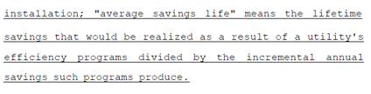

Statutory excerpt from trailer bill on pages 589 – definition of Average Savings Life:
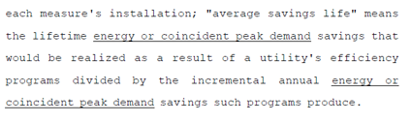

Statutory excerpt from CRGA on pages 530-531 – definition of Incremental Annual Energy Savings:
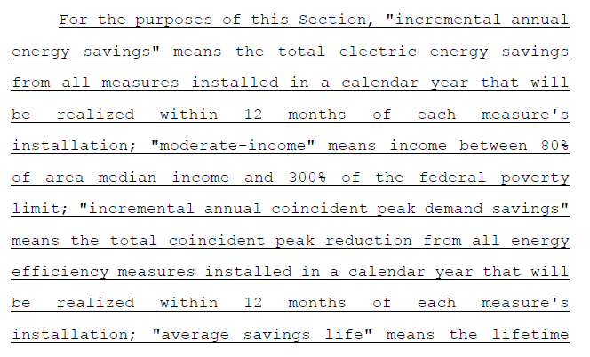
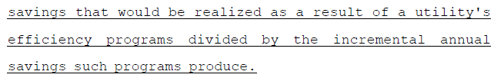

Statutory excerpt from CRGA on page 585 – Lifetime Energy Savings:
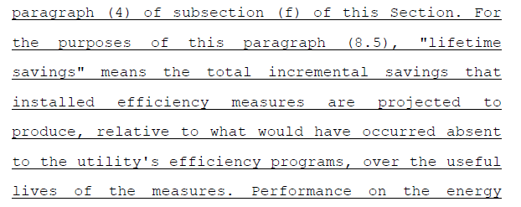

Statutory excerpt from trailer bill on page 633:
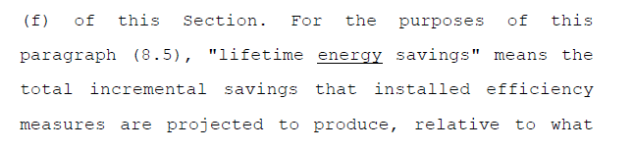

Statutory excerpt from CRGA on page 562 – Lifetime Peak Demand Savings:
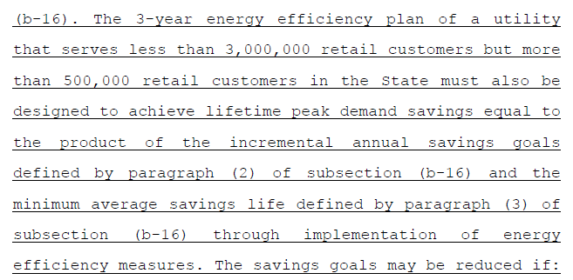

Statutory excerpt from trailer bill on page 620:
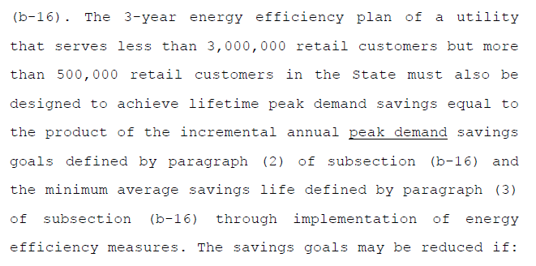

Statutory excerpt from CRGA on page 538 – definition of Low Income Households:
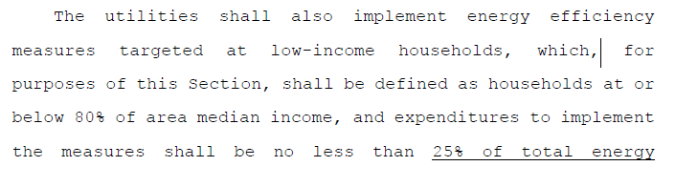
Statutory excerpt from CRGA on page 530 – Moderate Income:
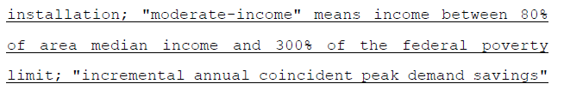

Statutory excerpt from trailer bill on page 589:
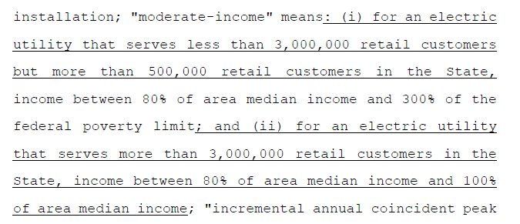

Statutory excerpt from CRGA on page 846 – repeal of electric on-bill financing program:
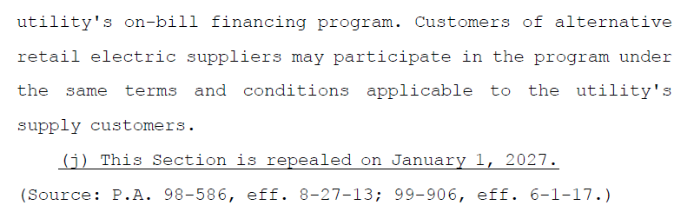

- Retaining LIEEAC Facilitator
- See Section 8-103B
- Policy Manual Edits:
    - Section 3.6, Low Income Energy Efficiency Accountability Committee Facilitator Independence: Edited to clarify that if a facilitator is used in ComEd’s service territory, Commission Staff holds the contract. Ameren retains the ability to hold the facilitator contract in its service territory.

Statutory excerpt from CRGA (page 543):
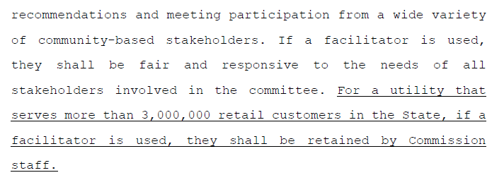

- Budget Allocation – Electric
- See Section 8-103B
- Policy Manual Edits:
    - Section 4.2, updated the low income budget for Ameren and ComEd to a minimum of 25% of total EE program spending

Statutory excerpt from CRGA (pages 538-539):
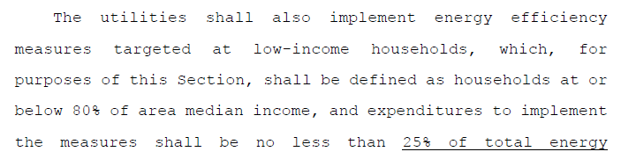
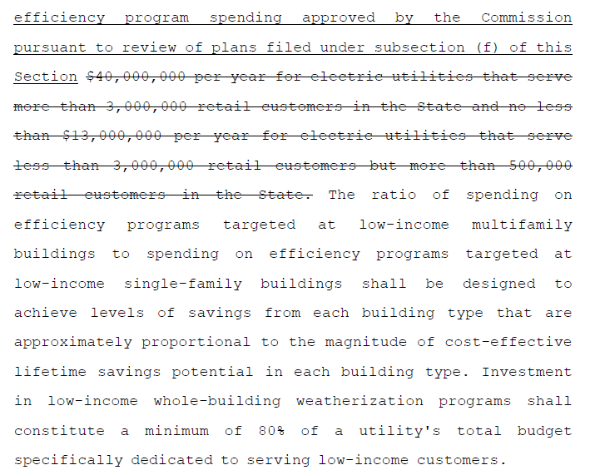

- Average Savings Life
  - See Section 8-103B(b-16) and Section 8-104(e-20)(3)(C)
  - Policy Manual Edits:
    - Added a new section (4.3) to describe electric and gas Average Savings Life

Statutory excerpt from CRGA on page 530 – electric average savings life requirement:
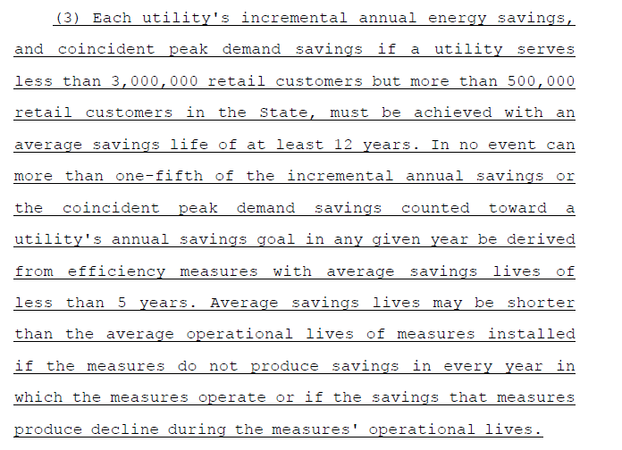

Statutory excerpt from trailer bill on page 588:
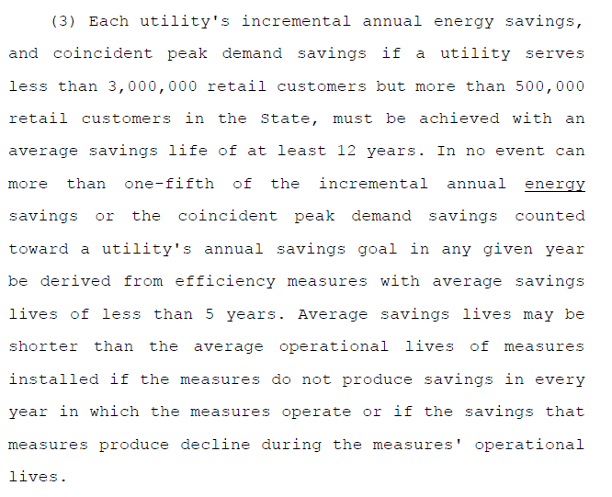

Statutory excerpt from CRGA on page 562 – calculating electric average savings life:
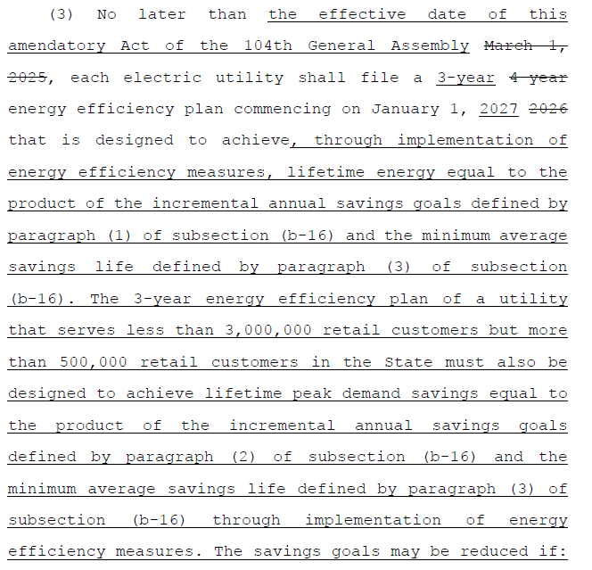

Statutory excerpt from trailer bill on pages 619-620:
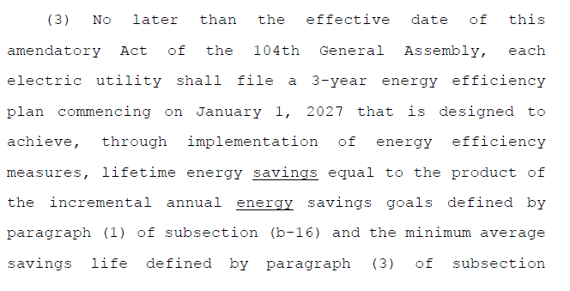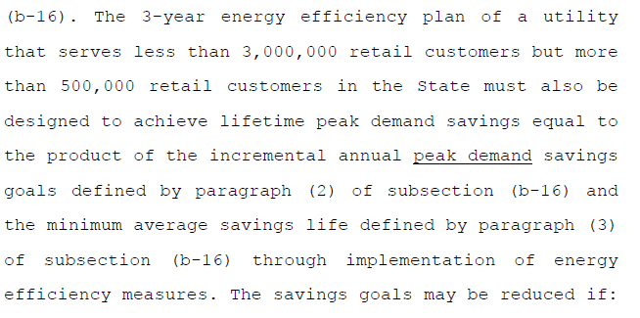

Statutory excerpts from CRGA on pages 613-615 – gas average savings life requirement:
…
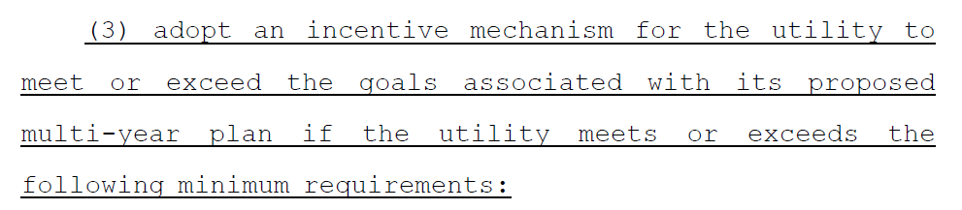
…
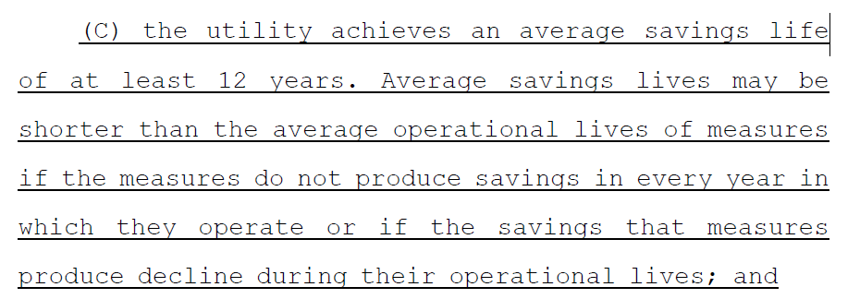

- Applicable Annual Incremental Goal and Cumulative Persisting Annual Savings
  - See Section 8-103B(b)
  - Policy Manual Edits:
    - Section 6.5, Program Administrator Quarterly Template Reports and Semi-Annual Narrative Reports:
      - Added reference to CPAS ending in 2026
      - Added reference to incremental annual and lifetime savings beginning in 2027 (ComEd and Ameren)
      - Added reference to incremental annual and lifetime peak demand savings goals beginning in 2027 (Ameren)
    - Section 11.1, Applicable Annual Incremental Goal:
      - Added sunset provision for end of 2026
    - Section 11.2, Cumulative Persisting Annual Savings:
      - Added sunset provision for end of 2026

Statutory excerpt from CRGA on page 516:
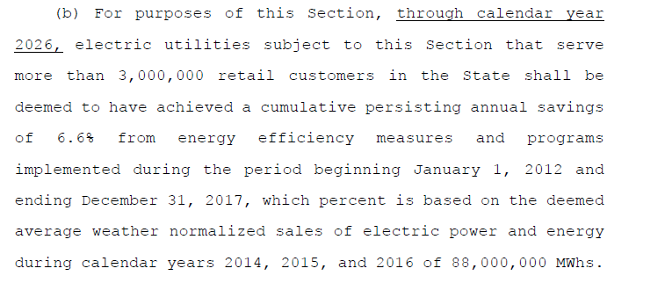

- Third Party Programs
- See Section 8-103B(g)(4)
- Policy Manual Edits:
    - Section 6.5, Program Administrator Quarterly Template Reports and Semi-Annual Narrative Reports: Added “if applicable” to the reference to Third Party Programs

Statutory excerpt from CRGA on page 569:
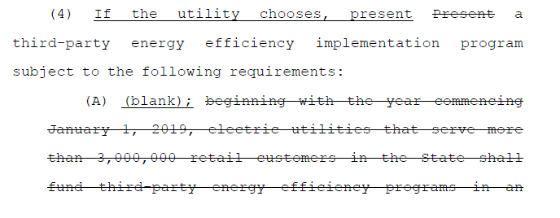

- Total Resource Cost Test
  - Policy Manual Edits:
    - Edited Section 8.1, for 8-103B statutory definition of TRC Test
      - 20 ILCS 3855/1-10 Definitions

Statutory excerpt from CRGA on pages 144-156 – TRC Test:
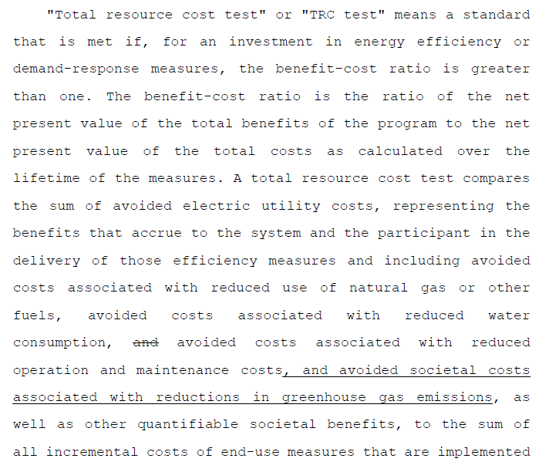
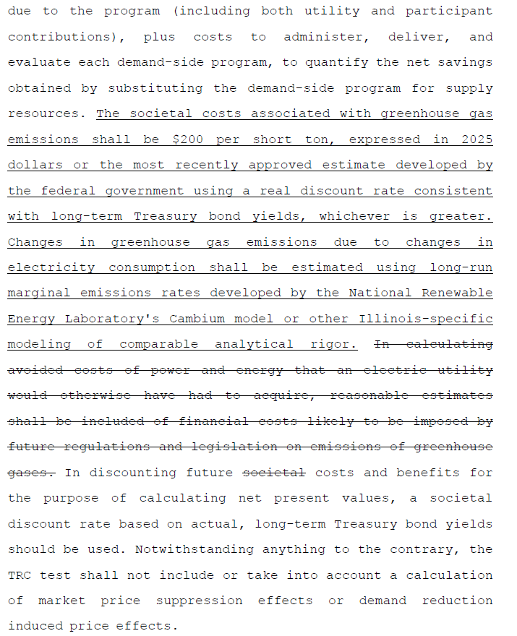

- Electric Savings Goals and Performance Mechanism Beginning in 2027
- See Section 8-103B(g)(8.5); Section 8-103B(b-16)(3)
- Policy Manual Edits:
  - Since the AAIG and CPAS sections of the Policy Manual sunset at the end of 2026 (see Sections 11.1 and 11.2), a new section 11.3 was added, Electric Savings Goals and Performance Mechanism Beginning in 2027, that references the new incentive structure and several requirements related to electric savings goals, including lifetime energy savings.

Statutory excerpt from CRGA on pages 584-585 – return on equity:
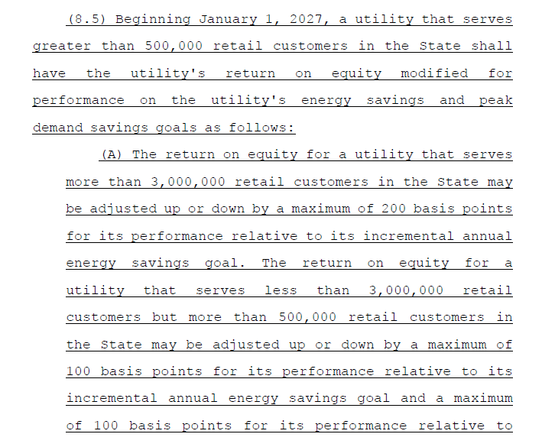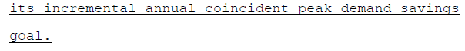

Statutory excerpt from trailer bill on pages 632-633:
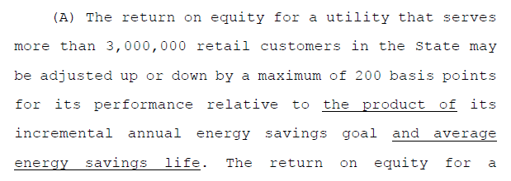
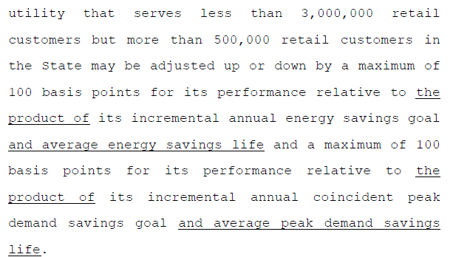
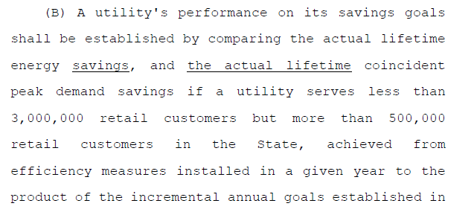

- Counting Fossil Fuel Savings Towards Electric Savings Goals
  - See Section 8-103B(b-25)
  - Policy Manual Edits:
    - Section 11.4, Counting Fossil Fuel Savings Towards Electric Savings Goals

Statutory excerpts from CRGA (pages 532-534):
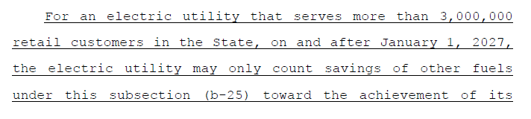
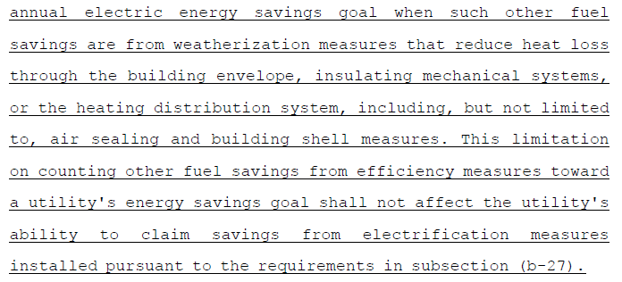
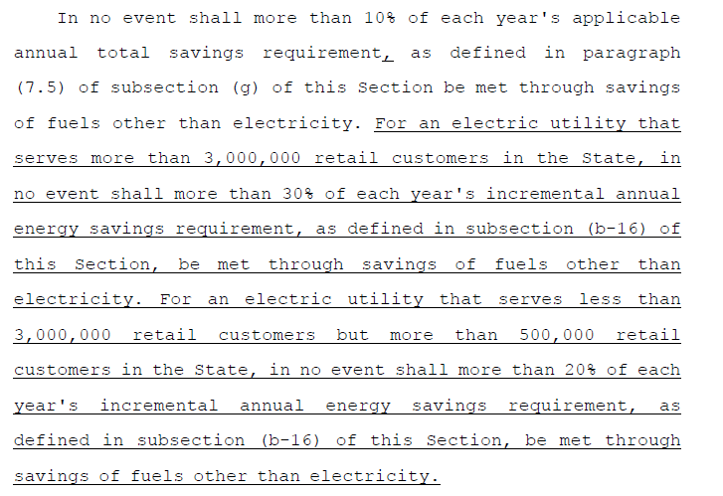

- Calculation of Annual Electric Planning Spending Limits
- See Section 8-103B(m)
- Policy Manual Edits:
    - Section 11.6, Calculation of Annual Electric Planning Spending Limits:
      - Edited the fixed percentages for each plan cycle and added a reference to the transition period
      - Edited the reference to calculating annual electric utility spending, which was changed per the trailer bill

Statutory excerpt from CRGA on page 598:
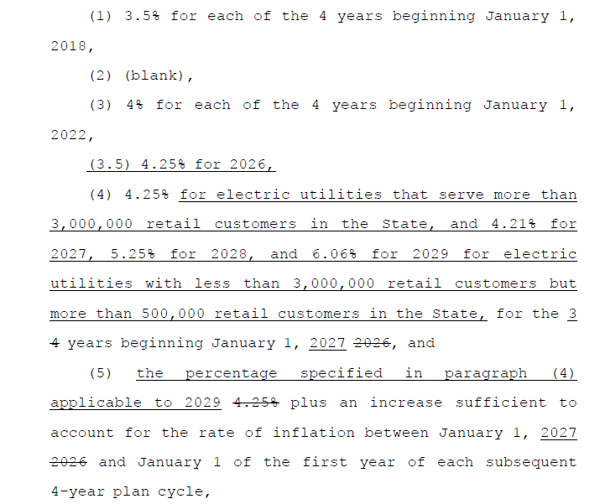

Statutory excerpt from CRGA on page 599:
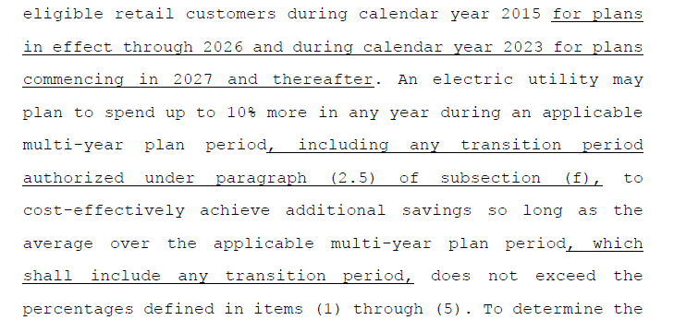

Statutory excerpt from trailer bill on pages 647-648:
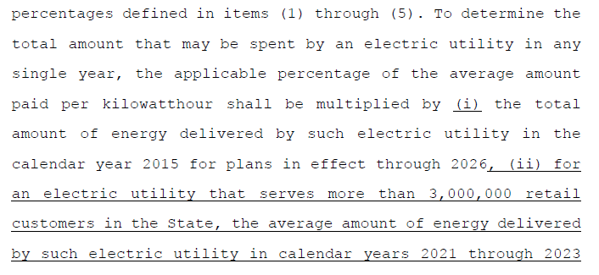
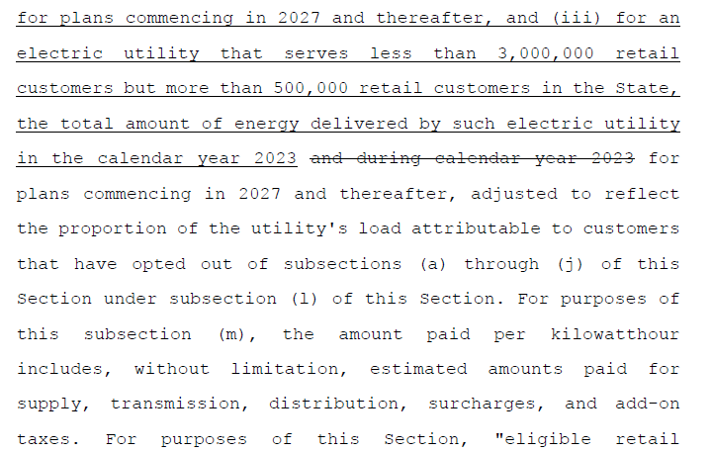

- Electrification
  - See Section 8-103B(b-27)
  - Policy Manual Edits:
    - Section 12.1, Electrification Energy Consumption Reduction

Statutory excerpt from CRGA on pages 535-537:
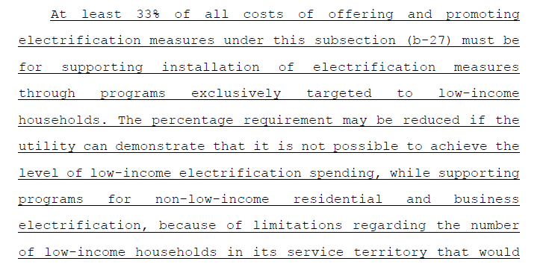
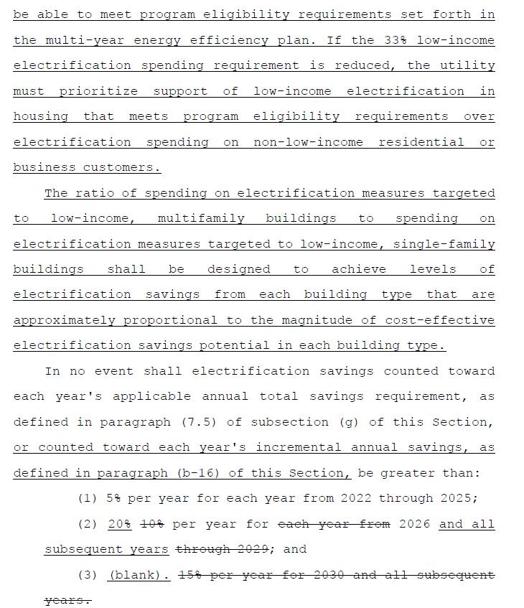

- Electrification Bill Impacts
  - See Section 8-103B(b-27)
  - Policy Manual Edits:
    - Section 12.2, Electrification Bill Impacts

Statutory excerpt from CRGA on pages 537-538:
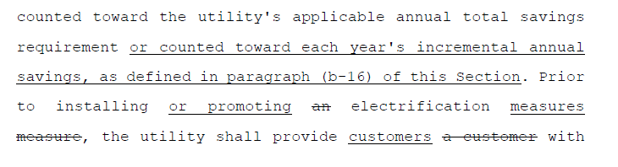
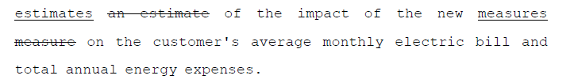

- Gas Edits

- Definitions
- Policy Manual Edits to the Glossary:
- Added definition of Average Savings Life
  - Section 8-104(e-20)
- Edited definition of Eligible Customer
  - Section 8-104(m-1)
- Edited definition of Low Income Customer
  - Section 8-104(e-5)
- Added definition of Low Income Households
  - Section 8-104(e-7)
- Added definition of Moderate Income
  - Section 8-104(e-20)
  - This definition was edited by the trailer bill.

Statutory excerpt from CRGA on page 616 – definition of Average Savings Life:
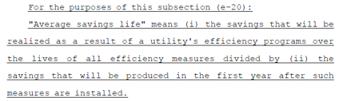

Statutory excerpt from CRGA on pages 623-632 – new (m-1) related to Eligible Customers:
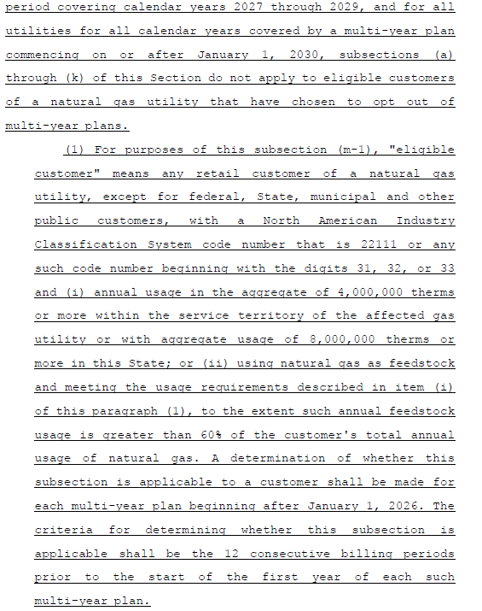

Statutory excerpt from CRGA on pages 606-607 – definition of Low Income Customer:
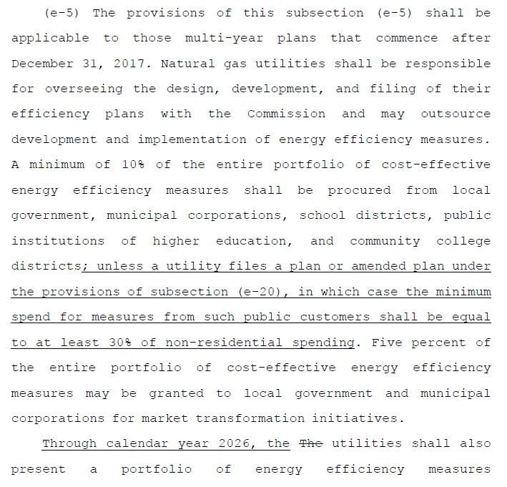
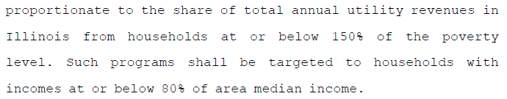

Statutory excerpt from CRGA on page 607 – definition of Low Income Households:
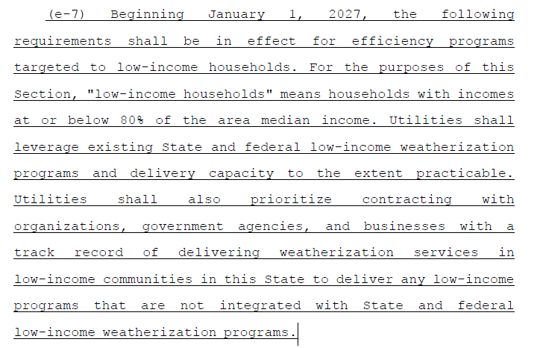

Statutory excerpt from CRGA on page 616 – Moderate Income:
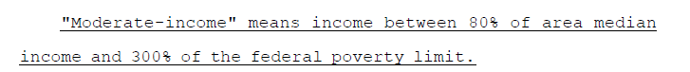

Statutory excerpt from trailer bill on page 589 – definition of Moderate Income:

- Gas Utility Budget Allocation
  - Policy Manual Edits:
    - Section 4.2, Budget Allocation
      - Section 8-104(e-5) applies if a multi-year plan is filed by Nicor Gas and/or Peoples Gas-North Shore Gas.
    - Section 4.3, Average Savings Life (new) – referenced above in electric section

Statutory excerpt from CRGA (e-5), page 606:
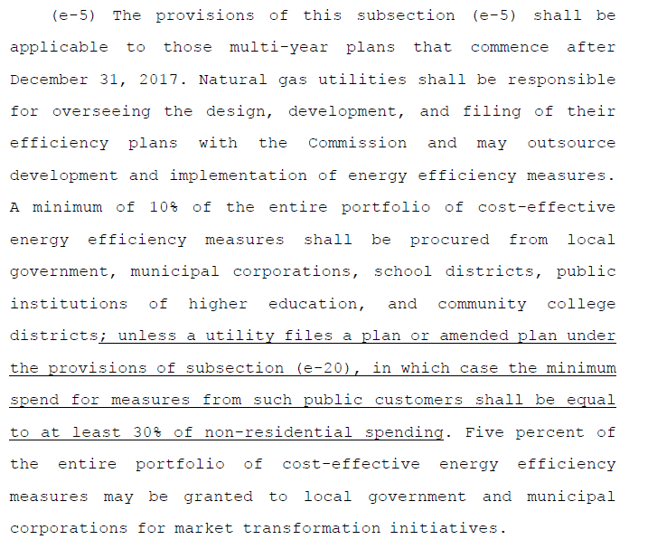

- Low Income Requirements for 8-104 Gas Programs
  - See Section 8-104(e-7), (e-8), and (e-20)
    - Subsection e-7 applies to Ameren, Nicor Gas, and Peoples Gas-North Shore Gas
    - Subsection e-8 applies to Ameren and Nicor Gas
    - Subsection e-20 applies to multi-year plans that may be filed by Nicor Gas and/or Peoples Gas-North Shore Gas and includes requirements for low income EE programs for Peoples Gas and North Shore Gas
  - Policy Manual Edits:
    - Section 4.2, Budget Allocation
    - If additional context is needed regarding gas utility low income requirements, that can be proposed during the 2027 Policy Manual update process.

Statutory excerpt from CRGA (e-5), page 606:

Statutory excerpt from CRGA (e-7) on page 607:
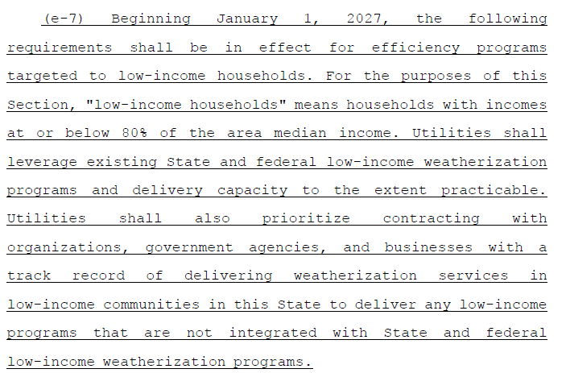

Statutory excerpt from CRGA (e-8) on pages 607-608:
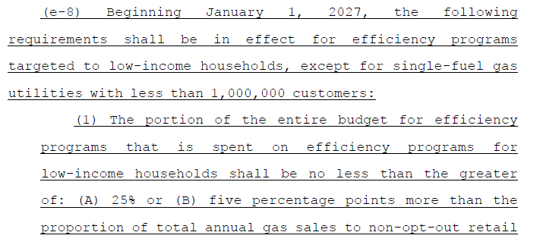
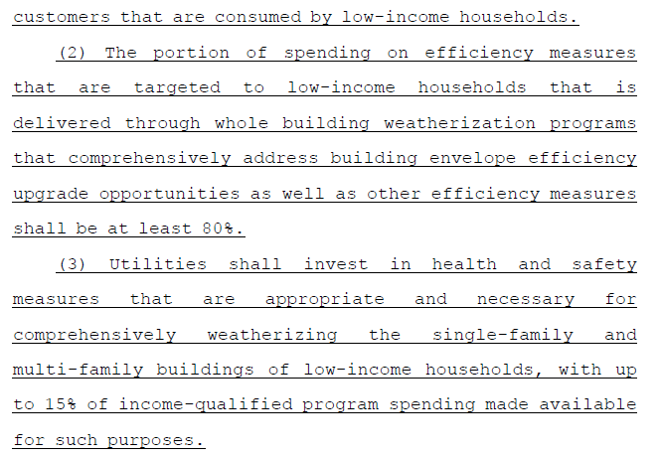

Statutory excerpt from CRGA (e-20) on pages 612-613:
