Memorandum
To: | Illinois SAG
From: | Nancy Iden, June Fang, Parini Shah, Laura Agapay-Read, Jeff Erickson, Guidehouse
CC: | Elizabeth Horne, ICC; Erin Daughton, ComEd; Randy Opdyke, Nicor Gas; Zachary Ross, ODC
Date: | February 24, 2026
Re: | Free Ridership Protocol Deviation from Illinois Statewide TRM, Version 14.0

This memorandum outlines the deviation to the residential free ridership (FR) protocol that Guidehouse plans to use for its evaluation of the following programs in 2026:
- ComEd Retail/Online programs (Residential Appliance Rebates and Marketplace 2.0)
- Nicor Gas Energy Savings Kits program
We plan to use the same approach for residential FR that we used in 2025 as outlined in our March 6, 2025 memo. A description of the TRM algorithms and our proposed deviations follows.

IL Technical Reference Manual Residential Participant Free-Ridership Protocols
For the ComEd Retail/Online programs, Figure 1 illustrates the relevant free ridership algorithm in IL Technical Reference Manual (TRM) Version 14.0.

Figure 1. IL TRM v14 Free Ridership Protocol for Residential Prescriptive Rebate (with No Audit)
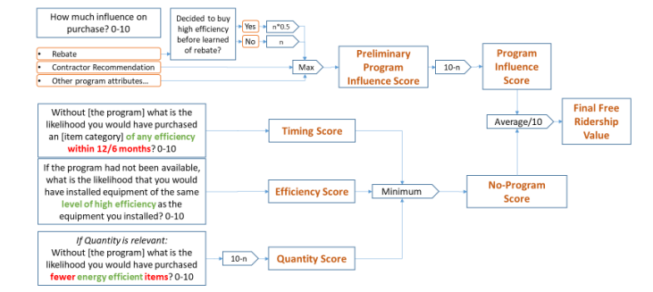
Source: 2025 Illinois Statewide Technical Reference Manual For Energy Efficiency. Version 14.0, Figure 4-6.

Figure 2 illustrates the relevant free ridership algorithm for the Energy Savings Kits program in the IL Technical Reference Manual (TRM) Version 14.0.
Figure 2. IL TRM v14 Free Ridership Protocol for Energy Savings Kits
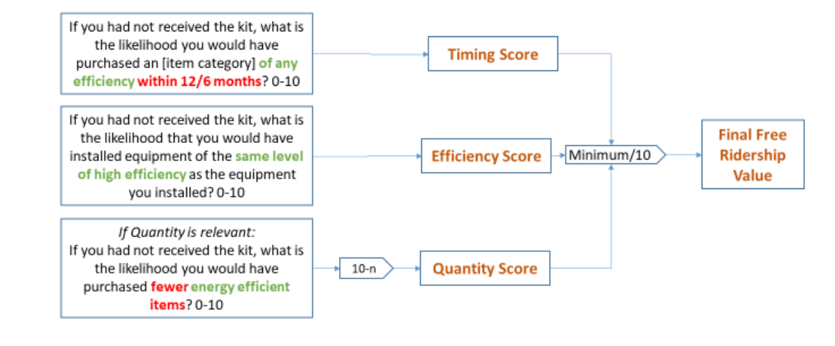
Source: 2025 Illinois Statewide Technical Reference Manual For Energy Efficiency. Version 14.0, Figure 4-11.

Proposed Deviation:
Guidehouse’s deviation is based on several modifications to the IL TRM Version 14.0 protocols for estimating FR of residential programs. The modifications are generally informed by improvements to the non-residential FR algorithm (which were deliberated in the IL NTG Working Group and updated in the TRM) that are analogous to the residential version.
The deviations diverge from the TRM in how they calculate components of free ridership, Program Influence and a Counterfactual, and how they apply quantity and timing adjustments.

- Calculation of Program Influence
Instead of taking the maximum influence score among several program factors to determine a Program Influence score (as the residential TRM algorithm does), the deviation relies on a single direct question about how influential the program was overall (as the non-residential TRM algorithm does). (Note that for energy saving kit programs, both TRM and deviation protocols exclude the component of Program Influence as it is not applicable to free kit programs.)
- Counterfactual / No-Program Scenarios
Instead of relying on likelihood scales across three dimensions: timing, efficiency, and quantity (as the residential TRM algorithm does), the deviation employs a discrete decision tree. Participants chose one of four specific action scenarios they would have taken. Depending on that choice, they are funneled into specific follow-up likelihood questions. This is consistent in structure with the IL TRM non‑residential free‑ridership framework, though question wording is adapted for residential contexts.
- Quantity and Timing Adjustments (Q&T)
Instead of being treated as equal peers to efficiency, timing and quantity are final adjustments. The deviation first calculates an Efficiency FR score and then applies a separate Q&T adjustment. In addition, the deviation approach is more granular in that it uses a formula based on the number of months a purchase was expedited rather than a broader 0-10 likelihood scale for the 6- or 12-month window. This mirrors the sequencing used in the IL TRM non-residential protocol.
(Note that the Q&T Adjustment is a part of the deviation protocol for both Residential Prescriptive Rebate programs and Energy Saving Kits programs.)

Figure 3 presents Guidehouse’s proposed free ridership protocol for Residential Rebate programs.
Figure 3. Proposed Free Ridership Protocol for Residential Rebate Programs
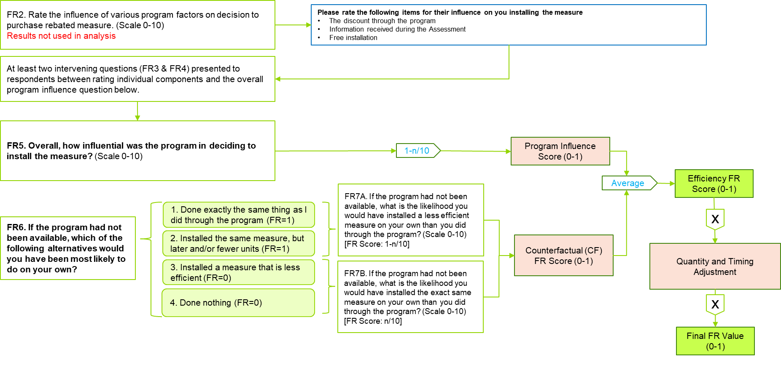
Source: Guidehouse

Figure 4 presents the corresponding proposed free ridership protocol for the Energy Savings Kits programs.
Figure 4. Proposed Free Ridership Protocol for Energy Saving Kits Programs
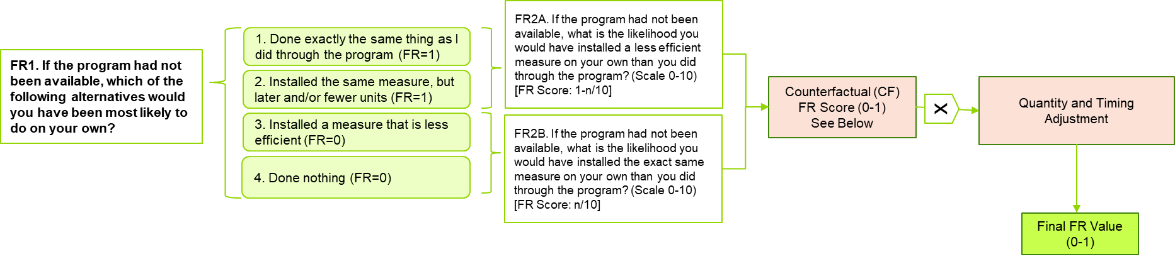
Source: Guidehouse

Figure 5 outlines the proposed Quantity and Timing Adjustment methodology applied to both Residential Rebate and Energy Savings Kits programs.”
Figure 5. Proposed Protocol for Quantity and Timing Adjustment for Residential Rebate and Energy Saving Kits Programs
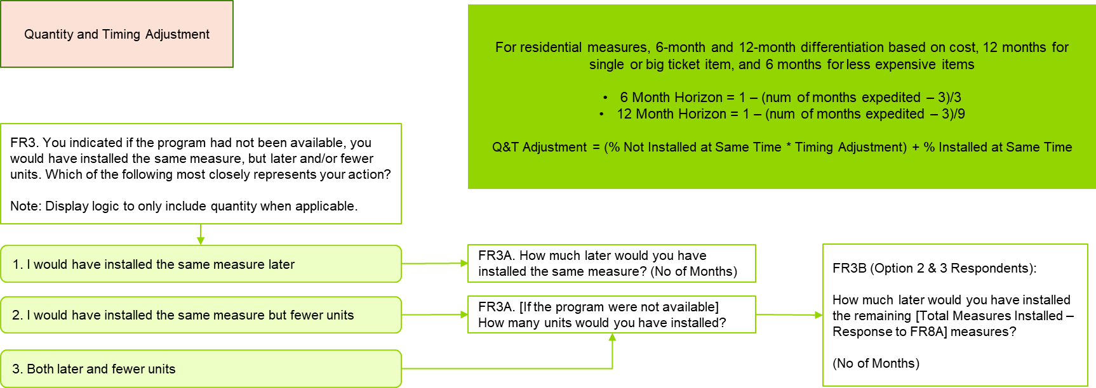
Source: Guidehouse.

