Estimating Savings in Calendar Year 2020 Due to the COVID-19 Pandemic

During the June 11, 2020 Small Group SAG meeting, the evaluation teams presented three options for estimating savings in CY2020 given the COVID-19 pandemic:

- Normalize savings for all years of EUL (recommended)
- Do not normalize savings in CY2020; normalize other years of EUL
- Do not normalize savings in a year of EUL

The evaluation teams are recommending option 1. In this option, the evaluators would normalize the CY2020 energy efficiency program savings, essentially aiming to estimate savings as if the pandemic had not occurred. This option would put the fully deemed and custom calculated savings on a level playing field, as those measures fully deemed by the TRM will not have their savings affected by the pandemic. Additionally, this option gives the utilities savings for an “expected” or “typical” year and treats the gas measures (which are claimed for the first year only) and the electric measures (which are claimed using CPAS) equivalently.

Pros and cons presented during June 11 meeting:

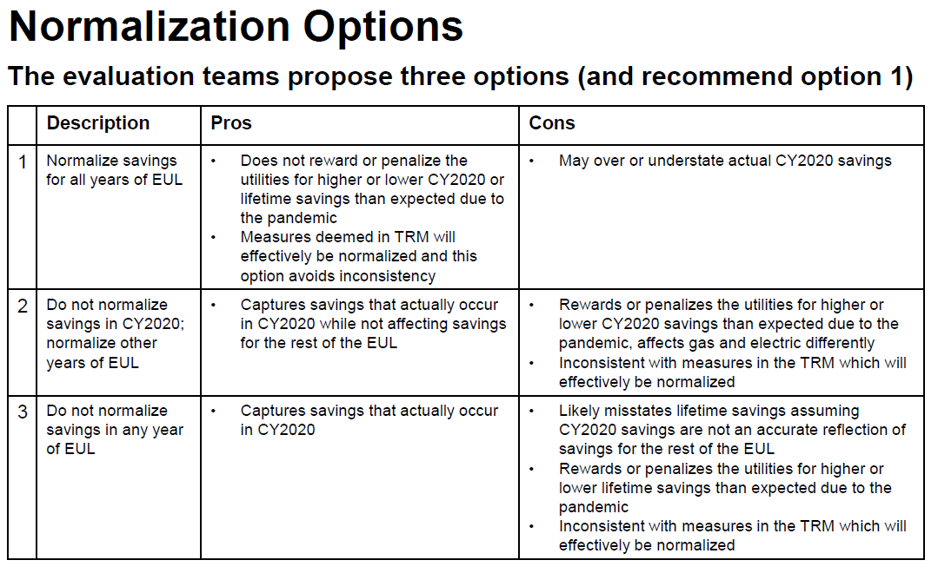

Feedback is due within 15 Business Days – by Friday, July 10
- Send comments to Carly Olig. Guidehouse (carly.olig@guidehouse.com) and Zach Ross, Opinion Dynamics (zross@opiniondynamics.com), CC’ing Celia Johnson (Celia@CeliaJohnsonConsulting.com).
- A follow-up discussion will be scheduled, if needed.

