Memorandum

To: IL TRM Technical Advisory Committee

FROM: CHERYL JENKINS, PROJECT MANAGER; SAM DENT, TECHNICAL LEAD

subject: IL TRM Version 9.0 draft NON-CONSENSUS memo and comparison exhibit: electric vehicle measures

date: 08/12/2020

Cc: CELIA JOHNSON, SAG

This memo documents positions and comments provided for the following issue for which consensus was not reached during the Version 9.0 update cycle:
Inclusion of two new measures in the TRM: ‘Electric Vehicles’ and ‘Electric Vehicles with Charger’
The issue is introduced below, followed by a Comparison Exhibit summarizing the key differences in opinion within the TAC, and finally an Appendix containing the 8/12/2020 draft of the two proposed measures in full.

Issue Summary
In February 2020, ComEd submitted a proposal to add Electric Vehicles (EVs) to the Illinois Technical Reference Manual (TRM) through VEIC’s (the IL-TRM Administrator) SharePoint Tracker. As a first step in the update process, VEIC reviewed all requests and provided a review of submitted proposals indicating an initial recommendation of the relative priority of each measure or update (March 6th). During this initial prioritization effort, VEIC posed a question relating to the inclusion of Electric Vehicles. Because the measure characterization proposed to claim savings from an electric measure substituting for fossil-fuel vehicles, VEIC asking whether all policy issues related to the eligibility of this measure had been resolved. Pending confirmation of eligibility, VEIC set the preliminary status as “not progressing”. VEIC did not receive any feedback from the TAC relating to this designation, and so this status remained in the “Prioritized List of IL TRM v9.0 Issues_Final” deliverable submitted to the TAC on April 1st.
Workpapers documenting proposed technical content for all measures that were listed as progressing in the prioritized list were due May 15th.
On the June 9th TAC call, Ameren stated that they were working on an additional workpaper for Electric Vehicles. On the call it was stated that they were not aware of any policy concerns relating to their support of Electric Vehicles. VEIC requested that Ameren present on the following TAC call (June 15th) how they were planning to structure and implement the measure. VEIC stated that the TAC could review the draft workpaper from a technical perspective but would need to follow up with other stakeholders on the policy and eligibility implications.
On June 12th, VEIC received the first draft of the Electric Vehicle measure from Applied Energy Group (AEG) on behalf of Ameren, and on June 15th AEG presented the proposal and algorithm to the TAC (slides in Appendix A). Shortly after, Jennifer Morris (ICC-Staff) sent an email (provided in Appendix B) indicating ICC-Staff’s position that “the proposed Electric Vehicle energy efficiency measure should not move forward through the IL-TRM process”. Kristol Simms (Ameren) sent a response on June 18th (provided in Appendix C).
In the knowledge that there were differences in the interpretation of applicable statutes to determine the eligibility of this measure for inclusion in the IL TRM, and that at least one stakeholder indicated they would be objecting, VEIC stated that the TAC would work together to ensure that the proposed measure is technically accurate, and concurrently develop this non-consensus exhibit to document the various positions on the statutory eligibility.
On June 22nd, VEIC received a second draft of the workpaper, together with a new workpaper for EVs bundled with an efficient charger. VEIC and the TAC have continued discussions on the technical content of these measures, and the 8/12/2020 draft version is provided in Appendix D. The inclusion of these measure in to the TRM, however, is dependent on the resolution of the discussion of their statutory eligibility.

Comparison Exhibit

Illinois Statewide TRM Version 9.0 Update: Comparison Exhibit of Non-Consensus Issues
Issue Description: Is it appropriate to include Electric Vehicle measures in the Technical Reference Manual?
Position | Rationale | Supporting Stakeholders
Yes | Kristol Simms on behalf of Ameren Illinois, August 11, 2020  Ameren Illinois supports the inclusion of two proposed additions to the Illinois Technical Reference Manual (TRM), version 9.0, which would authorize the offering of two different energy efficiency (EE) measures incentivizing the adoption of electric vehicles (EV) in Illinois. At the time of this submission, Ameren Illinois anticipates that consensus will be reached on the technical aspects of the proposed measures, including the benefits and costs to Illinois customers. The only non-consensus issues to be resolved in the TRM-approval docket involve whether the Commission has authority to approve the EV measures for inclusion in version 9 of the TRM and whether it is good policy to do so. Ameren Illinois respectfully submits that the Commission can and should resolve these issues in the TRM-approval docket and approve the measures for inclusion in version 9.0 of the TRM.  As a legal matter, nothing in Section 8-103B of the Public Utilities Act (PUA) limits the Commission’s authority to approve EV measures for inclusion in the EE program offerings in Illinois. Rather, Section 8-103B(b-25) recognizes the allowance of “programs that save both electricity and other fuels” and expressly provides for conversion of energy savings from “other fuels,” like fossil fuels, to be counted as “electric savings on an equivalent Btu basis at the premises.” (The proposed EV measures provide how the technical conversion would be done). Section 8-103B(b-25) also effects the specific legislative intent to allow electric utilities, like Ameren Illinois, to bundle traditional electric EE measures that save energy and reduce load with innovative measures that save energy and also have the potential to decrease environmental impacts, including through the reduction of fossil fuel consumption, and avoid the need for new generation, among other benefits to customers. While some parties may argue that each and every approved electric EE measure must result in load reduction, such an argument is inconsistent with other measures that do not directly reduce load (e.g., behavioral programs) and reflects an improperly limited view of the PUA and the Commission’s authority under it.  As a policy matter, approving the inclusion of EV measures in version 9.0 of the TRM would continue the State of Illinois down a path of being a leader in innovative, best-in-class energy efficiency programs that provide a wide-array of offerings, savings and other benefits to customers. For example, through a program design bundling energy audits, direct install and/or other measures with the EV and charger incentives, customers that purchase EVs could have opportunities to address potentially higher energy bills by taking advantage of bundled EV offers. And, importantly, at the time of this submission Ameren Illinois does not anticipate a dispute that the proposed two measures are cost-effective and would provide customer benefits and energy savings. Commission approval of the EV measures would also provide certainty on how savings would be evaluated and therefore would allow EV measures and the benefits they provide to be made available to customers as soon as the 2021 program year. Commission-approval would also send a clear message that EV measures can and should be considered by electric utilities to be included in the upcoming 2022-2025 EE Plans, which are currently under development.  Ameren Illinois provides the above summary of its position at the time of the TRM submission, but reserves its right to modify its position or address additional issues, including those raised by other parties, in any contested docket.  Finally, Ameren previously shared this position with ComEd, and ComEd concurs with Ameren’s statements and supports the inclusion of the two proposed additions to the IL-TRM. | Ameren IL, ComEd
No | Ali Al-Jabir, Brubaker & Associates, Inc. on behalf of the Illinois Industrial Energy Consumers (IIEC), July 17, 2020  The Illinois Industrial Energy Consumers (“IIEC”) opposes the proposal to include a new Electric Vehicle (“EV”) energy efficiency measure (“EV Measure”) in the Illinois Energy Efficiency Technical Resource Manual (“TRM”) as proposed by the Applied Energy Group on behalf of Ameren Illinois. There are sound legal and policy reasons to reject the proposed EV Measure.  From a legal standpoint, the EV Measure is inconsistent with the Illinois statutory framework governing energy efficiency programs that save fuels other than electricity. As the Illinois Commerce Commission Staff (“Staff”) noted in a June 15, 2020 email correspondence from Staff Economist Jennifer Morris, Section 8-103B (b-25) of the applicable Illinois statute allows a utility to count savings of fuels other than electricity toward the achievement of its annual savings goal (up to 10% of the savings goal) by converting the energy savings value associated with other fuels into electric energy savings on an equivalent Btu basis. However, this section of the statute makes it clear that such energy efficiency measures or programs can only count toward the achievement of a utility’s savings goals if they save both electricity and other fuels. Thus, an energy efficiency program or measure must result in electricity savings to be included in a utility’s energy efficiency program portfolio. The proposed EV Measure fails to meet this criterion because it would provide incentives for EV adoption that would result in increased electricity use rather than electricity savings. Clearly, an energy efficiency measure that results in higher electricity consumption cannot claim to save both electricity and other fuels. Therefore, the proposed EV Measure does not meet the applicable statutory requirements and cannot be included in the TRM.  The proposed EV Measure should also be rejected as a matter of policy. The focus of the Illinois energy efficiency programs is to encourage the adoption of measures that result in measurable and verifiable electricity (or natural gas) savings in a cost-effective manner. Moreover, utilities in Illinois are now eligible to earn a rate of return (“ROR”) on their investments in energy efficiency programs. Such ROR incentives are ostensibly intended to counter any alleged disincentive to invest in energy efficiency programs that utilities claim to exist due to the fact that energy efficiency programs reduce their revenue streams. IIEC is concerned that the proposed EV Measure could create a perverse incentive structure under which Illinois utilities would have the ability to increase electricity consumption on their systems while also boosting their revenues and earning a ROR incentive payment on their investment in the measure.  Therefore, the EV Measure would put Illinois ratepayers in the position of paying for both the implementation cost of the EV Measure and the associated ROR incentives, while utility shareholders would benefit from a higher revenue stream and an enhanced ROR. Clearly, this incentive structure is unreasonably skewed to the benefit of utility shareholders and unduly burdens ratepayers.  For the foregoing reasons, IIEC respectfully urges the rejection of the proposed EV Measure as a matter of law and policy. Thank you for the opportunity to submit these comments. | Illinois Industrial Energy Consumers
No | Cate York on behalf of Citizens Utility Board, July 17, 2020  The Citizens Utility Board agrees with Staff’s position that the proposed measures in 6.1.3 and 6.1.4 do not meet the requirements laid out in 8-103B. The fossil fuel energy that powers a gasoline or diesel vehicle is not the same as the fossil fuel energy that powers electricity generation, and the transportation and energy sectors have separate associated costs and regulatory frameworks. In order for a measure to be counted as having electricity savings under the utility energy efficiency program, the measure must displace electricity that would have been expended if not for the measure. As noted, electric vehicles do not reduce electric consumption; rather, they increase electric consumption.  If the utility customer already had an electric vehicle that was inefficient, and was seeking to buy a more efficient vehicle, then the savings that the new vehicle brought could be reasonably considered under the energy efficiency program parameters, because it reduces electricity consumption. The same reasoning would not apply to a charging station, as regardless of charging efficiency between tiers, the same amount of electricity is being consumed.  Electric vehicles are becoming more and more widely available, and optimized charging alongside lower distribution rates as a result of increased load have the potential to greatly benefit consumers. Larger electric vehicle market adoption is a worthy goal; however, use of ratepayer funds to incentivize vehicle and charging station purchase must comport with the statute. These measures, funded under the energy efficiency rider, do not. | Citizens Utility Board
No | David Brightwell on behalf of ICC-Staff, August 7, 2020  Staff remains concerned that Ameren’s proposed EV measures violate the current law. As just one example, adding delivery load from EVs needs to be reconciled with Section 8-103B(a) of the PUA which states that “It is the policy of the State that electric utilities are required to use cost-effective energy efficiency and demand-response measures to reduce delivery load.“ In addition, there are other provisions in the law that seem to prevent the EV measures proposed by Ameren. From a policy perspective Staff is also hesitant to support the use of EE funds to incent the purchase of load increasing measures.  Because of both legal and policy concerns, Staff agrees with Sam Dent’s comments that the proposed EE measures should be listed as non-consensus items. | ICC Staff
No | Chris Neme on behalf of NRDC, August 7, 2020  NRDC has given this issue some thought and would now like to weigh in. The bottom line is that though NRDC generally would like to see accelerated development of the electric vehicle market, we oppose the development of a TRM characterization for EVs as a fuel-switching measure (from gasoline to electricity) as part of the state’s electric efficiency programs. We would support development of an efficient EV measure (i.e. from standard efficiency EV to high efficiency EV) and/or an efficient EV charger (also directly saving electricity) if they were to be proposed instead.  At a high level, we have two reasons for opposing the proposed TRM measure.  - We believe that the proposed EV fuel-switching measure is inconsistent with at least the intent of the statute. The statute says that an electric utility “may count savings of fuels other than electricity towards the achievement of its annual savings goal” under specific circumstances. The specifics are that the electric utility was generating those savings of non-electric fuels by promoting “energy efficiency measures or programs that save both electricity and other fuels but are not jointly offered with a gas utility…” EVs are not a measure that saves both electricity and other fuels. It is our understanding that Ameren is arguing they can be a part of a program that is saving both electricity and other fuels. While that may be possible, depending on how one defines “program” (e.g. if one calls all residential efficiency initiatives a part of one residential “program”, as I believe Ameren does), we believe that a reasonable interpretation of the intent of this part of the statute is that the other fuel savings are resulting from the integrated delivery of multiple measures whose impacts are inter-connected, such as a through whole house retrofit that replaced an HVAC system, added better controls, insulated and sealed the building envelop, etc.  - Even if the legal interpretation or the understood intent of the law was different than suggested in the first point above, we have policy and practical concerns about promoting EVs as a fuel-switching measure within the electric efficiency program portfolios. First, given the amount of money that the electric utilities are allowed to budget for these program portfolios is capped by statute, we would prefer to see spending on building efficiency. Second, the amount of non-electric fuels that can be saved and converted to MWh equivalents and counted towards electric goals is also statutorily capped at 10% of those goals, and the utilities are already generating other fuel savings that are well in excess of that 10% cap. Further, the utilities are supposed to prioritize counting of non-electric fuel savings from low income customers. Thus, we don’t see how generating non-electric savings from EVs would even have a material impact on the ability of electric utilities to meet goals. Given all that, we would argue that it does not make sense to invest limited budget resources to developing this TRM measure.  We would be happy to discuss this further if helpful. | Natural Resources Defense Council
No | Taso Tsiganos on behalf of Attorney General’s Office, August 7, 2020  The Attorney General asks that this proposal be listed as a non-consensus item.  The statute requires that any energy efficiency measure save electricity as well as other fuels. The electric vehicle measure at issue only saves gasoline. The statute provides: "For those energy efficiency measures or programs that save both electricity and other fuels but are not jointly offered with a gas utility under plans approved under this Section and Section 8-104 or not offered with an affiliated gas utility under paragraph (6) of subsection (f) of Section 8-104 of this Act, the electric utility may count savings of fuels other than electricity toward the achievement of its annual savings goal, and the energy savings value associated with such other fuels shall be converted to electric energy savings on an equivalent Btu basis at the premises." 220 ILCS 5/8-103B(b-25)  The AG agrees with Staff’s comments and echoes Staff's concern regarding the accuracy of averages (average vehicle miles travelled), and other assumed proxies.  In addition to Staff’s reasoning, it is the AG's position that energy efficiency measures funded by electric delivery customers should prioritize programs that reduce electricity consumption, and thus produce savings for those customers. | Illinois Attorney General’s Office
No | Karen Lusson on behalf of NCLC, August 8, 2020  NCLC objects to including the proposed EV measure as an electric energy efficiency measure and including it in the IL-TRM for the reasons stated by ICC Staff, NRDC and the Attorney General's office. | National Consumer Law Center

APPENDIX A: AEG Slides for IL TAC on June 15th.
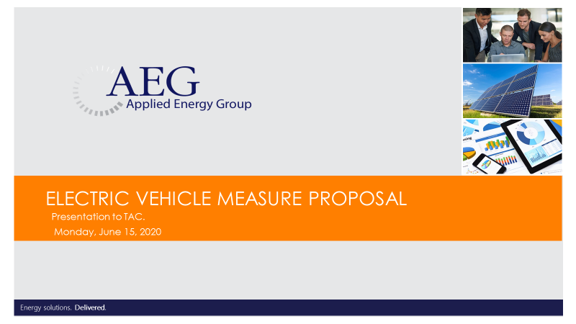

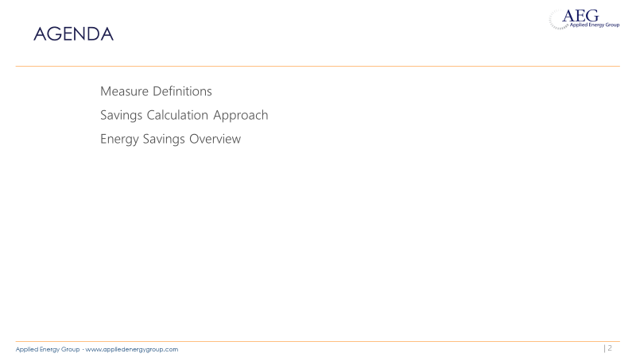

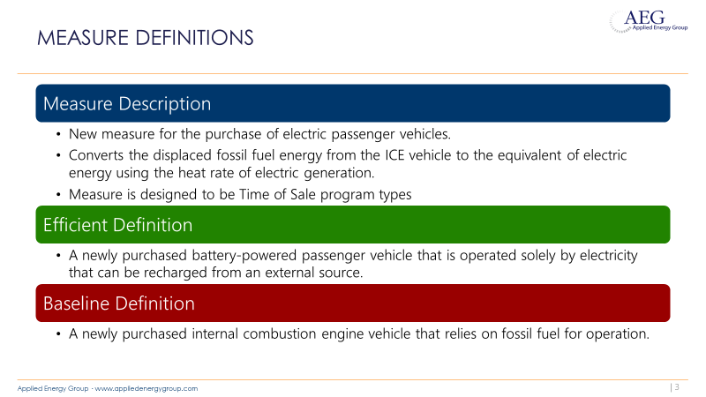

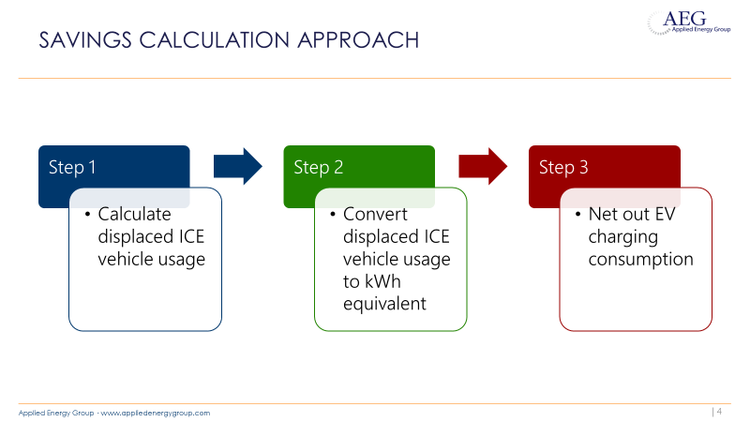

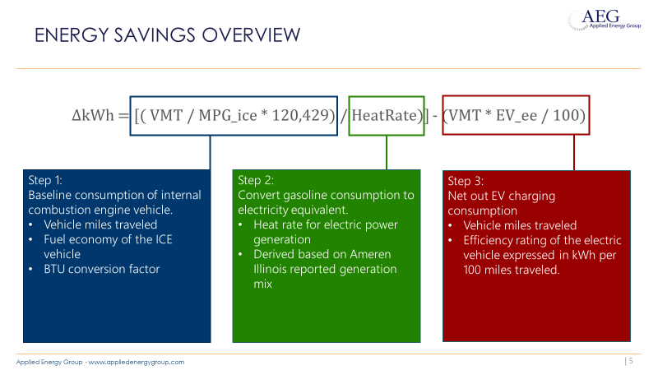

APPENDIX B: Email from Jennifer Morris, ICC Staff, June 15th.

Good afternoon TAC participants,

Thank you to Ameren and AEG for describing the proposed Electric Vehicle energy efficiency measure workpaper on this morning's TAC call. After the call we were able to touch base with our legal counsel on the feasibility of implementing this measure as an electric energy efficiency measure and including it in the IL-TRM. Our conclusion is that the proposed Electric Vehicle energy efficiency measure should not move forward through the IL-TRM process. Should Ameren disagree with the legal interpretation noted below and wish to pursue including electric vehicles as an electric energy efficiency measure in its EE programs, we would suggest that Ameren could make its proposal in its energy efficiency Plan filing with the ICC next March and the Commission can make a final determination.

Based on the call this morning, our understanding is that proponents believe this measure is allowed to be offered due to the following provision from Section 8-103B(b-25):

For those energy efficiency measures or programs that save both electricity and other fuels but are not jointly offered with a gas utility under plans approved under this Section and Section 8-104 or not offered with an affiliated gas utility under paragraph (6) of subsection (f) of Section 8-104 of this Act, the electric utility may count savings of fuels other than electricity toward the achievement of its annual savings goal, and the energy savings value associated with such other fuels shall be converted to electric energy savings on an equivalent Btu basis at the premises.
In no event shall more than 10% of each year's applicable annual incremental goal as defined in paragraph (7) of subsection (g) of this Section be met through savings of fuels other than electricity.

While this language does permit an electric utility to use savings from other fuels (10% limit) to meet its annual goal, the first line of this provision is clear that the measure has to save both (1) electricity and (2) other fuels (and not just other fuels such as gasoline), and electric vehicles do not save electricity, rather they actually increase electricity use. Therefore, we do not believe the proposed electric vehicle measure should move forward through the IL-TRM process since the "savings" cannot be counted toward an electric utility's savings goal.

Thank you,
Jennifer
__________________________________________________________________________________________
Jennifer H. Morris | Economist | Policy Division | Illinois Commerce Commission
527 East Capitol Avenue | Springfield, IL 62701
W: 217.785.1078 | C: 706.577.5450
Jennifer.Morris@illinois.gov

APPENDIX C: Email from Kristol Simms, Ameren, June 18th.
Jennifer:

We very much appreciate Staff providing its perspective on the legal aspects of the EV measures. Staff’s position, however, reflects the only objection to moving forward with discussing the policy and technical aspects of the proposed measure, so we’re interested in resolving how the TRM update process will proceed. We have a question, some suggestions and an observation, but welcome others’ thoughts as well.

First, Staff’s position on (b-25) focuses only on the term “measures” but does not address how that position can be reconciled with the term “or programs” which is also used in the statute, immediately after "measures". Notwithstanding any other legal issues, can Staff please elaborate on why an EV measure could not be included in “a program” that also saves electricity?

Second, the suggestion that the EV measure be precluded from the update process completely and, instead, that program administrators propose EV measures as part the upcoming four-year plans is troubling and seems to go against the purpose of this update process. As conveyed on the last TRM call, version 9 of the TRM will be used to develop the next four-year plan. There are important issues regarding including EV incentives in an EE portfolio that have been raised and should be addressed and resolved expeditiously. If we follow the TRM update process as outlined in the TRM itself, then any policy and technical issues can and should be discussed by the TAC experts so they can either come to consensus on the measure or, if no consensus is reached, the issues can be identified for the Commission as a non-consensus item. The Commission would then resolve the non-consensus item so that program administrators, interested stakeholders and customers would understand whether EV measures should be a part of the next plan (and if so, what values will be used to evaluate them). To shut down discussion and punt important policy and technical issues to the planning dockets would go against a key purpose and intent of the TRM, which is to minimize disputes and litigation in those planning dockets. It also needlessly delays resolution by the Commission of any non-consensus issues.

Finally, Ameren’s concern with how VEIC has managed this issue will be addressed directly with VEIC. But I would note that it seems we find ourselves faced with a situation where VEIC and others may be trying to quash important policy and technical discussions about a potential measure that needs Commission review and approval so that it can be considered by program administrators for plan development. I hope that I am misunderstanding where things are headed, but such an outcome should trouble this group as it would go against the purpose of the TRM.

Ameren proposes that we continue to follow the IL-TRM update process, as outlined in the TRM, and work collaboratively and expeditiously to try and resolve any issues with the EV measure characterization proposal. To the extent consensus cannot be reached, we can identify those limited areas for the Commission to resolve using the established TRM process.

I welcome any questions or further discussion that would be helpful.

Thank you,
Kristol

::::::::::::::::::::::::::::::::
KRISTOL W. SIMMS : : Director, Energy Efficiency Strategy & Innovation : : WFH 314-243-9315
Ameren Illinois Company : : 10 Executive Drive : : Collinsville, IL 62234

APPENDIX D: 8/12/2020 Draft of two measures
***Final content of measures will be included with the final memo***

6.1.3 Electric Vehicles

Description
The measure is for the purchase of electric passenger vehicles. As such, the measure proposed here reflects the electric passenger vehicle measure as a traditional energy efficiency investment by converting the displaced fossil fuel energy to the equivalent of electric energy using the heat rate of electric generation. This conversion causes energy savings to be accounted for as kilowatt hour equivalence (kWhe).
This measure was developed to be applicable to the following program types: TOS. If applied to other program types, the measure savings should be verified.

Definition of Efficient Equipment
A newly purchased battery-powered passenger vehicle or ‘Battery Electric Vehicle’ (BEV) that is powered solely by electricity that can be recharged from an external source.

Definition of Baseline Equipment
A newly purchased internal combustion engine vehicle that relies on fossil fuel for operation.

Deemed Lifetime of Efficient Equipment
The expected measure life is assumed to be 13 years. An adjustment should be applied to account for the proportion of BEV vehicles that move out of state.

Deemed Measure Cost
The incremental capital cost for this measure is assumed to be $4,496 based on the sales weighted average manufacturer suggested retail price of a newly purchased electric vehicle compared to a newly purchased baseline internal combustion vehicle.

Loadshape

Coincidence Factor
Coincidence factor is embedded in deemed demand reduction savings estimate so the coincidence factor is assumed to be 1.
Algorithm

Calculation of Energy Savings

Electric Energy Savings
ΔkWh = (((VMT * %InState) / MPG_ice * 120,429) / 3413) - ((VMT * %InState) * EV_ee / 100)
Where:
VMT = Annual vehicle miles traveled of the vehicle measure.
= 10,690
%Instate = Percentage of refueling (gasoline or electric charging) that occurs in Illinois
= Actual if determined by evaluation, else assume 93%
MPG_ice = Baseline fuel economy for the internal combustion engine vehicle expressed in miles per gallon.
= 28 MPG.
120,286 = Conversion factor for BTU per Gallon of Gasoline.
3413 = converts BTU to kWh
EV_ee = Actual nameplate operation efficiency for electric vehicle expressed in kWh per 100 miles.
= Actual. If unknown assume 30 kWh per 100 miles

∆kWh per Electric Vehicle = (((10,690 * 0.93)/28 * 120,286)/3413) – (10,690 * 0.93 * 30/100)
= 9,531 kWh

Summer Coincident Peak Demand Savings
ΔkW = - kW_vehicle * CF
Where:
kW_vehicle = Summer peak electric demand of the electric vehicle.
= 0.28 kW
CF = Summer peak coincidence factor
= 1

Natural Gas Savings
N/A

Water and Other Non-Energy Impact Descriptions and Calculation
N/A

Deemed O&M Cost Adjustment Calculation
Avoided Annual O&M cost = VMT * (O&M_ice - O&M_ee) / 100
Where:
O&M_ice = Baseline O&M cost for the internal combustion engine vehicle expressed in cents per mile.
= 5.38
O&M_ee = Efficient O&M cost for the electric vehicle expressed in cents per mile.
= 4.10
100 = Conversion factor for cents per dollar

Cost-Effectiveness Screening
For the purposes of screening an EV measure application for cost-effectiveness, the displaced fossil fuel consumption from the internal combustion engine vehicle and the electricity consumption of the EV should be accounted for separately. In general, the benefit and cost components used in evaluating the cost-effectiveness of an EV measure would include at least the following terms:
Benefits: ICE_gal + O&M_costs
Costs: kWh_ev + ΔkW + EV_cost
Where:
ICE_gal = Displaced fossil fuel consumption of internal combustion engine.
= (VMT * %InState) / MPG_ice
O&M_costs = Avoided operations and maintenance costs as defined in the “Deemed O&M Cost Adjustment Calculation” section.
kWh_ev = Electricity consumption of the electric vehicle.
= (VMT * %InState * EV_ee) / 100
EV_cost = Incremental cost of the electric vehicle as defined in the “Deemed Measure Cost” section.

Measure Code: CC-TRS-BEVS-V01-210101

Review Deadline: 1/1/2022

6.1.4 Electric Vehicles with Charger

Description
The measure is for the purchase of electric passenger vehicles bundled with the purchase of an efficient level 2 electric vehicle charger. As such, the measure proposed here reflects the electric passenger vehicle measure as a traditional energy efficiency investment by converting the displaced fossil fuel energy to the equivalent of electric energy using the heat rate of electric generation. This conversion causes energy savings to be accounted for as kilowatt hour equivalence (kWhe). Energy savings associated with the charger are also included. The EV charger component is designed to be consistent with the ENERGY STAR specification for Electric Vehicle Supply Equipment (EVSE) installed for residential household use. Networked chargers enable access to online energy management tools through an EVSE network. Non-networked chargers are standalone units that are not connected to other units through an EVSE network.
This measure was developed to be applicable to the following program types: TOS. If applied to other program types, the measure savings should be verified.

Definition of Efficient Equipment
A newly purchased battery-powered passenger vehicle or ‘Battery Electric Vehicle’ (BEV) that is powered solely by electricity paired with an efficient level 2 electric vehicle charger.

Definition of Baseline Equipment
A newly purchased internal combustion engine vehicle that relies on fossil fuel for operation with no EVSE installed.

Deemed Lifetime of Efficient Equipment
The expected measure life for the vehicle is assumed to be 13 years. An adjustment should be applied to account for the proportion of BEV vehicles that move out of state.
The expected measure life for the EV charger is assumed to be 10 years.

Deemed Measure Cost
The incremental capital cost for the EV is assumed to be $4,496 based on the sales weighted manufacturer suggested retail price of a newly purchased electric vehicle compared to a newly purchased baseline internal combustion vehicle.
The incremental cost for the EV charger is assumed to be $593 for a non-networked charger and $817 for a networked charger.

Loadshape

Coincidence Factor
Coincidence factor is embedded in deemed demand reduction savings estimate so the coincidence factor is assumed to be 1.
Algorithm

Calculation of Energy Savings

Electric Energy Savings
ΔkWh = (((VMT * %InState) / MPG_ice * 120,429) / 3413) - (VMT * %InState * EV_ee / 100) + (((Hours_PS + Hours_US) * SP_base) - (Hours_PS * SP_EEp + Hours_US * SP_EEu))/ 1000)

Where:
VMT = Annual vehicle miles traveled of the vehicle measure.
= 10,690
%Instate = Percentage of refueling (gasoline or electric charging) that occurs in Illinois
= Actual if determined by evaluation, else assume 93%
MPG_ice = Baseline fuel economy for the internal combustion engine vehicle expressed in miles per gallon.
= 28 MPG.
120,286 = Conversion factor for BTU per Gallon of Gasoline.
3413 = Converts BTU to kWh
EV_ee = Actual nameplate operation efficiency for electric vehicle expressed in kWh per 100 miles.
= 30 kWh per 100 miles
EV_kWh = Annual Driving Energy Consumed at Home (kWh)
= VMT * EV_ee / 100 * %Home_Charging
%Home_Charging = Percent of charging that is done at home
= 86%
= 2,967 kWh
Hours_C = Annual Active Charging Hours
= EV_kWh / Steady State Charger Output Capacity (kW)
= EV_kWh / 8.2
= 362 hours
Hours_P = Total Annual Hours Plugged In
= Annual # of Charging Sessions * Average EV Plug in Time per Charging Session (Hrs)
= (EV_kWh / 7.4) * 14.7
= 5,894 hours
Hours_PS = Annual Standby Hours Plugged In
= Hours_P - Hours_C
= 5,532 hours
Hours_US = Annual Standby Hours Unplugged
= 8760 - Hours_P
= 2,866 hours
SP_base = Baseline Average Standby Power (W)
= 3.7 for non-networked, 9.9 for networked
SP_EEp = Efficient Average Standby Power (W) with vehicle plugged in
= 4.3 for non-networked, 6.4 for networked
SP_EEu = Efficient Average Standby Power (W) in no vehicle mode
= 2.1 for non-networked, 3.2 for networked

∆kWh per Electric Vehicle with non-networked charger = (((10,690 * 0.93)/28 * 120,286)/3413) – (10,690 * 0.93 * 30/100) + (((5,532 + 2,866) * 3.7) - (5,532 * 4.3 + 2,866 * 2.1))/ 1000)
= 9,531 + 1.3
= 9,532.3 kWh
∆kWh per Electric Vehicle with networked charger = ((10,690/28 * 120,286)/3413) – (10,690 * 30/100) + (((5,532 + 2,866) * 9.9) - (5,532 * 6.4 + 2,866 * 3.2))/ 1000)
= 9,531 + 38.6
= 9,569.6 kWh

Summer Coincident Peak Demand Savings
ΔkW = - kW_vehicle * CF
Where:
kW_vehicle = Summer peak electric demand of the electric vehicle.
= 0.28 kW
CF = Summer peak coincidence factor
= 1

Natural Gas Savings
N/A

Water and Other Non-Energy Impact Descriptions and Calculation
N/A

Deemed O&M Cost Adjustment Calculation
Avoided Annual O&M cost = VMT * (O&M_ice - O&M_ee) / 100
Where:
O&M_ice = Baseline O&M cost for the internal combustion engine vehicle expressed in cents per mile.
= 5.38
O&M_ee = Efficient O&M cost for the electric vehicle expressed in cents per mile.
= 4.10
100 = Conversion factor for cents per dollar

Cost-Effectiveness Screening
For the purposes of screening an EV measure application for cost-effectiveness, the displaced fossil fuel consumption from the internal combustion engine vehicle and the electricity consumption of the EV should be accounted for separately. In general, the benefit and cost components used in evaluating the cost-effectiveness of an EV measure would include at least the following terms:
Benefits: ICE_gal + O&M_costs
Costs: kWh_ev + ΔkW + EV_cost
Where:
ICE_gal = Displaced fossil fuel consumption of internal combustion engine.
= (VMT * %InState) / MPG_ice
O&M_costs = Avoided operations and maintenance costs as defined in the “Deemed O&M Cost Adjustment Calculation” section.
kWh_ev = Electricity consumption of the electric vehicle.
= (VMT * %InState * EV_ee) / 100
EV_cost = Incremental cost of the electric vehicle as defined in the “Deemed Measure Cost” section.

Measure Code: CC-TRS-BVCH-V01-210101

Review Deadline: 1/1/2022

Average age of household vehicles in operation for 2017 from Table 1-26. National Transportation Statistics. Bureau of Transportation Statistics, US Department of Transportation.
Gasoline car costs based on average new vehicle MSRPs from Annual Energy Outlook 2019. U.S. Energy Information Administration, and EV costs based on 2019 sales weighted MSRP from evadoption.com. See “Electric Vehicle Incremental Cost Workpaper.xls for details.
Average annual vehicle miles traveled estimated based on Statewide average of data from the 2017 National Household Transportation survey, accessed 07/2020. See “20200622 2017 NHTS IL VMT.xlsx” for details.
It is estimated that half of charging that occurs away from home is out of state. The estimate of home charging is 86% from the RTF characterization based on 2014 Idaho National Laboratory study.
Estimated using the 2019 US Fuel Economy Guide fleetwide average for gasoline cars. Baseline MPG includes an efficiency adder of 4.2 MPG since gasoline vehicles replaced by EVs are more efficient than the fleet-wide average, according to NBER Working Paper No. 25771. “What Does an Electric Vehicle Replace?” by Jianwei Xing, Benjamin Leard, Shanjun Li. Issued in April 2019.
US Energy Information Administration.
Average electric vehicle efficiency based on light-duty vehicle miles per gallon from Annual Energy Outlook 2019. U.S. Energy Information Administration.
Summer peak demand impacts are a deemed value based on EV Charging Station Pilot Evaluation Report. Xcel CO. May 2015. Page 5.
kW_Vehicle accounts for the estimated average kW draw during the system peak.
According to the American Automobile Association (AAA) publication, "Your Driving Costs," 2010 Edition average vehicle maintenance costs are 5.38 cents per mile.
Maintenance for EVs is reduced by 28% based on DeLuchi, Mark and Lipman, Timothy, An Analysis of the Retail and Life Cycle Cost of Battery-Powered Electric Vehicles; UC-Davis Institute of Transportation Studies. http://escholarship.org/uc/item/50q9060k
Average age of household vehicles in operation for 2017 from Table 1-26. National Transportation Statistics. Bureau of Transportation Statistics, US Department of Transportation.
Based on Northwest Power and Conservation Council, Regional Technical Forum workbook for Level 2 Electric Vehicle Charger version 1.1. approved May 2019. https://rtf.nwcouncil.org/measure/level-2-electric-vehicle-charger
Gasoline car costs based on average new vehicle MSRPs from Annual Energy Outlook 2019. U.S. Energy Information Administration, and EV costs based on 2019 sales weighted MSRP from evadoption.com. See “Electric Vehicle Incremental Cost Workpaper.xls for details.
Based on Northwest Power and Conservation Council, Regional Technical Forum workbook for Level 2 Electric Vehicle Charger version 1.1. approved May 2019. https://rtf.nwcouncil.org/measure/level-2-electric-vehicle-charger.
Average annual vehicle miles traveled estimated based on Stateside average of data from the 2017 National Household Transportation survey, accessed 07/2020.
It is estimated that half of charging that occurs away from home is out of state. The estimate of home charging is 86% from the RTF characterization based on 2014 Idaho National Laboratory study.
Estimated using the 2019 US Fuel Economy Guide fleetwide average for gasoline cars. Baseline MPG includes an efficiency adder of 4.2 MPG since gasoline vehicles replaced by EVs are more efficient than the fleet-wide average, according to NBER Working Paper No. 25771. “What Does an Electric Vehicle Replace?” by Jianwei Xing, Benjamin Leard, Shanjun Li. Issued in April 2019.
US Energy Information Administration.
Average electric vehicle efficiency based on light-duty vehicle miles per gallon from Annual Energy Outlook 2019. U.S. Energy Information Administration.
Assumption consistent with RTF characterization based on 2014 Idaho National Laboratory study.
Analysis of WA and OR Cumulative EV Registrations through 2018 paired with Vehicle Maximum Power Acceptance (kW) data from Chargehub https://chargehub.com/en/find-the-right-charging-station-power.html
Avista Docket No. UE-160082 – Avista Utilities Semi-Annual Report on Electric Vehicle Supply Equipment Pilot Program (November 2018) Table 13 Avg. kWh Consumed per Session
Based on data provided by Avista. Total hours EV is plugged into charging station including both charge and standby time.
INL charger testing https://avt.inl.gov/evse-type/ac-level-2 and ENERGY STAR Market and Industry Scoping Report Electric Vehicle Supply Equipment (EVSE) September 2013 (source data is from INL).
2019 ENERGY STAR QPL of Residential EVSE. No Residential units, used commercial as a proxy. Averaged Partial On Mode Input Power (W) and Idle Mode Input Power (W)
2019 ENERGY STAR QPL of Residential EVSE. No Residential units, used commercial as a proxy. Averaged Partial On Mode Input Power (W) and Idle Mode Input Power (W).
Summer peak demand impacts are a deemed value based on EV Charging Station Pilot Evaluation Report. Xcel CO. May 2015. Page 5.
kW_Vehicle accounts for the estimated average kW draw during the system peak.
According to the American Automobile Association (AAA) publication, "Your Driving Costs," 2010 Edition average vehicle maintenance costs are 5.38 cents per mile.
Maintenance for EVs is reduced by 28% based on DeLuchi, Mark and Lipman, Timothy, An Analysis of the Retail and Life Cycle Cost of Battery-Powered Electric Vehicles; UC-Davis Institute of Transportation Studies. http://escholarship.org/uc/item/50q9060k

