ComEd Societal Non-Energy Impacts CY2025 Research Report

Energy Efficiency and Demand Response Plan
  - Program Year 2025 (CY2025)
  - (01/01/2025-12/31/2025)

Prepared for:

ComEd

DRAFT
April 24, 2026

Prepared by:

Harry Wang  Guidehouse | Yeab Lakew  Guidehouse | Victoria Molitor  Guidehouse | Sarah Karbachinskiy  Guidehouse

Submitted to:
ComEd
2011 Swift Drive
Oak Brook, IL 60523

Submitted by:
Guidehouse Inc.
167 N. Green Street
12th Floor
Chicago, IL 60607

Contact:

Charles Maglione, Partner  703.431.1983  cmaglione@guidehouse.com | Jeff Erickson, Director  608.616.4962  jeff.erickson@guidehouse.com | Neil Curtis, Director  802.526.5119  neil.curtis@guidehouse.com
Charles Ampong, Associate Director
608.446.3172
charles.ampong@guidehouse.com

This report was prepared by Guidehouse for ComEd. The work presented in this report represents Guidehouse’s professional judgment based on the information available at the time this report was prepared. Use of this report by any other party for whatever purpose should not, and does not, absolve such party from using due diligence in verifying the report’s contents. Neither Guidehouse nor any of its subsidiaries or affiliates assumes any liability or duty of care to such parties and hereby disclaims any such liability.
Table of Contents
1 Introduction 1
2 Energy Efficiency’s Impacts on Emissions and Human Health 2
3 Methodology 3
3.1 AVERT and COBRA 3
3.2 Estimation of Societal NEIs 5
4 Analysis Findings and Recommendations 7
4.1 Analysis Findings 7
5 Program-Level Societal NEI Estimates 9
6 Portfolio-Level Societal NEI Estimates 10
7 Portfolio-Level Carbon Reduction Estimates 11

Table of Tables, Figures, and Equations
Table 1. Total Discounted Societal NEI Estimates, CY2025 Programs 8
Table 2. CY2025 Societal NEI Estimates by Program in 2025 Dollars 9
Table 3. CY2025 Annual Portfolio-Level Societal NEI Estimates in 2025 Dollars 10
Table 4. CY2025 Annual Portfolio-Level Carbon Reduction Estimates 11

Figure 1. Least – Cost Merit Order Dispatch 2
Figure 2. Flowchart of Annual Estimation of CY2025 Health Benefits 5
Figure 3. ComEd CY2025 Electric CPAS Estimates: 2025-2064 8
Figure 4. ComEd CY2025 Societal NEI Estimates: 2025-2064 8

Introduction
Guidehouse conducted research to quantify and monetize societal Non-Energy Impacts (NEIs) associated with ComEd's CY2025 energy efficiency programs. This report presents research conducted by the Guidehouse team to develop monetized societal NEI values for use in the ComEd portfolio cost-effectiveness tests. Since CY2020, ComEd has reported the total resource cost (TRC) test values with and without societal NEIs.
Societal NEIs occur when energy efficiency programs reduce electricity generated from fossil fuels which reduces emissions, including PM_{2.5}, SO₂, NO_{x}, VOCs, NH₃, and CO₂. This reduction in emissions causes reduced adverse health impacts, which are monetizable. We used U.S. Environmental Protection Agency’s (EPA) AVoided Emissions and geneRation Tool (AVERT) and CO–Benefits Risk Assessment (COBRA) Health Impacts Screening and Mapping Tool to quantify and monetize these health impacts. At a high level, Societal NEIs associated with a ComEd energy efficiency program are represented by the total monetary value of illnesses and deaths avoided due to program-induced reduced emissions over 40 years, discounted to the year of implementation.
Guidehouse relies on guidelines from the Climate and Equitable Jobs Act (CEJA), the Illinois Policy Manual 3.0, and the Illinois Technical Reference Manual 13.0 (IL TRM v13.0) to quantify and monetize values for societal NEIs and for use in ComEd’s programmatic cost-effectiveness tests.
CEJA directs Illinois utilities to continue including the Societal NEIs in TRC tests and to report economic NEIs as follows:
“The plan shall be determined to be cost-beneficial…[including] the societal value of reduced carbon emissions and surface-level pollutants, particularly in environmental justice communities…. The independent evaluator shall determine…an estimate of job impacts and other macroeconomic impacts of the efficiency programs for that [plan] year.”

Energy Efficiency Impacts on Emissions and Human Health
Energy efficiency programs reduce demand for electricity generated by fossil fuels by implementing energy efficiency measures. The corresponding emissions reductions are from the electric generation facilities operating at the margin (i.e., not providing baseload) that have the most flexibility to add generation to the grid quickly. The reduction in air emissions causes a reduction in adverse human health outcomes and deaths. Our research focuses on calculating the emissions from the marginal generators and then estimating the health benefits from those emissions. As we describe below, Guidehouse used tools that the EPA develops and maintains to estimate the health benefits of reductions in exposure to emissions. The first tool estimates energy efficiency impacts on demand at the operating margin to quantify displaced emissions that can be attributed to demand savings. Displaced emissions are then used in a second tool informed by population health, epidemiology, and economics research to quantify the economic benefits of reduced adverse health outcomes.
The specific electric generating units impacted by these demand reductions depend on the load shape of the impacted customers, the hour of day, and time of year, among other factors. As Figure 1 shows below, electric generating units are dispatched in the order of their operating costs. Least-cost electric generating units tend to operate for the greatest portion of the year, and higher-cost electric generating units are reserved for periods of greater demand. Higher-cost, marginal generation units are often fueled by oil, coal, and natural gas combustion.
Figure 1. Least – Cost Merit Order Dispatch
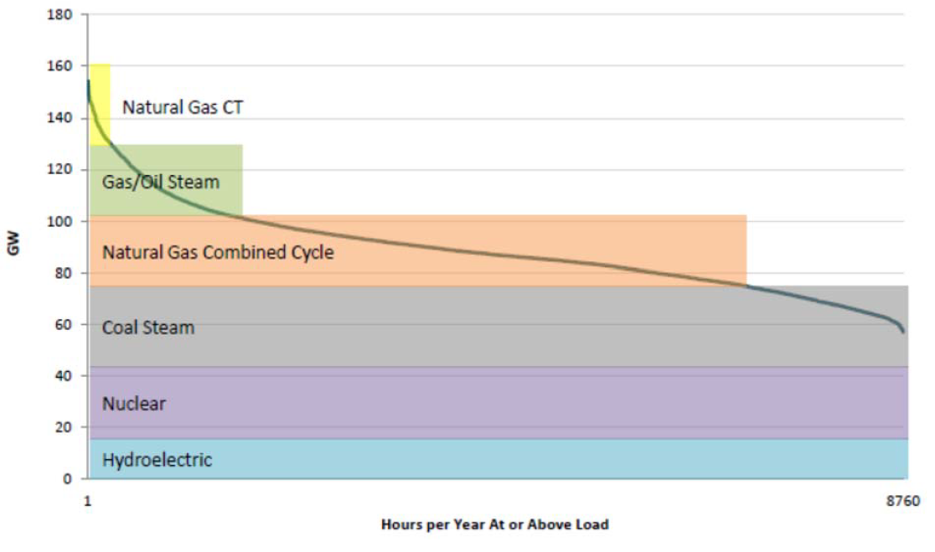
Figure Source: Synapse Energy Economics, 2015
Energy efficiency programs reduce demand at the operating margin, therefore demand reductions attributed to energy efficiency programs displace electric generation from higher-cost marginal generation sources. In the PJM territory, marginal sources supply energy via combustion of natural gas (69.4% of marginal sources) and coal (24.4%). Therefore, electric demand reductions due to ComEd energy efficiency programs can be linked to reductions in generation among natural gas, and coal-fired electric generating units.
Reducing generation from PJM's marginal generators causes substantial reductions in emissions of PM_{2.5}, SO₂, NO_{x}, and CO₂, since these pollutants are byproducts of coal and natural gas fuel combustion. The populations' exposure to these four pollutants increases the prevalence of numerous adverse health outcomes. For instance, premature infant and adult mortality have been linked to increased exposure to ambient air pollution. On an annual basis, the World Health Organization (WHO) estimates around 4.2 million premature deaths globally are linked to ambient air pollution exposure, with the most harmful pollutants being PM_{2.5}, SO₂, NO₂, and ozone. Increased exposure to these pollutants also leads to the development or exacerbation of respiratory and cardiovascular conditions. Each of the adverse health effects from ambient pollution exposure, particularly exposure to PM_{2.5} and ozone, represents a substantial economic cost.

Methodology
This section presents the methodology and usage of EPA tools to estimate the Societal NEIs associated with ComEd's CY2025 programs. Guidehouse first provides a summary of the two tools developed by the EPA that are essential to this analysis. This is followed by a summary of Guidehouse's methodology to quantify the health benefits attributed to CY2025 energy efficiency programs.

AVERT and COBRA
The EPA developed the Avoided Emissions and geneRation Tool (AVERT) to estimate the emissions benefits of energy efficiency and renewable energy policies and programs. The EPA also developed the CO-Benefits Risk Assessment (COBRA) to estimate the health and economic benefits associated with energy efficiency and renewable energy policies and programs.
The EPA’s AVERT translates the impacts of energy efficiency programs into county-level reductions in PM2.5, SO2, NOx, VOCs, NH3, and CO2 from reduced electricity generation across fossil-fueled electricity generating units. AVERT was first released in 2014 and has been reviewed, well-documented, and tested across multiple scenarios. More specifically, since the AVERT’s inception, the EPA has:
- Conducted external and internal peer reviews
- Benchmarked AVERT against an industry-standard electric power sector model, PROSYM
- Worked with states to beta-test the tool for functionality, appropriate uses, and clarity of the user manual.
COBRA is a peer-reviewed screening tool that establishes the air quality, human health, and associated economic impacts of various state- and county-level emission reduction scenarios. COBRA was updated in 2024 by the EPA to estimate changes in annual ambient concentrations of both particulate matter (PM_{2.5}) and ozone In previous years COBRA only estimated the health impacts of PM_{2.5}. COBRA continues to use the county-level emissions reduction results from AVERT to estimate health outcomes changes. Using information from AVERT on county-level changes in emissions, COBRA quantifies county-level air quality changes, estimates the resulting changes in health outcomes, and then calculates monetary values associated with these changes in health outcomes. COBRA estimates the number of health incidents avoided and the corresponding economic values for the following conditions. The last three health incidence (Hospital Admissions related to Alzheimer’s and Parkinson’s Disease, Stroke and Lung Cancer, Hay Fever/Rhinitis) are additions to the 2024 COBRA update.
- Infant and Adult Mortality
- Non-fatal Heart Attacks
- Hospital Admissions related to Respiratory and Cardiovascular Conditions
- Acute Bronchitis
- Upper and Lower Respiratory Symptoms,
- Asthma Exacerbations (attacks, shortness of breath, & wheezing)
- Asthma Emergency Room Visits
- Minor Restricted Activity Days
- Work Loss Days
- Hospital Admissions related to Alzheimer’s and Parkinson’s Disease
- Incidence of Stroke and Lung Cancer
- Incidence of Hay Fever/Rhinitis

Estimation of Societal NEIs
Guidehouse generated Societal NEI estimates for ComEd's CY2025 programs. Since ComEd programs cover a variety of measures with measure lives ranging from one to 40 years, Guidehouse included all cumulative persisting annual savings (CPAS) from CY2025 programs. This ensures that Guidehouse estimates can be associated with the full extent of CY2025 programs' energy savings.
To generate Societal NEI estimates, Guidehouse adopted an annual modeling approach. Guidehouse used CPAS values for CY2025 programs for annual Societal NEI estimates calculation, which spanned from 2025 through 2064. The annual approach is illustrated in Figure 2. Analyzing on an annual basis ensures that (1) each year's emissions impacts are consistent with generation activity expected in that year and (2) each year's health benefits estimates reflect the baseline population in that year. Additional detail providing context for each step in the analysis is provided in the following paragraphs.
Figure 2. Flowchart of Annual Estimation of CY2025 Health Benefits
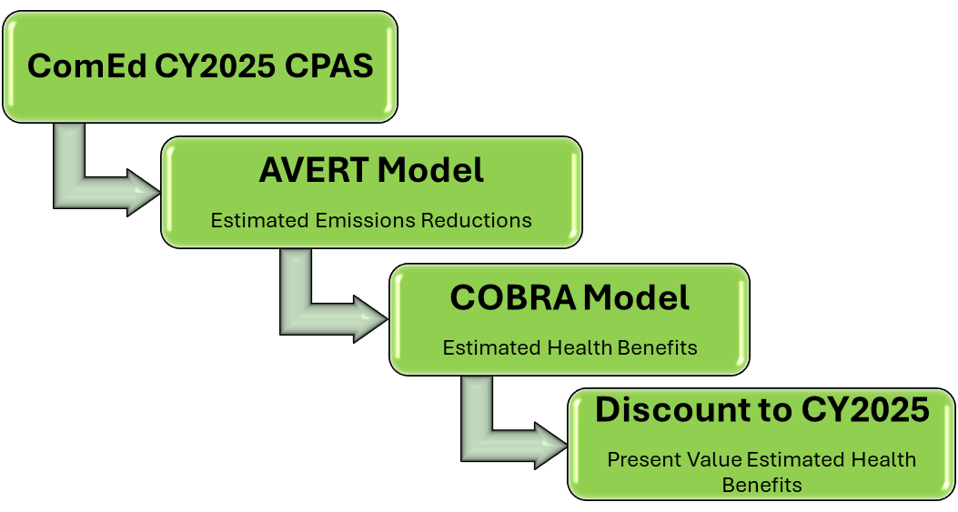
Source: Guidehouse
Step 1: Gather ComEd CY2025 Portfolio-Level CPAS Values
For this methodological summary, we focus on the annual estimation of societal health benefits for each program using that program’s CY2025 CPAS values beginning in 2025. In this first step, we gathered and aggregated ComEd CY2025 programs' CPAS data to construct a 40-year portfolio-level CPAS curve.
Step 2: Execute AVERT
For each year, we execute AVERT using portfolio-level CPAS values by analyzing all programs in the portfolio. AVERT uses a forecast of patterns of dispatching electric generating units to estimate marginal emissions rates (lbs/MWh) for PM2.5, SO2, NOx, VOCs, NH3, and CO2, then applies these emissions rates to energy efficiency savings (MWh) to determine a county-level reduction (lbs) in each of the four pollutants.
EPA currently maintains a 2023 baseline forecast of patterns of dispatching electric generating units for AVERT. This forecast is based on historical data through 2023, and EPA warns that this forecast is static and is only recommended for use for up to five years. Guidehouse considered the use of county-level estimates of emissions reductions from AVERT without any adjustments; however, historical trends in marginal emissions rates do not support this approach. For ComEd and PJM, marginal emissions rates have dropped considerably over the past four years. In PJM’s territory, the share of coal marginal generation sources dropped from 51.7% in 2015 to 24.4% in 2019. Transformations in the mix of electric generation sources, particularly marginal generation sources, can be expected to continue through 2050, as the use of renewables in electricity generation is forecasted to grow. Marginal emissions rates are expected to continue to decline as the energy mix becomes cleaner. Failing to adjust the AVERT analysis approach to accommodate trends in marginal emissions rates beyond five years into the future, therefore, it will likely overstate county-level emissions reductions. In turn, this will overstate health benefits for these years.
To generate more reasonable bounds on electric emission reduction estimates, Guidehouse forecasted marginal emission rates from 2020-2050 using PJM data and developed a set of adjustment factors for each year, downscaling the rates to the AVERT forecast. To account for the 40-year measure life in CPAS, Guidehouse used a trendline of adjusted factors from 2045-2050 to determine adjustment factors for 2051-2064.
Step 3: Execute COBRA
Guidehouse used the AVERT outputs in COBRA to estimate health impacts of reduced pollution exposure over a 40-year period. Reduced exposure to emissions in one year reduces acute morbidity for that specific year of analysis, and reduces the incidence of premature mortality for up to 20 years. COBRA includes adjustments for inflation throughout the 20 years, then discounts this stream of health benefits back to the year in which the energy savings are realized. Guidehouse uses a 2.40% discount rate for 2025-2064 from the TRM v13.0.
For each year of COBRA analysis, we used the average of national low- and high-sensitivity estimates for the health benefit estimate. Low- and high-sensitivity estimates of health benefits are based on two peer-reviewed studies estimating the link between ambient air pollution exposure and increases in premature mortality. Each study assessed premature mortality using a robust sample pool intended to represent the United States population, paying special attention to urban and rural populations and age brackets. Since both studies are credible, Guidehouse does not believe that either estimate is more representative than the other of the United States population and resulting population health impacts. Therefore, we used the mean of national low- and high-sensitivity estimates to construct annual health benefits estimates. In addition, since emission reductions and health benefits due to ComEd’s energy efficiency programs accrue both without and outside of Illinois, we used national societal NEIs in our analyses.
Step 4: Discount Results to CY2025
We discount future health benefits to present dollars using a 0.42% real discount rate. Health benefits estimates are expressed using dollars in the analysis year of interest (i.e., 2025 for CY25 analysis). For the cost-effectiveness test on a CY2025 program, we used the CY2025 program’s Societal NEI value adjusted to 2025 dollars. To remain consistent with other inputs to TRC tests, Guidehouse discounted each year's county-level COBRA results back to 2025 using the 0.42% real discount rate.

Analysis Findings and Recommendations

Analysis Findings
Figure 3 shows the CPAS Lifetime Net Saving estimates for CY2025, which is diminishing year-over-year from 2025 through 2064 as measures begin to reach the end of their effective useful lives. The curve of Lifetime Health Benefits of Societal NEIs is shown in Figure 4, which follows a similar trend as the program-level CPAS, diminishing at a steeper rate than CPAS due to predicted improvements in the efficiency of marginal generation.
Figure 3. ComEd CY2025 Electric CPAS Estimates: 2025-2064
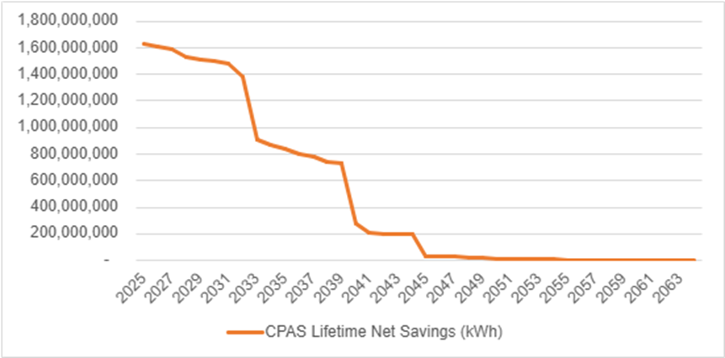
Source: ComEd Summary Impact Evaluation Report, CY2025 CPAS Electric.
Figure 4. ComEd CY2025 Societal NEI Estimates: 2025-2064
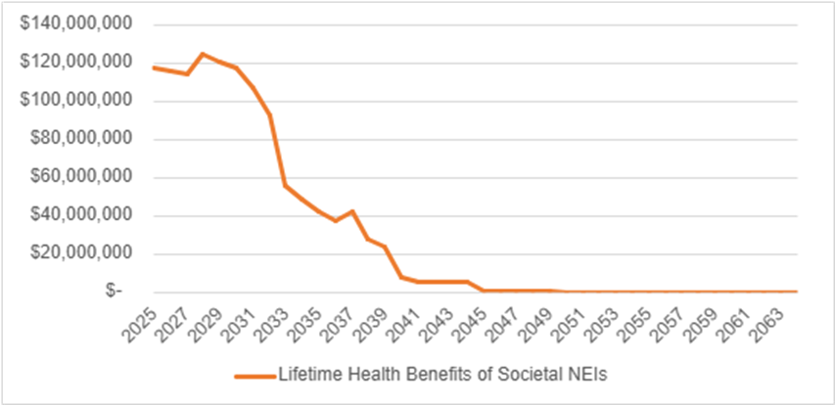
Source: Guidehouse analysis of ComEd CY2025 verified program savings.
Table 1 presents the final societal health benefits estimates for ComEd's CY2025 programs implemented between January 1, 2025 – December 31, 2025. Societal health benefits are discounted to the program year of interest (i.e., CY2025 total health benefits are presented in 2025 dollars).
Table 1. Total Discounted Societal NEI Estimates, CY2025 Programs
Program Year | CY2025 Verified Net Lifetime Savings (kWh) | Total Health Benefits  ($) | Total Health Benefits per kWh ($ Average)
CY2025 | 19,156,864,438 | $ 1,219,784,859 | $ 0.0637
Source: Guidehouse analysis of ComEd CY2025 verified program savings.

Program-Level Societal NEI Estimates
Table 2 provides Societal NEI estimates for ComEd CY2025 programs, expressed in both absolute dollars and dollars per kWh. Note that program-level dollar per kWh values are levelized to each program's CPAS. Each table assumes that CY2025 savings begin in the program year of interest, and societal health benefit estimates are expressed in the program year's dollars. Societal NEI estimates for each year are then estimated using the annual approach highlighted in the Methodology section, discounted back to 2025, then summed. The result is a lifetime Societal NEI estimate expressed in 2025 dollars.
Table 2. CY2025 Societal NEI Estimates by Program in 2025 Dollars
Sector | Program |  | CY2025 Verified Net Lifetime Savings (kWh) | Health Benefits per kWh  ($) | Total Health Benefits  ($)
Business & Public Sector | Behavior Bus/Pub |  | 303,345,051 | $0.0754 | $22,857,122
Business & Public Sector | Business Energy Analyzer (BEA) |  | 67,941,120 | $0.0745 | $5,061,108
Business & Public Sector | Incentives |  | 2,244,681,108 | $0.0624 | $140,041,518
Business & Public Sector | Midstream/Upstream |  | 3,602,008,042 | $0.0619 | $222,985,552
Business & Public Sector | New Construction - Bus/Pub |  | 74,939,856 | $0.0574 | $4,301,814
Business & Public Sector | Small Business |  | 2,433,450,574 | $0.0626 | $152,407,942
Business & Public Sector | Targeted Systems |  | 699,105,625 | $0.0682 | $47,647,860
Res & IE | ASI kWh Purchase |  | 20,630,328 | $0.0510 | $1,052,243
Res & IE | Behavior - Res/IE |  | 275,065,998 | $0.0734 | $20,183,096
Res & IE | Contractor/Midstream Rebates |  | 227,507,356 | $0.0645 | $14,683,455
Res & IE | Electric Homes New Construction |  | 18,600,298 | $0.0588 | $1,093,399
Res & IE | Multifamily Upgrades |  | 610,583,439 | $0.0561 | $34,238,333
Res & IE | New Construction - IE |  | 74,188,253 | $0.0574 | $4,259,762
Res & IE | Product Distribution |  | 2,487,791,518 | $0.0710 | $176,603,904
Res & IE | Retail/Online |  | 4,804,675,118 | $0.0618 | $297,050,176
Res & IE | Single-Family Upgrades |  | 158,582,931 | $0.0636 | $10,093,551
Res & IE | Whole Home Electric |  | 56,831,825 | $0.0570 | $3,242,081
Pilot | Automated System Optimization |  | 782,812 | $0.0720 | $56,396
Pilot | Virtual Energy Coach |  | 677,292 | $0.0754 | $51,035
Voltage Optimization | Voltage Optimization |  | 995,475,896 | $0.0622 | $61,874,513
Total |  |  | 19,156,864,438 | $0.0637 | $1,219,784,859
Source: Guidehouse analysis of ComEd CY2025 verified program savings.

Portfolio-Level Societal NEI Estimates
Table 3 shows the annual portfolio-level Societal NEI estimates for 2025-2064. ComEd can use Table 3 results to forecast Societal NEI estimates for new or redesigned energy efficiency programs. ComEd should estimate the new or redesigned programs' CPAS based on the new measure mix. This program-level CPAS should then be applied to annual portfolio-level benefit per kWh estimates provided in Table 3 to generate an annual Societal NEI estimate. ComEd should then take the summation of all years' estimates to generate a total Societal NEI estimate for the new or redesigned program.
Table 3. CY2025 Annual Portfolio-Level Societal NEI Estimates in 2025 Dollars
Year | Lifetime Health Benefits | Lifetime Health Benefits per kWh | CY2025 Verified Net Lifetime Savings (kWh)
2025 | $117,684,012 | $0.0724 | 1,626,533,333
2026 | $115,644,565 | $0.0720 | 1,605,285,126
2027 | $113,791,269 | $0.0717 | 1,586,263,845
2028 | $124,316,096 | $0.0813 | 1,529,675,115
2029 | $120,294,247 | $0.0794 | 1,514,602,231
2030 | $117,128,510 | $0.0781 | 1,499,367,781
2031 | $107,108,928 | $0.0725 | 1,476,903,708
2032 | $92,909,288 | $0.0670 | 1,387,218,763
2033 | $56,142,755 | $0.0615 | 913,450,172
2034 | $48,947,389 | $0.0560 | 874,072,562
2035 | $42,505,828 | $0.0506 | 840,207,483
2036 | $37,012,430 | $0.0460 | 803,815,365
2037 | $42,151,016 | $0.0541 | 779,260,568
2038 | $27,620,995 | $0.0371 | 745,122,444
2039 | $23,893,406 | $0.0326 | 731,996,443
2040 | $7,939,786 | $0.0283 | 280,798,236
2041 | $5,607,099 | $0.0275 | 203,841,646
2042 | $5,381,795 | $0.0268 | 201,127,672
2043 | $5,185,701 | $0.0260 | 199,284,605
2044 | $5,030,822 | $0.0253 | 198,916,820
2045 | $657,417 | $0.0245 | 26,814,029
2046 | $634,713 | $0.0237 | 26,813,462
2047 | $612,187 | $0.0228 | 26,813,462
2048 | $350,018 | $0.0219 | 15,964,725
2049 | $336,863 | $0.0211 | 15,964,725
2050 | $177,498 | $0.0203 | 8,756,544
2051 | $170,401 | $0.0195 | 8,756,544
2052 | $169,688 | $0.0194 | 8,756,544
2053 | $168,978 | $0.0193 | 8,756,544
2054 | $168,272 | $0.0192 | 8,756,544
2055 | $4,919 | $0.0148 | 331,583
2056 | $4,898 | $0.0148 | 331,583
2057 | $4,878 | $0.0147 | 331,583
2058 | $4,857 | $0.0146 | 331,583
2059 | $4,837 | $0.0146 | 331,583
2060 | $4,817 | $0.0145 | 331,583
2061 | $4,797 | $0.0145 | 331,583
2062 | $4,777 | $0.0144 | 331,583
2063 | $3,542 | $0.0139 | 254,081
2064 | $568 | $0.0094 | 60,652
Total Lifetime Health Benefits | $1,219,784,859 | $0.0637 | 19,156,864,438
Source: Guidehouse analysis of ComEd CY2025 verified program savings.

Appendix

Portfolio-Level Carbon Reduction Estimates
Table 4 presents the CO₂ reduction estimates for 2025-2064. The CO₂ reduction estimates are produced by AVERT and adjusted by Guidehouse’s reduction factors described in Estimation of Societal NEIs section. AVERT estimates CO₂ emission rates, but those estimates are not used in the COBRA analysis to determine societal health benefits.
Table 4. CY2025 Annual Portfolio-Level Carbon Reduction Estimates
Year | CY2025 Verified Net Lifetime Savings (kWh) | CY2025 Carbon Reductions (Tons) | CY2025 Carbon Reductions (Tons/MWh)
2025 | 1,626,533,333 | 1,108,629 | 0.6816
2026 | 1,605,285,126 | 1,094,138 | 0.6816
2027 | 1,586,263,845 | 1,081,166 | 0.6816
2028 | 1,529,675,115 | 913,389 | 0.5971
2029 | 1,514,602,231 | 776,473 | 0.5127
2030 | 1,499,367,781 | 642,034 | 0.4282
2031 | 1,476,903,708 | 612,544 | 0.4147
2032 | 1,387,218,763 | 556,697 | 0.4013
2033 | 913,450,172 | 354,311 | 0.3879
2034 | 874,072,562 | 327,278 | 0.3744
2035 | 840,207,483 | 303,296 | 0.3610
2036 | 803,815,365 | 286,910 | 0.3569
2037 | 779,260,568 | 274,999 | 0.3529
2038 | 745,122,444 | 259,951 | 0.3489
2039 | 731,996,443 | 252,415 | 0.3448
2040 | 280,798,236 | 95,721 | 0.3409
2041 | 203,841,646 | 69,366 | 0.3403
2042 | 201,127,672 | 68,330 | 0.3397
2043 | 199,284,605 | 67,593 | 0.3392
2044 | 198,916,820 | 67,358 | 0.3386
2045 | 26,814,029 | 9,062 | 0.3380
2046 | 26,813,462 | 9,001 | 0.3357
2047 | 26,813,462 | 8,941 | 0.3334
2048 | 15,964,725 | 5,287 | 0.3312
2049 | 15,964,725 | 5,251 | 0.3289
2050 | 8,756,544 | 2,860 | 0.3267
2051 | 8,756,544 | 2,841 | 0.3244
2052 | 8,756,544 | 2,841 | 0.3244
2053 | 8,756,544 | 2,841 | 0.3244
2054 | 8,756,544 | 2,841 | 0.3244
2055 | 331,583 | 108 | 0.3244
2056 | 331,583 | 108 | 0.3244
2057 | 331,583 | 108 | 0.3244
2058 | 331,583 | 108 | 0.3244
2059 | 331,583 | 108 | 0.3244
2060 | 331,583 | 108 | 0.3244
2061 | 331,583 | 108 | 0.3244
2062 | 331,583 | 108 | 0.3244
2063 | 254,081 | 82 | 0.3244
2064 | 60,652 | 20 | 0.3244
Total Lifetime Carbon Reduction | 19,156,864,438 | 9,265,325 | 0.4837
Source: Guidehouse analysis of ComEd CY2025 verified program savings.

U.S. EPA’s AVERT web site: https://www.epa.gov/avert Accessed: April 3, 2026.
U.S. EPA’s COBRA tool web site: https://www.epa.gov/cobra Accessed: April 3, 2026.
U.S. EPA. 2024. “Estimating the Co-Benefits of Clean Energy Policies CO-Benefits Risk Assessment (COBRA) Health Impacts Screening and Mapping Tool: How COBRA Works" https://www.epa.gov/system/files/documents/2024-04/how-cobra-works_17-april-2024.pdf.
https://www.ilsag.info/wp-content/uploads/IL_EE_Policy_Manual_Version_3.0_Final_11-3-2023.pdf
IL-TRM-Version-13.0-Volumes-1-4-Compiled-Final.pdf
CEJA (Illinois Clean and Equitable Jobs Act). Public Act 102-0662. https://www.ilga.gov/legislation/publicacts/102/PDF/102-0662.pdf. (passed September 15, 2021).
Synapse Energy Economics, 2015. “Air Emissions Displacement by Energy Efficiency and Renewable Energy: A Survey of Data, Methods, and Results”.
2019 PJM State of the Market Report, Table 3-52. https://www.monitoringanalytics.com/reports/PJM_State_of_the_Market/2019/2019-som-pjm-sec3.pdf.
World Health Organization. “Ambient (outdoor) air pollution” https://www.who.int/news-room/fact-sheets/detail/ambient-(outdoor)-air-quality-and-health Accessed: May 15, 2025.
U.S. EPA. “Air Pollution: Current and Future Challenges” https://www.epa.gov/clean-air-act-overview/air-pollution-current-and-future-challenges Accessed: April 15, 2025.
U.S. EPA. “Mortality Risk Valuation” https://www.epa.gov/environmental-economics/mortality-risk-valuation Accessed: May 17, 2025.
U.S. EPA’s AVERT web site: https://www.epa.gov/avert Accessed: April 3, 2026.
U.S. EPA’s COBRA tool web site: https://www.epa.gov/cobra Accessed: April 3, 2026.
U.S. EPA. “AVERT – Tutorial Homepage” https://www.epa.gov/avert/avert-tutorial-homepage Accessed: April 3, 2026.
U.S. EPA. 2024. “Estimating the Co-Benefits of Clean Energy Policies CO-Benefits Risk Assessment (COBRA) Health Impacts Screening and Mapping Tool: How COBRA Works". https://www.epa.gov/system/files/documents/2024-04/how-cobra-works_17-april-2024.pdf.
U.S. EPA. “COBRA Revision History” https://www.epa.gov/cobra/cobra-revision-history Accessed: April 3, 2026.
ComEd CY2025 Summary Impact evaluation Report – Table 2-3 CPAS Electric. March 31, 2026.
This forecast is updated by the EPA once annually and is based on historic patterns of dispatch of electric generating units and resource mix within the Mid-Atlantic region.
The EPA recommends that AVERT’s emissions estimates only be conducted for up to five years into the future. This is because the model provides a representation of the dynamics of electricity dispatch in a historical base year, and because AVERT cannot currently control for changes in dispatch due to transmission resources, fuel prices, demand for electricity, variable costs, and other factors.
PJM 2015 – 2019 CO2, SO2, and NOx Emission Rates Report. April 2020. https://www.pjm.com/-/media/library/reports-notices/special-reports/2019/2019-emissions-report.ashx?la=en.
Annual Energy Outlook 2020 (AEO2020) https://www.eia.gov/outlooks/aeo/pdf/AEO2020%20Electricity.pdf.
COBRA assumes that the incidences of premature mortality attributed to pollution exposure occurs over a 20-year period following exposure. COBRA currently assumes that 30% of premature deaths occur in the first year, 50%^ of deaths occur in years two through five, and the remaining 20% of deaths occur in years six through twenty. For more information, see page F-8 of the COBRA user manual: https://www.epa.gov/system/files/documents/2025-03/cobra-user-manual-v5.2.pdf.
In the case of analysis of emissions reductions in the year 2032, COBRA models the associated reductions in morbidity and mortality that can be expected to occur over a 20-year period between 2032 and 2051. This 20-year stream of health benefits is then discounted back to the analysis year, which in this case is 2032.
0.42% real discount rate based on the 10-year U.S. Treasury Bond Rates: https://www.ilsag.info/wp-content/uploads/IL-TRM-Version-13.0-Volumes-1-4-Compiled-Final.pdf
The Carbon adder to the TRC is defined by statute and do not form part of inclusion in this report - 20 ILCS 3855/1-56 (d-5)(1)(B)(i)

