|  |  |  |  |
| --- | --- | --- | --- |
|  | | | |
| ComEd CY2024 Societal Non-Energy Impacts Research Report  Energy Efficiency/Demand Response Plan:  Program Year 2024 (CY2024) (1/1/2024-12/31/2024) | | | |
| Prepared for:  ComEd  DRAFT  April 30, 2025 | | | |
| Prepared by: | | |  |
| Yeab Lakew Guidehouse | Victor Molitor Guidehouse | Ensar Biscevic Guidehouse |  |
|  | |  |  |
|  | |  |  |

**Submitted to:**

ComEd

2011 Swift Drive

Oak Brook, IL 60523

**Submitted by:**

Guidehouse Inc.

150 N. Riverside Plaza, Suite 2100

Chicago, IL 60606

**Contact:**

|  |  |  |
| --- | --- | --- |
| Charles Maglione, Partner  703.431.1983  [cmaglione@guidehouse.com](mailto:cmaglione@guidehouse.com)  Charles Ampong  608.446.3172  [Charles.ampong@guidehouse.com](mailto:Charles.ampong@guidehouse.com) | Jeff Erickson, Director  608.616.4962  [jeff.erickson@guidehouse.com](mailto:jeff.erickson@guidehouse.com) | Neil Curtis, Director  802.526.5119  [**neil.curtis@guidehouse.com**](mailto:neil.curtis@guidehouse.com) |

This report was prepared by Guidehouse for ComEd. The work presented in this report represents Guidehouse’s professional judgment based on the information available at the time this report was prepared. Use of this report by any other party for whatever purpose should not, and does not, absolve such party from using due diligence in verifying the report’s contents. Neither Guidehouse nor any of its subsidiaries or affiliates assumes any liability or duty of care to such parties, and hereby disclaims any such liability.

Table of Contents

Introduction 1

Background 1

Energy Efficiency's Impacts on Emissions and Human Health 3

Methodology 5

AVERT and COBRA 5

Estimation of Societal NEIs 6

Analysis Findings and Recommendations 9

Analysis Findings 9

Program-Level Societal NEI Estimates 11

Portfolio-Level Societal NEI Estimates 12

Portfolio-Level Carbon Reduction Estimates 14

Appendix 17

List of Tables and Figures

Figure 1. Least – Cost Merit Order Dispatch 4

Figure 2. Flowchart of Annual Estimation of CY2024 Health Benefits 7

Figure 3. ComEd CY2024 Electric CPAS Estimates: 2024-2053 10

Figure 4. ComEd CY2024 Societal NEI Estimates: 2024-2053 10

Table 1. Total Discounted Societal NEI Estimates, CY2024 Programs 11

Table 2. CY2024 Societal NEI Estimates by Program in 2024 Dollars 11

Table 3. CY2024 Annual Portfolio-Level Societal NEI Estimates in 2024 Dollars 12

Table 4. CY2024 Annual Portfolio-Level Carbon Reduction Estimates 14

Table 5. CY2024 vs CY2023 Societal NEI Estimates by Program - PM2.5 and Ozone Health Impact 17

Table 6. CY2024 vs CY2023 Societal NEI Estimates by Program - PM2.5 Health Impact 19

# Introduction

Guidehouse, on behalf of ComEd, conducted research to quantify and monetize societal, utility, and participant Non-Energy Impacts (NEIs) associated with ComEd's CY2024 energy efficiency programs. This report presents research conducted by the Guidehouse team to develop monetized societal NEI values for use in ComEd’s programs’ cost-effectiveness tests. Since CY2020, ComEd has reported the total resource cost (TRC) test values with and without societal NEIs.

 Societal NEIs occur when energy efficiency programs reduce electricity generated from fossil fuels which reduces emissions, including PM2.5, SO2, NOx, VOCs, NH3, and CO2. This reduction in emissions causes reduced adverse health impacts, which are monetizable. We used U.S. Environmental Protection Agency’s (EPA) AVoided Emissions and geneRation Tool (AVERT)[1] and CO–Benefits Risk Assessment (COBRA)[2] Health Impacts Screening and Mapping Tool to quantify and monetize these health impacts. At a high level, Societal NEIs associated with a ComEd energy efficiency program are represented by the total monetary value of illnesses and deaths avoided[3] due to program-induced reduced emissions over 20 years, discounted to the year of implementation.

 In this report, Guidehouse provides some background on NEIs in Illinois per both the Climate and Equitable Jobs Act (CEJA) and Future Energy Jobs Act (FEJA). Following this, Guidehouse presents the research and methodology used to quantify and monetize societal NEI values for use in ComEd’s programmatic cost-effectiveness tests. This report also includes recommendations for using societal NEI values in ComEd’s cost-effectiveness tests.

# Background

In December 2016, the Illinois General Assembly passed FEJA, which contains the following language on including additional non-energy benefits (now described as non-energy impacts, or NEIs) in energy efficiency programs' cost-effectiveness tests:

*"A total resource cost test compares the sum of avoided electric utility costs, representing the benefits that accrue to the system and participant in the delivery of those efficiency measures and including avoided costs associated with reduced use of natural gas or other fuels, avoided costs associated with reduced water consumption, and avoided costs associated with reduced operation and maintenance costs, as well as other quantifiable social benefits…"* [4]

  Additionally, in September 2021, the Illinois legislature passed CEJA with the following language directing Illinois utilities to continue including the Societal NEIs in TRC tests and to report economic NEIs:

*“The plan shall be determined to be cost-beneficial …[including] the societal value of reduced carbon emissions and surface-level pollutants, particularly in environmental justice communities…. The independent evaluator shall determine…an estimate of job impacts and other macroeconomic impacts of the efficiency programs for that [plan] year.”* [5]

 Currently, the Illinois Technical Reference Manual[6] (TRM) includes several monetized values for societal NEIs. The NEI values were derived from various state and federal sources and were added to the TRM via a stakeholder vetting process. The TRM quantifies this following societal NEI to include in TRC tests:

***“Societal: Avoided use of water (water savings) from energy efficiency programs:*** *Water savings are based on measurements consistent with federal standards. The value of the savings is determined by what Illinois customers would have paid for the water saved.“*

 Following FEJA's passage, ComEd and the Illinois Stakeholder Advisory Group (SAG) prioritized researching NEIs associated with the income eligible energy efficiency programs because substantial NEIs are typically associated with these programs. This prioritization is captured in the ComEd 2022–2025 Energy Efficiency and Demand Response Plan (Plan 6) Stipulation Agreement, below:

*“As part of ComEd’s 2022-2025 Plan filing and any ex post cost-effectiveness results reported for 2022-2025, ComEd agrees to present the TRC test results both with and without non-energy impacts (“NEIs”). NEIs specified within the Illinois Statewide Technical Reference Manual for Energy Efficiency (“IL-TRM”) will be included in both sets of calculations*.*”* [7]

Prior to FEJA's passage, the SAG considered expanding the number of NEIs included in the TRM but did not reach consensus.Stakeholders provided the following feedback on including additional NEIs in the TRM:

 Base calculations for NEIs on reputable studies

* Ensure NEIs quantities are reproducible
* Establish a logical connection between the NEIs and the related energy efficiency measures
* Quantify both negative and positive NEIs
* Use Illinois-specific data rather than a generic adder[8]

In 2017, Guidehouse, on behalf of ComEd, conducted research to quantify and monetize societal, utility, and participant NEIs associated with ComEd's energy efficiency programs. At the May 5, 2020 SAG NEI Working Group meeting, Guidehouse presented early findings from the societal and utility NEI research and provided an update on the planned participant NEI research. We presented an updated methodology for our societal NEI research at the July 15 and October 6, 2020, SAG NEI Working Group meetings which was used to conduct this research and is presented in this report. This report focuses on the methodology we developed to estimate Societal NEIs associated with ComEd’s energy efficiency programs.

# Energy Efficiency's Impacts on Emissions and Human Health

Energy efficiency programs reduce demand for electricity generated by fossil fuels by implementing energy efficiency measures. The corresponding emissions reductions are from the electric generation facilities operating at the margin (i.e., not providing baseload) that have the most flexibility to add generation to the grid quickly. The reduction in air emissions causes a reduction in adverse human health outcomes and deaths. Our research focuses on calculating the emissions from the marginal generators and then estimating the health benefits from those emissions. As we describe below, Guidehouse used tools that the EPA develops and maintains to estimate the health benefits of reductions in exposure to emissions. The first tool estimates energy efficiency impacts on demand at the operating margin to quantify displaced emissions that can be attributed to demand savings. Displaced emissions are then used in a second tool informed by population health, epidemiology, and economics research to quantify the economic benefits of reduced adverse health outcomes.

Specific electric generating units impacted by these demand reductions depend on the load shape of the impacted customers, the hour of day, and time of year, among other factors. As Figure 1 shows below, electric generating units are dispatched in the order of their operating costs. Least-cost electric generating units tend to operate for the greatest portion of the year, and higher-cost electric generating units are reserved for periods of greater demand. Higher-cost, marginal generation units are often fueled by oil, coal, and natural gas combustion.

Figure 1. Least – Cost Merit Order Dispatch

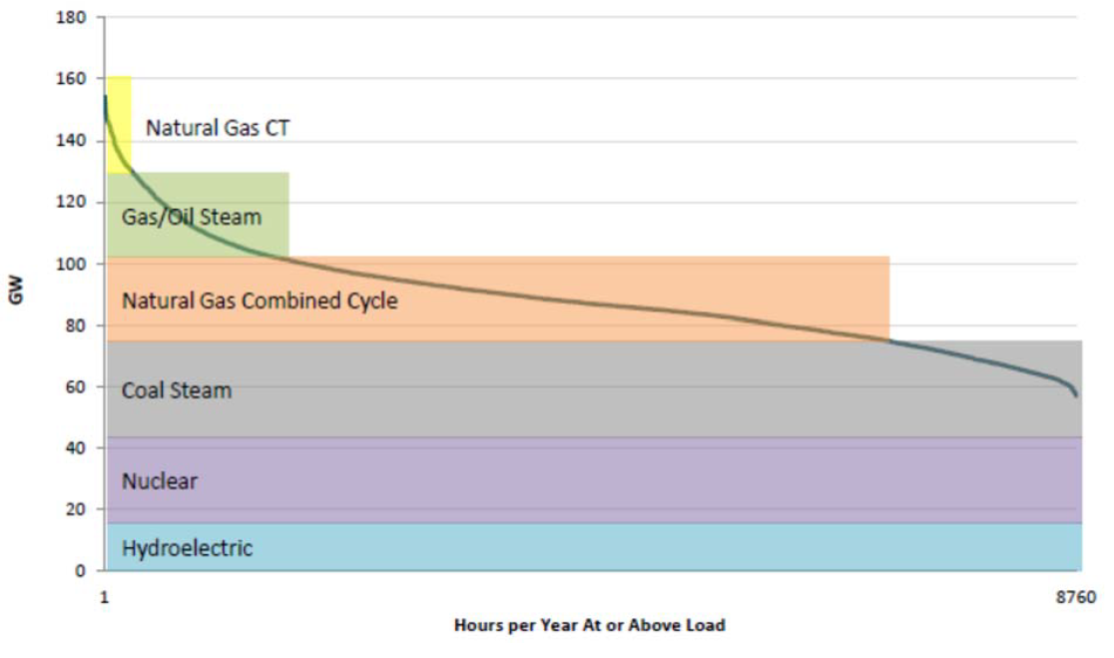

Source: Synapse Energy Economics, 2015[9]

Energy efficiency programs reduce demand at the operating margin, therefore demand reductions attributed to energy efficiency programs displace electric generation amongst higher-cost marginal generation sources. In the PJM territory, marginal sources supply energy via combustion of natural gas (69.4% of marginal sources) and coal (24.4%).[10] Therefore, electric demand reductions due to ComEd energy efficiency programs can be linked to reductions in generation among natural gas, oil steam, and coal-fired electric generating units.

Reducing generation from PJM's marginal generators causes substantial reductions in emissions of PM2.5, SO2, NOx, and CO2, since these pollutants are byproducts of coal and natural gas fuel combustion. The populations' exposure to these four pollutants increases the prevalence of numerous adverse health outcomes. For instance, premature infant and adult mortality have been linked to increased exposure to ambient air pollution. On an annual basis, the World Health Organization (WHO) estimates around 4.2 million premature deaths globally are linked to ambient air pollution exposure, with the most harmful pollutants being PM2.5, SO2, NO2, and ozone.[11] Increased exposure to these pollutants also leads to the development or exacerbation of respiratory and cardiovascular conditions. Each of the adverse health effects from ambient pollution exposure, particularly exposure to PM2.5 and ozone,[12] represents a substantial economic cost.[13]

# Methodology

This section presents the methodology and usage of EPA tools to estimate the Societal NEIs associated with ComEd's CY2024 programs. Guidehouse first provides a summary of the two tools developed by the EPA that are essential to this analysis. This is followed by a summary of Guidehouse's methodology to quantify the health benefits attributed to CY2024 energy efficiency programs.

## AVERT and COBRA

The EPA developed the Avoided Emissions and geneRation Tool (AVERT) to estimate the emissions benefits of energy efficiency and renewable energy policies and programs.[14] The EPA also developed the CO-Benefits Risk Assessment (COBRA) to estimate the health and economic benefits associated with energy efficiency and renewable energy policies and programs.[15]

The EPA’s AVERT translates the impacts of energy efficiency programs into county-level reductions in PM2.5, SO2, NOx, VOCs, NH3, and CO2 from reduced electricity generation across fossil-fueled electricity generating units. AVERT was first released in 2014 and has been reviewed, well-documented, and tested across multiple scenarios. More specifically, since the AVERT’s inception, the EPA has:

* Conducted external and internal peer reviews
* Benchmarked AVERT against an industry-standard electric power sector model, PROSYM
* Worked with states to beta-test the tool for functionality, appropriate uses, and clarity of the user manual.[16]

COBRA is a peer-reviewed screening tool that establishes the air quality, human health, and associated economic impacts of various state- and county-level emission reduction scenarios.[17] COBRA was updated in 2024 by the EPA to estimate changes in annual ambient concentrations of both particulate matter(PM2.5) and ozone, in previous years COBRA only estimated the health impacts of PM2.5.[18] COBRA continues to use the county-level emissions reduction results from AVERT to estimate health outcomes changes. Using information from AVERT on county-level changes in emissions, COBRA quantifies county-level air quality changes, estimates the resulting changes in health outcomes, and then calculates monetary values associated with these changes in health outcomes. COBRA estimates the number of health incidents avoided and the corresponding economic values for the following conditions. The last three health incidence (Hospital Admissions related to Alzheimer’s and Parkinson’s Disease, Stroke and Lung Cancer, Hay Fever/Rhinitis) are additions to the 2024 COBRA update.

* Infant and Adult Mortality
* Non-fatal Heart Attacks
* Hospital Admissions related to Respiratory and Cardiovascular Conditions
* Acute Bronchitis
* Upper and Lower Respiratory Symptoms,
* Asthma Exacerbations (attacks, shortness of breath, & wheezing)
* Asthma Emergency Room visits
* Minor Restricted Activity Days
* Work Loss Days
* Hospital Admissions related to Alzheimer’s and Parkinson’s Disease
* Incidence of Stroke and Lung Cancer
* Incidence of Hay Fever/Rhinitis

## Estimation of Societal NEIs

Guidehouse generated Societal NEI estimates for ComEd's CY2024 programs. Since ComEd programs cover a variety of measures with measure lives ranging from one to 30 years, Guidehouse included all cumulative persisting annual savings (CPAS) from CY2024 programs. This ensures that Guidehouse estimates can be associated with the full extent of CY2024 programs' energy savings.

 To generate Societal NEI estimates, Guidehouse adopted an annual modeling approach. For each year, Guidehouse used CPAS values for CY2024 programs, which spanned 2024 through 2053. The annual approach is illustrated in Figure 2. Analyzing on an annual basis ensures that (1) each year's emissions impacts are consistent with generation activity expected in that year and (2) each year's health benefits estimates reflect the baseline population in that year. Additional detail providing context for each step in the analysis is provided in the following paragraphs.

Figure 2. Flowchart of Annual Estimation of CY2024 Health Benefits

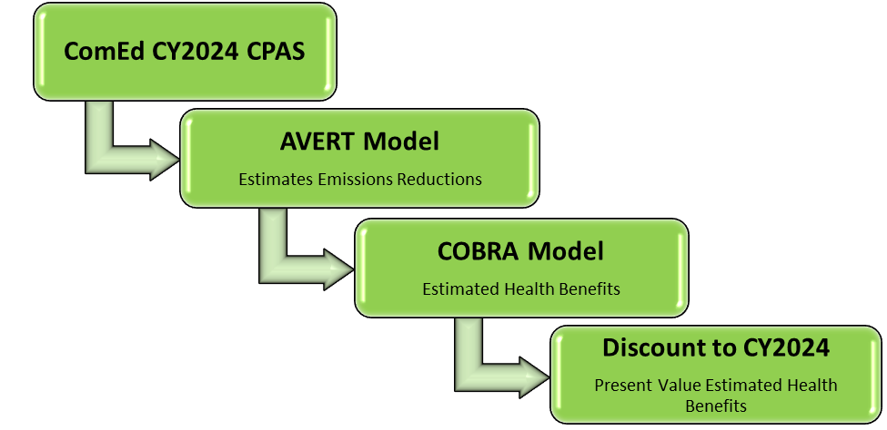

Source: Guidehouse

**Step 1: Gather ComEd CY2024 Portfolio-Level CPAS Values**

For this methodological summary, we focus on the annual estimation of societal health benefits for one program using that program’s CY2024 CPAS values beginning in CY2024. In this first step, we gathered and aggregated ComEd CY2024 programs' CPAS data[19] to construct a 30-year portfolio-level CPAS curve.

**Step 2: Execute AVERT**

For each year, execute AVERT using portfolio-level CPAS values. AVERT uses a forecast[20] of patterns of dispatching electric generating units to estimate marginal emissions rates (lbs/MWh) for PM2.5, SO2, NOx, VOCs, NH3, and CO2, then applies these emissions rates to energy efficiency savings (MWh) to determine a county-level reduction (lbs) in each of the four pollutants.

EPA currently maintains a 2024 baseline forecast of patterns of dispatching electric generating units for AVERT. This forecast is based on historical data through 2024, and EPA warns that this forecast is static and is only recommended for use for up to five years.[21] Guidehouse considered the use of county-level estimates of emissions reductions from AVERT without any adjustments; however, historical trends in marginal emissions rates do not support this approach. For ComEd and PJM, marginal emissions rates have dropped considerably over the past four years.[22] In PJM’s territory, the share of coal marginal generation sources dropped from 51.7% in 2015 to 24.4% in 2019. Transformations in the mix of electric generation sources, particularly marginal generation sources, can be expected to continue through 2050, as the use of renewables in electricity generation is forecasted to grow.[23] Marginal emissions rates are expected to continue to decline as the energy mix becomes cleaner. Failing to adjust the AVERT analysis approach to accommodate trends in marginal emissions rates beyond five years into the future, therefore, overstates county-level emissions reductions. In turn, this will overstate health benefits for these years.

To generate more reasonable bounds on electric emission reduction estimates, Guidehouse forecasted marginal emission rates from 2020-2050 using Pennsylvania-New Jersey-Maryland Interconnection (PJM) data and developed a set of adjustment factors for each year, downscaling the rates to the AVERT forecast. To account for the 30-year measure life in CPAS, Guidehouse used a trendline of adjusted factors from 2040-2050 to determine adjustment factors for 2050-2053.

**Step 3: Execute COBRA**

Guidehouse used the AVERT outputs in COBRA to estimate health impacts of reduced pollution exposure over a 30-year period. Reduced exposure to emissions in one year reduces acute morbidity in the year of analysis and reduces the incidence of premature mortality for up to 30 years.[24] COBRA includes adjustments for inflation throughout the 30 years, then discounts this stream of health benefits back to the year in which the energy savings are realized.[25] EPA provided Guidehouse a custom valuation file using a 2.40% discount rate for 2024-2053 from the Illinois Technical Reference Manual (TRM) v12.0.[26]

For each year of COBRA analysis, we used the mean of national low- and high-sensitivity estimates for the health benefit estimate. Low- and high-sensitivity estimates of health benefits are based on two peer-reviewed studies estimating the link between ambient air pollution exposure and increases in premature mortality. Each study assessed premature mortality using a robust sample pool intended to represent the United States population, paying special attention to urban and rural populations and age brackets. Since both studies are credible, Guidehouse does not believe that either estimate is more representative than the other of the United States population and resulting population health impacts. Therefore, we used the mean of national low- and high-sensitivity estimates to construct annual health benefits estimates. In addition, since emission reductions and health benefits due to ComEd’s energy efficiency programs accrue both without and outside of Illinois, we used national societal NEIs in our analyses.

**Step 4: Discount Results to CY2024**

Health benefits estimates are expressed using dollars in the analysis year of interest. For the cost-effectiveness test on a CY2024 program, we used the CY2024 program’s Societal NEI value adjusted to 2024 dollars. To remain consistent with other inputs to TRC tests, Guidehouse discounted each year's county-level COBRA results back to 2024 using a 0.42% real discount rate.

# Analysis Findings and Recommendations

## Analysis Findings

Figure 3 shows the CPAS Lifetime Net Saving estimates for CY2024, curve shown below is diminishing year-over-year from 2024 through 2053 as measures begin to reach their effective useful lives. Following Guidehouse's annual analysis methodology, the curve of Lifetime Health Benefits of Societal NEIs is shown in Figure 4, which follows a similar trend as the program-level CPAS, diminishing at a steeper rate than CPAS due to predicted improvements in the efficiency of marginal generation.

Figure 3. ComEd CY2024 Electric CPAS Estimates: 2024-2053

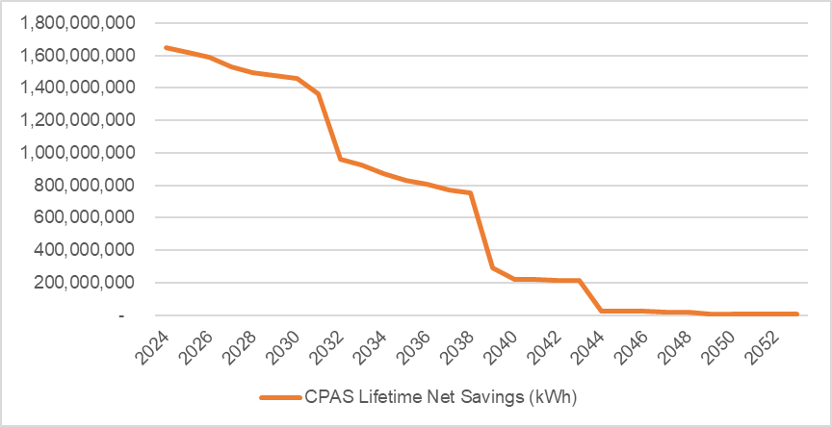

Source: ComEd Summary Impact Evaluation Report, CY2024 CPAS Electric.

Figure 4. ComEd CY2024 Societal NEI Estimates: 2024-2053

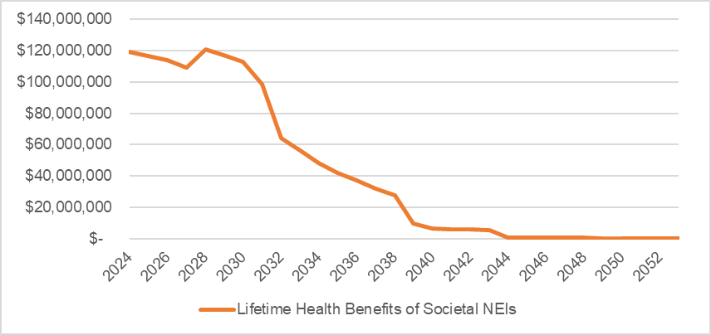

Source: Guidehouse analysis of ComEd CY2024 verified program savings.

Table 1 presents the final societal health benefits estimates for ComEd's CY2024 programs implemented between January 1, 2024 – December 31, 2024. Societal health benefits are discounted to the program year of interest (i.e., CY2024 total health benefits are presented in 2024 dollars).

Table 1. Total Discounted Societal NEI Estimates, CY2024 Programs

|  |  |  |  |
| --- | --- | --- | --- |
| Program Year | CY2024 Verified Net Lifetime Savings (kWh) | $Total Health Benefits | $Total Health Benefits per kWh (Average) |
| **CY2024** | **19,378,592,772** | **$1,251,990,420** | **$0.0646** |

Source: Guidehouse analysis of ComEd CY2024 verified program savings.

# Program-Level Societal NEI Estimates

Table 2 provides Societal NEI estimates for ComEd CY2024 programs, expressed in both absolute dollars and dollars per kWh. Note that program-level dollar per kWh values are levelized to each program's CPAS. Each table assumes that CY2024 savings begin in the program year of interest, and societal health benefit estimates are expressed in the program year's dollars. Societal NEI estimates for each year are then estimated using the annual approach highlighted in the Methodology section, discounted back to 2024, then summed. The result is a lifetime Societal NEI estimate expressed in 2024 dollars.

Table 2. CY2024 Societal NEI Estimates by Program in 2024 Dollars

| Sector | Program | CY2024 Verified Net Lifetime Savings (kWh) | $ Health Benefits per kWh | $ Total Health Benefits |
| --- | --- | --- | --- | --- |
| Business & Public Sector | Incentives | 3,008,661,591 | $0.0638 | $192,063,226 |
| Business & Public Sector | Small Business | 2,867,668,211 | $0.0643 | $184,412,200 |
| Business & Public Sector | Midstream/Upstream | 2,414,053,272 | $0.0640 | $154,500,231 |
| Business & Public Sector | Targeted Systems | 748,048,215 | $0.0691 | $51,712,486 |
| Business & Public Sector | Behavior Bus/Pub | 305,413,707 | $0.0751 | $22,932,972 |
| Business & Public Sector | New Construction - Bus/Pub | 94,615,199 | $0.0591 | $5,587,796 |
| Business & Public Sector | EMS - Small Business - Pilot | 932,516 | $0.0637 | $59,431 |
| Res & IE | Retail/Online | 5,017,697,758 | $0.0605 | $303,475,917 |
| Res & IE | Product Distribution | 2,192,667,999 | $0.0735 | $161,078,539 |
| Res & IE | Multifamily Upgrades | 405,636,835 | $0.0598 | $24,263,493 |
| Res & IE | Contractor/Midstream Rebates | 254,048,427 | $0.0657 | $16,687,055 |
| Res & IE | Single-Family Upgrades | 149,269,652 | $0.0656 | $9,785,097 |
| Res & IE | New Construction - IE | 45,515,672 | $0.0615 | $2,799,305 |
| Res & IE | Whole Home Electric | 14,625,730 | $0.0644 | $942,534 |
| Res & IE | ASI kWh Purchase | 16,291,033 | $0.0522 | $849,802 |
| Res & IE | Electric Homes New Construction | 5,378,287 | $0.0622 | $334,730 |
| Res & IE | Behavior - Res/IE | 358,650,175 | $0.0731 | $26,219,025 |
| Voltage Optimization | Voltage Optimization | 1,479,418,494 | $0.0637 | $94,286,581 |
| **CY2024 Portfolio Total Electric Contribution to CPAS** | | **19,378,592,772** | **$0.0646** | **$1,251,990,420** |

Source: Guidehouse analysis of ComEd CY2024 verified program savings.

# Portfolio-Level Societal NEI Estimates

Table 3 highlights the annual portfolio-level Societal NEI estimates for 2024-2053. For new or redesigned energy efficiency programs, ComEd should estimate the new or redesigned programs' CPAS based on the new measure mix. This program-level CPAS should then be applied to annual portfolio-level benefit per kWh estimates provided in Table 3 to generate an annual Societal NEI estimate. ComEd should then take the summation of all years' estimates to generate a total Societal NEI estimate for the new or redesigned program.

Table 3. CY2024 Annual Portfolio-Level Societal NEI Estimates in 2024 Dollars

| Year | Lifetime Health Benefits | Lifetime Health Benefits per kWh | CY2024 Verified Net Lifetime Savings (kWh) |
| --- | --- | --- | --- |
| 2024 | $119,110,220 | $0.0724 | 1,646,140,336 |
| 2025 | $116,399,490 | $0.0720 | 1,615,539,676 |
| 2026 | $113,931,531 | $0.0717 | 1,588,220,895 |
| 2027 | $109,029,454 | $0.0714 | 1,526,535,642 |
| 2028 | $120,867,003 | $0.0809 | 1,493,636,074 |
| 2029 | $117,132,565 | $0.0793 | 1,476,240,114 |
| 2030 | $113,207,144 | $0.0778 | 1,455,371,627 |
| 2031 | $98,603,344 | $0.0722 | 1,365,390,699 |
| 2032 | $64,064,146 | $0.0667 | 960,734,844 |
| 2033 | $56,485,938 | $0.0612 | 922,938,031 |
| 2034 | $48,464,463 | $0.0558 | 869,137,745 |
| 2035 | $41,816,859 | $0.0504 | 830,138,952 |
| 2036 | $37,005,735 | $0.0458 | 807,126,015 |
| 2037 | $31,988,641 | $0.0414 | 773,316,643 |
| 2038 | $27,896,148 | $0.0369 | 755,682,145 |
| 2039 | $9,533,754 | $0.0325 | 293,062,628 |
| 2040 | $6,228,252 | $0.0281 | 221,319,702 |
| 2041 | $5,959,663 | $0.0274 | 217,594,588 |
| 2042 | $5,727,153 | $0.0267 | 214,892,681 |
| 2043 | $5,559,131 | $0.0259 | 214,491,880 |
| 2044 | $582,782 | $0.0251 | 23,206,442 |
| 2045 | $565,916 | $0.0244 | 23,202,309 |
| 2046 | $544,786 | $0.0235 | 23,136,298 |
| 2047 | $371,839 | $0.0227 | 16,354,932 |
| 2048 | $358,265 | $0.0219 | 16,354,932 |
| 2049 | $120,500 | $0.0209 | 5,765,388 |
| 2050 | $115,833 | $0.0201 | 5,765,388 |
| 2051 | $111,203 | $0.0193 | 5,765,388 |
| 2052 | $106,609 | $0.0185 | 5,765,388 |
| 2053 | $102,052 | $0.0177 | 5,765,388 |
| **Total Lifetime Health Benefits** | **$1,251,990,420** | **$0.0646** | **19,378,592,772** |

Source: Guidehouse analysis of ComEd CY2024 verified program savings.

# Portfolio-Level Carbon Reduction Estimates

AVERT estimates CO2 emission rates, but those estimates are not used in the COBRA analysis to determine health benefits. The following table presents the CO2 reduction estimates for 2024-2053. The CO2 reduction estimates are produced by AVERT and adjusted by Guidehouse’s reduction factors described in *Estimation of Societal NEIs section.*

Table 4. CY2024 Annual Portfolio-Level Carbon Reduction Estimates

| Year | CY2024 Verified Net Lifetime Savings (kWh) | CY2024 Carbon Reductions (Tons) | CY2024 Carbon Reductions (Tons/MWh) |
| --- | --- | --- | --- |
| 2024 | 1,646,140,336 | 1,121,995 | 0.6816 |
| 2025 | 1,615,539,676 | 1,101,132 | 0.6816 |
| 2026 | 1,588,220,895 | 1,082,500 | 0.6816 |
| 2027 | 1,526,535,642 | 1,040,434 | 0.6816 |
| 2028 | 1,493,636,074 | 891,868 | 0.5971 |
| 2029 | 1,476,240,114 | 756,816 | 0.5127 |
| 2030 | 1,455,371,627 | 623,215 | 0.4282 |
| 2031 | 1,365,390,699 | 566,279 | 0.4147 |
| 2032 | 960,734,844 | 385,580 | 0.4013 |
| 2033 | 922,938,031 | 358,016 | 0.3879 |
| 2034 | 869,137,745 | 325,416 | 0.3744 |
| 2035 | 830,138,952 | 299,668 | 0.3610 |
| 2036 | 807,126,015 | 288,118 | 0.3570 |
| 2037 | 773,316,643 | 272,897 | 0.3529 |
| 2038 | 755,682,145 | 263,642 | 0.3489 |
| 2039 | 293,062,628 | 101,083 | 0.3449 |
| 2040 | 221,319,702 | 75,437 | 0.3409 |
| 2041 | 217,594,588 | 74,049 | 0.3403 |
| 2042 | 214,892,681 | 73,012 | 0.3398 |
| 2043 | 214,491,880 | 72,759 | 0.3392 |
| 2044 | 23,206,442 | 7,855 | 0.3385 |
| 2045 | 23,202,309 | 7,841 | 0.3379 |
| 2046 | 23,136,298 | 7,766 | 0.3357 |
| 2047 | 16,354,932 | 5,453 | 0.3334 |
| 2048 | 16,354,932 | 5,416 | 0.3312 |
| 2049 | 5,765,388 | 1,896 | 0.3289 |
| 2050 | 5,765,388 | 1,883 | 0.3266 |
| 2051 | 5,765,388 | 1,870 | 0.3244 |
| 2052 | 5,765,388 | 1,857 | 0.3221 |
| 2053 | 5,765,388 | 1,844 | 0.3199 |
| **Total Lifetime Carbon Reduction** | **19,378,592,772** | **9,817,598** | **0.5066** |

Source: Guidehouse analysis of ComEd CY2024 verified program savings.

# Appendix

Table 5 provides Societal NEI estimates for ComEd CY2024 compared to CY2023 programs, expressed in both absolute dollars and dollars per kWh. This is to show the difference in health benefits from the updates that have occurred in COBRA, as stated in Section 4.1. The EPA updated COBRA which now includes the health impacts of ozone which were not included in COBRA estimates when it was used for CY2023 analysis, PM2.5, were the only health impact functions that were included. Table 5 results were included in the CY2024 cost effectiveness analysis.

Table 5. CY2024 vs CY2023 Societal NEI Estimates by Program - PM2.5 and Ozone Health Impact

|  |  | 2024 | | | 2023 | | |
| --- | --- | --- | --- | --- | --- | --- | --- |
| Sector | Program | CY2024 Verified Net Lifetime Savings (kWh) | $ Health Benefits per kWh | $ Total Health Benefits | CY2023 Verified Net Lifetime Savings (kWh) | $ Health Benefits per kWh | $ Total Health Benefits |
| Business & Public Sector | Incentives | 3,008,661,591 | $0.0638 | $192,063,226 | 2,716,726,762 | $0.0301 | $81,828,582 |
| Business & Public Sector | Small Business | 2,867,668,211 | $0.0643 | $184,412,200 | 2,902,350,098 | $0.0312 | $90,558,296 |
| Business & Public Sector | Midstream/Upstream | 2,414,053,272 | $0.0640 | $154,500,231 | 1,566,918,012 | $0.0308 | $48,305,598 |
| Business & Public Sector | Targeted Systems | 748,048,215 | $0.0691 | $51,712,486 | 617,059,570 | $0.0329 | $20,313,344 |
| Business & Public Sector | Behavior Bus/Pub | 305,413,707 | $0.0751 | $22,932,972 | 288,553,690 | $0.0339 | $9,785,799 |
| Business & Public Sector | New Construction - Bus/Pub | 94,615,199 | $0.0591 | $5,587,796 | 181,696,446 | $0.0282 | $5,118,830 |
| Business & Public Sector | EMS - Small Business - Pilot | 932,516 | $0.0637 | $59,431 | - | - | - |
| Business & Public Sector | Assessments | - | - | - | 8,316,215 | $0.0337 | $280,164 |
| Res & IE | Retail/Online | 5,017,697,758 | $0.0605 | $303,475,917 | 2,144,085,171 | $0.0303 | $65,004,199 |
| Res & IE | Product Distribution | 2,192,667,999 | $0.0735 | $161,078,539 | 2,415,609,366 | $0.0331 | $80,057,282 |
| Res & IE | Multifamily Upgrades | 405,636,835 | $0.0598 | $24,263,493 | 426,798,392 | $0.0292 | $12,460,496 |
| Res & IE | Contractor/Midstream Rebates | 254,048,427 | $0.0657 | $16,687,055 | 171,214,859 | $0.0301 | $5,146,918 |
| Res & IE | Single-Family Upgrades | 149,269,652 | $0.0656 | $9,785,097 | 129,227,661 | $0.0306 | $3,957,904 |
| Res & IE | New Construction - IE | 45,515,672 | $0.0615 | $2,799,305 | 17,520,340 | $0.0291 | $510,440 |
| Res & IE | Whole Home Electric | 14,625,730 | $0.0644 | $942,534 | - | - | - |
| Res & IE | ASI kWh Purchase | 16,291,033 | $0.0522 | $849,802 | 15,115,464 | $0.0264 | $398,431 |
| Res & IE | Electric Homes New Construction | 5,378,287 | $0.0622 | $334,730 | 4,541,660 | $0.0299 | $135,705 |
| Res & IE | Behavior - Res/IE | 358,650,175 | $0.0731 | $26,219,025 | 291,987,668 | $0.0337 | $9,845,075 |
| Pilot | Industrial Energy Management Information Systems | - | - | - | 6,746,976 | $0.0336 | $226,854 |
| Pilot | Heat Pump Water Heater Pilot | - | - | - | 306,544 | $0.0303 | $9,281 |
| Market Transformation | ENERGY STAR Retail Products Platform | - | - | - | 137,797,829 | $0.0308 | $4,240,879 |
| Voltage Optimization | Voltage Optimization | 1,479,418,494 | $0.0637 | $94,286,581 | 1,034,874,812 | $0.0303 | $31,330,740 |
| **Portfolio Total Electric Contribution to CPAS** | | **19,378,592,772** | **$0.0646** | **$1,251,990,420** | **15,077,447,533** | **$0.0311** | **$469,514,818** |

Source: Guidehouse analysis of ComEd CY2024 and CY2023 verified program savings.

In Table 6, we show the difference in health benefits for the purpose of comparing the PM2.5 only health impact considered in the societal evaluation for CY2024 against CY2023. The 2024 COBRA update included additional health incidents (Hospital Admissions related to Alzheimer’s and Parkinson’s Disease, Stroke and Lung Cancer, Hay Fever/Rhinitis) which resulted in higher CY2024 total health benefits compare to CY2023.

Table 6. CY2024 vs CY2023 Societal NEI Estimates by Program - PM2.5 Health Impact

|  |  | 2024 | | | 2023 | | |
| --- | --- | --- | --- | --- | --- | --- | --- |
| Sector | Program | CY2024 Verified Net Lifetime Savings (kWh) | $ Health Benefits per kWh | $ Total Health Benefits | CY2023 Verified Net Lifetime Savings (kWh) | $ Health Benefits per kWh | $ Total Health Benefits |
| Business & Public Sector | Incentives | 3,008,661,591 | $0.0468 | $140,922,387 | 2,716,726,762 | $0.0301 | $81,828,582 |
| Business & Public Sector | Small Business | 2,867,668,211 | $0.0472 | $135,237,202 | 2,902,350,098 | $0.0312 | $90,558,296 |
| Business & Public Sector | Midstream/Upstream | 2,414,053,272 | $0.0470 | $113,560,213 | 1,566,918,012 | $0.0308 | $48,305,598 |
| Business & Public Sector | Targeted Systems | 748,048,215 | $0.0503 | $37,598,819 | 617,059,570 | $0.0329 | $20,313,344 |
| Business & Public Sector | Behavior Bus/Pub | 305,413,707 | $0.0541 | $16,512,483 | 288,553,690 | $0.0339 | $9,785,799 |
| Business & Public Sector | New Construction - Bus/Pub | 94,615,199 | $0.0434 | $4,106,187 | 181,696,446 | $0.0282 | $5,118,830 |
| Business & Public Sector | EMS - Small Business - Pilot | 932,516 | $0.0469 | $43,725 | - | - | - |
| Business & Public Sector | Assessments | - | - | - | 8,316,215 | $0.0337 | $280,164 |
| Res & IE | Retail/Online | 5,017,697,758 | $0.0441 | $221,486,367 | 2,144,085,171 | $0.0303 | $65,004,199 |
| Res & IE | Product Distribution | 2,192,667,999 | $0.0531 | $116,337,697 | 2,415,609,366 | $0.0331 | $80,057,282 |
| Res & IE | Multifamily Upgrades | 405,636,835 | $0.0436 | $17,673,334 | 426,798,392 | $0.0292 | $12,460,496 |
| Res & IE | Contractor/Midstream Rebates | 254,048,427 | $0.0479 | $12,179,251 | 171,214,859 | $0.0301 | $5,146,918 |
| Res & IE | Single-Family Upgrades | 149,269,652 | $0.0475 | $7,094,912 | 129,227,661 | $0.0306 | $3,957,904 |
| Res & IE | New Construction - IE | 45,515,672 | $0.0452 | $2,056,034 | 17,520,340 | $0.0291 | $510,440 |
| Res & IE | Whole Home Electric | 14,625,730 | $0.0471 | $688,591 | - | - | - |
| Res & IE | ASI kWh Purchase | 16,291,033 | $0.0382 | $622,035 | 15,115,464 | $0.0264 | $398,431 |
| Res & IE | Electric Homes New Construction | 5,378,287 | $0.0457 | $245,548 | 4,541,660 | $0.0299 | $135,705 |
| Res & IE | Behavior - Res/IE | 358,650,175 | $0.0526 | $18,876,142 | 291,987,668 | $0.0337 | $9,845,075 |
| Pilot | Industrial Energy Management Information Systems | - | - | - | 6,746,976 | $0.0336 | $226,854 |
| Pilot | Heat Pump Water Heater Pilot | - | - | - | 306,544 | $0.0303 | $9,281 |
| Market Transformation | ENERGY STAR Retail Products Platform | - | - | - | 137,797,829 | $0.0308 | $4,240,879 |
| Voltage Optimization | Voltage Optimization | 1,479,418,494 | $0.0469 | $69,369,020 | 1,034,874,812 | $0.0303 | $31,330,740 |
| **Portfolio Total Electric Contribution to CPAS** | | **19,378,592,772** | **$0.0472** | **$914,609,948** | **15,077,447,533** | **$0.0311** | **$469,514,818** |

Source: Guidehouse analysis of ComEd CY2024 and CY2023 verified program savings.

1. U.S. EPA’s AVERT web site: <https://www.epa.gov/avert> Accessed: December 23, 2020.
2. U.S. EPA’s COBRA tool web site: <https://www.epa.gov/cobra> Accessed: December 23, 2020.
3. <https://www.epa.gov/cobra/how-does-cobra-work#:~:text=COBRA%20contains%20detailed%20emission%20estimates,2016%2C%202023%2C%20or%202028>. Accessed: December 23, 2020.
4. FEJA (Illinois Future Energy Jobs Act). Public Act 099-0906. <https://www.ilga.gov/legislation/publicacts/99/PDF/099-0906.pdf>. (Passed December 7, 2016).
5. CEJA (Illinois Clean and Equitable Jobs Act). Public Act 102-0662. <https://www.ilga.gov/legislation/publicacts/102/PDF/102-0662.pdf>. (passed September 15, 2021).
6. IL SAG. Illinois Statewide Technical Reference Manual for Energy Efficiency, Version 11.0. <https://www.ilsag.info/wp-content/uploads/IL-TRM-Version-11.0-Volumes-1-4-Compiled-Final.pdf>.
7. ComEd. 2021. Commonwealth Edison Company 2022-2025 Energy Efficiency & Demand Response Plan (Plan 6) filed March 1. Springfield, IL: Illinois Commerce Commission (ICC). [www.icc.illinois.gov/docket/files.aspx?no=17-0312&docId=254601](http://www.icc.illinois.gov/docket/files.aspx?no=17-0312&docId=254601).
8. IL SAG (Illinois Stakeholder Advisory Group). 2016. Documentation of TAC Review of Non-Energy Benefits - Memorandum to Technical Advisory Committee. Springfield, IL: [s3.amazonaws.com/ilsag/IL-TAC_Documentation-of-TAC-Review-of-Non-Energy-Benefits_Memo_02-09-2016.pdf](https://s3.amazonaws.com/ilsag/IL-TAC_Documentation-of-TAC-Review-of-Non-Energy-Benefits_Memo_02-09-2016.pdf).
9. Synapse Energy Economics, 2015. “Air Emissions Displacement by Energy Efficiency and Renewable Energy: A Survey of Data, Methods, and Results”
10. 2019 PJM State of the Market Report, Table 3-52. <https://www.monitoringanalytics.com/reports/PJM_State_of_the_Market/2019/2019-som-pjm-sec3.pdf>
11. <https://www.who.int/news-room/fact-sheets/detail/ambient-(outdoor)-air-quality-and-health> Accessed: August 17, 2020.
12. <https://www.epa.gov/clean-air-act-overview/air-pollution-current-and-future-challenges> Accessed: April 15, 2025.
13. <https://www.epa.gov/environmental-economics/mortality-risk-valuation> Accessed: August 17, 2020.
14. <https://www.epa.gov/avert> Accessed: December 17, 2020.
15. <https://www.epa.gov/cobra> Accessed: December 17, 2020.
16. <https://www.epa.gov/avert/avert-tutorial-homepage>. Accessed: May 31, 2023.
17. <https://www.epa.gov/statelocalenergy/how-cobra-works>. Accessed: April 30, 2020.
18. COBRA Revision History <https://www.epa.gov/cobra/cobra-revision-history>. Accessed: April 15, 2025.
19. ComEd CY2024 Summary Impact evaluation Report – Table 2-3 CPAS Electric. April 30, 2025.
20. This forecast is updated by the EPA once annually and is based on historic patterns of dispatch of electric generating units and resource mix within the Mid-Atlantic region.
21. The EPA recommends that AVERT’s emissions estimates only be conducted for up to five years into the future. This is because the model provides a representation of the dynamics of electricity dispatch in a historical base year, and because AVERT cannot currently control for changes in dispatch due to transmission resources, fuel prices, demand for electricity, variable costs, and other factors.
22. PJM 2015 – 2019 CO2, SO2, and NOx Emission Rates Report. April 2020. <https://www.pjm.com/-/media/library/reports-notices/special-reports/2019/2019-emissions-report.ashx?la=en>
23. Annual Energy Outlook 2020 (AEO2020) <https://www.eia.gov/outlooks/aeo/pdf/AEO2020%20Electricity.pdf>
24. COBRA assumes that the incidences of premature mortality attributed to pollution exposure occurs over a 20 year period following exposure. COBRA currently assumes that 30% of premature deaths occur in the first year, 50%^ of deaths occur in years two through five, and the remaining 20% of deaths occur in years six through twenty. For more information, see page F-8 of the COBRA user manual: <https://www.epa.gov/sites/production/files/2020-06/documents/cobra_user_manual_june_2020.pdf>
25. In the case of analysis of emissions reductions in the year 2032, COBRA models the associated reductions in morbidity and mortality that can be expected to occur over a 20 year period between 2032 and 2051. This 20 year stream of health benefits is then discounted back to the analysis year, which in this case is 2032.
26. IL SAG. Illinois Statewide Technical Reference Manual for Energy Efficiency, Version 12.0. [**https://www.ilsag.info/wp-content/uploads/IL-TRM-Version-12.0-Volumes-1-4-Compiled-Final.pdf**](https://www.ilsag.info/wp-content/uploads/IL-TRM-Version-12.0-Volumes-1-4-Compiled-Final.pdf)