Ameren Illinois Company

2024 Business Program Impact Evaluation Report

Appendix e: Luminaire-Level Lighting Controls Market Transformation Pilot - 2024 Market Progress Evaluation Report

Draft

March 13, 2024

Contents

1. Executive Summary 4

1.1 Background 4

1.2 Research Objectives and Methods 4

1.3 Key Findings 5

2. Introduction and Background 7

2.1 Pilot Implementation 9

2.2 Research Objectives 9

3. Methods 11

3.1 Training Assessment Surveys 11

3.2 Market Actor Surveys 12

3.3 Market Analysis 13

3.4 Market Transformation Savings 14

3.5 Sources and Mitigation of Error 15

4. Detailed Findings 16

4.1 Training Assessments 16

4.2 Market Actor Research 18

4.3 Market Analysis 23

4.4 Market Transformation Savings 30

Appendix A. Data Collection Instruments 31

Appendix B. Glossary of Lighting Control Terminology 32

Table of Tables & Figures

Table 1. 2024 LLLC Pilot MPI Goal Achievement 6

Table 2. LLLC Pilot MPI Summary 8

Table 3. LLLC Pilot MPIs Assessed in 2024 Evaluation 10

Table 4. Research Questions and Subsequent Research Activities 11

Table 5. Training Assessment Survey Fielding Summary 12

Table 6. Customer Survey Fielding Summary 12

Table 7. Trade Ally Survey Fielding Summary 13

Table 8. LLLC Market Shares Forecasted by Natural Market Baseline 14

Table 9. Per-Fixture Costs of Typical LLLC Systems 24

Table 10. 2024 LLLC Pilot MT Savings Roll-Up 30

Figure 1. LLLC Pilot Logic Model 8

Figure 2. Pre-Training Self-Reported LLLC and NLC Knowledge (n=50) 16

Figure 3. Post-Training Self-Reported LLLC and NLC Knowledge (n=8) 17

Figure 4. Customer and Trade Ally Familiarity with NLCs and LLLCs 18

Figure 5. Customer Familiarity with Lighting Control Technologies (n=353) 19

Figure 6. Trade Ally Familiarity with Individual Lighting Control Technologies (n=37) 19

Figure 7. Incidence of Lighting Controls Installed in Facilities (n=327) 20

Figure 8. Trade Ally Recommendations and Installations of LLLCs and NLCs 21

Figure 9. Customer Priorities for Lighting Equipment (n=353) 22

Figure 10. LLLC Supply Chain Overview 27

# Executive Summary

This report presents results from the first annual market progress evaluation of Ameren Illinois Company’s (AIC) Luminaire Level Lighting Controls (LLLC) Market Transformation (MT) Pilot, covering the 2024 program year. The objective of the 2024 evaluation was to assess the status of key market progress indicators (MPIs) and estimate verified energy and peak demand savings attributable to LLLC Pilot interventions in 2024.

## Background

AIC operates the LLLC Pilot as a Market Transformation Initiative (MTI). AIC’s energy efficiency portfolio has historically focused on resource acquisition (RA) programs. In RA programs, the program implementer aims to directly influence the decision-making and behaviors of individual actors (i.e., program participants), encouraging them to take energy-saving actions they would not have taken in the absence of program interventions. The LLLC Pilot, however, is an MT program. Theoretically, MT programs involve a shift in focus away from influencing individuals’ actions and instead toward changing the structure and function of an entire market. By doing so, MT programs have the potential to provide substantial benefits to society because the offering directly influences various market dynamics and the actions of a broader pool of market actors.

## Research Objectives and Methods

The 2024 LLLC Pilot market progress evaluation included market-, process-, and impact-oriented components. The evaluation addressed the following key objectives:

* Review and characterize LLLC Pilot implementation
* Explore opportunities for LLLC Pilot improvement, including increased overall effectiveness or ease of implementation
* Assess LLLC training effectiveness and knowledge transfer
* Assess 2024 levels of awareness and understanding of LLLCs among market actors
* Measure changes in LLLC market share
* Estimate net energy savings associated with the LLLC Pilot

To address these research objectives, the evaluation team utilized both primary data collection and secondary research activities, including the following:

* Training assessment surveys administered to trade allies before and after completing AIC’s in-person and online LLLC training (n=50 and n=8, respectively)
* Market actor surveys of both AIC commercial customers and lighting trade allies (n=350 and n=37, respectively)
* Market analysis involving a review of secondary data sources and third-party sales data
* MT savings analysis to estimate net energy savings attributable to the LLLC Pilot

## Key Findings

The LLLC Pilot implemented a combination of in-person workshops, an online course, and marketing support efforts in 2024 that, by all available metrics, effectively informed trade allies operating in AIC service territory about LLLC functionality, benefits, and associated AIC RA offerings. Training participants demonstrated increased knowledge and familiarity with LLLCs and broadly expressed satisfaction with their training experience. More broadly, trade allies and business customers throughout AIC service territory similarly demonstrated increases in LLLC awareness and experience, marking progress toward MPIs meant to track anticipated market outcomes associated with LLLC Pilot efforts.

According to AIC business customers, 1.5% of their facilities have LLLC equipment installed as of 2024, which is more than twice the 0.7% forecasted by the 2023 AIC LLLC MTI Business Plan’s natural market baseline (NMB) meant to forecast adoption in the absence of any AIC interventions.[1] AIC incentive-based offerings seemingly played a substantial role in the market, fully accounting for the estimated increase in adoption. Within the current MT savings framework, the associated savings are claimed in their entirety by the RA offerings; however, current evaluation findings broadly suggest that the LLLC Pilot played a direct role in encouraging LLLC adoption and pursuit of available incentives. As the market continues to develop and mature, AIC staff may consider whether both RA and MT efforts remain necessary for stimulating ongoing market transformation.

Based on the evaluation activities conducted in 2024, we present the following key findings:

* **Key Finding #1:** The LLLC Pilot is still in the early stages of promoting long-term market transformation, with 2024 marking the first year of anticipated increases in recommendations and installations based on the 2023 AIC LLLC MTI Business Plan. LLLCs remain a relatively novel technology, accounting for less than 1% of the lighting market nationally and in Illinois as recently as 2023.
* **Key Finding #2:** Workshop and online training participants express high satisfaction and indicate substantial increases in LLLC knowledge and confidence following training participation. After participating in the in-person workshops and online training, trade allies reported an average increase of more than 40% in their knowledge of LLLCs and their confidence selling LLLCs to clients. Notably, these results reflect feedback from a small sample of eight respondents to the post-training assessment survey.
* **Key Finding #3:** Customer and trade ally awareness and familiarity with LLLCs are tracking toward LLLC Pilot goals, represented by MPI targets set for 2027, some of which have already been mostly or fully realized.
  + Customer awareness of LLLCs increased from 21% in 2023 to 36% in 2024, making progress toward the MPI target of 50% customer awareness of LLLCs by 2027.
  + Trade ally awareness of LLLCs remains above 90% in 2024, very close to the MPI target of 95% trade ally awareness of LLLCs by 2027.
  + Trade ally familiarity with LLLCs increased from 63% in 2023 to 70% in 2024, in line with the MPI target of 70% trade ally LLLC familiarity by 2027.
* **Key Finding #4:** Trade ally recommendations and installations of LLLCs are tracking toward LLLC Pilot goals and demonstrate clear market progress.
  + Half of all trade allies surveyed have made LLLC recommendations, marking progress toward the MPI target of 65% of trade allies recommending LLLCs by 2027.
  + The portion of trade allies with experience installing LLLCs increased from just over one-third (36%) in 2023 to nearly two-thirds (63%) in 2024.
* **Key Finding #5:** As of 2024, 1.5% of AIC business customers surveyed have LLLCs installed in their facilities, exceeding the 0.7% LLLC adoption forecasted by the 2023 AIC LLLC MTI Business Plan. However, AIC’s 2024 incentive-based RA offerings effectively account for 100% of the market lift above and beyond the NMB-forecasted market share. Although LLLC Pilot training efforts likely contributed directly to increasing LLLC adoption via incentive-based program participation, the associated savings are already fully accounted for by the RA offerings and, therefore, are not eligible to be claimed by the LLLC Pilot.

Table 1 provides a summary of the progress towards LLLC Pilot MPIs as of 2024 relative to targets set for 2027. These findings are discussed in more detail and presented with historical context in Section 4.

Table 1. 2024 LLLC Pilot MPI Goal Achievement

| MPI Description | 2024 MPI Results | 2027 MPI Target |
| --- | --- | --- |
| **MPI I:** Increased awareness of LLLCs among the target market | * 36% customer awareness * 92% installer awareness | * 50% customer awareness * 95% installer awareness |
| **MPI II:** Increased familiarity with LLLCs among the target market | * 37% customer familiarity * 70% trade ally familiarity | * 3.5/5 (70%) familiarity across target markets |
| **MPI III:** Increased recommendation of LLLCs among the target market | * 50% of the target market surveyed recommends LLLCs | * 65% of the applicable target market recommends LLLCs |
| **MPI IV:** Increased installation of LLLCs among end-use customers | * 1.5% of customers surveyed have LLLCs installed * Five of seven customers (71%) followed through on LLLC recommendations | * 65% of customers install LLLCs when recommended by contractors or installers |
| **MPI V:** Increased number of trained contractors and installers | * Training participants report a 42% increase in LLLC knowledge, and 51% are confident selling LLLCs | * 25% of program allies can explain, describe, and sell LLLCs |

# Introduction and Background

LLLCs, a subset of NLCs, have been available for about a decade, but are still in the early stages of market adoption. AIC and Illinois stakeholders recognized significant untapped energy savings potential from LLLCs, and in late 2021, AIC launched the LLLC Pilot as an MTI to accelerate the adoption of LLLCs within its service territory. 2024 marked the third full year of LLLC Pilot implementation and the first in which several measurable market outcomes were anticipated to begin taking effect.

AIC’s energy efficiency portfolio has historically focused on RA programs. In RA programs, the program implementer aims to directly influence the decision-making and behaviors of individual actors (i.e., program participants), encouraging them to take energy-saving actions they would not have taken in the absence of program interventions. The LLLC Pilot, however, is an MT program. Theoretically, MT programs involve a shift in focus away from influencing individuals’ actions and instead toward changing the structure and function of an entire market. By doing so, MT programs have the potential to provide substantial benefits to society because the offering directly influences various market dynamics and the actions of a broader pool of market actors. MT programs are generally more complex to design and implement than RA programs for several reasons:

* They are aimed at affecting dynamic markets involving an array of actors.
* The timeframe on which MT programs operate is generally longer (often 10+ years).[2]
* The savings/impacts are typically harder to measure in the absence of traditional tracking data.
* Attribution claims will be more complicated and uncertain.

As a result, substantial efforts are required to launch and measure the progress of MT programs. Over the first two years of the LLLC Pilot, Opinion Dynamics worked with AIC and its consultant, Resource Innovations, to review and finalize foundational materials, including a logic model, MPIs and associated targets, NMB forecasting, and a multi-year evaluation plan for the LLLC Pilot. These materials were memorialized and approved by the Illinois Stakeholder Advisory Group (SAG) in the 2023 AIC LLLC MTI Business Plan.[3]

Figure 1 illustrates the logic model established in the 2023 AIC LLLC MTI Business Plan.

Figure 1. LLLC Pilot Logic Model

Table 2 summarizes MPIs established by the 2023 AIC LLLC MTI Business Plan meant to track anticipated market outcomes associated with LLLC Pilot efforts, along with their 2027 targets.

Table 2. LLLC Pilot MPI Summary

| MPI Number | MPI Description | 2027 MPI Target |
| --- | --- | --- |
| **MPI I** | Increased awareness of LLLCs among the target market | * 50% customer awareness * 95% installer awareness |
| **MPI II** | Increased familiarity with LLLCs among the target market | * 3.5/5 (70%) familiarity across target markets |
| **MPI III** | Increased recommendation of LLLCs among the target market | * 65% of the applicable target market recommends LLLCs |
| **MPI IV** | Increased installation of LLLCs among end-use customers | * 65% of customers install LLLCs when recommended by contractors or installers |
| **MPI V** | Increased number of trained contractors and installers | * 25% of program allies can explain, describe, and sell LLLCs |
| **MPI VI** | Increased stocking of LLLC equipment among distributors | * A minimum of three key distributors stock LLLCs as a business practice |
| **MPI VII** | Increased LLLC listing in the DesignLights Consortium (DLC) Qualified Products List (QPL) | * Five additional manufacturers list their products on the DLC QPL |

Given the complexity associated with the LLLC Pilot, Opinion Dynamics worked with AIC and Resource Innovations to design research activities over a three-year time horizon (2024–2026) to help provide clarity to AIC, Illinois Commerce Commission (ICC) Staff, and the Illinois SAG regarding how the LLLC MTI would be evaluated on a long-term basis. These research activities, outlined in the 2023 AIC LLLC MTI Business Plan, are designed to repeat on a three-year cycle as program activities continue.

## Pilot Implementation

Leidos implements the LLLC Pilot on behalf of AIC with design and planning support provided by Resource Innovations. In 2024, the LLLC Pilot offered four in-person workshops, each in a different part of AIC’s service territory with the intent of reaching a variety of different trade allies involved in selling or installing lighting to AIC customers. These in-person workshops and events provided opportunities for implementation staff to educate wide-ranging market actors on LLLC functionality, benefits, and associated AIC RA offerings. The LLLC Pilot also offered an online training course, which was made available to trade allies and promoted via the in-person workshops. The online course consisted of asynchronous modules that gave trainees in-depth education on LLLCs. Those who completed the online course in its entirety earned a certification of completion from AIC. In addition to the in-person workshops and online course, implementation staff provided marketing support and other in-person events to engage trade allies, including a symposium and ad hoc demonstrations of LLLC technology. These training and engagement efforts collectively aimed to educate trade allies about LLLC functionality, benefits, and associated AIC RA offerings, thus encouraging trade allies to promote adoption of the technology among their clients (i.e., AIC business customers).

## Research Objectives

The 2024 LLLC Pilot market progress evaluation addressed the following key objectives:

* Review and characterize LLLC Pilot implementation
* Explore opportunities for LLLC Pilot improvement, including increased overall effectiveness or ease of implementation
* Assess LLLC training effectiveness and knowledge transfer
* Assess 2024 levels of awareness and understanding of LLLCs among market actors
* Measure changes in LLLC market share
* Estimate net energy savings associated with the LLLC Pilot

Through these objectives, the 2024 evaluation sought to assess five of the seven MPIs established in the 2023 AIC LLLC MTI Business Plan. In 2024, we focused on assessing the short- and mid-term MPIs (for which progress was expected to begin by 2024). Measurable progress on MPIs VI and VII is not expected to occur until closer to 2027, and therefore, we did not include assessments of them in this report. All seven MPIs and their inclusion in the 2024 evaluation are detailed in Table 3.

Table 3. LLLC Pilot MPIs Assessed in 2024 Evaluation

| MPI Description | Assessed in  2024 Evaluation? |
| --- | --- |
| **MPI I:** Increased awareness of LLLCs among the target market | P |
| **MPI II:** Increased familiarity with LLLCs among the target market | P |
| **MPI III:** Increased recommendation of LLLCs among the target market | P |
| **MPI IV:** Increased installation of LLLCs among end-use customers | P |
| **MPI V:** Increased number of trained contractors and installers | P |
| **MPI VI:** Increased stocking of LLLC equipment among distributors |  |
| **MPI VII:** Increased LLLC listing in the DLC QPL |  |

# Methods

The evaluation team conducted four research activities in 2024, including:

* Training assessment surveys administered to trade allies before and after completing AIC’s in-person and online LLLC training,
* Market actor surveys of both AIC customers and trade allies,
* Market analysis involving a review of secondary data sources and third-party sales data, and
* MT savings analysis to estimate net energy savings attributable to the LLLC Pilot.

The following sections describe these four activities in more detail, and the research questions associated with each activity are presented in Table 4 below.

Table 4. Research Questions and Subsequent Research Activities

|  |  |
| --- | --- |
| Research Activities | Associated Research Questions |
| Pre- and Post-Training Assessment Surveys | * Are training participants familiar with and knowledgeable about NLCs and LLLCs? * Who is participating in the online training, and how did they hear about the course? * Were training participants satisfied with the course content, and did they report improved knowledge of LLLCs? |
| Market Actor Surveys with Customers and Trade Allies | * How familiar are market actors with LLLC equipment? * How knowledgeable are market actors about LLLC equipment? * Do market actors have experience purchasing, recommending, or installing LLLC equipment? |
| Market Analysis | * What are the most impactful and noteworthy trends in the broader lighting control and LLLC markets? |
| MT Savings Analysis | * What are the net energy savings from LLLC Pilot activities? |

## Training Assessment Surveys

The evaluation team conducted online surveys with trade allies who enrolled in the LLLC Pilot trainings. We conducted two rounds of assessments with training participants: a pre-training assessment before any training participation and a post-training survey directly following completion of the online training course. Trade allies could take part in the in-person workshops or online training independently; however, participants typically begin by participating in the in-person workshop and then are directed to the online training course.

Trade allies were required to at least begin the pre-training assessment as part of training attendance, either via QR code presented during the in-person training or via a link embedded at the start of the online training. Because the survey was offered in both places, respondents were given the option to opt out if they had already provided their responses. The post-training was embedded at the end of the online training course as a pre-requisite to completing the final certification. Survey fielding began in concert with the first 2024 in-person workshop and launch of the online training platform in early November 2024 and continued fielding through the end of December.[4]

Fifty trade allies completed the pre-training assessment survey before beginning the in-person workshop or online course, and survey responses suggest that all fifty completed the survey during the in-person workshop. Eight trade allies completed the subsequent online post-training assessment survey. Table 5 summarizes the pre- and post-training assessment survey fielding efforts.

Table 5. Training Assessment Survey Fielding Summary

| Survey Instrument | Completes |
| --- | --- |
| Pre-training Assessment | 50 |
| Post-training Assessment | 8 |

## Market Actor Surveys

The evaluation team conducted two surveys with market actors, one with end-user customers and one with trade allies. Through these surveys, our team developed current estimates of awareness and familiarity with LLLC technology among key populations (MPI I and MPI II), current and anticipated LLLC demand, and non-energy benefits associated with LLLC installation. Our team also relied on survey responses to develop estimates of trade ally recommendation/installation prevalence (MPI III and MPI IV). Where possible, we compared survey results against equivalent responses to the prior year’s evaluation survey efforts to capture market developments and progress in alignment with the LLLC Pilot’s MT framework established by the 2023 AIC LLLC MTI Business Plan. When noted in the detailed findings, the evaluation team tested for statistically significant differences (*p*<0.10) from equivalent 2023 survey efforts.

#### Customer Survey

The evaluation team conducted a web survey with 353 general-population commercial customers, reflecting a yield of 1.6%. Survey fielding occurred in October and November 2024. Each sampled customer received an email invitation and up to two reminder emails. The sample frame included 25,959 commercial customers in AIC territory for whom available data from AIC included a valid email address. We administered the survey in waves, prioritizing customers not included in the 2023 evaluation survey to avoid repeat respondents, until we met our completion goal of 350 responses, ultimately contacting 22,382 customers. Table 6 summarizes the customer survey fielding effort.

Table 6. Customer Survey Fielding Summary

| Sample Frame | Sample Size | Completes | Yield |
| --- | --- | --- | --- |
| 25,959 | 22,382 | 353 | 1.6% |

#### Trade Ally Survey

The evaluation team conducted a web survey with 37 trade allies in the AIC service territory, reflecting a yield of 2.7%. Survey fielding took place in October and November 2024. Each trade ally received an email invitation and up to two reminder emails. The evaluation team attempted a census of all 1,355 lighting distributors and installers in AIC territory for whom available data from AIC included a valid email address. We also disqualified respondents who previously participated in AIC’s LLLC training or incentive-based offerings to avoid overlap with training assessment surveys. Table 7 summarizes the trade ally survey fielding effort.

Table 7. Trade Ally Survey Fielding Summary

| Sample Size | Completes | Yield |
| --- | --- | --- |
| 1,355 | 37 | 2.7% |

## Market Analysis

The evaluation team conducted secondary research to track LLLC market activity regionally and nationally. The literature review focused on LLLC technological advancements, including LLLCs in codes and standards and saturation levels as a benchmark for LLLC saturation identified through primary, AIC-specific research. We began by assembling available literature and secondary research on LLLC and lighting control market developments and key market drivers. The sources include studies from third-party organizations like the Northwest Energy Efficiency Alliance (NEEA) and the New Buildings Institute (NBI). We also reviewed national data from the US Department of Energy (DOE) on overall lighting market trends in the commercial sector. Finally, we compared our relevant results from primary research, including LLLC market shares and primary barriers and benefits, to comparable research conducted by firms like Cadeo and DNV.

In addition, the evaluation team also purchased and analyzed third-party sales data from Advanced Market Analytics (AMA). AMA is a third-party market research firm that compiles market data from various sources, including government agencies and trade associations, supplemented by interviews with product manufacturers and distributors and qualitative research with other industry experts. AMA sales data includes lighting market sales volumes and revenue totals at the state and national levels. It distinguishes between various lighting technologies, including lighting controls, but does not include reliable LLLC-specific sales figures. As such, the evaluation team treated AMA research as supplementary to primary research conducted with AIC-specific market actors that focused explicitly on LLLC equipment.

## Market Transformation Savings

According to the Illinois TRM, an NMB represents a “forecast in which no utility-funded energy-efficiency programmatic interventions exist.”[5] In the context of the LLLC Pilot, the NMB reflects an annual estimate of what LLLC saturation among AIC business customers would be without any utility program interventions. The 2023 AIC LLLC MTI Business Plan included an in-depth analysis and modeling process to establish the NMB forecast. Table 8 lists the annual NMB-forecasted LLLC market share from 2023 to 2027.

Table 8. LLLC Market Shares Forecasted by Natural Market Baseline

| Year | NMB-Forecasted  Market Share |
| --- | --- |
| 2023 | 0.49% |
| 2024 | 0.66% |
| 2025 | 0.90% |
| 2026 | 1.23% |
| 2027 | 1.66% |

To calculate the net energy savings attributable to LLLC Pilot activities, the evaluation team took the total energy savings associated with all LLLC units installed in AIC territory and subtracted NMB-forecasted savings and LLLC savings from RA programs implemented by AIC. To estimate current levels of LLLC adoption in AIC service territory, we relied on market actor survey findings from AIC business customers. We then multiplied the total LLLC units among AIC customers in 2024 by Unit Energy Savings (UES) established by the 2023 AIC LLLC MTI Business Plan using savings assumptions recommended by the Illinois TRM. We then subtracted the portion of those savings forecasted by the NMB estimate and the portion of savings associated with incented LLLCs already claimed by AIC RA offerings. Equation 1 summarizes the estimation of MT savings attributable to the LLLC Pilot.

Equation 1. MT Savings Estimation Framework

$$MT Savings=\left(LLLC Units × UES\right)-NMB Savings-RA Savings$$

Where:

$MT Savings$ = Total MT Savings Claimable by the LLLC Initiative

$LLLC Units$ = Total Units of LLLCs in AIC Territory

$UES$ = Unit Energy Savings (Baseline Unit Energy Consumption Minus EE Unit Energy Consumption)

$NMB Savings$ = LLLC Savings Forecasted by NMB

$RA Savings$ = LLLC Savings Associated with RA Offerings

## Sources and Mitigation of Error

The evaluation team took steps to mitigate potential sources of error throughout the planning and implementation of this evaluation. In particular, we considered the following types of error:

* **Analysis Error:** To minimize unintended inconsistencies in analysis of survey or secondary data error, a separate team member reviewed all calculations to verify their accuracy.
* **Survey Sampling Error:** The evaluation team surveyed 353 business customers from a sample of all AIC business customers. Even with over 350 respondents, the error bounds associated with an estimate intended to be representative of the much larger total population can limit the precision of a given estimate, particularly for very low-incidence estimates. Only the customer survey involved sampling; all other data collection activities conducted as part of this evaluation were census attempts, and the concept of survey sampling error does not apply to census attempts.
* **Survey Measurement Error:** The validity and reliability of survey data were addressed through multiple strategies. First, we relied on our experience to create questions aligned with the idea or construct they were intended to measure (i.e., face value validity). We reviewed the questions to ensure that we did not ask double-barreled questions (i.e., questions that ask about two subjects but allow only one response) or loaded questions (i.e., questions that are slanted one way or the other). We also thoroughly checked the overall logical flow of the questions to avoid confusing respondents, which would decrease reliability. All survey instruments were reviewed by key members of the evaluation team and provided to AIC and ICC Staff for review.
* **Nonresponse and Self-Selection Bias:** Survey efforts have the potential for non-response bias due to possible differences between those who self-select to respond to surveys and those who do not. We attempted to mitigate this possible bias by sending multiple reminder emails at different times of the day and week and by making training assessment surveys required for training completion.

# Detailed Findings

The following sections provide detailed findings from 2024 evaluation efforts.

## Training Assessments

The pre- and post-training assessments captured input from individuals who participated in the LLLC Pilot’s 2024 in-person workshops and online training. According to attendee lists made available by implementation staff, a total of 87 individual participants attended at least one of the four in-person workshops, of whom 50 completed the pre-training assessment. These participants included distributors (20%, n=10), facility managers (20%, n=10), contractors (16%, n=8), manufacturers (14%, n=7), and consultants (12%, n=6). Pre-training survey respondents also represented companies of varying sizes with 50% (n=25) coming from companies with fewer than ten employees and 28% (n=14) from companies with 500 or more employees.

#### Knowledge and Familiarity

As part of the training assessments, we asked respondents about their familiarity with NLCs and LLLCs. NLCs are lighting systems that rely on sensors and network interfaces to control luminaires, retrofit kits, or lamps. LLLCs are a subset of NLCs where controls and sensors are embedded within individual luminaires, providing particularly granular and customizable lighting control capabilities. Prior to participating in LLLC Pilot training, trade allies reported limited knowledge of NLCs and LLLCs. Nearly half (48%) of respondents said they had little to no knowledge of NLCs, and few considered themselves knowledgeable about LLLCs or NLCs (10% and 12%, respectively). Despite this somewhat limited level of self-reported knowledge of LLLCs, about three-quarters of participants were able to accurately identify whether configuring LLLCs requires access to every fixture (74%) as well as qualification requirements for AIC LLLC incentives (76%). Figure 2 summarizes pre-training survey respondents’ self-reported rating of knowledge level regarding each technology on a six-point scale.

Figure 2. Pre-Training Self-Reported LLLC and NLC Knowledge (n=50)

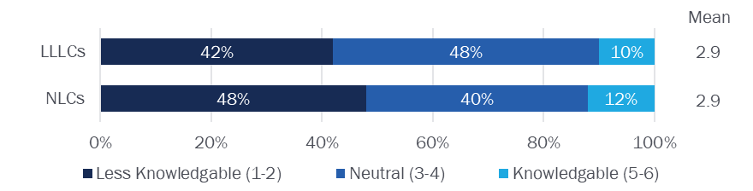

Following completion of the in-person workshop and online training, respondents reported a statistically significant increase (*p*<0.10) in knowledge of both technologies. The post-training survey respondents reported a 41% increase in LLLC knowledge and a 52% increase in NLC knowledge based on their mean knowledge ratings. Following the training, respondents also reported a 50% increase in confidence selling LLLCs. Post-training respondents also demonstrated a general understanding of LLLC benefits, with seven of the eight mentioning energy savings and three acknowledging improved lighting quality for the controlled area. Note that these findings reflect feedback from a sample of only eight post-training survey respondents and, therefore, may not reliably represent the perspectives of all training participants. Figure 3 illustrates the training participants’ self-reported level of knowledge regarding each technology following AIC training.

Figure 3. Post-Training Self-Reported LLLC and NLC Knowledge (n=8)

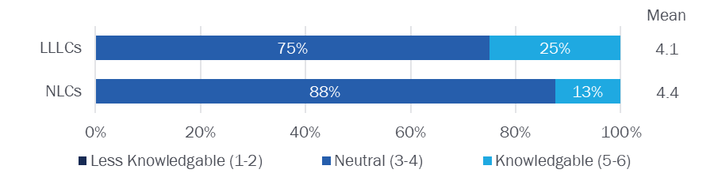

#### Training Feedback

Seven of the eight post-training survey respondents indicated they were satisfied with the online training course. Three respondents said they appreciated the thoroughness of the course content and the level of detail in the modules. The only respondent dissatisfied with the online course suggested additional case studies for LLLC applications. Seven respondents also acknowledged that the online training course improved their ability to sell, install, and set up LLLC systems.

Similarly, seven of the eight respondents also reported satisfaction with the in-person workshop. One respondent said seeing the system interface and having capabilities explained in real-time was particularly beneficial. Another acknowledged that it provided a great opportunity to connect with other industry professionals. However, respondents were split on which training they found most improved their ability to sell, install, and set up LLLC systems. Four said the in-person workshop was more beneficial. In contrast, three said the online training was more beneficial, highlighting the value of making both options available to the range of trade allies involved in recommending, selling, and installing lighting equipment.

## Market Actor Research

Customer survey respondents (n=353) represent a variety of sectors and own/operate facilities, including multifamily housing (14%, n=50), professional services (12%, n=41), trade services (12%, n=43), and agriculture (11%, n-40). About half (56%, n=199) have one business location, and most (80%, n=284) pay their facility’s full electric bill.

Trade ally survey respondents similarly represent a variety of professions and roles, including sales representatives (35%, n=13), lighting contractors (30%, n=11), and distributors (30%, n=11). To qualify for the survey, trade allies needed to install, sell, or recommend lighting products, and most also reported working with lighting controls (92%, n=34).

#### Awareness and Familiarity

At least one-third of customers surveyed indicated they were aware of LLLCs (36%) and NLCs (47%). Customers reported an average LLLC familiarity level of 37% (1.6 on a 4-point scale). This level of LLLC awareness represents a statistically significant increase (*p*<0.10) from 21% the year prior, indicating progress toward the MPI target of 50% customer awareness by 2027. Meanwhile, the vast majority of trade allies surveyed indicated they are aware of LLLCs (92%) and NLCs (89%). Trade ally LLLC awareness is consistent with equivalent results from the prior evaluation year and is already very nearly in line with the MPI target of 95% trade ally awareness by 2027. Trade allies also reported an average LLLC familiarity level of 70% (2.8 on a 4-point scale), in line with the associated MPI target for 2027. Figure 4 summarizes trade ally and customer familiarity with LLLC and NLC technologies.

MPI I 2027 Target*: 50% customer awareness and 95% trade ally awareness*

MPI II 2027 Target*: 70% mean familiarity rating for trade allies and customers*

Figure 4. Customer and Trade Ally Familiarity with NLCs and LLLCs

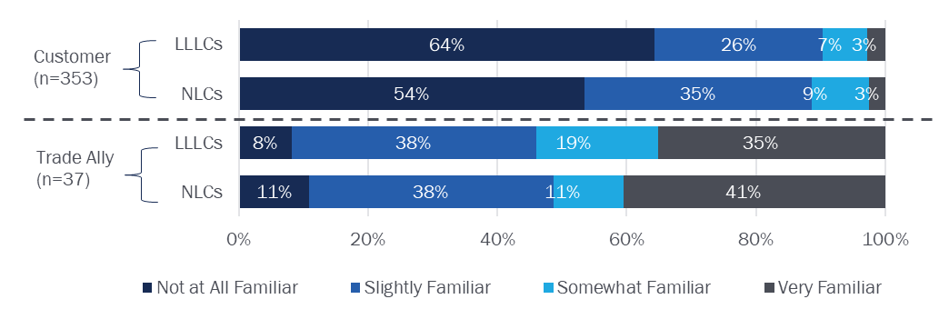

We also asked customers and trade allies about their familiarity with individual lighting controls. Customers reported the highest level of familiarity with dimmer switches (80%) and motion sensors (76%). In comparison, trade allies reported the highest level of familiarity with occupancy sensors (92%), followed by motion sensors (89%) and dimmer switches (84%). Figure 5 summarizes customer-reported familiarity with individual lighting control technologies and Figure 6 shows trade ally-reported familiarity levels.

Figure 5. Customer Familiarity with Lighting Control Technologies (n=353)

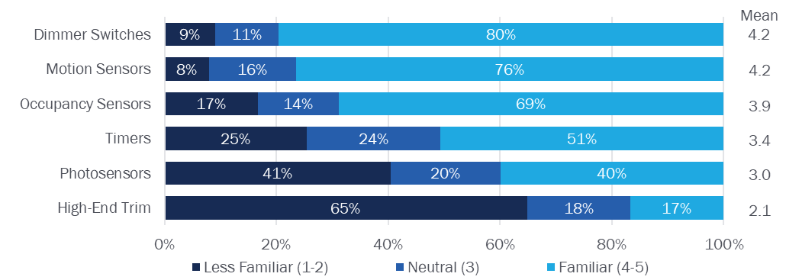

Figure 6. Trade Ally Familiarity with Individual Lighting Control Technologies (n=37)

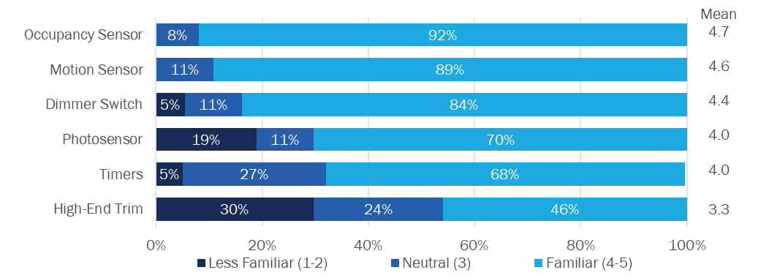

Note: Dimmer switches control the current flowing into a light fixture to increase or decrease brightness, high-end trim involves “task tuning” or reducing the brightness of light according to the size of the space, and photosensors automatically control lighting based on the presence of natural light.

#### Customer Experience with Lighting Controls

According to the customer survey, 1.5% (n=5) of commercial customers across AIC’s service territory have LLLCs installed in their facilities, and a majority of respondents (62%) do not have any lighting controls installed. Among the five respondents who reported having LLLCs installed, nearly all said they were satisfied with the installation process (100%), cost (100%), and performance of their LLLC equipment (80%). For individual lighting control technologies, the incidence of each technology mirrors customers’ self-reported familiarity levels: the most commonly installed controls are motion sensors (20%), followed by dimmer switches (14%) and occupancy sensors (10%). Figure 7 below illustrates the incidence of installed lighting control types among respondents.

Figure 7. Incidence of Lighting Controls Installed in Facilities (n=327)

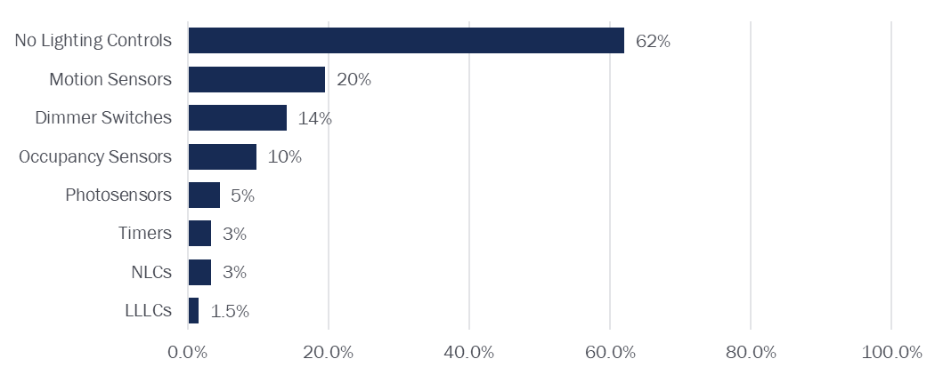

Customers who were aware of LLLCs reported AIC as the most common source of awareness for LLLCs (27%), followed by lighting contractors (19%) and other facility owners (15%). This represents a statistically significant increase (*p*<0.10) from the 2023 evaluation of the LLLC Pilot, in which 13% of customers reported learning about LLLCs from AIC. Despite the prevalence of lighting contractors as a source of LLLC awareness, only seven respondents received a recommendation from a contractor to install LLLCs. Although, it is noteworthy that five of these seven respondents followed the recommendation to install LLLCs.

#### Trade Ally Experience with Lighting Controls

Among 50 trade ally survey respondents, 73% currently make sales recommendations, and 43% currently handle lighting installations. At least half of those who sell or recommend lighting (n=36) have recommended LLLCs (50%) or NLCs (64%). This is tracking toward the MPI III goal of 65% of trade allies recommending LLLCs to clients by 2027. Among installers (n=16), about two-thirds have installed LLLCs (63%) or NLCs (69%). This is also tracking toward the MPI IV goal of 65% of trade allies installing LLLCs when they recommend them to clients. This represents an increase from 36% of trade allies surveyed with LLLC installation experience in the 2023 survey. Figure 8 displays the distribution of trade allies with experience recommending and installing LLLCs and NLCs.

MPI III 2027 Target*: 65% of trade allies recommending LLLCs*

MPI IV 2027 Target*: 65% of customers follow through on LLLC recommendations*

Figure 8. Trade Ally Recommendations and Installations of LLLCs and NLCs

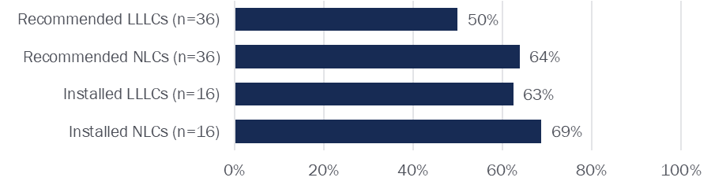

Out of the 16 respondents who installed lighting controls, less than half conducted ten or more lighting control installations in the past year (44%). Seven of the ten trade allies with experience installing LLLCs had installed LLLCs in the past year. Trade ally survey respondents suggested LLLCs are most commonly installed in warehousing, distribution, or wholesale facilities (54%) and education or childcare facilities (33%). Further, half of the ten trade allies with LLLC installation experience (n=5) suggested that LLLCs are no harder or easier to install than other types of lighting controls. Two trade allies also found LLLCs slightly more difficult to install than other types of controls.

#### Lighting Installation Motivations and Future Demand

When considering lighting options for their facility, most surveyed customers prioritize energy cost savings (84%) and energy savings (82%). More advanced capabilities like demand response, asset tracking, and enhancements to safety systems were less important. Trade ally respondents also accurately assumed their clients prioritize energy cost savings (97%) and energy savings (93%). Figure 9 lists all customer lighting priorities from most important to least important.

Figure 9. Customer Priorities for Lighting Equipment (n=353)

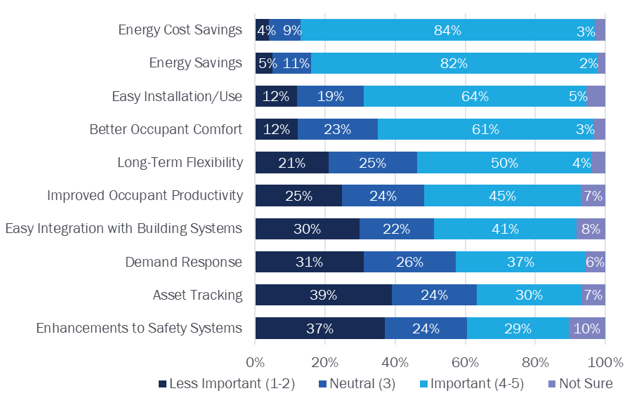

The 1.5% of customer survey respondents (n=5) who said they had LLLCs installed reported several benefits associated with LLLC systems. The most reported benefits of LLLCs from these five respondents were energy cost savings (n=3), easy installation and use (n=3), energy savings (n=2), and better occupant comfort (n=2). Despite the low current level of LLLC saturation, customer survey respondents indicated the potential for LLLC adoption in the relatively near future. By the end of 2026, 22% of respondents said they plan to install new lighting at their facility, 16% plan to install new lighting controls, and 3% plan to install new LLLC equipment.

#### Barriers to LLLC Adoption

Trade allies with at least some awareness of LLLCs (n=24) frequently reported two key barriers to customer LLLC adoption: (1) the high cost of the equipment and installation and (2) the lack of awareness of LLLC benefits and operations among customers. Half (50%) of trade allies pointed to cost as a primary barrier, and 29% identified the lack of knowledge regarding LLLCs as an impediment to customers’ decisions to adopt LLLCs. Regarding these barriers, the trade ally survey respondents provided further details:

* **Upfront cost feedback:** One trade ally noted that “the cost [of LLLCs] without the incentives to justify them [is too high],” leading customers to opt for other lighting control options or to not install lighting controls. Another respondent said LLLCs are commonly “more expensive upfront than [the cost] a client wants to incur.”
* **Awareness and familiarity feedback:** One respondent claimed that “end user familiarity and long-term comfort with using the control system to manage their facilities” has not been where it would need to be with some clients for them to justify installation of the technology. Another trade ally said their staff needs “additional training and knowledge on [LLLCs]” to effectively educate clients on the technology.

## Market Analysis

This section presents detailed findings from a review of existing research and secondary sources regarding LLLC market trends, barriers and pathways to LLLC adoption, and market actor experiences selling, installing, and purchasing LLLCs.

### Overarching Lighting Market Trends

Given their size, concentration of lighting, and typical use cases, commercial facilities are considered the primary candidates for LLLC adoption. Schools, offices, and warehouses account for the highest total square footage of lighting among buildings in the US. Further, despite the commercial sector accounting for significantly fewer total fixtures than the residential sector, commercial facilities make up more than half of total lighting energy consumption.[6] The DOE estimated an increased adoption of lighting controls of nearly 30% between 2017 and 2035, and commercial buildings already have some of the highest use cases for lighting controls.[7]

Although commercial lighting controls continue to increase in popularity, LLLC adoption is still in its very early stages, accounting for just 1% of the broader lighting market, according to recent available research. One study of Massachusetts commercial lighting customers found that NLCs and LLLCs have less than a 1% share of the state’s lighting market. Additionally, 85% of commercial lighting fixtures in the state are controlled by manual switches.[8] Another study surveyed lighting contractors in Minnesota and found that 1% of all projects they completed involved LLLCs.[9] Despite limited nationwide adoption, industry experts suggest that building design is steadily moving toward increasing interconnectivity between systems like lighting and HVAC, which aligns well with the intended outcome of LLLC installations.[10]

### LLLC Adoption

This section explores current barriers to LLLC installation and pathways to increased adoption.

#### Barriers

As already mentioned, high incremental costs are common barriers to LLLC installation. A 2020 US Lighting Market Characterization study from the DOE calculated the average per-fixture cost of three LLLC system types: Clever, Hybrid, and Smart. Clever systems only meet the DesignLights Consortium’s basic requirements to be classified as LLLCs and can include high-end trim, dimming, occupancy sensors, and photocells. Hybrid systems have similar capabilities as well as a standalone gateway that allows for improved energy monitoring. Smart systems have all the capabilities of hybrid systems and also collect and use energy and non-energy data to help optimize space conditions for lighting and other applications. The average cost of these systems is typically under $100 per fixture; however, as commercial lighting projects can consist of thousands of lighting fixtures, total LLLC system costs can amount to hundreds of thousands of dollars. Table 9 lists the per-fixture costs for each of the three types of LLLC systems.[11]

Table 9. Per-Fixture Costs of Typical LLLC Systems

| LLLC Type | Per-Fixture  Cost |
| --- | --- |
| Clever | $49 |
| Hybrid | $63 |
| Smart | $90 |

Another barrier to LLLC adoption is a lack of awareness of the technology among customers and contractors and a lack of experienced LLLC installers. According to several studies reviewed by the evaluation team, market actors note that their customers are generally unaware of LLLCs and the associated benefits. This aligns with findings from this evaluation’s customer survey, which found that 64% of customers were unaware of LLLCs in 2024. A 2021 LLLC Market Characterization study from NEEA also found that market actors sometimes pointed to their technicians’ lack of technical skills to install LLLCs and other NLCs.[12] Another 2023 study by Cadeo found that contractors were often unaware of LLLCs, highlighting the value of LLLC training like the ones offered by the LLLC Pilot.[13]

Despite the perceived complexity of LLLC installations, one lighting designer reported in an interview with BetterBricks that wiring for LLLCs is not necessarily more difficult or time-consuming than standard lighting and that LLLCs are more straightforward to work with at the fixture level than standard controls.[14] Most respondents to the trade ally survey who install LLLCs (n=8), also indicated that LLLCs were no more difficult to install than other lighting fixtures.

Lastly, the literature indicates inconsistency with LLLC naming conventions and standards. Contractors interviewed in a 2020 LLLC Market Characterization study had sometimes heard LLLCs referred to as “embedded controls” or “individual controls.” They expressed confusion as to whether this terminology applied to broader lighting control systems or individual fixtures.[15] Given the terminology inconsistency, contractors may struggle to understand the specific use cases and benefits of LLLCs. Further, NEEA’s 2016 LLLC Market Characterization found that some LLLC products do not fit the DesignLights Consortium’s standards for LLLCs, which require networking of luminaires and devices, high-end trim, and software reconfigurable zoning.[16]

#### Pathways

Several market interventions have the potential to help increase LLLC adoption, including improved energy codes, promotion through lighting designers, and incentive programs for distributors, contractors, and end users. According to the US Office of Energy Efficiency and Renewable Energy, the DOE deemed two different code models for determining residential and commercial energy savings.[17] The commercial model code is the American Society of Heating, Refrigerating, and Air-Conditioning Engineers (ASHRAE) Standard 90.1-2019.[18] Each model code is updated every three years. These model codes reflect recommendations from the DOE and are not adopted as standard practice by every state. Currently, fifteen states, including Illinois, enforce the 2019 version of the ASHRAE (90.1-2019) as their state commercial energy code.[19] However, the ASHRAE's most recent version (2019 with 2022 addenda) does not include LLLCs.[20]

Utilities and other organizations can also offer monetary incentives for increased manufacturing, sales, and installation of LLLCs. These incentives are applied to the cost of the LLLC system at different levels of the supply chain to motivate different market actors. For example, AIC currently offers incentives to business customers to install LLLCs through the Standard Initiative and Small Business Initiative. Research elsewhere suggests that upstream incentives for manufacturers and distributors can lower customer production costs and upfront costs. According to lighting market actors interviewed across the country by the publication BetterBricks, some companies elsewhere in the country have experimented with offering “Lighting as a Service,” opting to lease equipment rather than purchasing, with the intent of allowing end users to continually upgrade their system as new technology is developed or becomes available.[21] Market actors familiar with “Lighting as a Service” offerings suggested that these programs can be used in both new construction and retrofit scenarios.

Educational programs and training—like those currently offered by the LLLC Pilot—represent another pathway to increasing LLLC installation. A study by Cadeo in 2023 emphasized the popularity of these training opportunities among contractors.[22] Meanwhile, a 2016 Market Characterization Study from NEEA found that many LLLC manufacturers also offer their training for installers to learn about their specific products but do not necessarily provide broader education around new technologies.[23] The same study also concluded that existing training programs through utilities and third-party providers are essential to promoting LLLC awareness among installers, highlighting the value of continued LLLC training for keeping installers updated on new developments and encouraging adoption of the technology.[24]

#### Use Cases for LLLCs

New construction of large facilities and large-scale lighting retrofits represent prime candidates for LLLC systems. One 2021 study of Massachusetts market actors suggests that most conversion of controls happens during large-scale lighting replacement projects.[25] Other market actors often indicated that schools, office buildings, and hospitals are ideal facility types for LLLCs and NLCs, given their need for large-area lighting.[26] Opinion Dynamics’ 2022 Nonresidential NEIs Case Study found that LLLCs could be advantageous in healthcare settings or facilities with high-bay lighting to help reduce operations and maintenance costs by monitoring fixture lifecycles and ensuring fixtures do not burn out while the facility is operating.[27] Further, as current lighting fixtures age, buildings constructed more than five years ago will soon be good candidates for upgrades to advanced lighting controls.

### Market Actors

The market for LLLC equipment includes a variety of market actors, including manufacturers, lighting designers, contractors, and end users. This section reviews the intricacies of the LLLC supply chain and available research on market actors’ experiences with LLLCs.

#### Supply Chain

The supply chain for LLLCs and other NLC systems follows a similar path to typical lighting fixtures but with some notable differences. DNV’s 2021 Market Study found that while most standard or standalone lighting controls are typically provided by manufacturers directly to distributors or contractors/installers, connected lighting controls frequently pass through at least one other market actor before reaching distributors.[28] Some LLLC manufacturers do not install the control packages themselves, instead sending equipment to a technical specifier for setting up and installing control packages, and may also coordinate with contractors or end users to plan out the best equipment for their use case. NEEA’s 2016 Market Study also reported that equipment is often passed on to lighting distributors and larger lighting contractors, and smaller contractors tend to purchase their equipment from those distributors.[29]

Figure 10 below displays the flow of materials and LLLC equipment to different actors in the supply chain.[30]

Figure 10. LLLC Supply Chain Overview

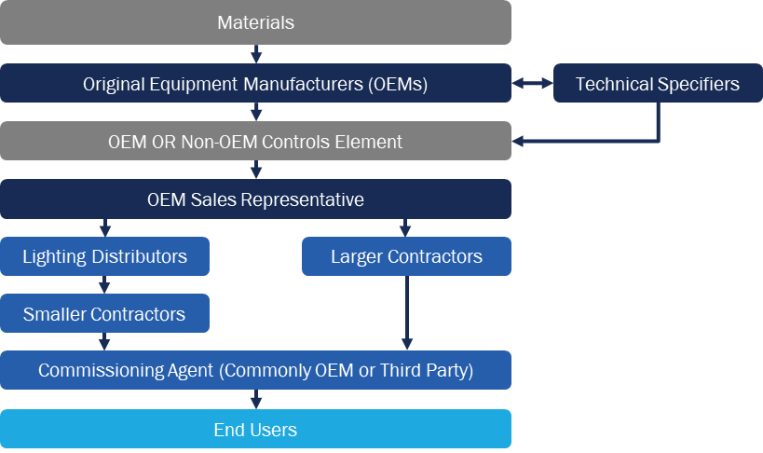

#### Market Actor Experiences

Market actors report wide-ranging experiences with LLLC manufacturing, sales, and installation, including key challenges and successes. This section breaks down their experiences and feedback based on available secondary research.

##### Manufacturers and Distributors

Given the novelty of the technology, LLLC manufacturers include smaller companies and, therefore, often follow a different supply chain than other standard lighting controls. Sometimes, LLLC manufacturers partner with larger lighting manufacturers to incorporate control packages into existing fixture designs. In other cases, larger lighting manufacturers may design and produce both the control package and the lighting fixtures in-house. In some cases, manufacturers can also customize their products to the needs of specific end users and use cases.[31] In a 2021 Market Study, some manufacturers suggested that advanced lighting controls like LLLCs can be prohibitively expensive for general lighting manufacturers to produce, lending some market security (i.e., reduced competition) to those companies with existing LLLC control package designs. [32]

Manufacturer experience with sales and promotion of LLLC products also varies. A survey of lighting manufacturers in Massachusetts found that they promoted LLLCs more frequently than they stocked them (57% and 43% of the time, respectively), which in some cases resulted from the need to commission individual designs to fit client needs.[33] Designers can also play an important role in helping manufacturers establish unique elements of each LLLC system they produce. Some manufacturers also reported difficulties quantifying LLLC sales due to the variation in the approaches to packaging and selling the equipment, where distinguishing between the number of fixtures and the number of control packages is not always straightforward.[34]

##### Contractors

As the last contributors to the LLLC supply chain, contractors are crucial in driving LLLC adoption and engaging directly with customers. In a 2021 Massachusetts study, many contractors who do not install LLLCs said they were at least somewhat familiar with advanced lighting control technology but not well-versed enough to install LLLC systems confidently.[35] Contractors interviewed for a 2016 NEEA study actively advocated for additional training and education on LLLC systems, including those with direct experience installing LLLCs. They emphasized that with the continuous innovation in advanced lighting controls, contractors will need ongoing support and training to keep up with technological changes.[36] Further, some market actors suggested that contractors with experience working in larger commercial facilities where LLLCs are most viable may be best positioned to pursue their installation. In contrast, smaller lighting contractors may be at somewhat of a disadvantage.[37]

##### End Users

End-user adoption of LLLCs hinges on system affordability and customer education. Although commercial building owners and operators are becoming more aware of NLCs and LLLCs, they may not fully understand their benefits.[38] Installers who are more familiar with LLLCs are more likely to recommend the equipment and effectively help their clients understand their value proposition.[39] Further, a 2020 study found that building owners or operators who recently installed lighting *without* any NLCs cited a lack of awareness as the primary reason they did not install them.[40]

## Market Transformation Savings

Following the methodology outlined in Section 3.4, we used customer survey responses, NMB forecasts, and 2024 AIC RA program tracking data to estimate energy savings attributable to the LLLC Pilot’s MT activities during 2024. The evaluation team relied on a formula consisting of total LLLCs in AIC territory and associated savings, NMB-forecasted savings, and LLLC savings from RA programs implemented by AIC to estimate MT savings for 2024. Equation 2 provides the MT savings formula.

Equation 2. MT Savings Estimation

$$MT Savings=\left(LLLC Units X UES\right)-NMB Savings-RA Savings$$

The results of our analysis are outlined in Table 10. Based on responses to the customer survey, we estimate the 2024 LLLC market share among AIC business customers to be 1.53% or 11,190 total LLLC units. This is more than twice the NMB-forecasted 2024 market share of 0.66% or 4,827 total LLLC units.[41] However, we also find that more than 23,000 LLLC units were installed through AIC’s RA programs in 2024. Therefore, the RA programs alone account for substantially more total LLLC units than our estimated market share. As a result, we do not attribute any MT energy savings to the LLLC Pilot for 2024.

Table 10. 2024 LLLC Pilot MT Savings Roll-Up

| Metric | % | Units | kWh  Savings |
| --- | --- | --- | --- |
| 2024 Overall Market Sharea | 1.53% | 11,190 | 2,325,315 |
| NMB Forecasted Market Share | 0.66% | 4,827 | 1,003,077 |
| Standard Initiative | N/A | 9,967 | 2,663,332 |
| Small Business Initiative – SBDI Channel | N/A | 13,677 | 2,619,688 |
| 2024 MT Savings |  | 0 | 0 |

a Overall market share among AIC commercial customers is based on the 2024 market actor customer survey.

The finding that more LLLC units were installed through AIC’s RA programs in 2024 than were estimated from the customer survey in total across AIC’s service territory demonstrates the presence of error in our overall market share estimate.[42] The minimum actual number of units in the market cannot be less than the 23,644 units installed through AIC initiatives in 2024 and is likely higher. However, this finding is not particularly methodologically concerning in that it simply highlights a limitation of survey-based numerical estimates for low-incidence occurrences. The error bounds associated with such estimates are often relatively large relative to the estimate itself. In this case, the estimated sampling error associated with the survey-based estimate of LLLC market share is large enough that the total estimate falls below the total number of units installed through AIC RA programs. As LLLC adoption increases, the sampling error around survey-based estimates of LLLC market shares is expected to decrease.

1. Data Collection Instruments

This appendix contains the data collection instruments used for the training assessment and market actor surveys.

*Pre-Training Assessment Survey Instrument*:



*Post-Training Assessment Survey Instrument*:



*Customer Survey Instrument*:



*Trade Ally Survey Instrument*:



1. Glossary of Lighting Control Terminology

This appendix provides definitions for commonly used lighting control terminology.[43]

* **Lighting Controls:** Any system that enables users to either manually or automatically turn lights on and off. Some lighting controls enable users to adjust light output to control the brightness of specific fixtures.
* **Networked Lighting Controls (NLCs):** A type of lighting system that uses sensors and network interfaces to control luminaires, retrofit kits, or lamps.
* **Luminaire Level Lighting Controls (LLLCs):** A subset of NLCs where individual luminaires have embedded lighting control logic or sensors.
* **High-End Trim:** High-End Trim is a lighting control technology that involves “task tuning”, or reducing the brightness of light according to the size of the space the lighting occupies, either based on user preference or recommendations.
* **Photosensors:** Photosensors automatically control lighting based on the presence of natural light
* **Dimmer Switches:** Dimmer switches are common lighting control outputs that control the current flowing into a light fixture while it is on, which can increase or decrease the brightness emitted by the fixture.

Contact:

Evan Tincknell   
Associate Director  
etincknell@opiniondynamics.com

1. Ameren Illinois Luminaire Level Lighting Controls (LLLC) Market Transformation Initiative Business Plan. October 25, 2023.
2. 2024 Illinois Statewide Technical Reference Manual for Energy Efficiency Version 12.0 Volume 4: Cross-Cutting Measures and Attachments, Attachment C.
3. Ameren Illinois Luminaire Level Lighting Controls (LLLC) Market Transformation Initiative Business Plan. October 25, 2023.
4. The evaluation team plans to continue fielding these surveys on a rolling basis in 2025 as new trainees engage with the online training platform and take part in future in-person workshops.
5. 2024 Illinois Statewide Technical Reference Manual for Energy Efficiency Version 12.0 Volume 4: Cross-Cutting Measures and Attachments, Attachment C.
6. US Office of Energy Efficiency & Renewable Energy. *2020 U.S. Lighting Market Characterization*. US Department of Energy, 2024, [2020 US Lighting Market Characterization](https://www.energy.gov/sites/default/files/2024-08/ssl-lmc2020_apr24.pdf).
7. Ibid; Clay Elliott. *Lighting Market Trends*. Navigant (on behalf of the US Department of Energy), 2020, [Lighting Market Trends](https://www.energy.gov/sites/default/files/2020/02/f71/ssl-rd2020-elliott-market.pdf).
8. DNV. *2020 C&I Lighting Controls Market Study*. DNV, 2021, [MA20C11-E-LCR_Lighting-Controls-Final-Report_20210630.pdf](https://ma-eeac.org/wp-content/uploads/MA20C11-E-LCR_Lighting-Controls-Final-Report_20210630.pdf).
9. Cadeo. *Luminaire Level Lighting Control (LLLC) Market Characterization*. Cadeo Group, 2023, [CEE LLLC Market Char Report 13OCT23.pdf](https://www.etamn.org/sites/default/files/research-papers/CEE%20LLLC%20Market%20Char%20Report%2013OCT23.pdf).
10. Craig DiLouie. *Leviton’s David Buerer Talks Lighting Control Trends*. The Lighting Controls Association, 2024, [Leviton’s David Buerer Talks Lighting Control Trends](https://lightingcontrolsassociation.org/2024/07/30/levitons-david-buerer-talks-lighting-control-trends/).
11. Teddy Kisch and Kate DoVale. *2020 Luminaire Level Lighting Controls Incremental Cost Study*. Energy Solutions (on behalf of Northwest Energy Efficiency Alliance), 2021, [2020 LLLC Incremental Cost Study](https://neea.org/img/documents/2020-LLLC-Incremental-Cost-Study.pdf).
12. DNV. *2020 C&I Lighting Controls Market Study*. DNV, 2021.; Cadeo. *Luminaire Level Lighting Control (LLLC) Market Characterization*. Cadeo Group, 2023.; Research Into Action, Inc. and Energy 350. *Luminaire Level Lighting Controls (LLLC) Market Characterization and Baseline Report*. Northwest Energy Efficiency Alliance, 2016.; Teddy Kisch and Kate DoVale*. 2020 Luminaire Level Lighting Controls Incremental Cost Study*. Energy Solutions (on behalf of Northwest Energy Efficiency Alliance), 2021.
13. Cadeo. Luminaire Level Lighting Control (LLLC) Market Characterization. Cadeo Group, 2023, [CEE LLLC Market Char Report 13OCT23.pdf](https://www.etamn.org/sites/default/files/research-papers/CEE%20LLLC%20Market%20Char%20Report%2013OCT23.pdf).
14. BetterBricks. *Luminaire Level Lighting Controls: The Future of Intelligent Lighting - Ask the Experts*. Northwest Energy Efficiency Alliance, [LLLC-AskTheExpert-QA_Series.pdf](https://betterbricks.com/uploads/resources/LLLC-AskTheExpert-QA_Series.pdf).
15. Cadeo. Luminaire Level Lighting Control (LLLC) Market Characterization. Cadeo Group, 2023, [CEE LLLC Market Char Report 13OCT23.pdf](https://www.etamn.org/sites/default/files/research-papers/CEE%20LLLC%20Market%20Char%20Report%2013OCT23.pdf)
16. Research Into Action, Inc. and Energy 350. *Luminaire Level Lighting Controls (LLLC) Market Characterization and Baseline Report*. Northwest Energy Efficiency Alliance, 2016, [Market Characterization and Baseline Report](https://neea.org/img/uploads/luminaire-level-lighting-controls-lllc-market-characterization-and-baseline-report.pdf).
17. US Office of Energy Efficiency & Renewable Energy. *Building Energy Codes Program: Codes 101*. U.S. Department of Energy, [Codes 101 | Building Energy Codes Program](https://www.energycodes.gov/codes-101#:~:text=Energy%20codes%20are%20holistic%20minimum%20energy%20efficiency%20requirements,multifamily%2C%20commercial%2C%20institutional%2C%20industrial%29%20and%20particular%20building%20renovations.).
18. Ibid.
19. US Office of Energy Efficiency & Renewable Energy. *Building Energy Codes Program: Municipal Commercial Energy Code Efficiency Infographic*. DOE, 2024, [Infographics | Building Energy Codes Program](https://www.energycodes.gov/infographics).
20. ASHRAE. *2019 Update Focuses on Energy-Saving Measures, Addresses Fan Efficiency, Pump Requirements*. HVAC&R Industry Newsletter, 2019, [2019 Update of Standard 90.1 | ashrae.org](https://www.ashrae.org/news/hvacrindustry/2019-update-of-standard-90-1).
21. BetterBricks. *Luminaire Level Lighting Controls: The Future of Intelligent Lighting - Ask the Experts*. Northwest Energy Efficiency Alliance, [LLLC-AskTheExpert-QA_Series.pdf](https://betterbricks.com/uploads/resources/LLLC-AskTheExpert-QA_Series.pdf).
22. Cadeo. *Luminaire Level Lighting Control (LLLC) Market Characterization*. Cadeo Group, 2023, [CEE LLLC Market Char Report 13OCT23.pdf](https://www.etamn.org/sites/default/files/research-papers/CEE%20LLLC%20Market%20Char%20Report%2013OCT23.pdf).
23. Research Into Action, Inc. and Energy 350. *Luminaire Level Lighting Controls (LLLC) Market Characterization and Baseline* Report. Northwest Energy Efficiency Alliance, 2016, [Market Characterization and Baseline Report](https://neea.org/img/uploads/luminaire-level-lighting-controls-lllc-market-characterization-and-baseline-report.pdf).
24. Craig DiLouie. *Leviton’s David Buerer Talks Lighting Control Trends*. The Lighting Controls Association, 2024, [Leviton’s David Buerer Talks Lighting Control Trends](https://lightingcontrolsassociation.org/2024/07/30/levitons-david-buerer-talks-lighting-control-trends/).
25. DNV. *2020 C&I Lighting Controls Market Study*. DNV, 2021, [MA20C11-E-LCR_Lighting-Controls-Final-Report_20210630.pdf](https://ma-eeac.org/wp-content/uploads/MA20C11-E-LCR_Lighting-Controls-Final-Report_20210630.pdf).
26. BetterBricks. *Luminaire Level Lighting Controls: The Future of Intelligent Lighting - Ask the Experts*. Northwest Energy Efficiency Alliance, [LLLC-AskTheExpert-QA_Series.pdf](https://betterbricks.com/uploads/resources/LLLC-AskTheExpert-QA_Series.pdf).
27. Opinion Dynamics. *AIC Nonresidential NEIs Case Study Results*. Opinion Dynamics Corporation, 2022, <https://www.ilsag.info/wp-content/uploads/AIC-Nonresidential-NEIs-Marketing-Cut-Sheets_FINAL.pdf>.
28. DNV. *2020 C&I Lighting Controls Market Study*. DNV, 2021, [MA20C11-E-LCR_Lighting-Controls-Final-Report_20210630.pdf](https://ma-eeac.org/wp-content/uploads/MA20C11-E-LCR_Lighting-Controls-Final-Report_20210630.pdf).
29. Research Into Action, Inc. and Energy 350. *Luminaire Level Lighting Controls (LLLC) Market Characterization and Baseline* Report. Northwest Energy Efficiency Alliance, 2016, [Market Characterization and Baseline Report](https://neea.org/img/uploads/luminaire-level-lighting-controls-lllc-market-characterization-and-baseline-report.pdf).
30. DNV. *2020 C&I Lighting Controls Market Study*. DNV, 2021, [MA20C11-E-LCR_Lighting-Controls-Final-Report_20210630.pdf](https://ma-eeac.org/wp-content/uploads/MA20C11-E-LCR_Lighting-Controls-Final-Report_20210630.pdf).
31. Research Into Action, Inc. and Energy 350. *Luminaire Level Lighting Controls (LLLC) Market Characterization and Baseline* Report. Northwest Energy Efficiency Alliance, 2016, [Market Characterization and Baseline Report](https://neea.org/img/uploads/luminaire-level-lighting-controls-lllc-market-characterization-and-baseline-report.pdf).
32. DNV. 2020 C&I Lighting Controls Market Study. DNV, 2021, [MA20C11-E-LCR_Lighting-Controls-Final-Report_20210630.pdf](https://ma-eeac.org/wp-content/uploads/MA20C11-E-LCR_Lighting-Controls-Final-Report_20210630.pdf).
33. Ibid.
34. [Research Into Action, Inc. and Energy 350. *Luminaire Level Lighting Controls (LLLC) Market Characterization and Baseline* Report. Northwest Energy Efficiency Alliance, 2016, [Market Characterization and Baseline Report](https://neea.org/img/uploads/luminaire-level-lighting-controls-lllc-market-characterization-and-baseline-report.pdf).](https://neea.org/img/uploads/luminaire-level-lighting-controls-lllc-market-characterization-and-baseline-report.pdf) 
35. DNV. 2020 C&I Lighting Controls Market Study. DNV, 2021, [MA20C11-E-LCR_Lighting-Controls-Final-Report_20210630.pdf](https://ma-eeac.org/wp-content/uploads/MA20C11-E-LCR_Lighting-Controls-Final-Report_20210630.pdf).
36. [Research Into Action, Inc. and Energy 350. *Luminaire Level Lighting Controls (LLLC) Market Characterization and Baseline* Report. Northwest Energy Efficiency Alliance, 2016, [Market Characterization and Baseline Report](https://neea.org/img/uploads/luminaire-level-lighting-controls-lllc-market-characterization-and-baseline-report.pdf).](https://neea.org/img/uploads/luminaire-level-lighting-controls-lllc-market-characterization-and-baseline-report.pdf) 
37. DNV. 2020 C&I Lighting Controls Market Study. DNV, 2021, [MA20C11-E-LCR_Lighting-Controls-Final-Report_20210630.pdf](https://ma-eeac.org/wp-content/uploads/MA20C11-E-LCR_Lighting-Controls-Final-Report_20210630.pdf).
38. Cadeo. *Luminaire Level Lighting Control (LLLC) Market Characterization*. Cadeo Group, 2023, [CEE LLLC Market Char Report 13OCT23.pdf](https://www.etamn.org/sites/default/files/research-papers/CEE%20LLLC%20Market%20Char%20Report%2013OCT23.pdf).
39. Ameren Illinois Luminaire Level Lighting Controls (LLLC) Market Transformation Initiative Business Plan. October 25, 2023.
40. DNV. 2020 C&I Lighting Controls Market Study. DNV, 2021, [MA20C11-E-LCR_Lighting-Controls-Final-Report_20210630.pdf](https://ma-eeac.org/wp-content/uploads/MA20C11-E-LCR_Lighting-Controls-Final-Report_20210630.pdf).
41. The 2024 NMB market share represents the forecasted level of LLLC adoption in the absence of any AIC program interventions.
42. Potential sources of error include survey sampling error, measurement error, and non-response bias, as detailed in Section 3.5. Survey sampling error is the only one of these that is readily quantifiable.
43. Craig DiLouie. *Introduction to Lighting Controls*. The Lighting Controls Association, 2017, <https://lightingcontrolsassociation.org/2017/07/21/introduction-to-lighting-controls/>.